

**Module Code & Module Title**

**CS6P05NI Final Year Project**

**Assessment Weightage & Type**

**40% Final Project Report**

**Year and Semester**

**2021-22 Autumn**

**Student Name: Abhishek Rokaya**

**London Met ID: 19030695**

**College ID: NP01CP4A190164**

**Internal Supervisor: Mohit Sharma**

**External Supervisor: Ankit Tandukar**

**Assignment Due Date: 27th April 2022**

**Assignment Submission Date: 27th April 2022**

**Word Count:**

*I confirm that I understand my coursework needs to be submitted online via Google Classroom under the relevant module page before the deadline in order for my assignment to be accepted and marked. I am fully aware that late submissions will be treated as non-submission and a marks of zero will be awarded.*

**Abstract**

Table of Contents

1. Introduction 1

1.1 Project Description 1

1.2 Problem Scenario 1

1.3 Project as a Solution 2

1.4 Aims and Objectives 4

1.5 Structure of the report 4

1.5.1 Background 4

1.5.2 Development 4

1.5.3 Testing and Analysis 5

1.5.4 Conclusion 5

2. Background 6

2.1 About the end users 6

2.1.1 Discussion with client 6

2.1.2 End Users 7

2.2 Understanding the solution 7

2.3 Similar Projects 8

2.4 Comparisons 12

2.5 Critical evaluation of the comparisons 13

3. Development 14

3.1 Considered Methodologies 14

3.2 Selected Methodology 16

3.3 Phases of Methodology 17

3.4 Survey 19

3.4.1 Pre-Survey Results 19

3.4.2 Post-Survey Results 20

3.5 Requirement Analysis 21

3.5.1 Feature Requirements 21

3.5.2 Hardware and Software Requirements 21

3.6 Design 22

3.6.1 ERD 24

3.6.2 Overall Use Case Diagram 25

3.6.3 Functional UML Diagrams 26

3.7 Implementation 125

3.7.1 System Architecture 125

3.7.2 Database Implementation 127

4. Testing and analysis 129

4.1 Test Plan 129

4.1.1 Unit Testing, Test Plan 129

4.1.2 System Testing, Test Plan 129

4.2 Unit Testing 129

4.3 System Testing 129

4.4 Critical Analysis 129

5. Conclusion 130

5.1 Legal, Social and Ethical Issues 131

5.1.1 Legal Issues 131

5.1.2 Social Issues 131

5.1.3 Ethical Issues 131

5.2 Advantages 132

5.3 Limitations 133

5.4 Future Work 133

6. Reference 134

7. Appendix 136

7.1 Appendix A: Pre-Survey 136

7.1.1 Pre-Survey Form 136

7.1.2 Sample of filled pre-survey forms 140

7.1.3 Pre-Survey Result 149

7.2 Appendix B: Post-Survey 154

7.2.1 Post-Survey Form 154

7.2.2 Sample of Filled Post-Survey Forms 157

7.2.3 Post-Survey Result 163

7.3 Appendix C: Sample Codes 167

7.3.1 Sample code of the UI 167

7.3.2 Sample code for the Automation Script 168

7.4 Appendix D: Designs 169

7.4.1 Gantt Chart 169

7.4.2 Work Breakdown Structure 170

7.4.3 Algorithms and Flowcharts 171

7.4.4 ER Diagram Creation Process 172

7.4.5 Software Requirement Specification (SRS) 178

7.4.6 Wireframes 200

7.5 Appendix E: Screenshots of the System 223

7.6 Appendix F: User Feedback 223

7.6.1 User Feedback Form 223

7.6.2 Sample of Filed User Feedback Forms 223

7.7 Appendix G: Future Work 223

7.7.1 Readings for future work 223

**List of Figures**

Figure 1: Survey of problem 2

Figure 2: Survey of solution 1 3

Figure 3: Survey of solution 2 3

Figure 4: Dent-inn 9

Figure 5: DentaLife 10

Figure 6: Kumari Dental Care 11

Figure 7: RUP Methodology (TestBytes, 2019) 14

Figure 8: Prototype Methodology (Martin, 2021) 15

Figure 9: Incremental Methodology (GeeksForGeeks, 2019) 15

Figure 10: Final ERD: 24

Figure 11: Overall Use Case Diagram 25

Figure 12: Use Case Diagram – User Registration 26

Figure 13: Collaboration Diagram – User Registration 27

Figure 14: Activity Diagram – User Registration 28

Figure 15: Sequence Diagram – User Registration 29

Figure 16: Use Case Diagram – User Login 30

Figure 17: Collaboration Diagram – User Login 30

Figure 18: Activity Diagram – User Login 31

Figure 19: Sequence Diagram – User Login 32

Figure 20: Use Case Diagram – User View Profile 33

Figure 21: Collaboration Diagram – User View Profile 33

Figure 22: Activity Diagram – User View Profile 34

Figure 23: Sequence Diagram – User View Profile 35

Figure 24: Use Case Diagram – User Edit Profile 36

Figure 25: Collaboration Diagram – User Edit Profile 36

Figure 26: Activity Diagram – User Edit Profile 37

Figure 27: Sequence Diagram – User Edit Profile 38

Figure 28: Use Case Diagram – User Book Appointment 39

Figure 29: Collaboration Diagram – User Book Appointment 40

Figure 30: Activity Diagram – User Book Appointment 41

Figure 31: Sequence Diagram – User Book Appointment 42

Figure 32: Use Case Diagram – User View Appointment 43

Figure 33: Collaboration Diagram – User View Appointment 43

Figure 34: Activity Diagram – User View Appointment 44

Figure 35: Sequence Diagram – User View Appointment 45

Figure 36: Use Case Diagram – User Cancel Appointment 46

Figure 37: Collaboration Diagram – User Cancel Appointment 46

Figure 38: Activity Diagram – User Cancel Appointment 47

Figure 39: Sequence Diagram – User Cancel Appointment 48

Figure 40: Use Case Diagram – User View Doctor 49

Figure 41: Collaboration Diagram – User View Doctor 49

Figure 42: Activity Diagram – User View Doctor 50

Figure 43: Sequence Diagram – User View Doctor 51

Figure 44: Use Case Diagram – User View Report 52

Figure 45: Collaboration Diagram – User View Report 52

Figure 46: Activity Diagram – User View Report 53

Figure 47: Sequence Diagram – User View Report 54

Figure 48: Use Case Diagram – User View Services 55

Figure 49: Collaboration Diagram – User View Services 55

Figure 50: Activity Diagram – User View Services 56

Figure 51: Sequence Diagram – User View Services 57

Figure 52: Use Case Diagram – Admin Login 58

Figure 53: Collaboration Diagram – Admin Login 58

Figure 54: Activity Diagram – Admin Login 59

Figure 55: Sequence Diagram – Admin Login 60

Figure 56: Use Case Diagram – Admin View Users 61

Figure 57: Collaboration Diagram – Admin View Users 61

Figure 58: Activity Diagram – Admin View Users 62

Figure 59: Sequence Diagram – Admin View Users 63

Figure 60: Use Case Diagram – Admin Delete Users 64

Figure 61: Collaboration Diagram – Admin Delete Users 64

Figure 62: Activity Diagram – Admin Delete Users 65

Figure 63: Sequence Diagram – Admin Delete Users 66

Figure 64: Use Case Diagram – Admin View Doctors 67

Figure 65: Collaboration Diagram – Admin View Doctors 67

Figure 66: Activity Diagram – Admin View Doctors 68

Figure 67: Sequence Diagram – Admin View Doctors 69

Figure 68: Use Case Diagram – Admin Add Doctors 70

Figure 69: Collaboration Diagram – Admin Add Doctors 70

Figure 70: Activity Diagram – Admin Add Doctors 71

Figure 71: Sequence Diagram – Admin Add Doctors 72

Figure 72: Use Case Diagram – Admin Delete Doctors 73

Figure 73: Collaboration Diagram – Admin Delete Doctors 74

Figure 74: Activity Diagram – Admin Delete Doctors 75

Figure 75: Sequence Diagram – Admin Delete Doctors 76

Figure 76: Use Case Diagram – Admin Edit Doctors 77

Figure 77: Collaboration Diagram – Admin Edit Doctors 77

Figure 78: Activity Diagram – Admin Edit Doctors 78

Figure 79: Sequence Diagram – Admin Edit Doctors 79

Figure 80: Use Case Diagram – Admin Add Report 80

Figure 81: Collaboration Diagram – Admin Add Report 81

Figure 82: Activity Diagram – Admin Add Report 82

Figure 83: Sequence Diagram – Admin Add Report 83

Figure 84: Use Case Diagram – Admin Delete Report 84

Figure 85: Collaboration Diagram – Admin Delete Report 85

Figure 86: Activity Diagram – Admin Delete Report 86

Figure 87: Sequence Diagram – Admin Delete Report 87

Figure 88: Use Case Diagram – Admin Edit Report 88

Figure 89: Collaboration Diagram – Admin Edit Report 88

Figure 90: Activity Diagram – Admin Edit Report 89

Figure 91: Sequence Diagram – Admin Edit Report 90

Figure 92: Use Case Diagram – Admin View Reports 91

Figure 93: Collaboration Diagram – Admin View Reports 91

Figure 94: Activity Diagram – Admin View Reports 92

Figure 95: Sequence Diagram – Admin View Reports 93

Figure 96: Use Case Diagram – Admin Book Appointment 94

Figure 97: Collaboration Diagram – Admin Book Appointment 94

Figure 98: Activity Diagram – Admin Book Appointment 95

Figure 99: Sequence Diagram – Admin Book Appointment 96

Figure 100: Use Case Diagram – Admin View Appointments 97

Figure 101: Collaboration Diagram – Admin View Appointments 97

Figure 102: Activity Diagram – Admin View Appointments 98

Figure 103: Sequence Diagram – Admin View Appointments 99

Figure 104: Use Case Diagram – Admin Cancel Appointment 100

Figure 105: Collaboration Diagram – Admin Cancel Appointment 100

Figure 106: Activity Diagram – Admin Cancel Appointment 101

Figure 107: Sequence Diagram – Admin Cancel Appointment 102

Figure 108: Use Case Diagram – Admin Approve Appointment 103

Figure 109: Collaboration Diagram – Admin Approve Appointment 103

Figure 110: Activity Diagram – Admin Approve Appointment 104

Figure 111: Sequence Diagram – Admin Approve Appointment 105

Figure 112: Use Case Diagram – Admin Reject Appointment 106

Figure 113: Collaboration Diagram – Admin Reject Appointment 106

Figure 114: Activity Diagram – Admin Reject Appointment 107

Figure 115: Sequence Diagram – Admin Reject Appointment 108

Figure 116: Use Case Diagram – Admin Finish Appointment 109

Figure 117: Collaboration Diagram – Admin Finish Appointment 109

Figure 118: Activity Diagram – Admin Finish Appointment 110

Figure 119: Sequence Diagram – Admin Finish Appointment 111

Figure 120: Use Case Diagram – Admin View Services 112

Figure 121: Collaboration Diagram – Admin View Services 112

Figure 122: Activity Diagram – Admin View Services 113

Figure 123: Sequence Diagram – Admin View Services 114

Figure 124: Use Case Diagram – Admin Add Services 115

Figure 125: Collaboration Diagram – Admin Add Services 115

Figure 126: Activity Diagram – Admin Add Services 116

Figure 127: Sequence Diagram – Admin Add Services 117

Figure 128: Use Case Diagram – Admin Delete Services 118

Figure 129: Collaboration Diagram – Admin Delete Services 119

Figure 130: Activity Diagram – Admin Delete Services 120

Figure 131: Sequence Diagram – Admin Delete Services 121

Figure 132: Use Case Diagram – Admin Edit Service 122

Figure 133: Collaboration Diagram – Admin Edit Service 122

Figure 134: Activity Diagram – Admin Edit Service 123

Figure 135: Sequence Diagram – Admin Edit Service 124

Figure 136: System Architecture (AskPython, 2022) 126

Figure 137: Database Implementation Code – 1 127

Figure 138: Database Implementation Code - 2 127

Figure 139: Database Implementation Code – 3 128

Figure 140: Database Implementation Code – 4 128

Figure 141: Pre-Survey Form - 1 136

Figure 142: Pre-Survey Form - 2 137

Figure 143: Pre-Survey Form - 3 137

Figure 144: Pre-Survey Form - 4 138

Figure 145: Pre-Survey Form - 5 138

Figure 146: Pre-Survey Form - 6 139

Figure 147: Sample 1 of pre-survey form - 1 140

Figure 148: Sample 1 of pre-survey form - 2 140

Figure 149: Sample 1 of pre-survey form - 3 141

Figure 150: Sample 1 of pre-survey form - 4 141

Figure 151: Sample 1 of pre-survey form - 5 142

Figure 152: Sample 2 of pre-survey form - 1 143

Figure 153: Sample 2 of pre-survey form - 2 143

Figure 154: Sample 2 of pre-survey form - 3 144

Figure 155: Sample 2 of pre-survey form - 4 144

Figure 156: Sample 2 of pre-survey form - 5 145

Figure 157: Sample 3 of pre-survey form - 1 146

Figure 158: Sample 3 of pre-survey form - 2 146

Figure 159: Sample 3 of pre-survey form - 3 147

Figure 160: Sample 3 of pre-survey form - 4 147

Figure 161: Sample 3 of pre-survey form - 5 148

Figure 162: Pre-Survey Result – 1 149

Figure 163: Pre-Survey Result - 2 149

Figure 164: Pre-Survey Result – 3 150

Figure 165: Pre-Survey Result - 4 150

Figure 166: Pre-Survey Result - 5 151

Figure 167: Pre-Survey Result - 6 151

Figure 168: Pre-Survey Result - 7 152

Figure 169: Pre-Survey Result - 8 153

Figure 170: Post-Survey Form - 1 154

Figure 171: Post-Survey Form - 2 155

Figure 172: Post-Survey Form - 3 155

Figure 173: Post-Survey Form - 4 156

Figure 174: Post-Survey Form - 5 156

Figure 175: Sample 1 of post-survey form - 1 157

Figure 176: Sample 1 of post-survey form - 2 157

Figure 177: Sample 1 of post-survey form - 3 158

Figure 178: Sample 1 of post-survey form - 4 158

Figure 179: Sample 2 of post-survey form - 1 159

Figure 180: Sample 2 of post-survey form - 2 159

Figure 181: Sample 2 of post-survey form - 3 160

Figure 182: Sample 2 of post-survey form - 4 160

Figure 183: Sample 3 of post-survey form - 1 161

Figure 184: Sample 3 of post-survey form - 2 161

Figure 185: Sample 3 of post-survey form - 3 162

Figure 186: Sample 3 of post-survey form - 4 162

Figure 187: Post-Survey Result – 1 163

Figure 188: Post-Survey Result - 2 163

Figure 189: Post-Survey Result - 3 164

Figure 190: Post-Survey Result - 4 164

Figure 191: Post-Survey Result - 5 165

Figure 192: Post-Survey Result - 6 165

Figure 193: Post-Survey Result - 7 166

Figure 194: Gantt chart 169

Figure 195: Work Breakdown Structure 170

Figure 196: User-patientUser Relation 172

Figure 197: patientUser-Appointment Relation 173

Figure 198: Report-Appointment Relation 173

Figure 199: Doctor-Appointment Relation 173

Figure 200: Service-Appointment Relation 174

Figure 201: System Perspective Diagram 180

Figure 202: Overall Use Case of the System 181

Figure 203: UI of Home Page 1 192

Figure 204: UI of Home Page 2 193

Figure 205: UI of Home Page 3 193

Figure 206: UI of Home Page 4 194

Figure 207: UI of Home Page 5 194

Figure 208: UI of Home Page 6 195

Figure 209: UI of Home Page 7 195

Figure 210: UI of Home Page 8 196

Figure 211: UI of Home Page 9 196

Figure 212: Wireframe - Home Page 200

Figure 213: Wireframe - User Registration 201

Figure 214: Wireframe - User Login 202

Figure 215: Wireframe - Admin Login 203

Figure 216: Wireframe - User Dashboard 204

Figure 217: Wireframe - User View Appointment 205

Figure 218: Wireframe - User Book Appointment 206

Figure 219: Wireframe - User View Doctor 207

Figure 220: Wireframe - User View Report 208

Figure 221: Wireframe - User View Service 209

Figure 222: Wireframe - User View Profile 210

Figure 223: Wireframe - User Edit Profile 211

Figure 224: Wireframe - Admin Dashboard 212

Figure 225: Wireframe - Admin View Appointment 213

Figure 226: Wireframe - Admin Approve Appointment 214

Figure 227: Wireframe - Admin Book Appointment 215

Figure 228: Wireframe - Admin View Doctor 216

Figure 229: Wireframe - Admin Add Doctor 217

Figure 230: Wireframe - Admin View Report 218

Figure 231: Wireframe - Admin Add Report 219

Figure 232: Wireframe - Admin View Service 220

Figure 233: Wireframe - Admin Add Service 221

Figure 234: Wireframe - Admin View Users 222

**List of Tables**

Table 1: Analysis of Similar Project 12

Table 2: High Level Use Case – User Registration 25

Table 3: High Level Use Case – User Login 28

Table 4: High Level Use Case – User View Profile 31

Table 5: High Level Use Case – User Edit Profile 34

Table 6: High Level Use Case – User Book Appointment 38

Table 7: High Level Use Case – User View Appointment 42

Table 8: High Level Use Case – User Cancel Appointment 44

Table 9: High Level Use Case – User View Doctors 47

Table 10: High Level Use Case – User View Report 50

Table 11: High Level Use Case – User View Services 53

Table 12: High Level Use Case – Admin Login 56

Table 13: High Level Use Case – Admin View Users 59

Table 14: High Level Use Case – Admin Delete Users 62

Table 15: High Level Use Case – Admin View Doctors 65

Table 16: High Level Use Case – Admin Add Doctors 68

Table 17: High Level Use Case – Admin Delete Doctors 72

Table 18: High Level Use Case – Admin Edit Doctors 75

Table 19: High Level Use Case – Admin Add Report 79

Table 20: High Level Use Case – Admin Delete Report 83

Table 21: High Level Use Case – Admin Edit Report 86

Table 22: High Level Use Case – Admin View Reports 90

Table 23: High Level Use Case – Admin Book Appointment 92

Table 24: High Level Use Case – Admin View Appointments 96

Table 25: High Level Use Case – Admin Cancel Appointment 98

Table 26: High Level Use Case – Admin Approve Appointment 101

Table 27: High Level Use Case – Admin Reject Appointment 104

Table 28: High Level Use Case – Admin Finish Appointment 107

Table 29: High Level Use Case – Admin View Services 110

Table 30: High Level Use Case – Admin Add Services 113

Table 31: High Level Use Case – Admin Delete Services 117

Table 32: High Level Use Case – Admin Edit Services 120

Table 33: User Attributes 168

Table 34: patientUser Attributes 169

Table 35: Doctor Attribute 169

Table 36: Service Attribute 170

Table 37: Appointment attribute 170

Table 38: Report attribute 171

Table 39: Functional Requirement 1 179

Table 40: Functional Requirement 2 180

Table 41: Functional Requirement 3 181

Table 42: Functional Requirement 4 182

Table 43: Functional Requirement 5 183

Table 44: Functional Requirement 6 184

Table 45: Functional Requirement 7 185

Table 46: Performance Requirement 192

Table 47: Safety Requirement 192

Table 48: Other Software Quality Attributes 193

**Table of Abbreviation**

|  |  |
| --- | --- |
| IT | Information Technology |
| ERD | Entity Relation Diagram |
|  |  |
|  |  |
|  |  |

# 1. Introduction

## 1.1 Project Description

Dental hygiene is the practice of keeping the mouth clean, and it is often regarded as the most effective method of preventing cavities (dental caries), gingivitis, periodontitis, and other dental problems. It also aids in the prevention of foul breath (halitosis). Regular dental visit is necessary since it helps to keep our teeth and gums healthy. It is recommended that we visit a dental clinic at least once every six months.

A good dental care is necessary if we face any problems related to our teeth and gums. If not treated properly, we may face various difficulties like constant tooth pain, not being able to eat properly and many more. There are millions of people who face daily dental related problems in their lives all over the world. In Nepal, there is no proper facility to get an appointment for our dental check-up. There are thousands of people who visit dental clinics in Nepal every single day. But due to lack of proper resources, people have to wait for hours and hours even if they have a slight problem just to consult with a doctor.

Time is a precious thing and we should not waste it waiting in line for hours. So keeping that in mind, this project is a dental application/management system which lets users to book an appointment for their dental requirements. This will help save people a lot of time and is convenient as well.

## 1.2 Problem Scenario

People who have a tight schedule don't have enough time to wait in long line for their dental check-up. Sometimes there is no guarantee if their turn will come or not. It is very hectic for people to wait in long lines for a few minutes of consultation as well. Especially now, in times of Covid, it is very risky to stay in crowds as well. Here, the clinics still use old paper style report so there is very high chance that the report will get lost or misplaced. So, if in case, the patient goes to a new dentist, there is a chance that he/she might have to check their whole teeth again to see what had happened.

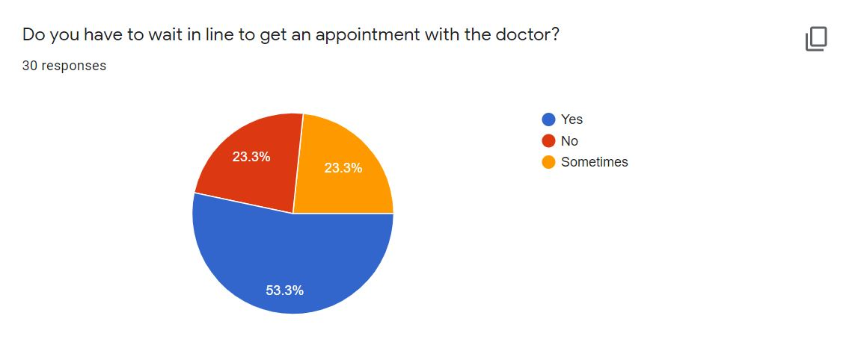

Figure 1: Survey of problem

According to a survey done, it was found that over 50% had to wait in long lines to get an appointment with the doctor whereas around 23% sometimes had to wait in lines.

## 

## 1.3 Project as a Solution

This Dental Appointment System is important for the country as technology grows fast in the world. The goal of developing this project is to provide better solutions to the problems faced by patients. This website will allow customers to schedule an appointment for their dental check-up from home or from the office. In the present situation, there is no such appointment system available in Nepal. Patients find it difficult to book an appointment for their dental check-up. Either they must wait a very long line in crowd or must call some known doctors to schedule an appointment. Patients can also view their reports in their profile, so they will never lose their dental record and it will be much easier to access it in future if the patients face any problems.

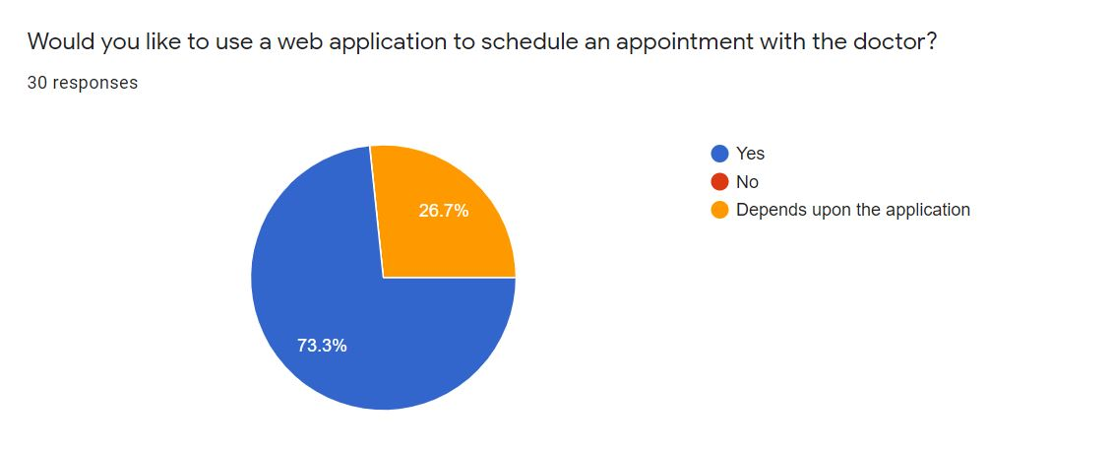

Figure 2: Survey of solution 1

According to the pie chart, it shows that over 70% of them would like to use a web based application to schedule an appointment with the doctor whereas the rest would like to use it depending upon the application.

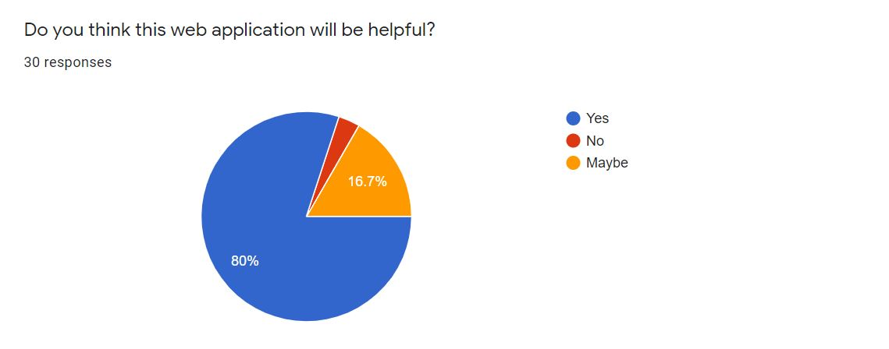

Figure 3: Survey of solution 2

According to the above pie chart of the survey, it was found that 80% of the people thought this web application will be useful whereas 16.7% thought it might be helpful.

At the end of this project, a prototype will be created that will provide a solution to the problem found. This system would be a web-based system where an overall online registration process and appointments will be carried out. Finally, the proposed system would save time for the patients.

## 1.4 Aims and Objectives

The primary aim of this project is to create a user-friendly web application that allows users to schedule a dental check-up appointment and save time rather than going to the clinic and waiting in line.

The following objectives are pursued in order to achieve this aim:

* To learn about the Python and its Django Framework along with it features.
* To use a relational database to comprehend and implement a database management system in the real world.
* To create a web application that allows to people book an appointment for their dental check-up.
* To work on the project using incremental methodology.
* Make the UI as user-friendly and interactive as possible.

## 1.5 Structure of the report

### 1.5.1 Background

* About end user
* Understanding the solution
* Similar Projects
* Comparisons

### 1.5.2 Development

* Considered Methodologies
* Selected Methodology
* Phases of methodology
* Survey Results
  + Pre-Survey Results
  + Post-Survey Results
* Requirement Analysis
* Design
* Implementation

### 1.5.3 Testing and Analysis

* Test Plan
  + Unit Testing, Test plan
  + System Testing, Test Plan
* Unit Testing
* System Testing
* Critical Analysis

### 1.5.4 Conclusion

* Legal, Social and Ethical Issues
  + Legal Issues
  + Social Issues
  + Ethical Issues
* Advantages
* Limitations
* Future Work

# 2. Background

## 2.1 About the end users

### 2.1.1 Discussion with client

Phulchowki Dental Clinic is a dental clinic located at Thaiba, Lalitpur. The founder and Managing Director of the clinic, Dr. Prashamsa Khadka has agreed to be the client for this project as she, including other staff, found this project very useful, feasible and effective.

According to Dr. Prashamsa Khadka, Founder and Managing Director of Phulchowki Dental Clinic, the following issues were identified during the discussion and meeting:

**Problem:**

According to her, there wasn't any system to book an appointment. People either had to call or wait in line. The lines were very long and sometimes very crowded as well. Especially in time of covid, it was very hard to even maintain social distance which increased the risk of transmission. She also stated that the records were written manually in a paper which made it very hard to access the records. Patients used to lose their reports frequently which made them difficult to have access to their previous history. So she had been looking for such system to implement.

**Solution:**

This system will allow users to book the appointment. Users can view the list of available doctors and select their desired doctors for their desired services. The system allows them to book, cancel and check the booking status. The report can also be uploaded which makes it easier for both patient and doctors.

**Client's Requirements:**

* Users should have their profile.
* Users should be able to book their appointment easily through the system.
* The system should also have features to cancel the appointment as well as check the appointment booking status.
* List of available doctors along with their description.
* Admin should be able to cancel user's appointment if the need arises.
* User should be able to view their report online as well.
* The Admin will manage the doctor's list and well as the user's list.
* The Admin will upload the doctor's approved report to the system for the user's to see.

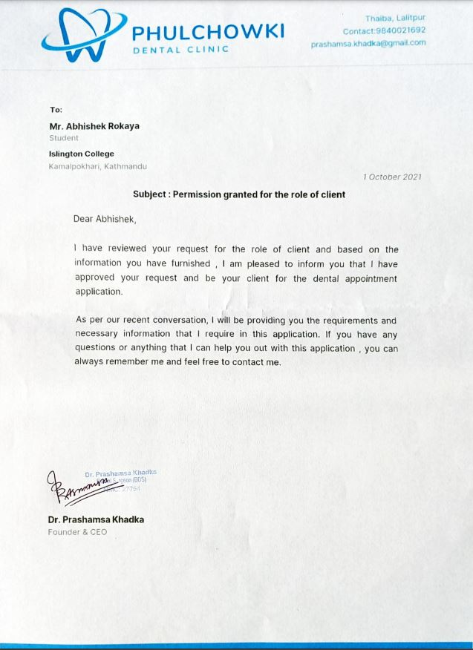

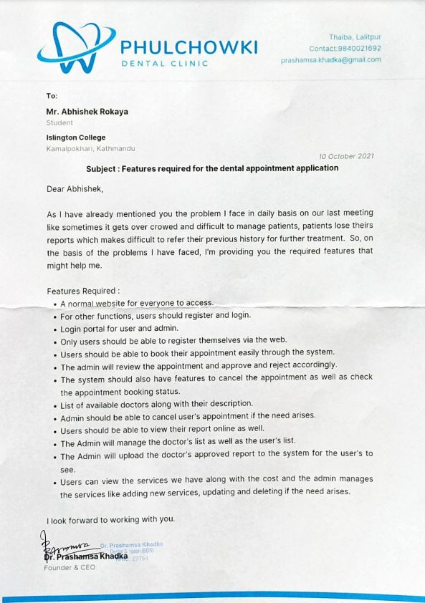

### 2.1.2 End Users

The end users for the application will be multiple people who wants to book a dental appointment. The targeted users are the general public looking for an easier way to schedule a dental appointment with the doctor.

## 2.2 Understanding the solution

**2.2.1 Overview of the system**

The system is web-based application named "Dental Appointment System" for "Phulchowki Dental Clinic" located in Thaiba, Lalitpur. The main objective of the application is to provide an online platform for users to book their dental appointment based on their time and convenience. It is a simple application in which user can also view their reports of their appointment visit and select their desired doctors and services.

**2.2.2 Technology**

**Django Python Framework:**

For my project, I have decided to use the Django Python Framework. The reason I chose this framework is because it has better CDN connectivity and content management. It also has a faster processing. Django uses the MTV architecture due to which the transmission over the internet is easier and faster.

**HTML, CSS, JavaScript and Bootstrap**

For the frontend of the web application, I have decided to use HTML, CSS, JavaScript and Bootstrap, which is the framework of CSS.

**SQLite3**

For the database, I have decided to use SQLite to store the database. Django uses SQLite database by default so it is easier to use this database than others which is why I chose this.

**Visual Studio Code IDE:**

The IDEs that I will be using to develop the application is Visual Studio Code. Microsoft's Visual Studio Code (often known as VS Code) is a free open source text editor. Windows, Linux, and macOS are all supported by VS Code. Although the editor is minimal, it contains several strong capabilities that have helped VS Code become one of the most popular development environment tools in recent years.

**Hardware Requirements**

For the project to run, it doesn't need any high-end hardware device. Just a normal working device with a proper internet connection will work fine.

## 2.3 Similar Projects

**2.3.1 Dent-inn**

Dent-inn is a dental clinic located at Durbar-marg of Kathmandu, Nepal. The application is a web based application. In this application, you can fill out an online appointment form. The form requires name, phone, email, date, time, preferred doctor and message. However, you cannot select a particular service from the appointment from itself. There is also a section where you can view the in house doctors. In this application, you do not need register as a user. Anyone can just visit the website and book an appointment. There is no section for uploading report meaning you can only book an appointment for your dental check-up and nothing more.

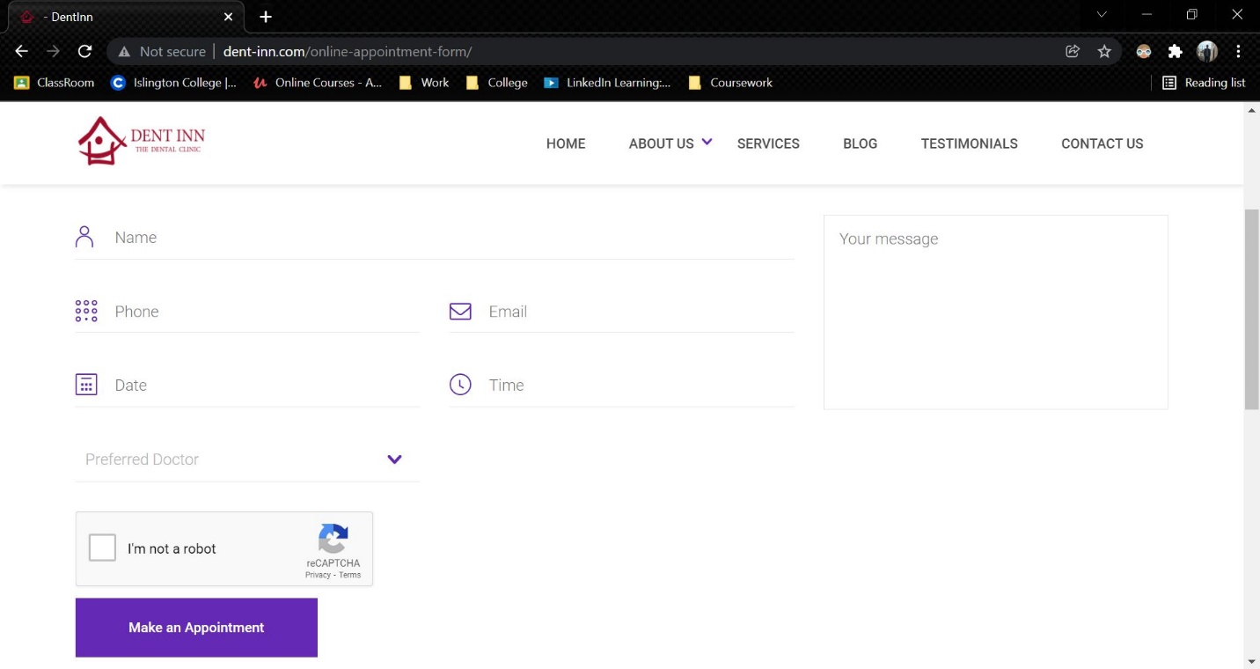

Figure 4: Dent-inn

Link to the website: <http://www.dent-inn.com/>

**2.3.2 DentaLife**

DentaLife is also a dental clinic located at Jamal, Kathmandu. Although the website is similar to Dent-inn, the appointment section of this web is quite different. It used google forms in order to collect the appointment details. This web uses no backend.

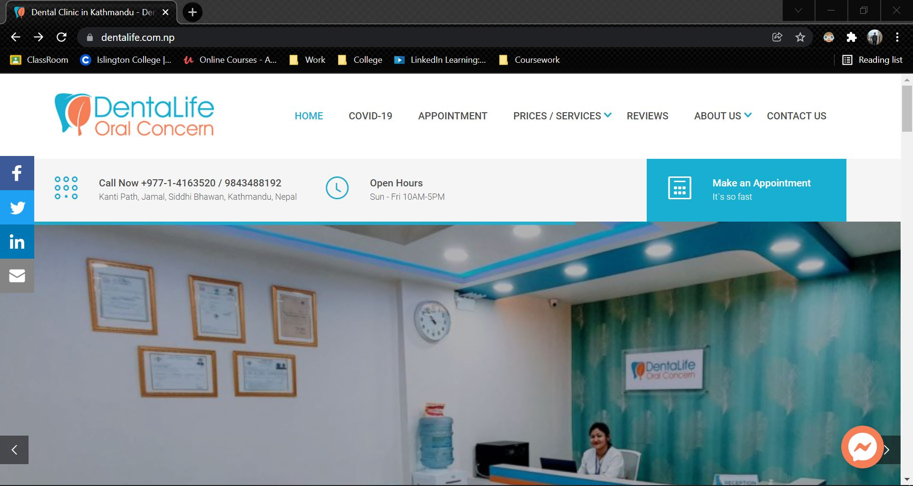

Figure 5: DentaLife

Link to the website: <https://dentalife.com.np/>

**2.3.3 Kumari Dental Care**

Kumari Dental Care is a dental clinic located at Jhamsikhel, Lalitpur. It is also a web based application where any user can book an appointment. In this web application, the first name, last name, email, needs and message. In this clinic, only one doctor is present. There is no login and register feature here as well. There is no report option here as well, meaning user will only use this website once for their appointment.

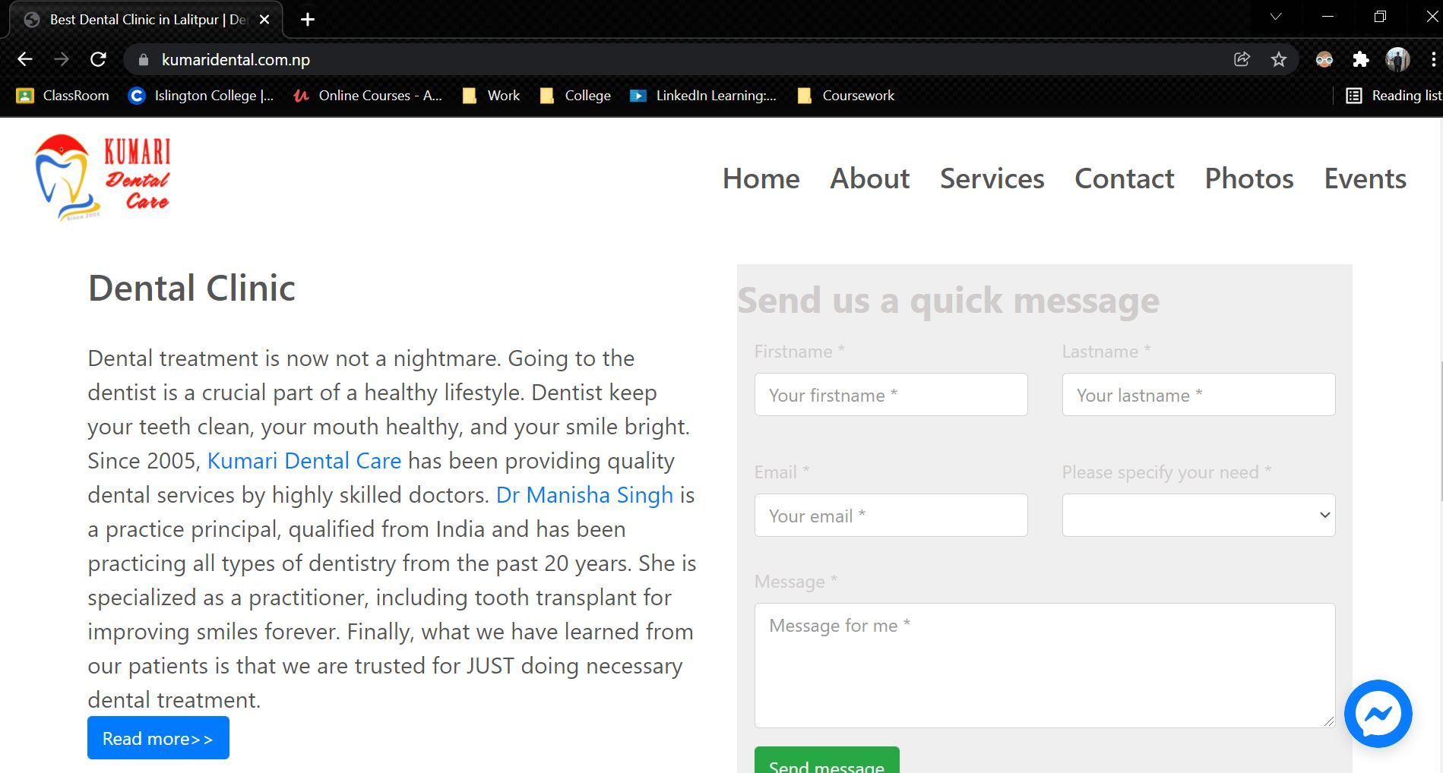

Figure 6: Kumari Dental Care

Link to the website: <https://kumaridental.com.np/index.html>

## 2.4 Comparisons

The table below shows the comparison of different web based applications for the online appointment booking system.

|  |  |  |  |  |  |
| --- | --- | --- | --- | --- | --- |
| S.No | **Features** | Dent-inn | DentaLife | Kumari Dental | My System |
| 1. | Online Appointment Booking Module | ✓ | ✓ | ✓ | ✓ |
| 2. | Doctor Selection | ✓ | ✓ | 🗶 | ✓ |
| 3. | Service Selection | 🗶 | 🗶 | ✓ | ✓ |
| 4. | View Report | 🗶 | 🗶 | 🗶 | ✓ |
| 5. | View Doctors | ✓ | 🗶 | ✓ | ✓ |
| 6. | Login | 🗶 | 🗶 | 🗶 | ✓ |
| 7. | Register | 🗶 | 🗶 | 🗶 | ✓ |
| 8. | Day and Time Selection | ✓ | ✓ | ✓ | ✓ |
| 9. | Description | ✓ | ✓ | ✓ | ✓ |

Table 1: Analysis of Similar Project

## 2.5 Critical evaluation of the comparisons

Comparing the systems, it is found that none of the other similar system have a login or register feature. 2 out 3 website uses Google form as their appointment booking system to collect the user's data. 2 out of 3 website also had the option to select which doctor they wanted to select to get an appointment with. Only one of the three website had the option to select what service the user wanted to get. Others used the description field to write what they wanted. All of the website does have the date and time selection with a place for extra description of their appointment. However, it appears none of the similar websites have the feature to view their report of the visit. All of the similar system focuses only on gaining patient for the appointment and does not seem to care afterwards. However, in my system, we keep track of every visits of the users along with their reports of every visit. In my system, we also show the details of the doctors with the qualification along with the price of the service. This system is very much transparent compared to others and it is for free meaning users do not have to pay any price to use this system.

# 3. Development

## 3.1 Considered Methodologies

**3.1.1 RUP Methodology**

The Rational Unified Process (RUP) is an approach for developing agile software. The project life cycle is divided into four phases by RUP. All six main development disciplines are practiced at each phase: business modelling, requirements, analysis and design, implementation, testing, and deployment. RUP provides a systematic way to build this type of system, focusing on the production of an executable architecture in the early stages of the project, that is, before committing resources on a large scale. (TestBytes, 2019)

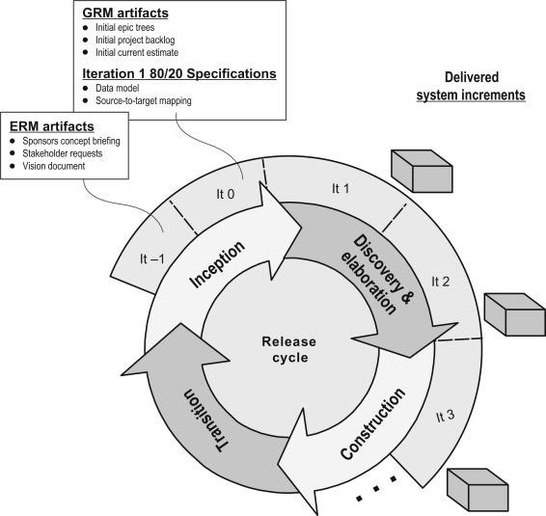

Figure 7: RUP Methodology (TestBytes, 2019)

**Justification for considering the methodology:**

* The development process can be done back and forth
* End users have the ability to provide continuous feedback.
* This model focuses on the quality of the software with accurate documentation.

**Reason for not selecting this methodology**

* It relies strongly on expert and skilled team members.
* The process of development is far too complicated and disorderly.
* The focus on integration throughout development may have an impact on testing and other quality assurance phases.

**3.1.2 Prototype Methodology**

Prototype Model is a software development model in which prototype is built, tested, and reworked until an acceptable prototype is achieved. (Martin, 2021) It also serves as a foundation for the creation of the final system or software. It's best used in situations where the project's requirements aren't fully understood. It is an iterative, trial-and-error process that occurs between the developer and the client.

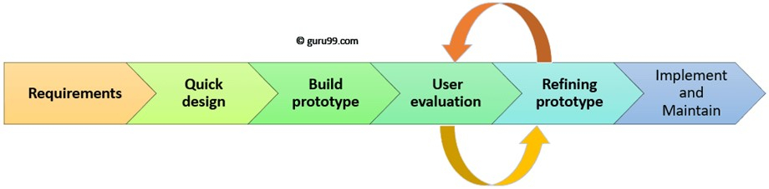

Figure 8: Prototype Methodology (Martin, 2021)

**Justification for considering the methodology:**

* There is room for improvement, which implies that new requirements may be addressed quickly.
* It aids both developers and users in gaining a better understanding of the system.
* The integration needs are well defined, and the deployment channels are chosen early on.
* It has the ability to actively include users in the development process.

**Reason for not selecting this methodology**

* Because to the constantly changing client needs, it has weak documentation.
* The system's complexity may rise as a result.
* There may be an excessive amount of variety in requirements.

**3.1.3 Incremental Methodology**

In Incremental Methodology, first a simple working system is constructed and supplied to the customer, with only a few basic features. Over many successive iterations successive versions are implemented and delivered to the customer until the desired system is realised. (Mall, 2014) The following diagram shows the incremental development model:

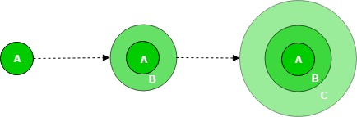

Figure 9: Incremental Methodology (GeeksForGeeks, 2019)

The product is broken down into multiple parts, each of which is designed and constructed independently (termed as builds). When all of the components have been completed, they are delivered to the client. This allows for partial product usage while avoiding a lengthy development process. It also necessitates a significant upfront financial investment, with the long wait time eliminated. This model of development also helps ease the traumatic effect of introducing completely new system all at once.

(Ghahrai, 2016)

## 3.2 Selected Methodology

**Incremental Methodology**

There are various types of software development methodology. Some are designed for large, high-investment projects, while others are designed for smaller ones. While developing a software, the research on a methodology should be done properly and chosen in a very conscious way. I chose the Incremental Model methodology for my project. The incremental model is a software development technique in which the model is defined, implemented, and tested one step at a time until the product is complete. It consists of both development and maintenance. When a product meets all of its specifications, it is said to be done. This model combines the elements of the waterfall model with the iterative philosophy of prototyping. (Ghahrai, 2016)

**Reason to select this methodology over prototype and RUP methodology**

The system is created in prototypes, which are utilized as a model for inspection, feedback collection, and improvement for the next prototype, according to the prototype approach. During the early stages, these prototypes aren't given much attention and are built quickly with the purpose of being discarded. Because this is a tiny project, prototype technique necessitates a high level of client/end-user participation and contact, which is not physically practical. It's tough to create prototypes rapidly, because each module may take different expertise to construct, with some modules reliant on others. The prior prototypes, on the other hand, are discarded and unusable. Making prototypes for each iteration takes a long time.

In RUP Methodology, the development process is way too complex and disorganized. Since this project is to be done alone, it was better to avoid such development project. The team members also are needed to be expert to develop the software. This was not possible in the given scenario. While adding new features, there might only be more confusion and cause lots of issues during the testing phase so I chose incremental methodology over this methodology.

All things considered, we can conclude that increments was the preferable choice based on the approaches discussed above. The incremental method starts early in the development process with a first release of software and gradually enhances it. It's similar to prototyping, except instead of resuming development, it improves on what's already been done. This strategy breaks the project into minor iterations that can be handled as sub-projects and is suitable for developing a web application. Several iterations can be made to improve the web application's functions and features, as well as additions to functions in future iterations with updated versioning. It entails both development and maintenance at the same time. It's perfect since each module or component may be created independently, resulting in a better product at the end of each iteration. It is easier to estimate the project's risk because testing and debugging the program is easier in each iteration. Testing is also done in a separate step for each iteration in this manner.

## 3.3 Phases of Methodology

There are 4 phases involves in the Incremental model and they are enumerated below:

**3.3.1 Requirement Analysis:**

The first stage in the incremental model is to analyse the product's problem situation and identify the specifications. The functional requirements of the system are understood by the requirement analysis team. This procedure is essential for designing apps utilizing the incremental model. All of the system's criteria are obtained during this procedure through study of publications, books, and web sites, as well as surveys and interviews with end users.

The requirements for my system were acquired through a survey and analysed based on how the end user would want to utilize the program and what features they desired.

**3.3.2 Design and Development:**

Following the collection of all specifications, the major functions and features to be employed in the software are determined. Risks are identified during this phase, as are the instruments that will be used. During this phase, wireframes, use case diagrams, collaboration diagrams, sequence diagrams, and class diagrams are also created. The functionality of the system and the development technique have been successfully designed.

After analysing the requirements, the general design of the project began with the creation of the system's wireframes. Following the creation of the wireframe, the class diagram and use cases for the overall system were established. Following the creation of the class diagram, the ERD for the system's database was created, and the system's code/development was initiated.

**3.3.3 Testing:**

After developing the system's functionality, it is tested in this phase to ensure that the developed system is fully functional and error-free. This phase assesses the consistency of all existing functionalities as well as the addition of new features. A variety of testing methods are utilized to test the activity of each task.

Following the end of the system's development, different forms of testing were performed, including unit testing, system testing, Blackbox testing, and Whitebox testing.

**3.3.4 Implementation:**

When the testing phase is finished, the project goes on to the implementation phase. It includes both the final coding developed during the development phase and the testing of the functionality during the testing phase. After this phase is completed, the number of working products is improved and updated all the way to the final system product. This phase reviews and discusses the entire system, as well as the features and modifications that will be required in future iterations.

After testing is completed, the system's final coding is accomplished, and the focus shifts to enhancing the system, fixing errors, and adding new features.

## 3.4 Survey

### 3.4.1 Pre-Survey Results

A survey was conducted during the requirement analysis phase where details about the scenario people face and what might make the application better was recorded. A total of 30 people filled out the survey and the details that was gathered are as follows:

1. 43.3% of them have their dental check-up in over a year, 26.7% of them in a year, 26.7% in every 6 months and 3.3% in every 3 months.
2. 53.3% have to wait in line to get an appointment, 23.3% sometime have to wait in line and 23.3% of them doesn't have to wait in line.
3. 86.7% have never used an online appointment booking system whereas 13.3% have.
4. 73.3% said they would like to use a web based application to schedule an appointment with the doctor whereas the remaining 26.7% said it would depend on the application.
5. 80% thinks this application will be helpful, 16.7% thinks the application might be helpful whereas 3.3% thought it will not be helpful.
6. 76.7% thinks having an online report will be useful whereas 23.3% thinks it might be useful.

Link to the survey: <https://forms.gle/x1DkhUFqgoDTmZ886>

Click here to see the pre-survey results and responses

### 3.4.2 Post-Survey Results

After the completion of the development phase, another survey was conducted which recorded the response of people to how the system was. A total of 55 people filled out the survey and the results that was gathered are as follows:

1. 74.5% of the total people rated 5 star for the UI of the application. 23.6% rated it as 4 star and 1.8% rated it as 3 star.
2. 87.3% of the total people rated 5 star for the functionality of the system whereas the rest 12.7% rated it as 4 star.
3. 49.1% of them liked viewing the report function the most among others. 40% liked the Booking of Appointment most whereas the rest 10.9% liked the browsing of doctor the most.
4. 100% of the people saw themselves as using this application.
5. 100% of the people would recommend this application to others.
6. Most of the people would like to see payment and chat system in the future.

Link to the survey: https://forms.gle/Y7jvWTMVgvhn8wCr7

Click here to see the post-survey results and responses

## 3.5 Requirement Analysis

### 3.5.1 Feature Requirements

**3.5.1.1 Functional**

* User can register and login in the system.
* User can schedule an appointment for their booking.
* User can cancel their booking.
* Admin can approve, reject or cancel the user's appointment.
* Admin can add report of the finished appointment.
* Admin can add, update and delete the doctors and services.

**3.5.1.2 Non-Functional**

* User can view their report of their finished appointment.
* User can view the list of doctors along with their details.
* User can view the services available along with the cost and description.

**3.5.1.3 Usable**

* There is a navigation bar available in the side for users to switch pages.
* Unregistered users can send their queries through contact form in home page.
* User can search and sort their appointment and report list.
* User can download a pdf of their report.

### 3.5.2 Hardware and Software Requirements

Since this project is a web application, there are no required hardware requirements for loading or accessing it. The following are some of the requirements for operating this web application:

* Good and stable Internet Connection.
* Any working laptop or computer.
* Web Browsers like Google Chrome, Microsoft Edge, etc.

Click here to see the SRS Document of this project.

## 3.6 Design

For the design part of the project, UML Diagrams, ER Diagram and Class Diagrams are created. Use Case Diagram, Collaboration Diagram, Activity Diagram and Sequence Diagrams are created for each of the function of the system. However, an overall use case diagram is also created for the overall system. ER Diagram and Class Diagram is also created for the overall system. The designs are given below:

UML, which stands for Unified Modelling Language, is a way to visually represent the architecture, design, and implementation of complex software systems. (Lucid, 2022) There are thousands of lines of code in an application, and it's tough to keep track of the links and hierarchies inside a software system when developing code. The software system is divided into components and subcomponents using UML diagrams.

**Use Case Diagram:** A use case diagram is a way to summarize details of a system and the users within that system. (TechTarget, 2020) It is often depicted as a graphical representation of the interactions between various parts in a system. Use case diagrams define the events in a system and how they flow, but they do not describe how those events are implemented.

**Collaboration Diagram:** A collaboration diagram, also known as a communication diagram, is an illustration of the relationships and interactions among software objects in the Unified Modelling Language (UML). (Lewis, 2019) These diagrams may be used to depict the dynamic behaviour of a certain use case as well as identify the role of each component.

**Activity Diagram:** Another significant behavioural diagram in UML diagram is the activity diagram, which is used to explain dynamic characteristics of the system. Activity diagram is essentially an advanced version of flow chart that modelling the flow from one activity to another activity. (Paradigm, 2022)

**Sequence Diagram:** UML Sequence Diagrams are interaction diagrams that show how processes are performed. They document the interaction of items in the context of a collaborative effort. Sequence Diagrams are time focused, and they graphically express the sequence of the interaction by utilizing the vertical axis of the diagram to indicate time, what messages are conveyed, and when. (Paradigm, 2022)

**Class Diagram:** In software engineering, a class diagram in the Unified Modelling Language (UML) is a type of static structure diagram that describes the structure of a system by showing the system's classes, their attributes, operations (or methods), and the relationships among objects. (Paradigm, 2022)

**ER Diagram:** ER Diagram stands for Entity Relationship Diagram, also known as ERD is a diagram that displays the relationship of entity sets stored in a database. (Peterson, 2022) In other words, ER diagrams aid in the explanation of database logical structure. Entities, attributes, and relationships are the three main elements around which ER diagrams are built.

### 3.6.1 ERD

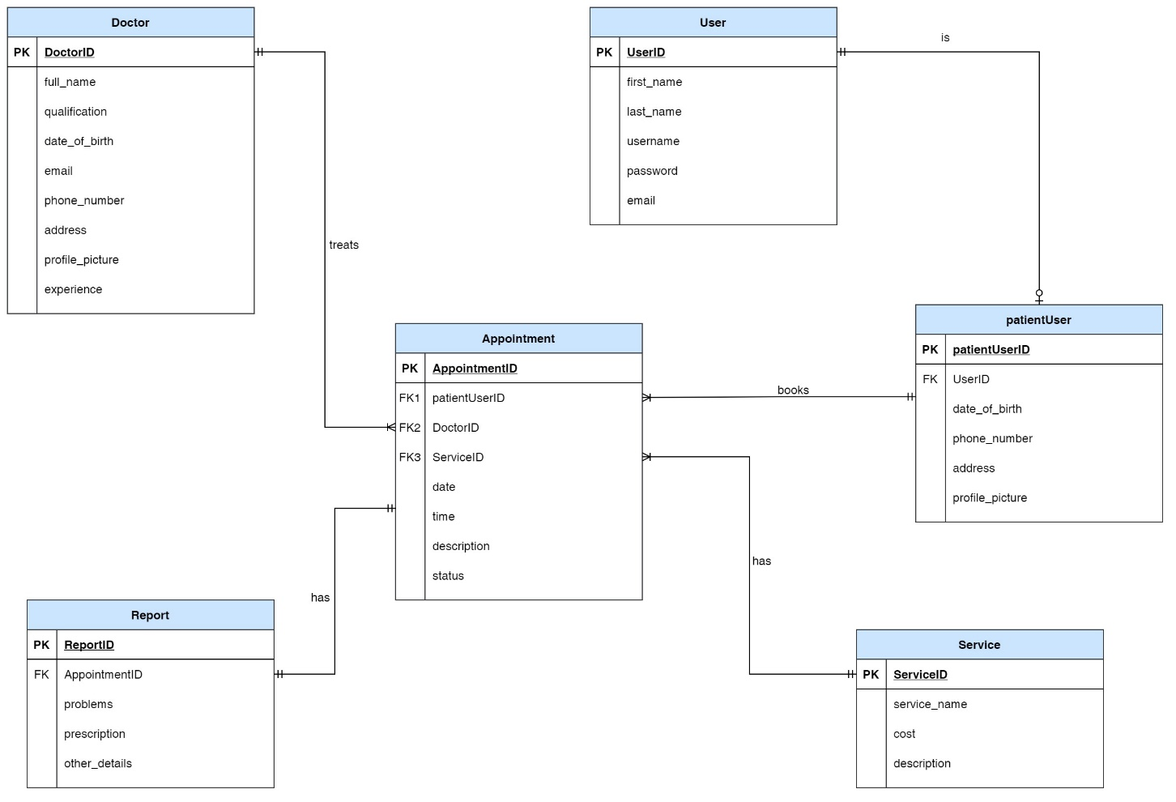

Figure 10: Final ERD:

Here, we can see User is a default database table of Django which has limited fields. So, to extend it, we created a new table called patientUser i.e. all patientUser must be a user but a user can either be a patientUser or an admin. There is Doctor and services table. The appointment table takes patientUser, services and doctor as a foreign key. A doctor treats more than one appointment but an appointment can only belong to one doctor. Similarly, a patientUser can book many appointment but an appointment can only belong to one patientUser. An appointment also has one service but a service can have multiple appointment. The report then takes appointment as a foreign key. A report can belong to only one appointment and an appointment can only have one report.

Details to ERD Creation process

### 3.6.2 Class Diagram

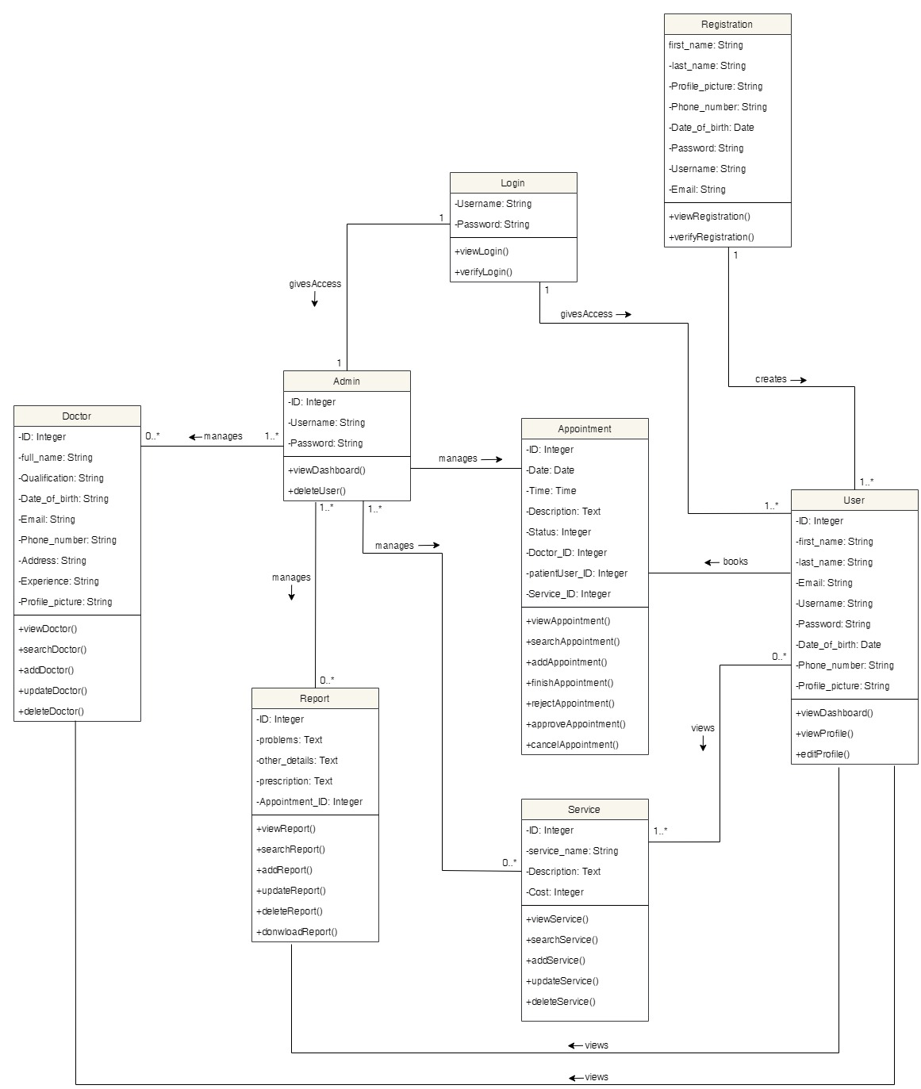

Figure 11: Class Diagram

### 3.6.3 Overall Use Case Diagram

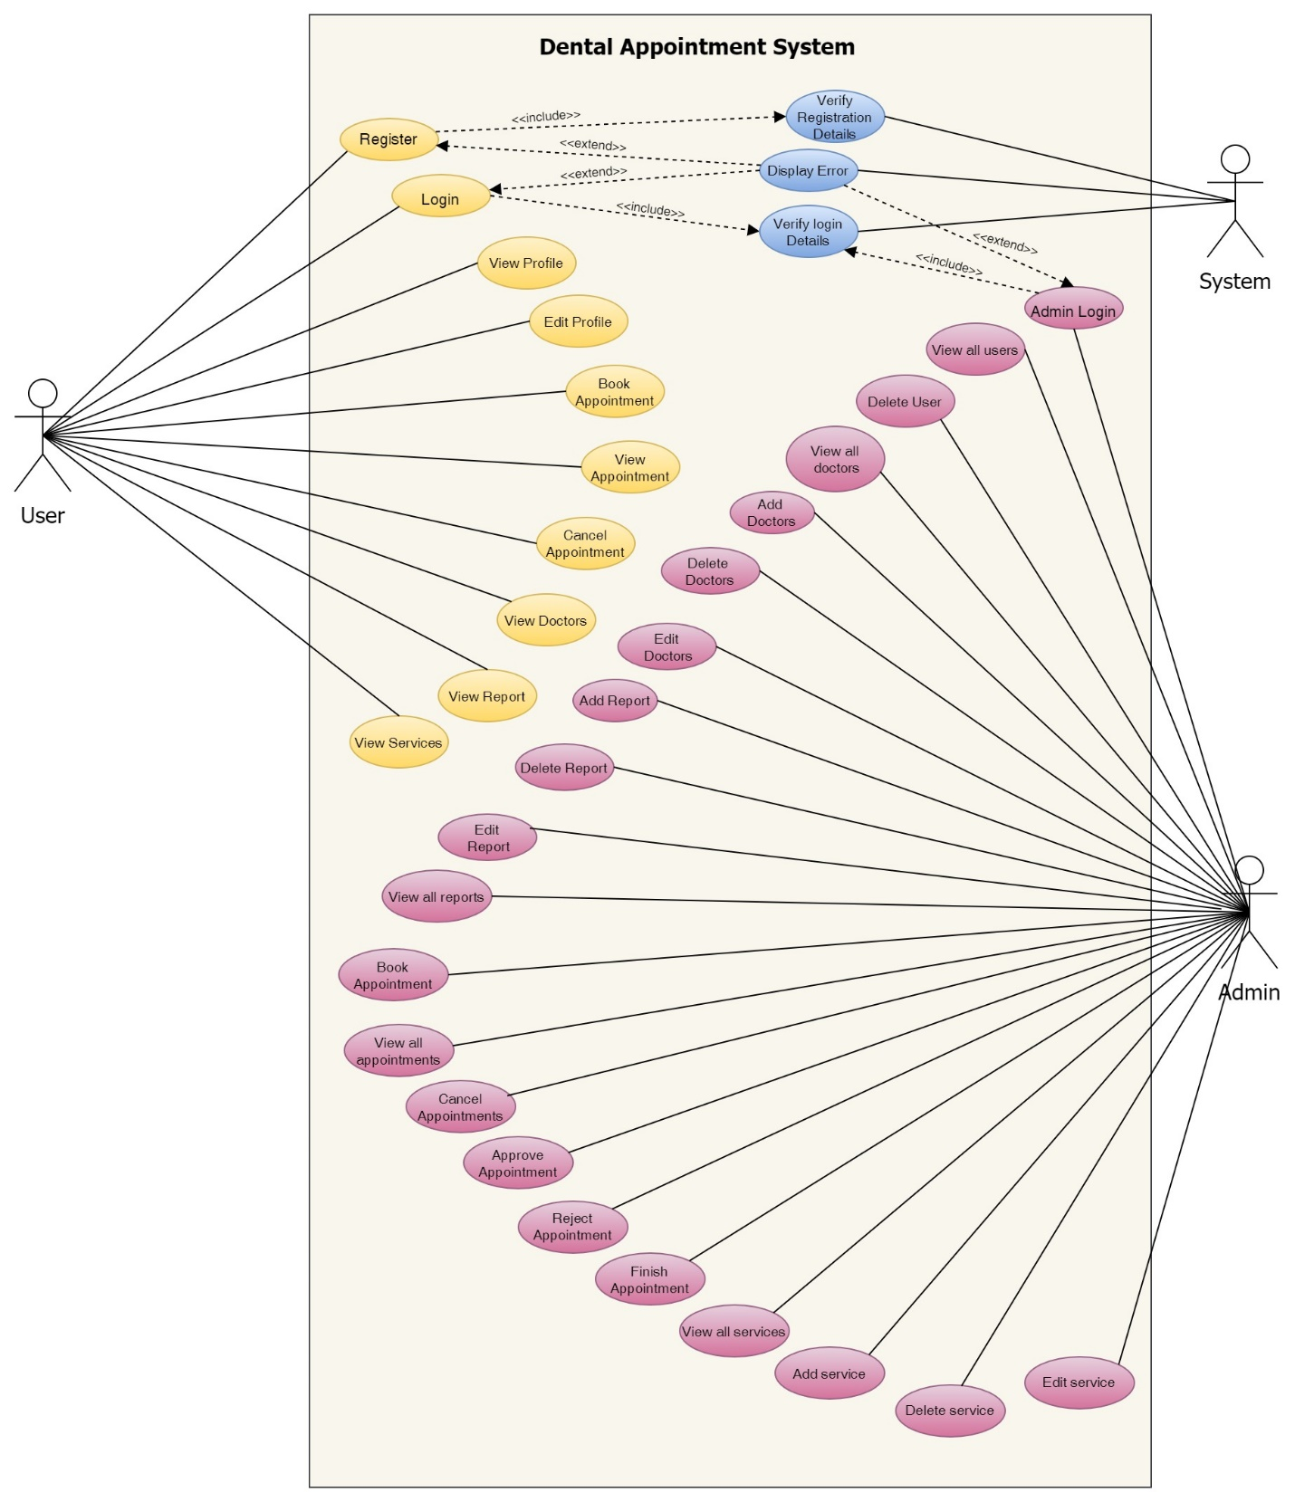

Figure 12: Overall Use Case Diagram

### 3.6.4 Functional UML Diagrams

**User**

1. Register to the system

**High Level Use Case Description**

|  |  |
| --- | --- |
| **Use Case:** | Register |
| **Actor:** | User |
| **Description:** | New users that are not registered in the system register into system. The registration is then verified by the system. |

Table 2: High Level Use Case – User Registration

**Use Case Diagram**

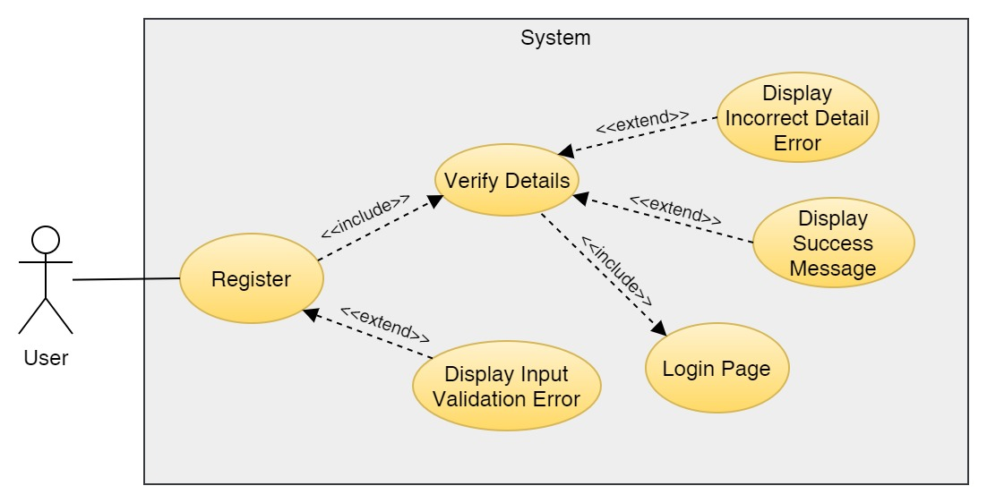

Figure 13: Use Case Diagram – User Registration

**Collaboration Diagram**

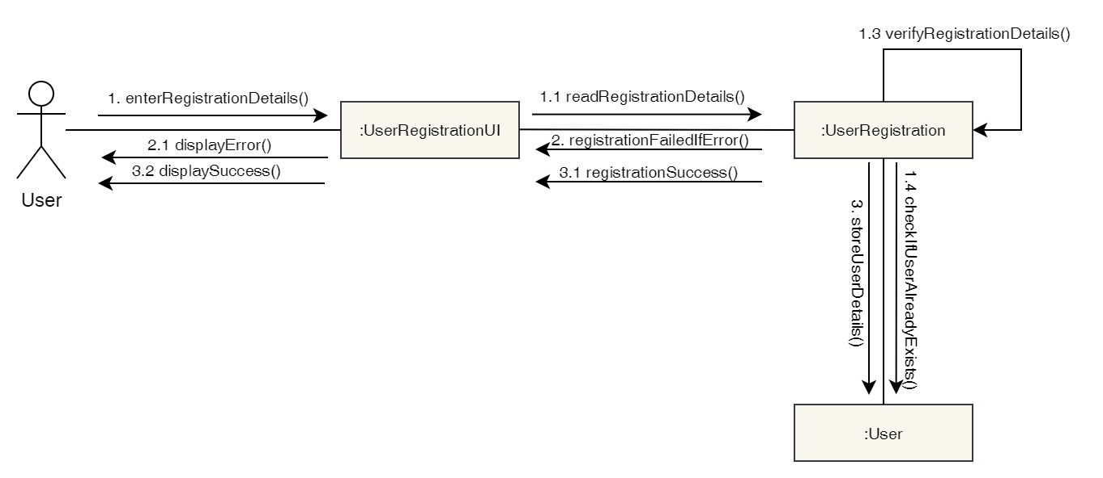

Figure 14: Collaboration Diagram – User Registration

**Activity Diagram**

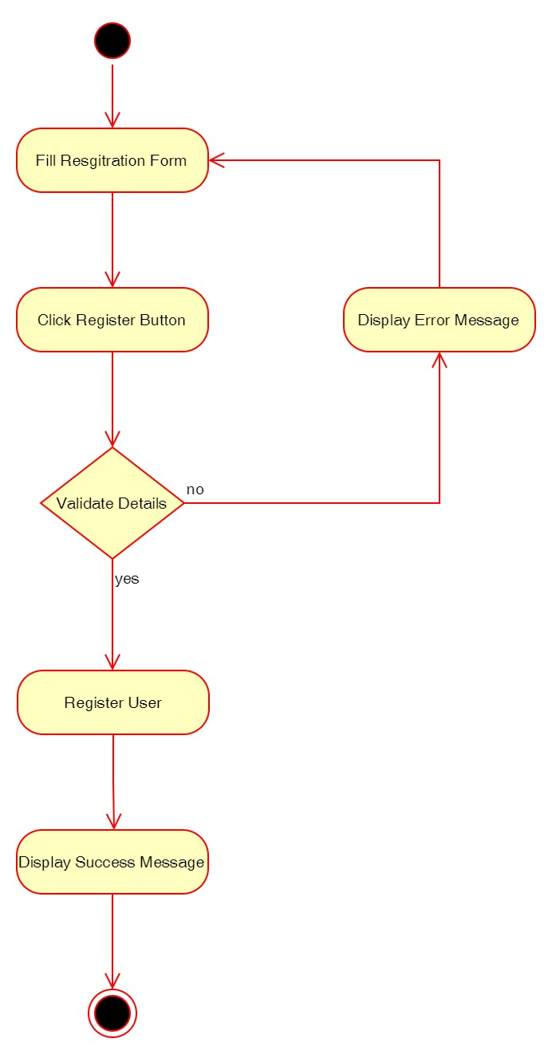

Figure 15: Activity Diagram – User Registration

**Sequence Diagram**

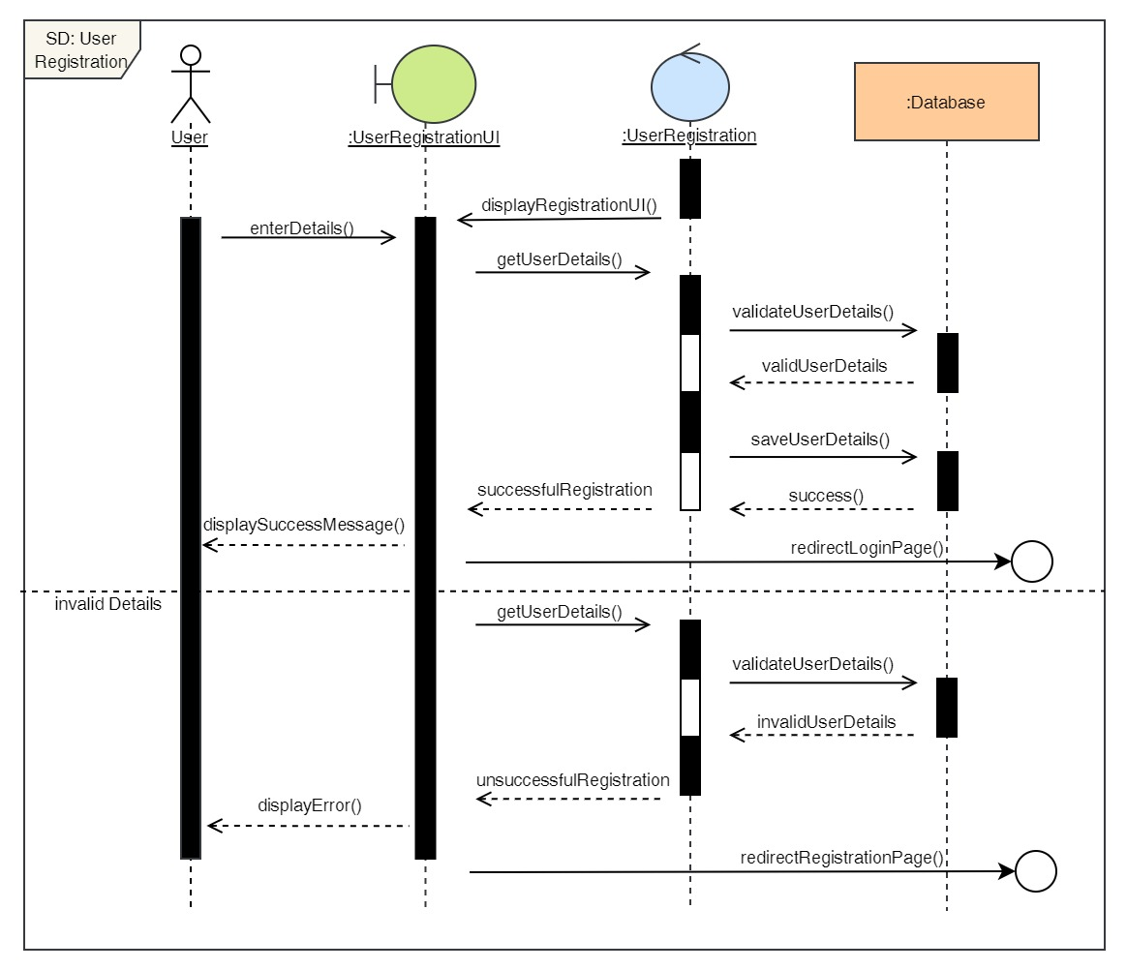

Figure 16: Sequence Diagram – User Registration

2. Login to the system

**High Level Use Case Description**

|  |  |
| --- | --- |
| **Use Case:** | Login |
| **Actor:** | User |
| **Description:** | In order to use the system and use its features, the user must log in to the system. The login details is then verified by the system. |

Table 3: High Level Use Case – User Login

**Use Case Diagram**

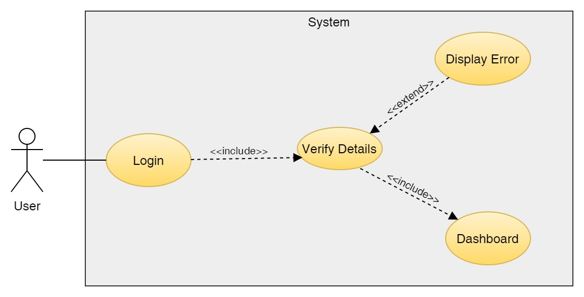

Figure 17: Use Case Diagram – User Login

**Collaboration Diagram**

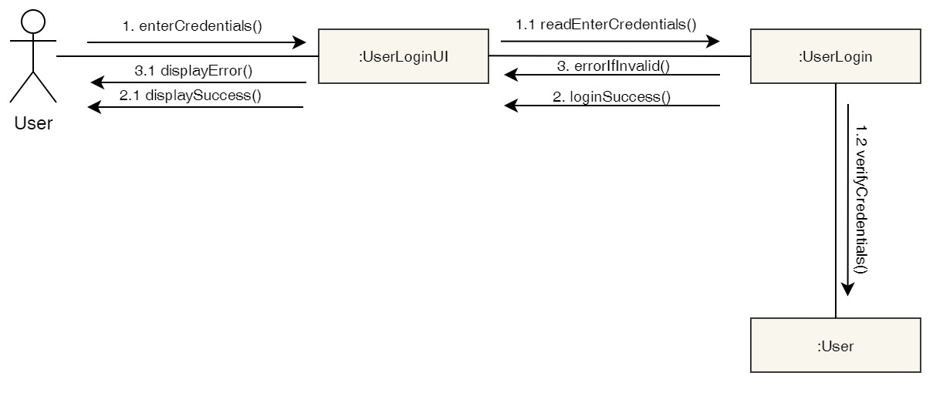

Figure 18: Collaboration Diagram – User Login

**Activity Diagram**

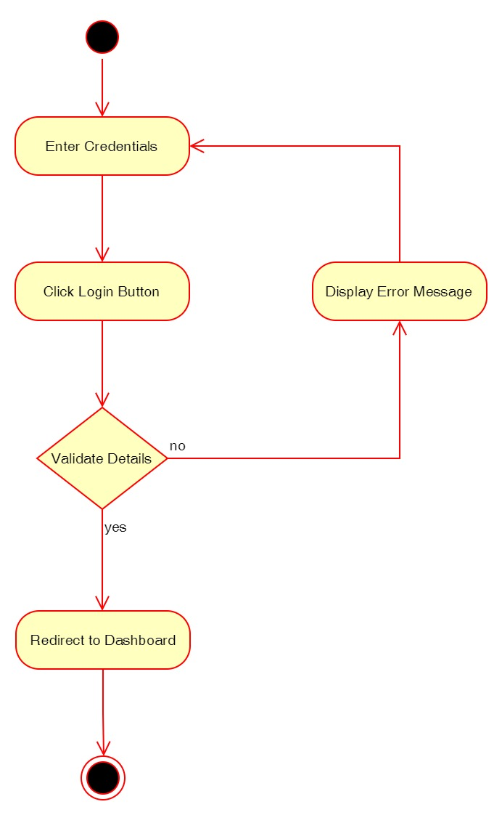

Figure 19: Activity Diagram – User Login

**Sequence Diagram**

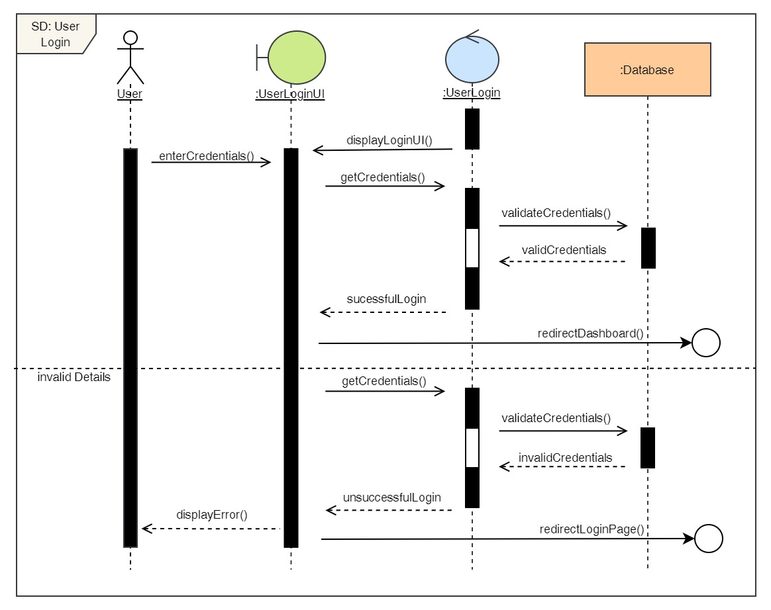

Figure 20: Sequence Diagram – User Login

3. View Profile

**High Level Use Case Description**

|  |  |
| --- | --- |
| **Use Case:** | View Profile |
| **Actor:** | User |
| **Description:** | The user can view their profile where they can see their details which they input. |

Table 4: High Level Use Case – User View Profile

**Use Case Diagram**

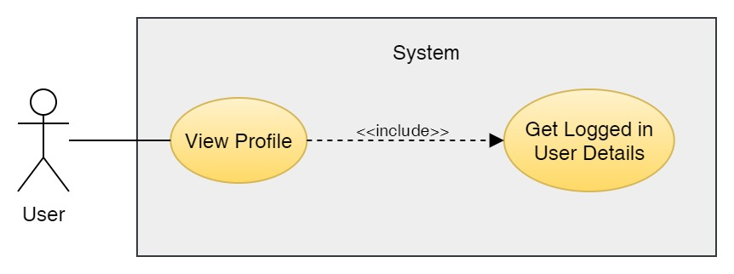

Figure 21: Use Case Diagram – User View Profile

**Collaboration Diagram**

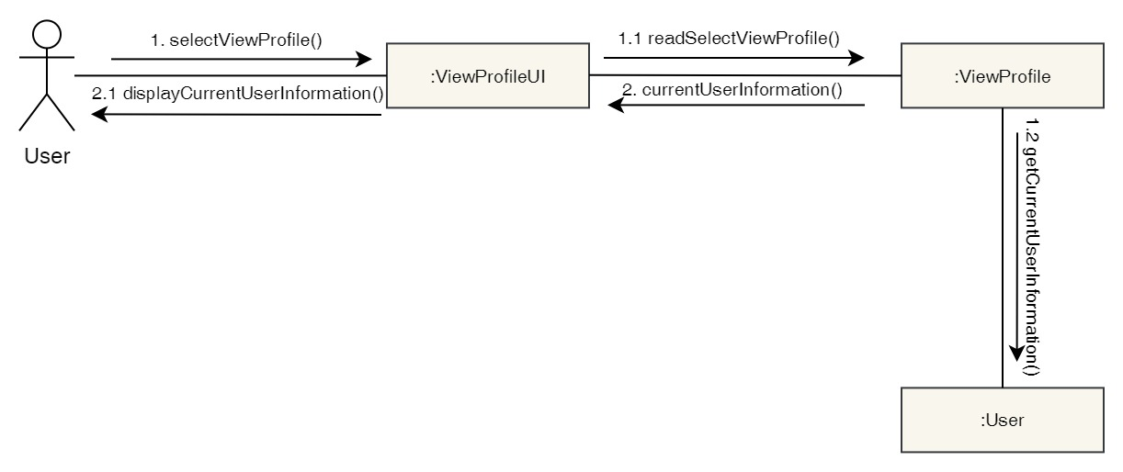

Figure 22: Collaboration Diagram – User View Profile

**Activity Diagram**

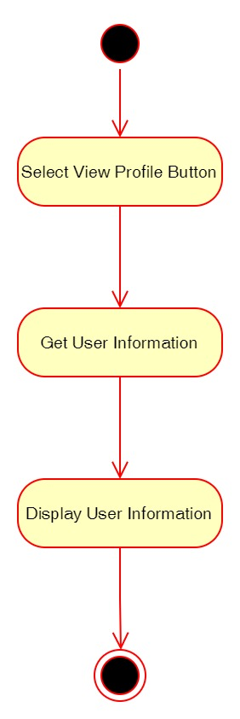

Figure 23: Activity Diagram – User View Profile

**Sequence Diagram**

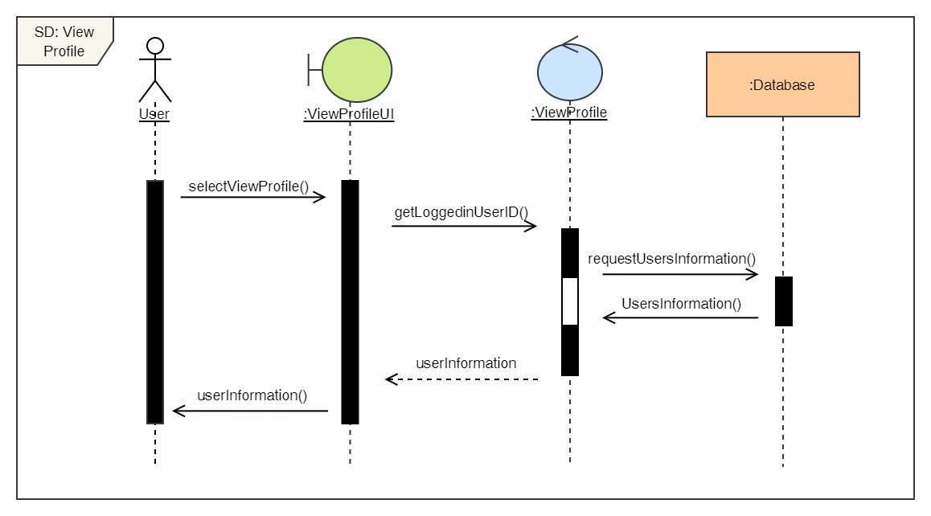

Figure 24: Sequence Diagram – User View Profile

4. Edit Profile

**High Level Use Case Description**

|  |  |
| --- | --- |
| **Use Case:** | Edit Profile |
| **Actor:** | User |
| **Description:** | The user can update their profile details if they have changed anything from what they previously entered. |

Table 5: High Level Use Case – User Edit Profile

**Use Case Diagram**

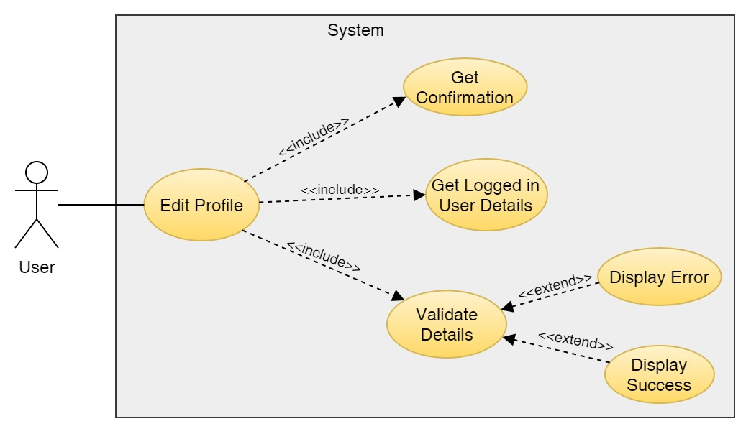

Figure 25: Use Case Diagram – User Edit Profile

**Collaboration Diagram**

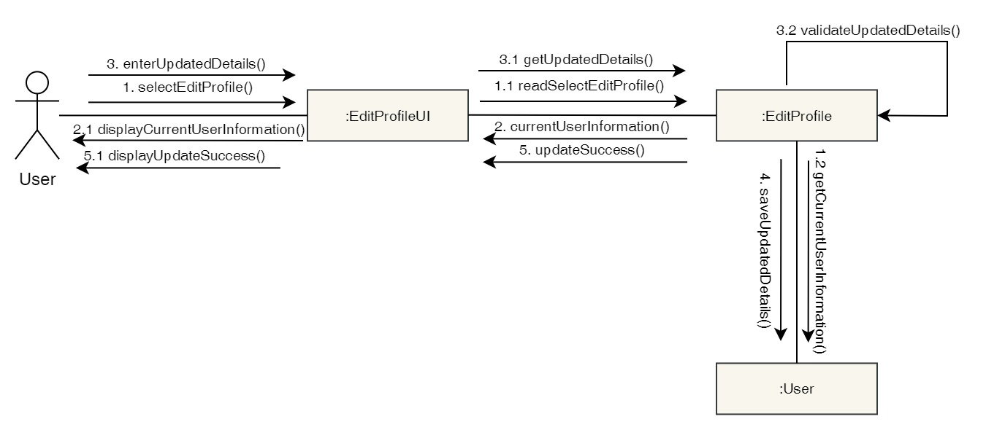

Figure 26: Collaboration Diagram – User Edit Profile

**Activity Diagram**

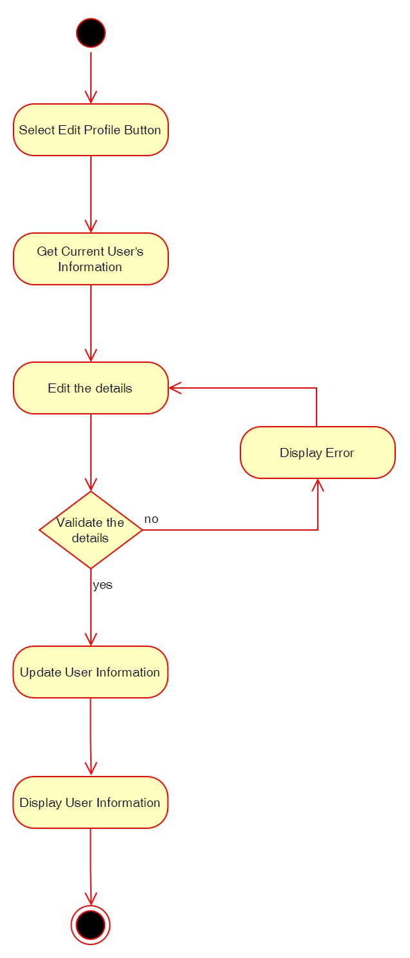

Figure 27: Activity Diagram – User Edit Profile

**Sequence Diagram**

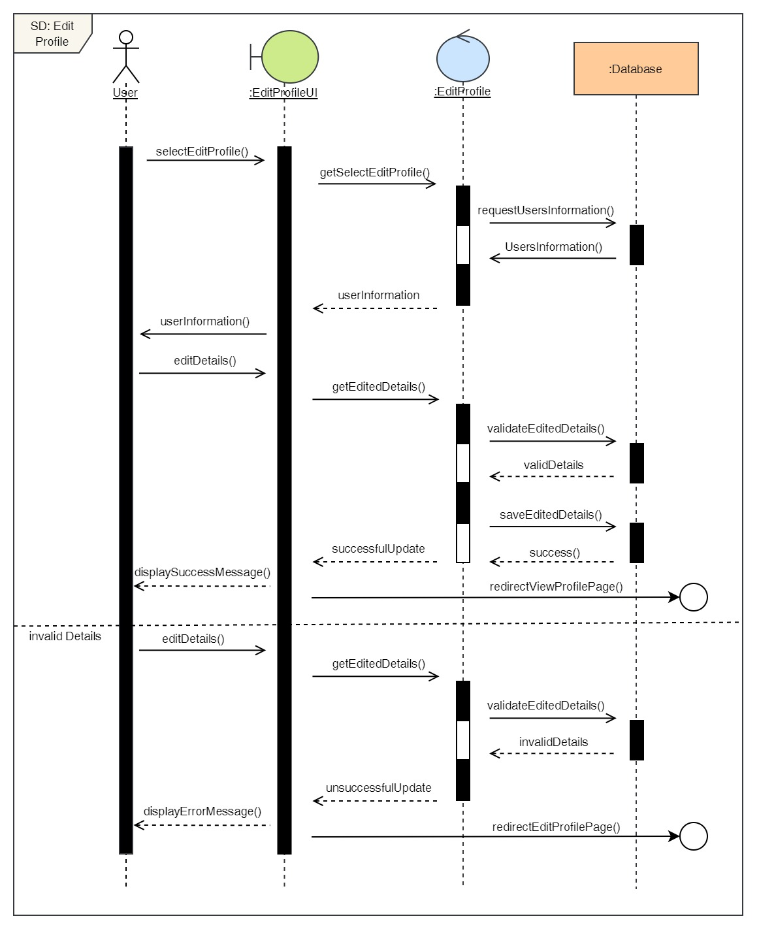

Figure 28: Sequence Diagram – User Edit Profile

5. Book a Dental Appointment

**High Level Use Case Description**

|  |  |
| --- | --- |
| **Use Case:** | Book Appointment |
| **Actor:** | User |
| **Description:** | User can book appointment for any dental services by selecting the desired date, time, doctor and service. |

Table 6: High Level Use Case – User Book Appointment

**Use Case Diagram**

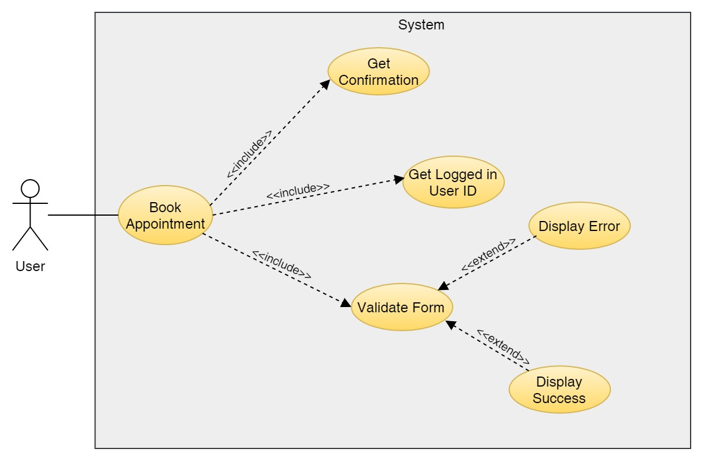

Figure 29: Use Case Diagram – User Book Appointment

**Collaboration Diagram**

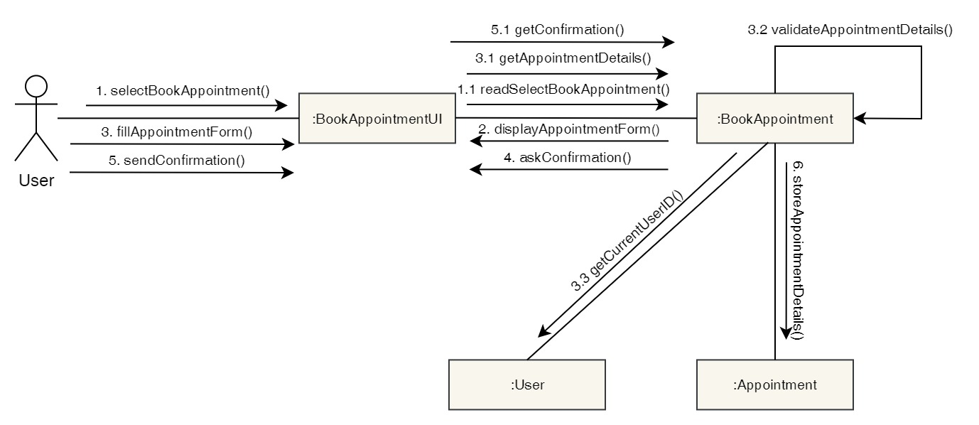

Figure 30: Collaboration Diagram – User Book Appointment

**Activity Diagram**

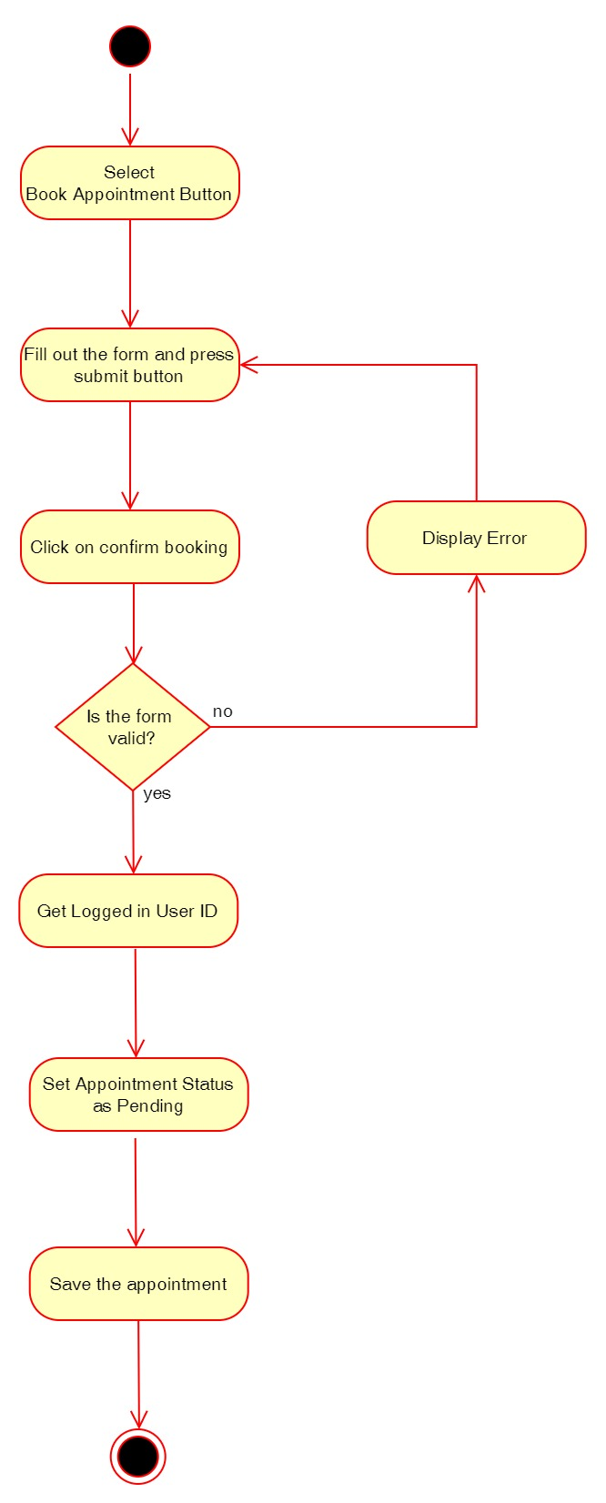

Figure 31: Activity Diagram – User Book Appointment

**Sequence Diagram**

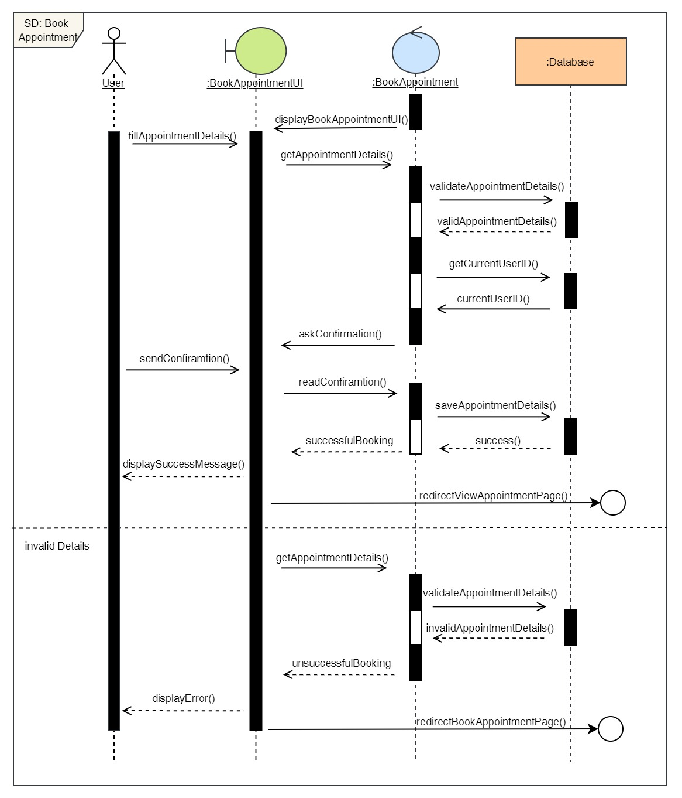

Figure 32: Sequence Diagram – User Book Appointment

6. View Appointment

**High Level Use Case Description**

|  |  |
| --- | --- |
| **Use Case:** | View Appointment |
| **Actor:** | User |
| **Description:** | Users can view their current appointments as well as their appointments history. |

Table 7: High Level Use Case – User View Appointment

**Use Case Diagram**

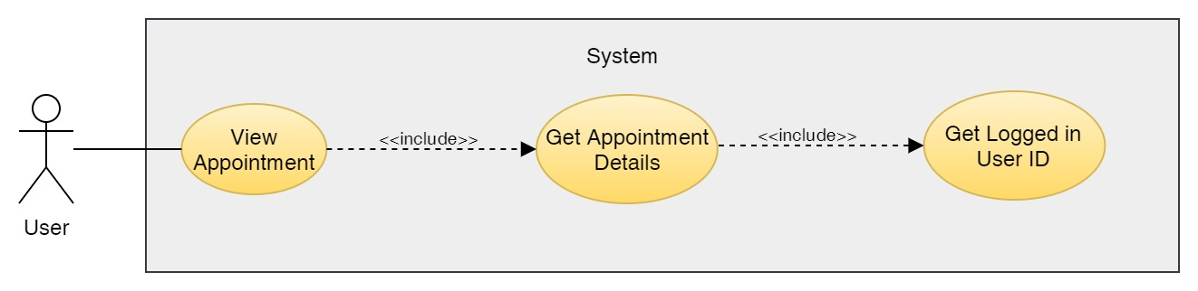

Figure 33: Use Case Diagram – User View Appointment

**Collaboration Diagram**

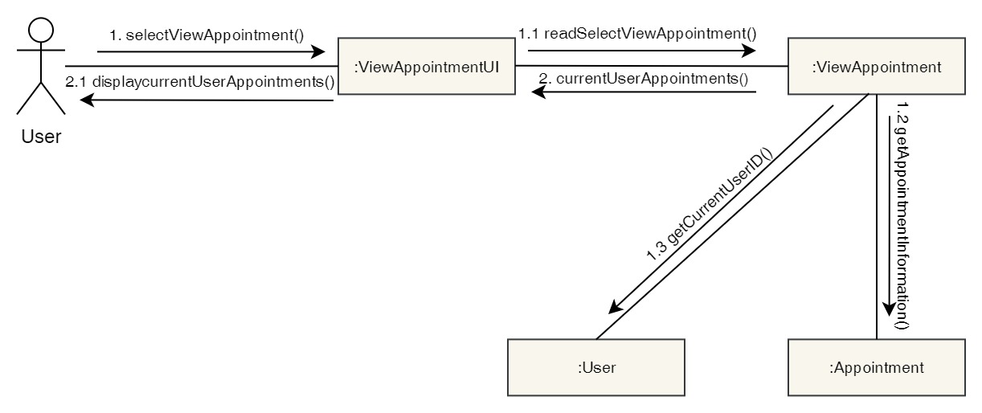

Figure 34: Collaboration Diagram – User View Appointment

**Activity Diagram**

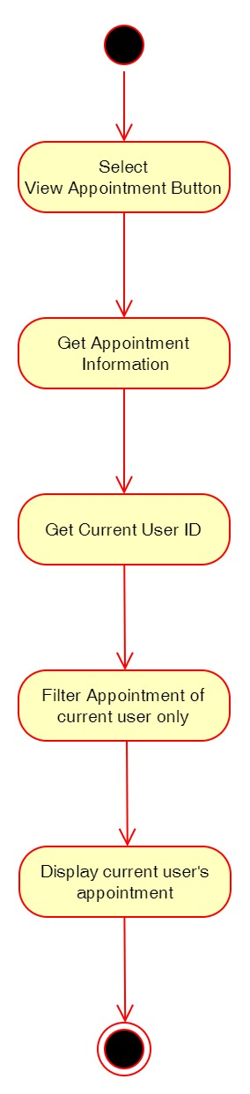

Figure 35: Activity Diagram – User View Appointment

**Sequence Diagram**

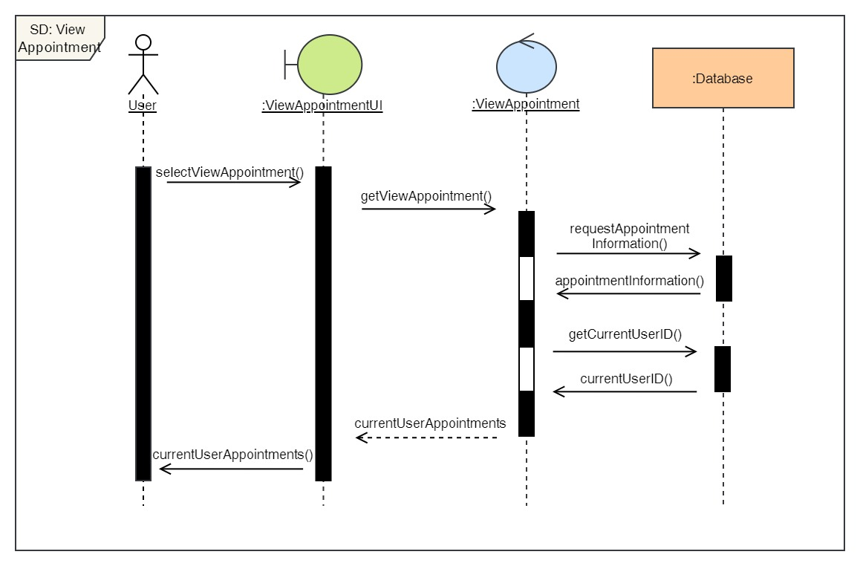

Figure 36: Sequence Diagram – User View Appointment

7. Cancel Appointment

**High Level Use Case Description**

|  |  |
| --- | --- |
| **Use Case:** | Cancel Appointment |
| **Actor:** | User |
| **Description:** | The user can cancel their pending appointment or the appointment that has been confirmed. |

Table 8: High Level Use Case – User Cancel Appointment

**Use Case Diagram**

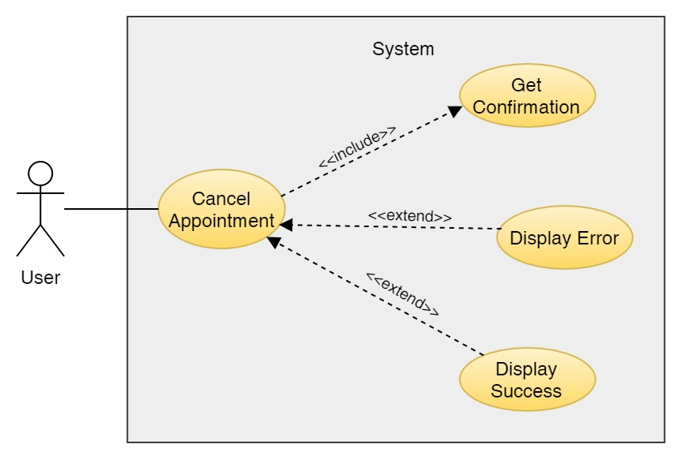

Figure 37: Use Case Diagram – User Cancel Appointment

**Collaboration Diagram**

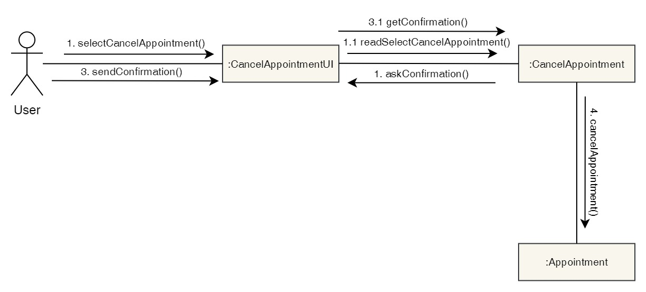

Figure 38: Collaboration Diagram – User Cancel Appointment

**Activity Diagram**

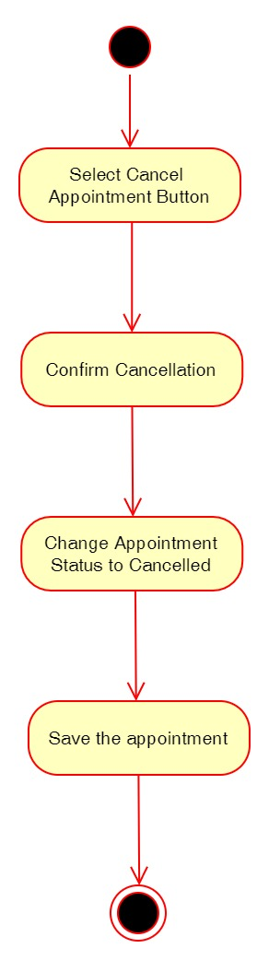

Figure 39: Activity Diagram – User Cancel Appointment

**Sequence Diagram**

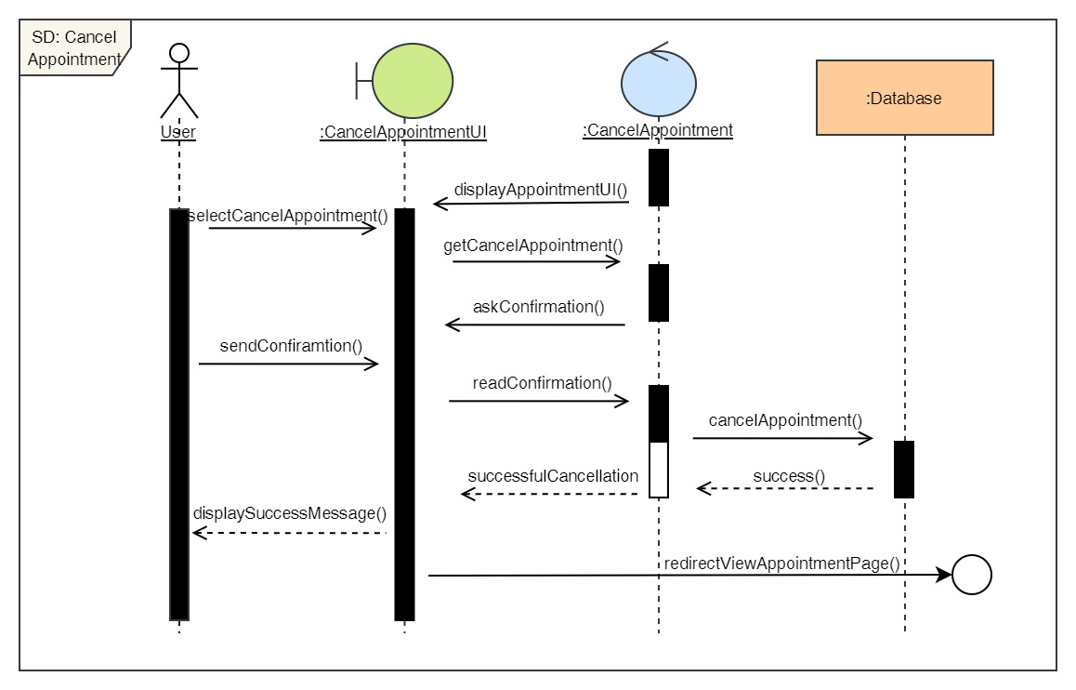

Figure 40: Sequence Diagram – User Cancel Appointment

8. View available doctors

**High Level Use Case Description**

|  |  |
| --- | --- |
| **Use Case:** | View Doctors |
| **Actor:** | User |
| **Description:** | Users can view doctors that are available at the clinic and read their description and see their qualification as well. |

Table 9: High Level Use Case – User View Doctors

**Use Case Diagram**

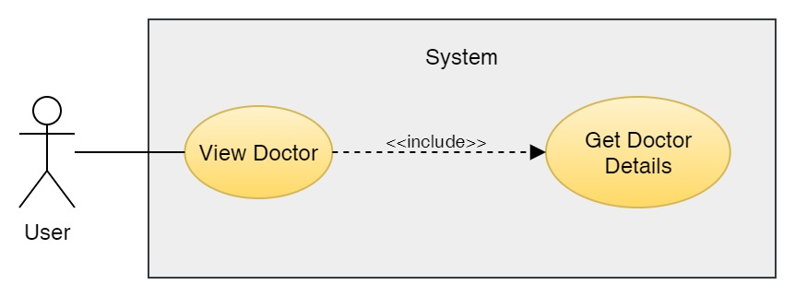

Figure 41: Use Case Diagram – User View Doctor

**Collaboration Diagram**

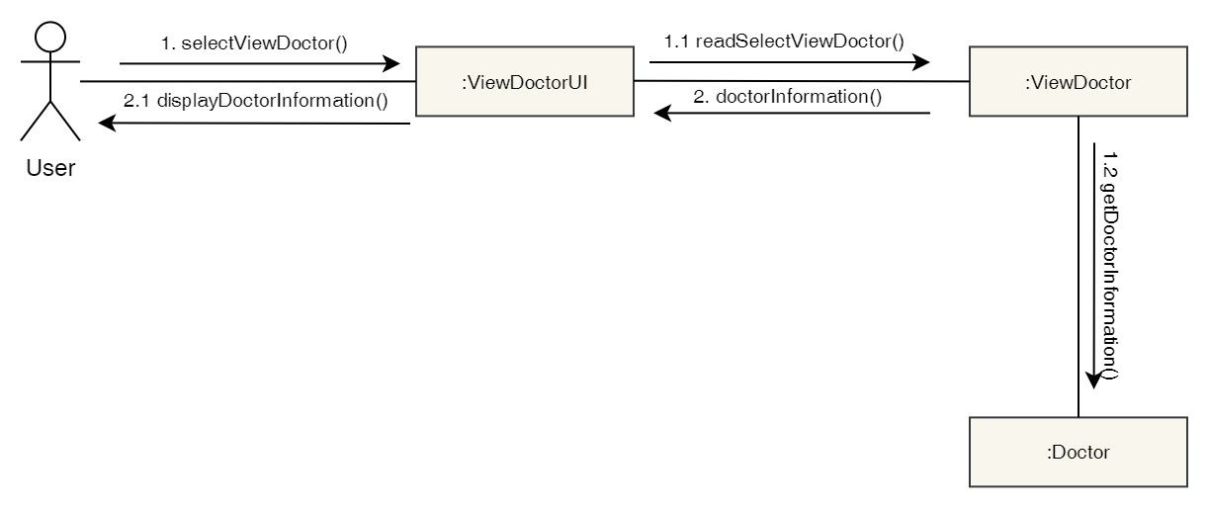

Figure 42: Collaboration Diagram – User View Doctor

**Activity Diagram**

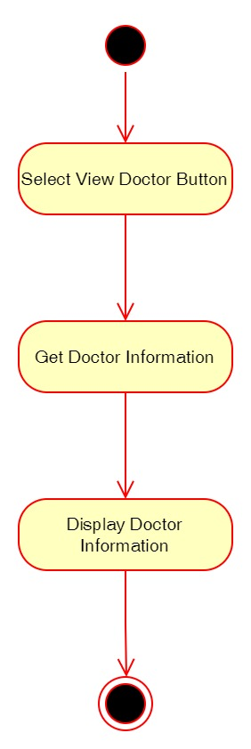

Figure 43: Activity Diagram – User View Doctor

**Sequence Diagram**

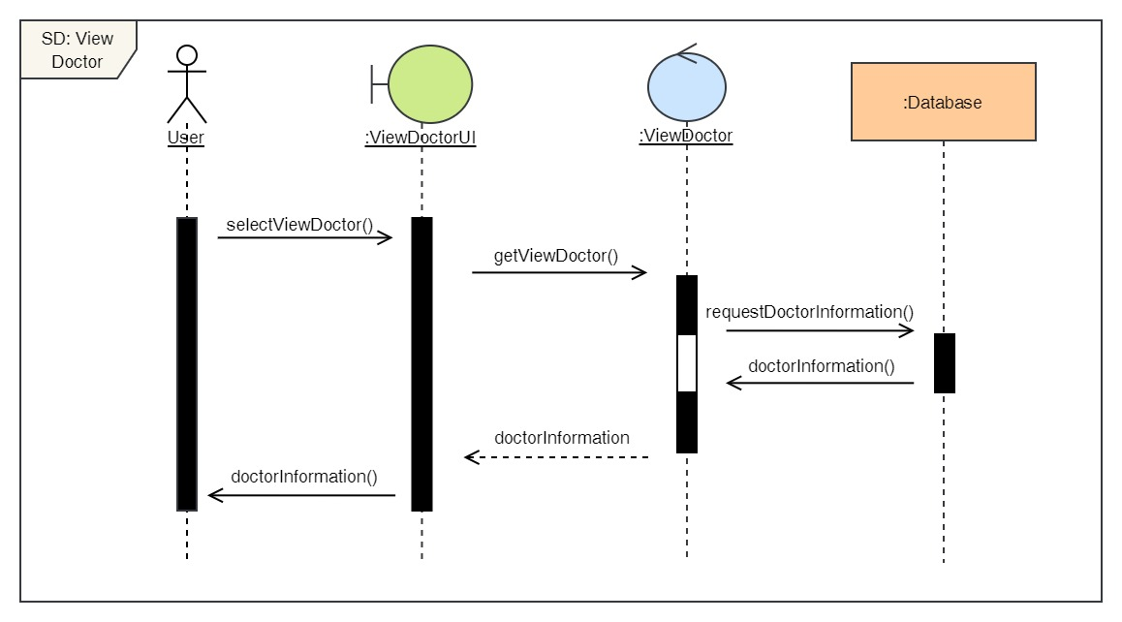

Figure 44: Sequence Diagram – User View Doctor

9. View report

**High Level Use Case Description**

|  |  |
| --- | --- |
| **Use Case:** | View Report |
| **Actor:** | User |
| **Description:** | Users can view report about their visit to the clinic. They can download it as well. |

Table 10: High Level Use Case – User View Report

**Use Case Diagram**

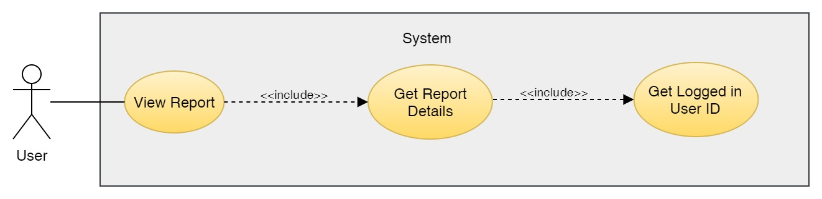

Figure 45: Use Case Diagram – User View Report

**Collaboration Diagram**

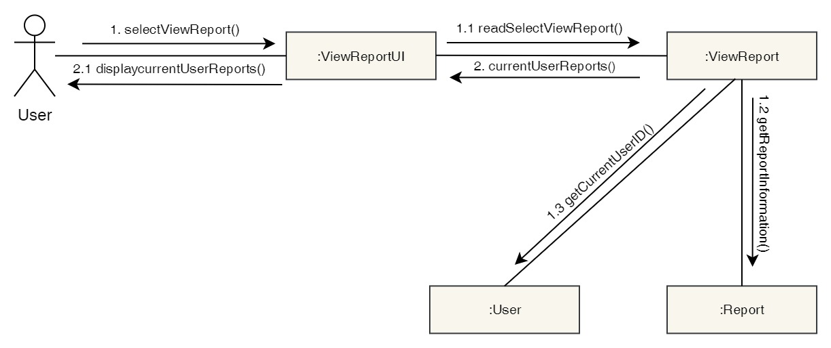

Figure 46: Collaboration Diagram – User View Report

**Activity Diagram**

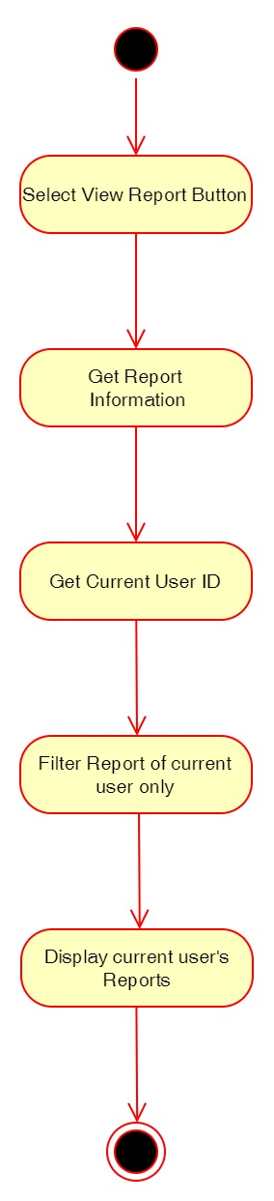

Figure 47: Activity Diagram – User View Report

**Sequence Diagram**

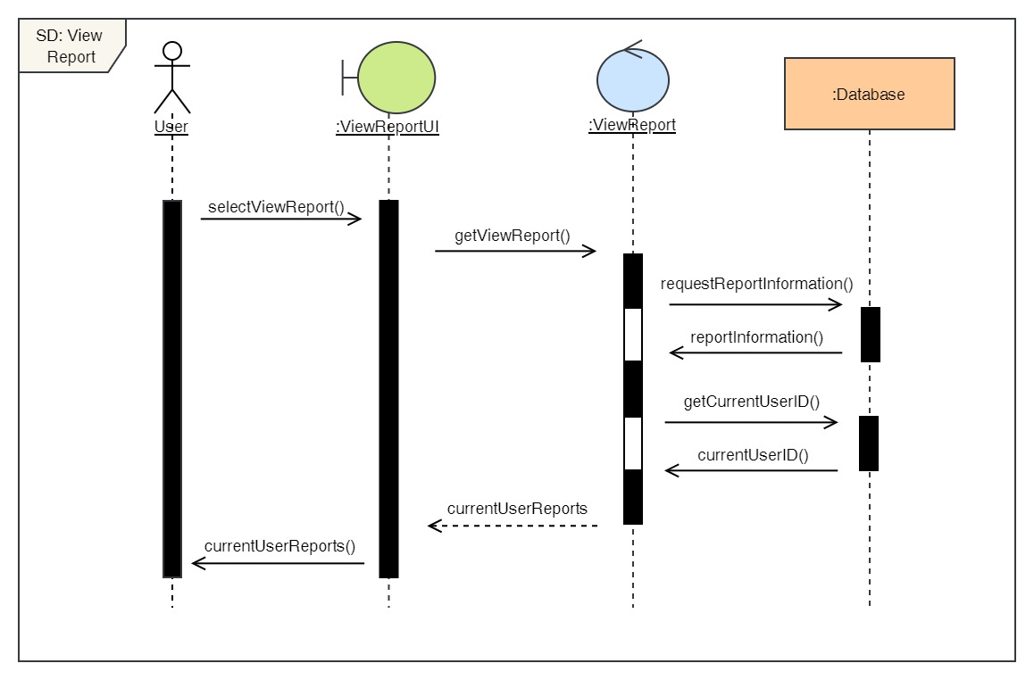

Figure 48: Sequence Diagram – User View Report

10. View services

**High Level Use Case Description**

|  |  |
| --- | --- |
| **Use Case:** | View Services |
| **Actor:** | User |
| **Description:** | Users can view the list of services available along with the cost of it and description. |

Table 11: High Level Use Case – User View Services

**Use Case Diagram**

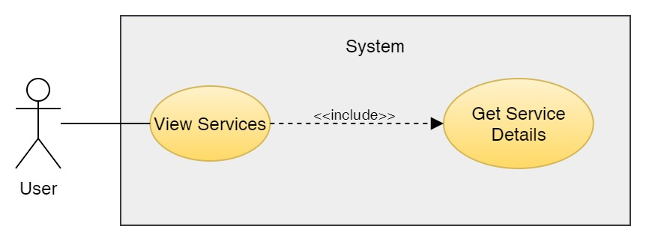

Figure 49: Use Case Diagram – User View Services

**Collaboration Diagram**

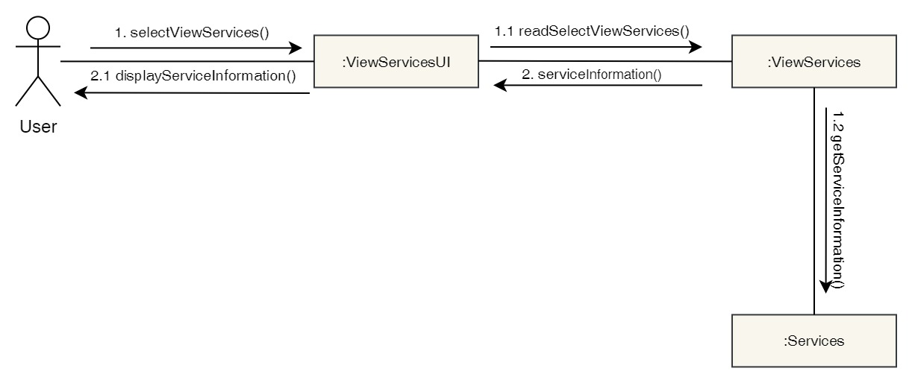

Figure 50: Collaboration Diagram – User View Services

**Activity Diagram**

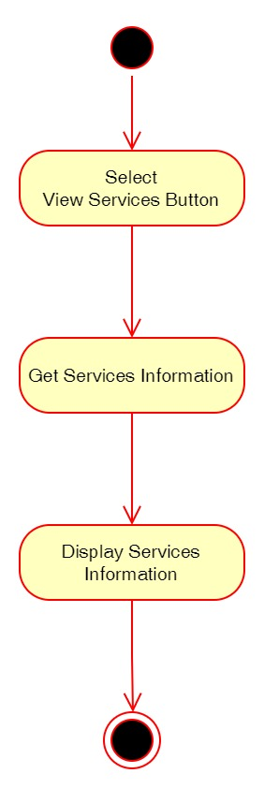

Figure 51: Activity Diagram – User View Services

**Sequence Diagram**

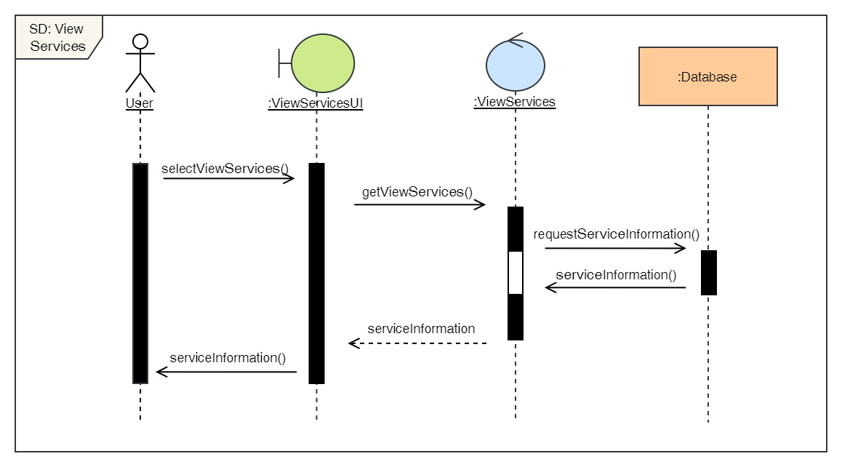

Figure 52: Sequence Diagram – User View Services

**Admin**

11. Login to the system

**High Level Use Case Description**

|  |  |
| --- | --- |
| **Use Case:** | Admin Login |
| **Actor:** | Admin |
| **Description:** | In order to use the admin side system and its features, the admin must log in to the system. The login details is then verified by the system. |

Table 12: High Level Use Case – Admin Login

**Use Case Diagram**

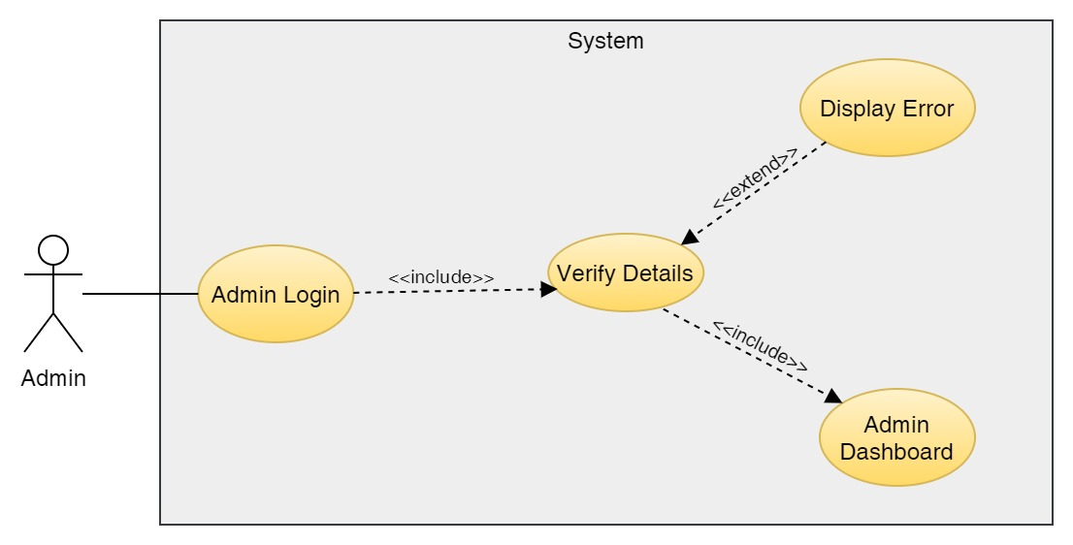

Figure 53: Use Case Diagram – Admin Login

**Collaboration Diagram**

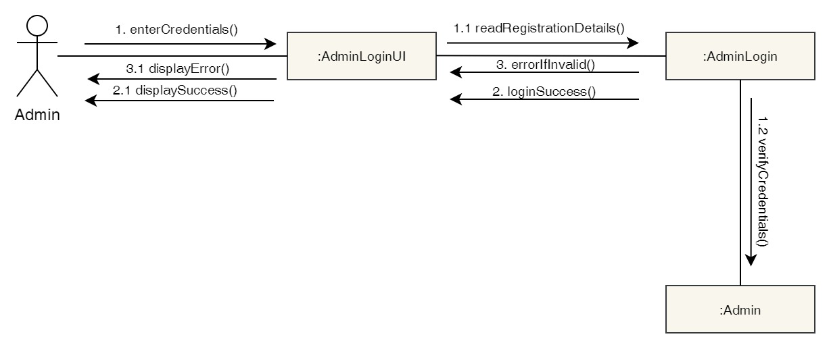

Figure 54: Collaboration Diagram – Admin Login

**Activity Diagram**

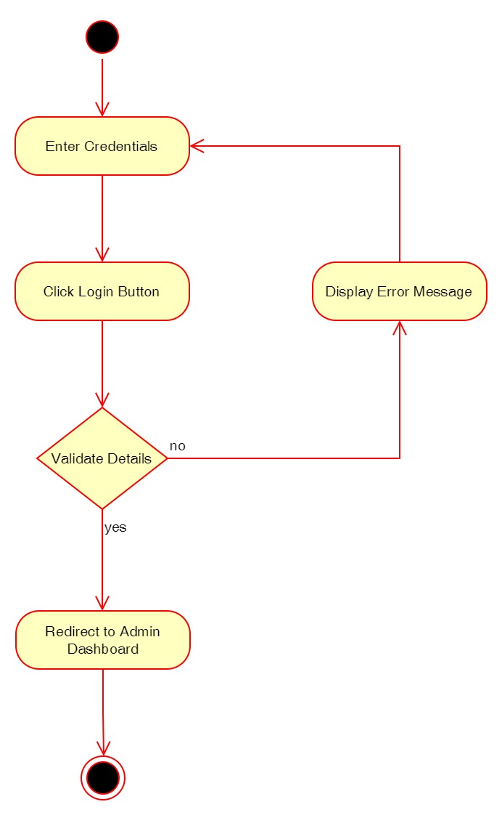

Figure 55: Activity Diagram – Admin Login

**Sequence Diagram**

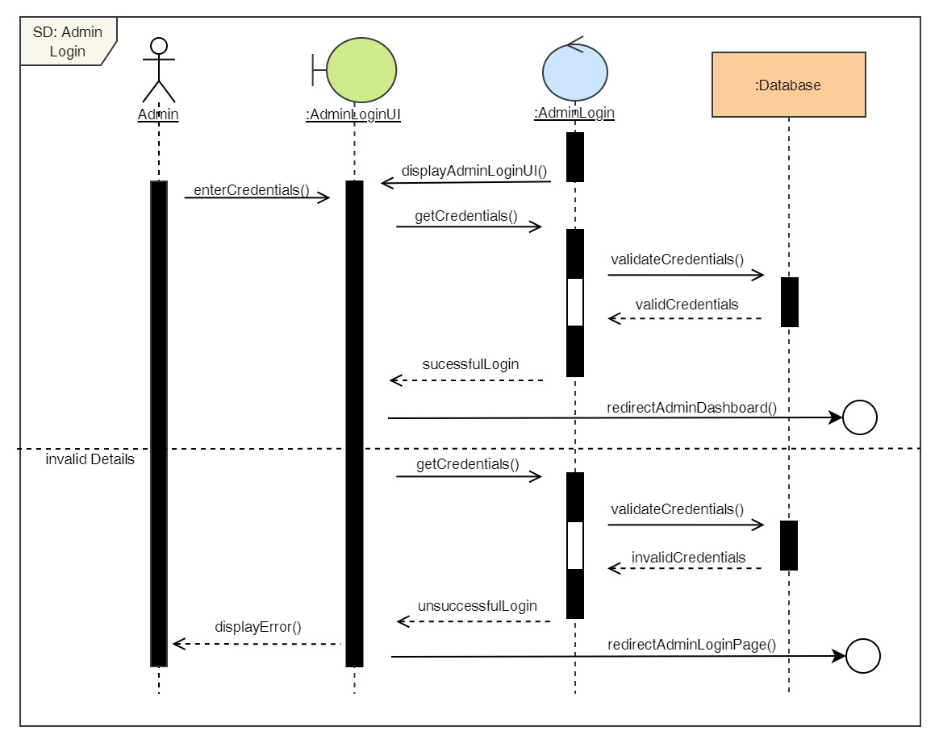

Figure 56: Sequence Diagram – Admin Login

12. View all users

**High Level Use Case Description**

|  |  |
| --- | --- |
| **Use Case:** | View all users |
| **Actor:** | Admin |
| **Description:** | Admin can view all the user that are registered to the system. |

Table 13: High Level Use Case – Admin View Users

**Use Case Diagram**

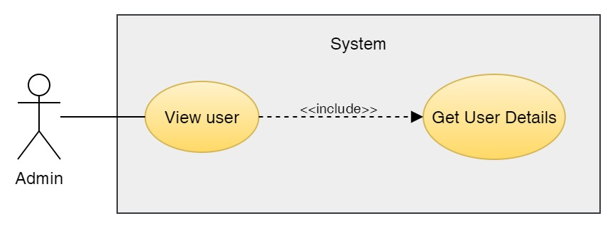

Figure 57: Use Case Diagram – Admin View Users

**Collaboration Diagram**

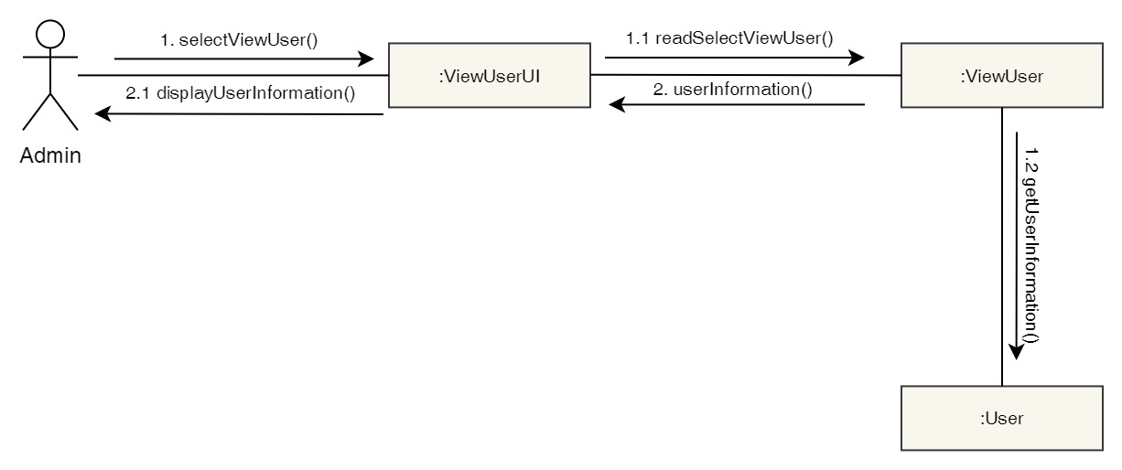

Figure 58: Collaboration Diagram – Admin View Users

**Activity Diagram**

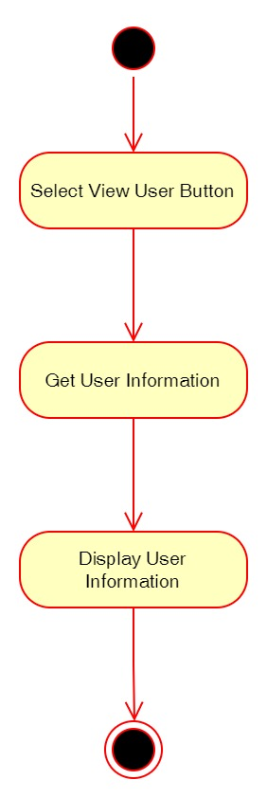

Figure 59: Activity Diagram – Admin View Users

**Sequence Diagram**

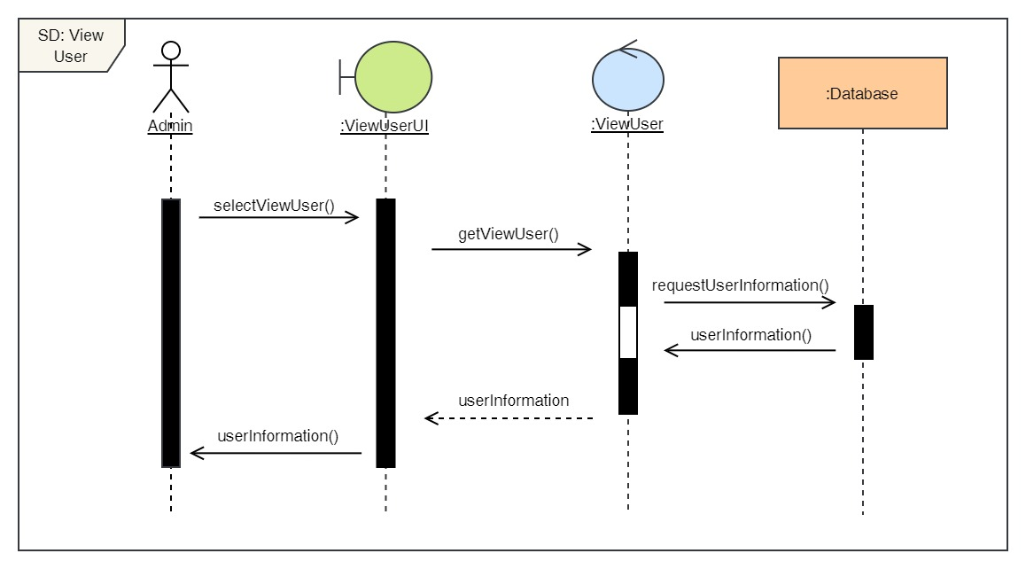

Figure 60: Sequence Diagram – Admin View Users

13. Delete users

**High Level Use Case Description**

|  |  |
| --- | --- |
| **Use Case:** | De-Register User |
| **Actor:** | Admin |
| **Description:** | Admin can delete existing users from the system. |

Table 14: High Level Use Case – Admin Delete Users

**Use Case Diagram**

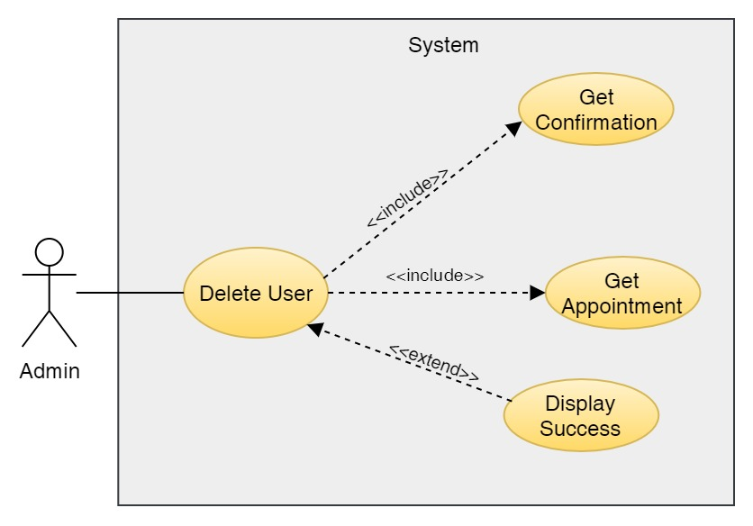

Figure 61: Use Case Diagram – Admin Delete Users

**Collaboration Diagram**

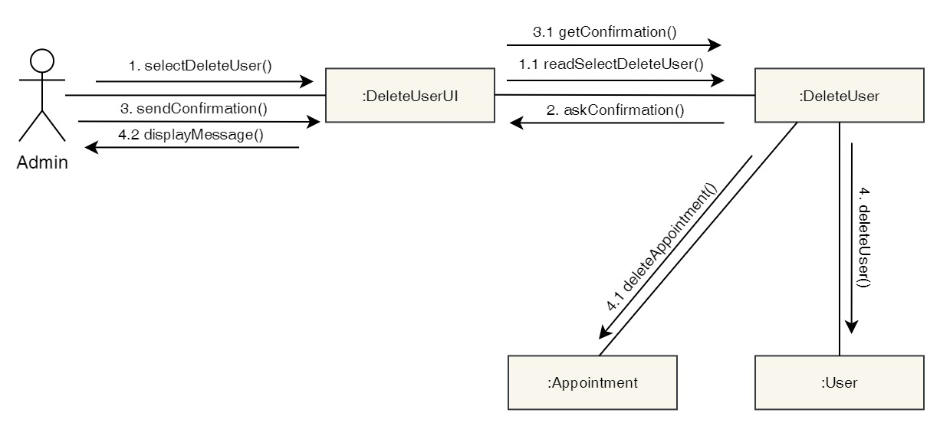

Figure 62: Collaboration Diagram – Admin Delete Users

**Activity Diagram**

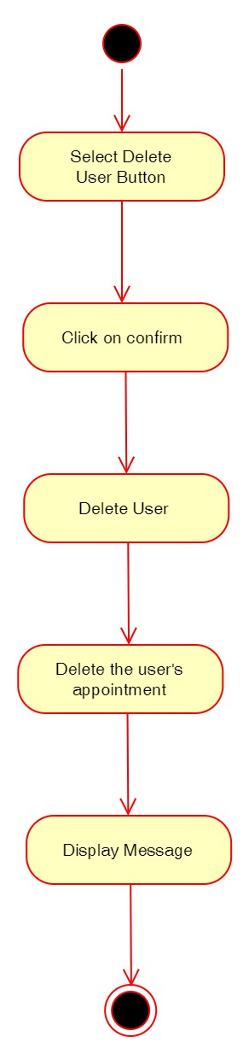

Figure 63: Activity Diagram – Admin Delete Users

**Sequence Diagram**

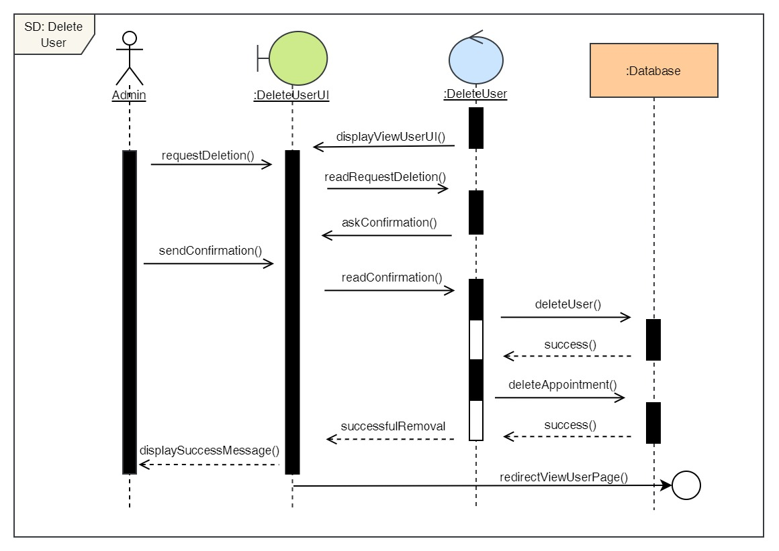

Figure 64: Sequence Diagram – Admin Delete Users

14. View all doctors

**High Level Use Case Description**

|  |  |
| --- | --- |
| **Use Case:** | View doctors |
| **Actor:** | Admin |
| **Description:** | Admin can view all the existing doctors in the system. |

Table 15: High Level Use Case – Admin View Doctors

**Use Case Diagram**

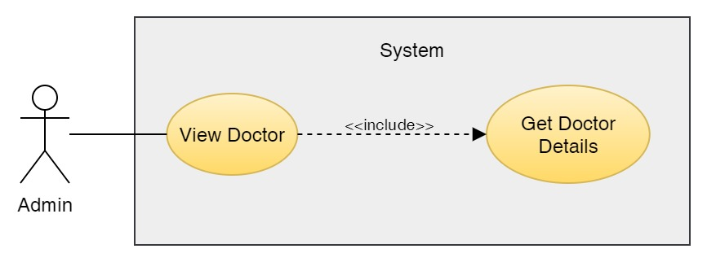

Figure 65: Use Case Diagram – Admin View Doctors

**Collaboration Diagram**

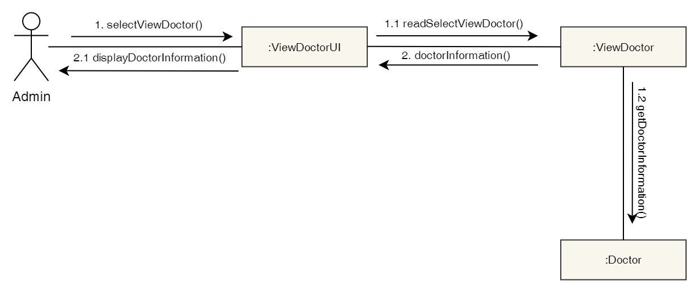

Figure 66: Collaboration Diagram – Admin View Doctors

**Activity Diagram**



Figure 67: Activity Diagram – Admin View Doctors

**Sequence Diagram**

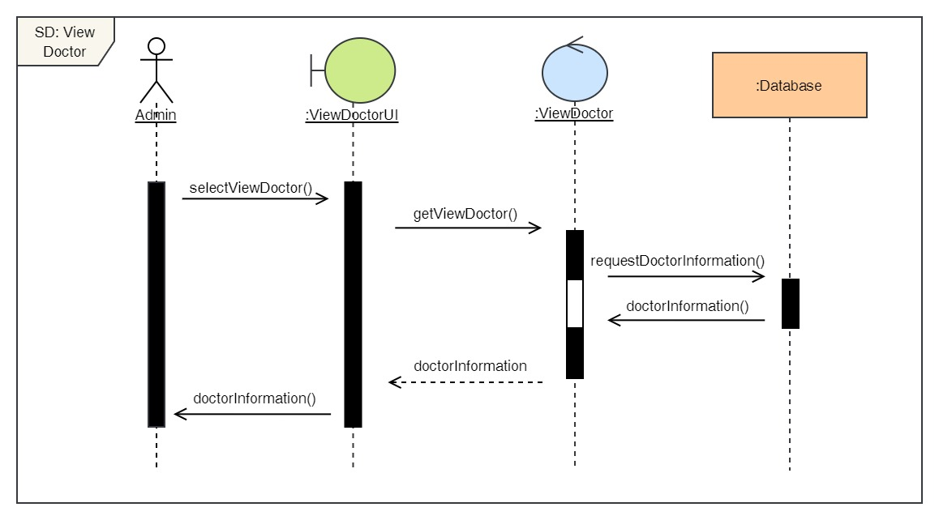

Figure 68: Sequence Diagram – Admin View Doctors

15. Add new doctors

**High Level Use Case Description**

|  |  |
| --- | --- |
| **Use Case:** | Add Doctors |
| **Actor:** | Admin |
| **Description:** | Admin can add new doctors to the system along with their description. |

Table 16: High Level Use Case – Admin Add Doctors

**Use Case Diagram**

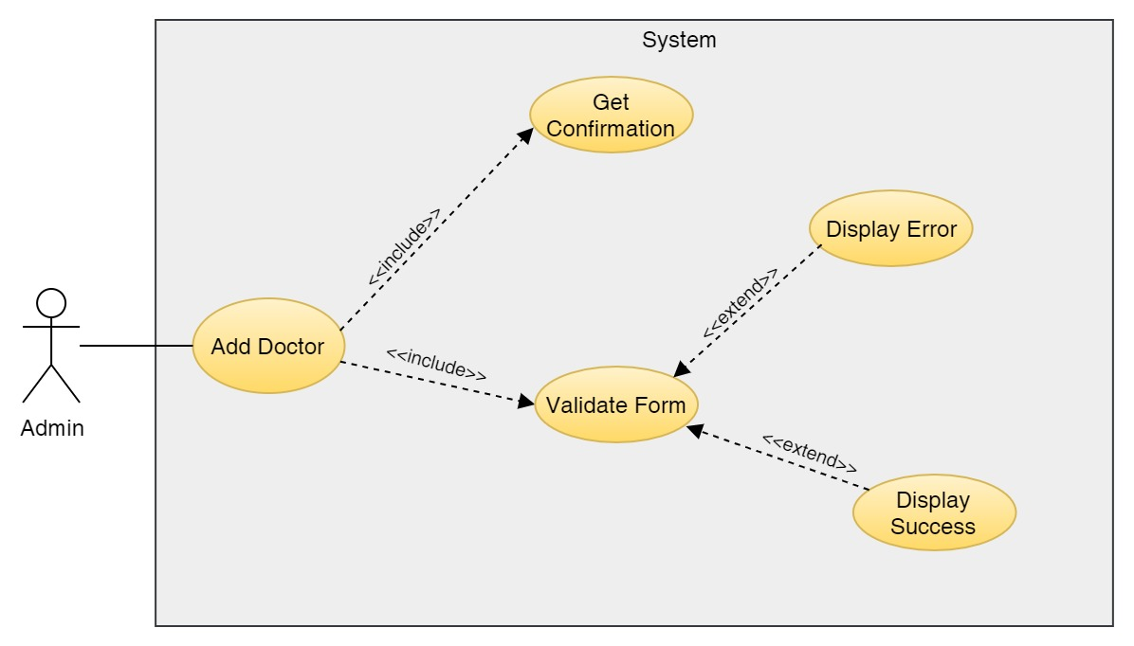

Figure 69: Use Case Diagram – Admin Add Doctors

**Collaboration Diagram**

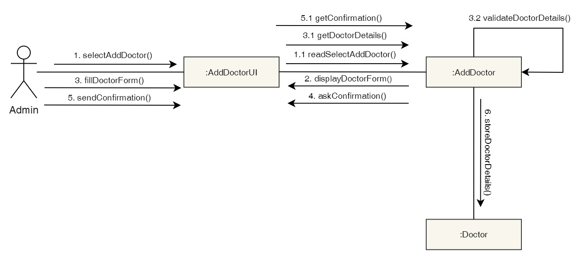

Figure 70: Collaboration Diagram – Admin Add Doctors

**Activity Diagram**

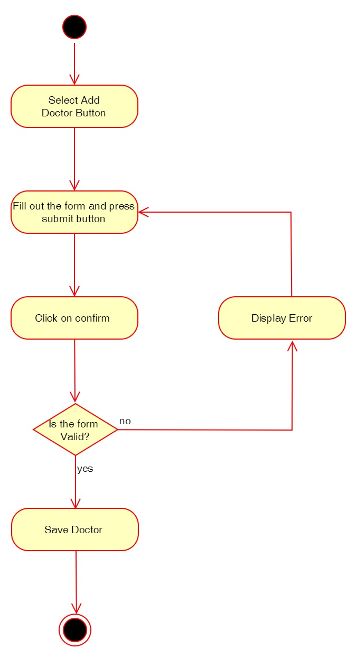

Figure 71: Activity Diagram – Admin Add Doctors

**Sequence Diagram**

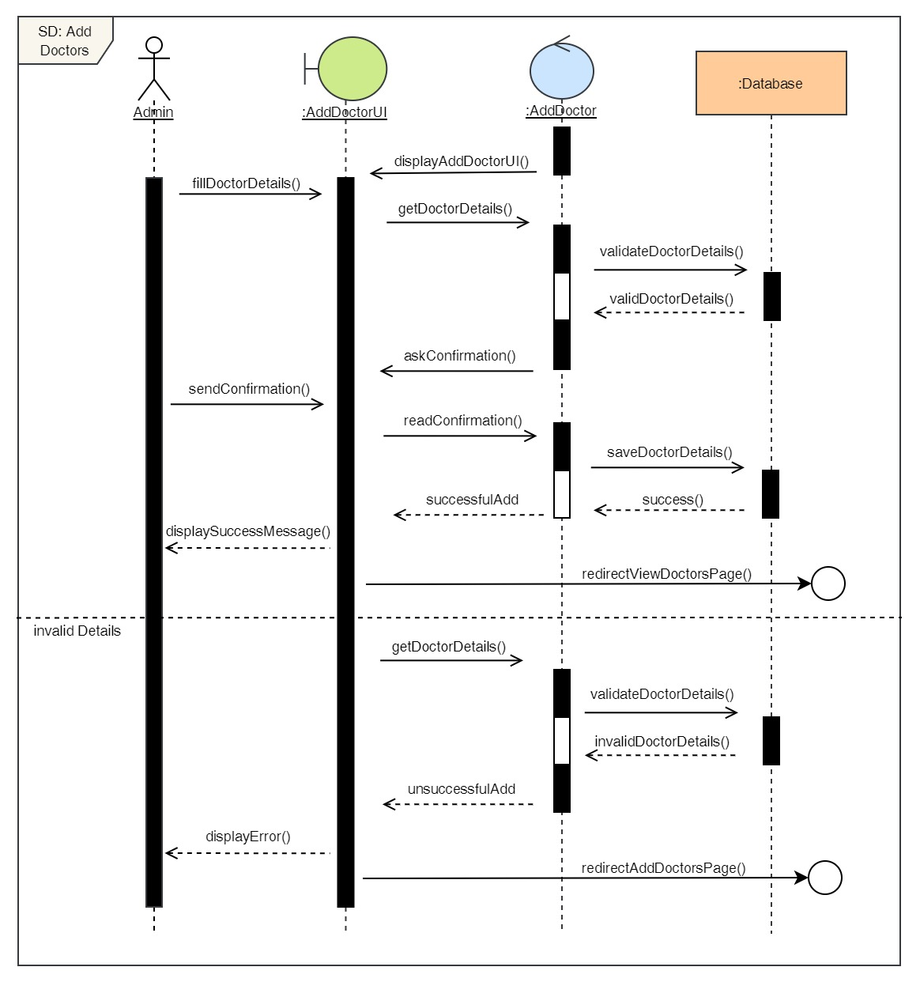

Figure 72: Sequence Diagram – Admin Add Doctors

16. Delete doctors

**High Level Use Case Description**

|  |  |
| --- | --- |
| **Use Case:** | Delete Doctors |
| **Actor:** | Admin |
| **Description:** | Admin can remove existing doctors from the system if the doctor is no longer working in the clinic. |

Table 17: High Level Use Case – Admin Delete Doctors

**Use Case Diagram**

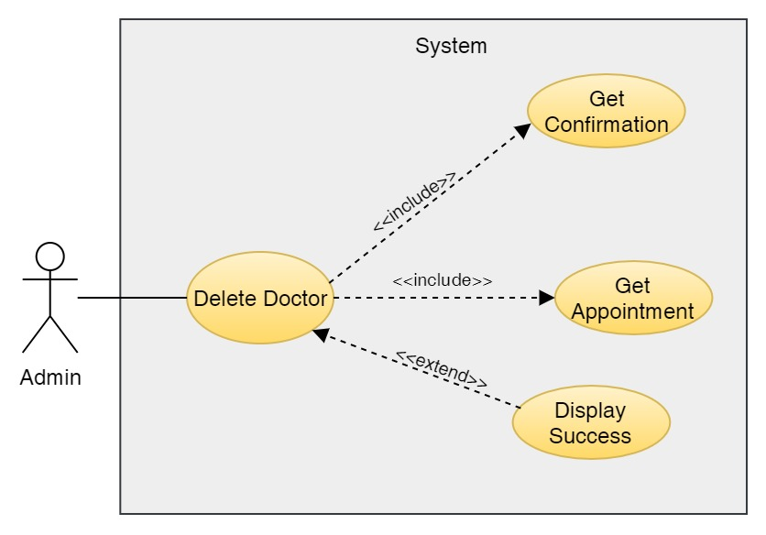

Figure 73: Use Case Diagram – Admin Delete Doctors

**Collaboration Diagram**

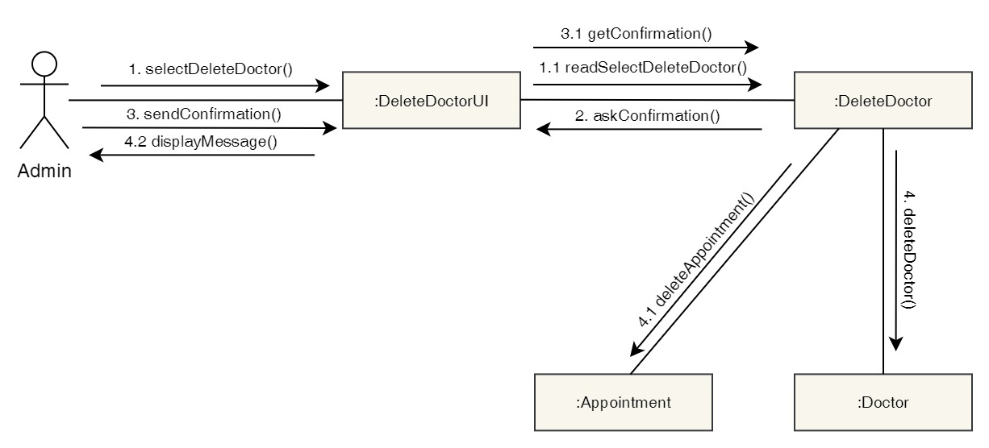

Figure 74: Collaboration Diagram – Admin Delete Doctors

**Activity Diagram**

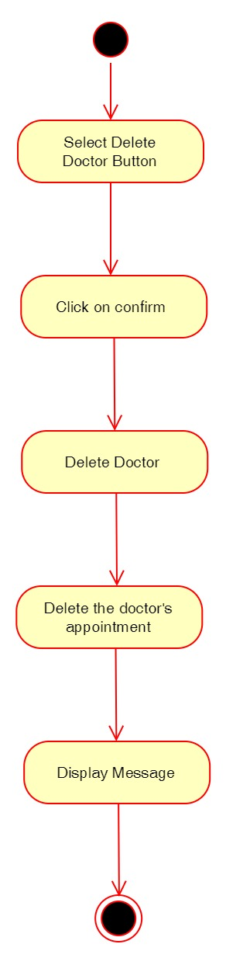

Figure 75: Activity Diagram – Admin Delete Doctors

**Sequence Diagram**

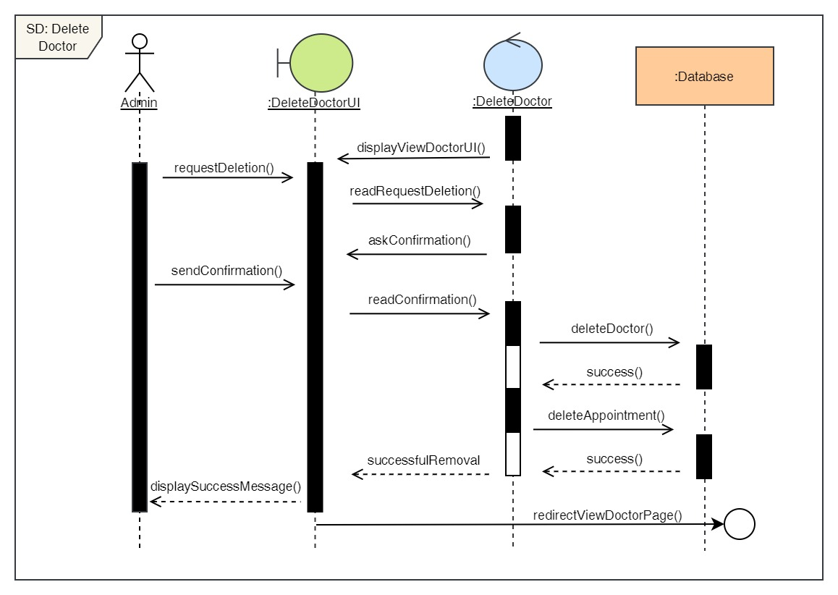

Figure 76: Sequence Diagram – Admin Delete Doctors

17. Edit doctors

**High Level Use Case Description**

|  |  |
| --- | --- |
| **Use Case:** | Edit Doctors |
| **Actor:** | Admin |
| **Description:** | Admin can update the details of the existing doctors in the system. |

Table 18: High Level Use Case – Admin Edit Doctors

**Use Case Diagram**

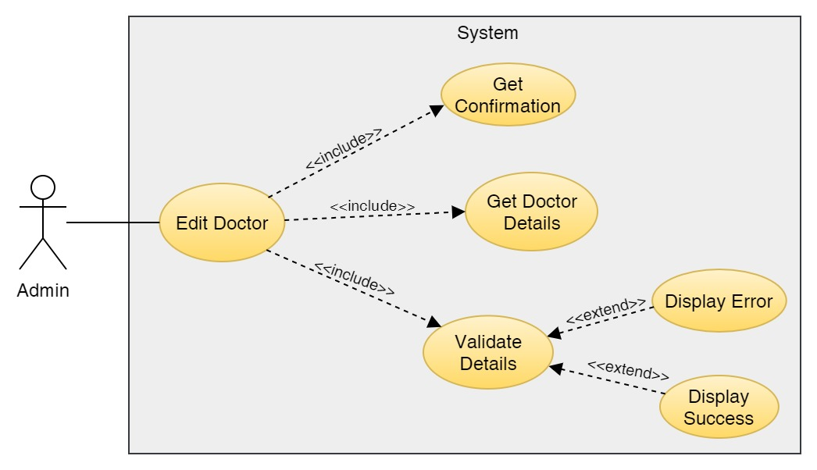

Figure 77: Use Case Diagram – Admin Edit Doctors

**Collaboration Diagram**

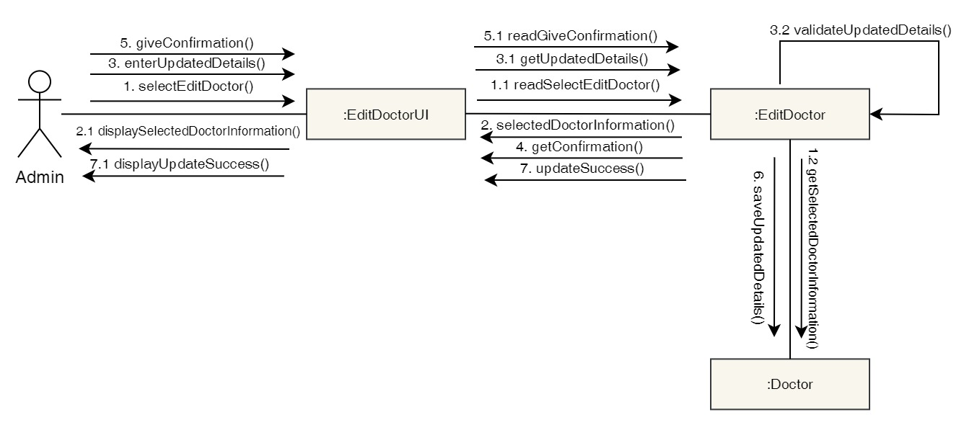

Figure 78: Collaboration Diagram – Admin Edit Doctors

**Activity Diagram**

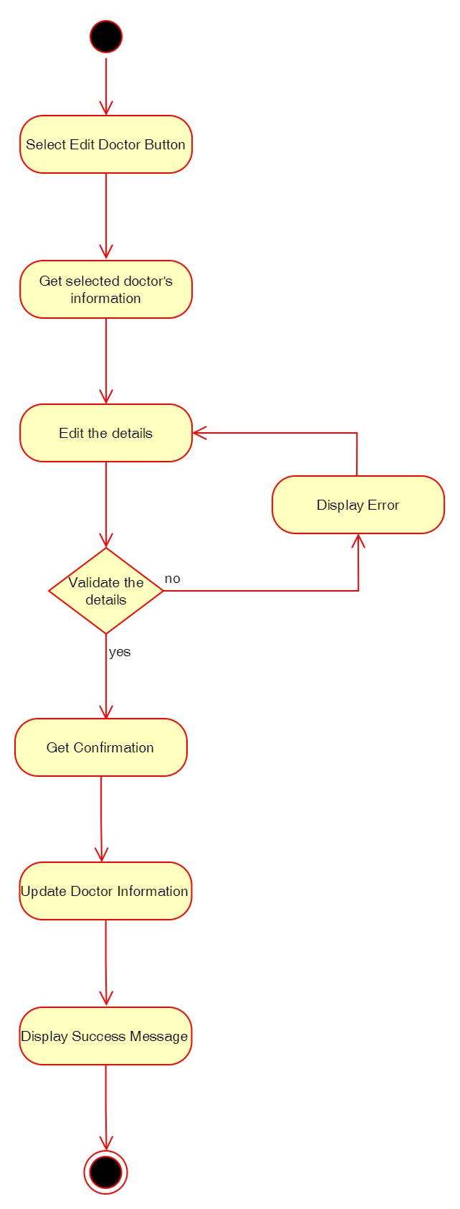

Figure 79: Activity Diagram – Admin Edit Doctors

**Sequence Diagram**

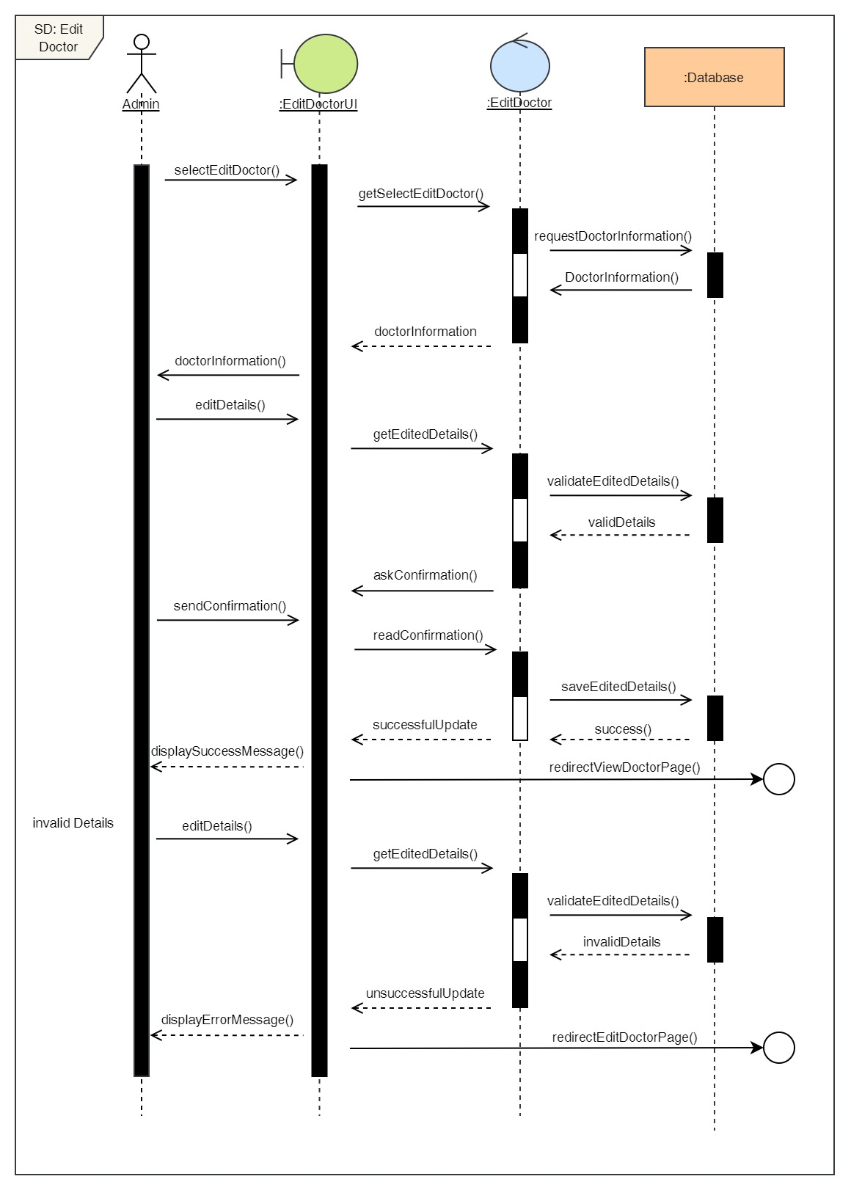

Figure 80: Sequence Diagram – Admin Edit Doctors

18. Add Report

**High Level Use Case Description**

|  |  |
| --- | --- |
| **Use Case:** | Add Report |
| **Actor:** | Admin |
| **Description:** | Admin can add reports of the appointments that has been completed. |

Table 19: High Level Use Case – Admin Add Report

**Use Case Diagram**

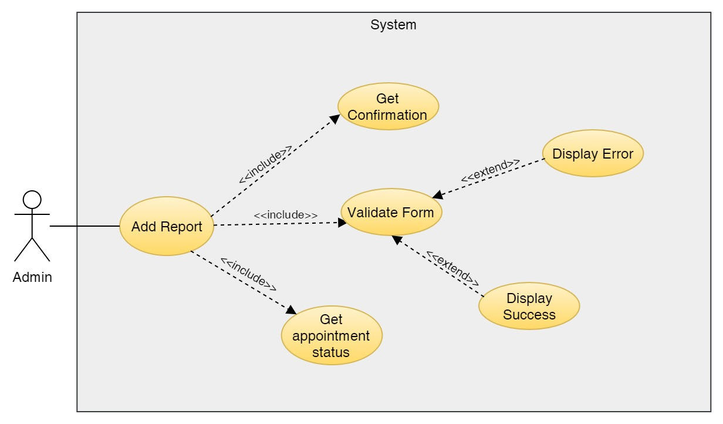

Figure 81: Use Case Diagram – Admin Add Report

**Collaboration Diagram**

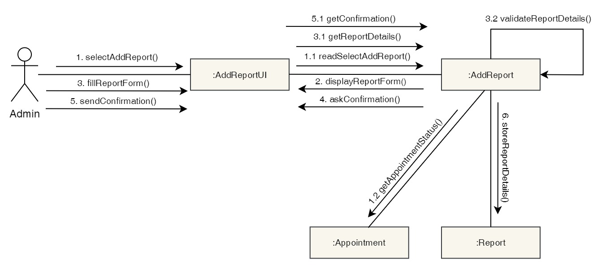

Figure 82: Collaboration Diagram – Admin Add Report

**Activity Diagram**

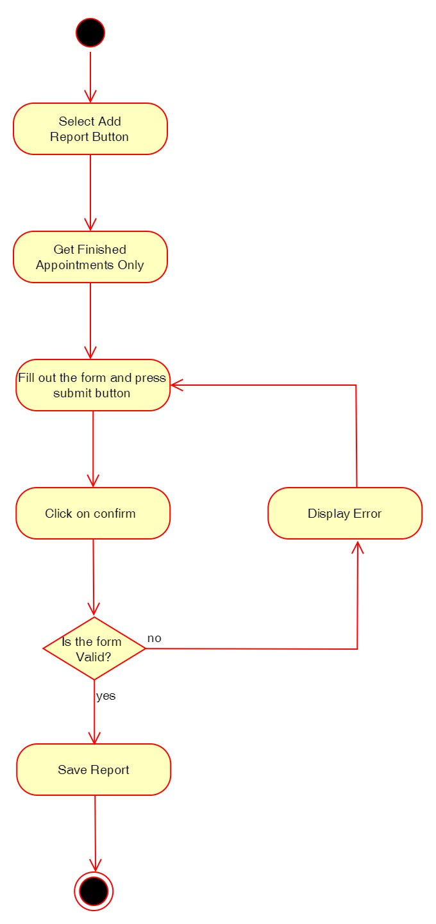

Figure 83: Activity Diagram – Admin Add Report

**Sequence Diagram**

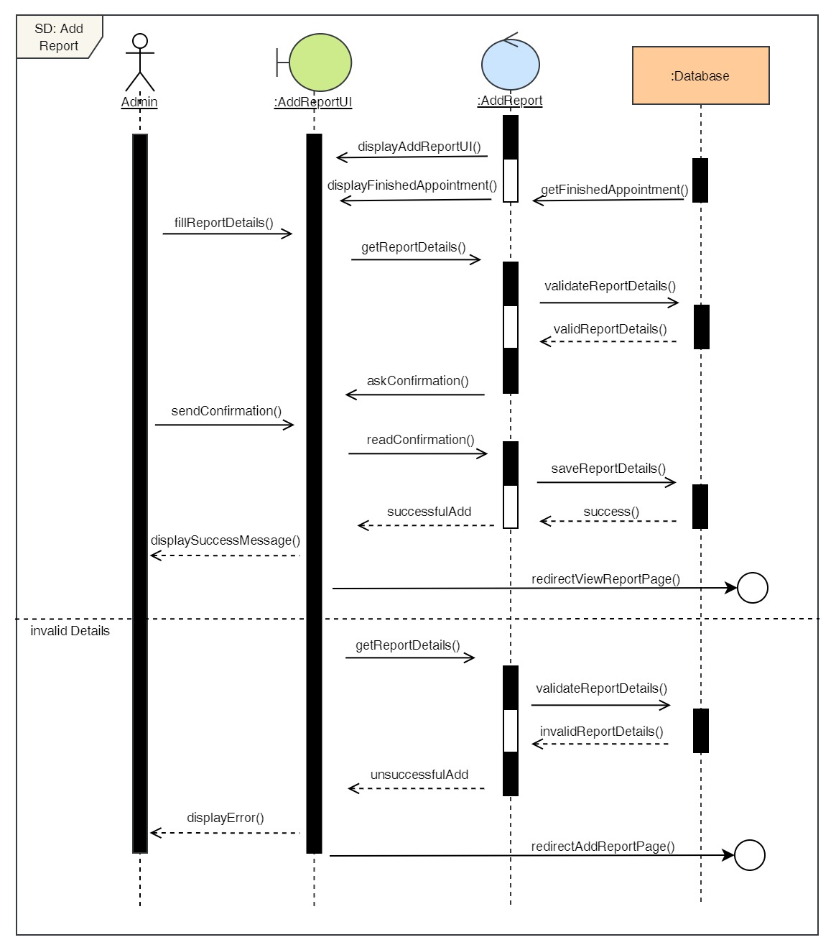

Figure 84: Sequence Diagram – Admin Add Report

19. Delete Report

**High Level Use Case Description**

|  |  |
| --- | --- |
| **Use Case:** | Delete Report |
| **Actor:** | Admin |
| **Description:** | Admin can add remove existing reports from the system. |

Table 20: High Level Use Case – Admin Delete Report

**Use Case Diagram**

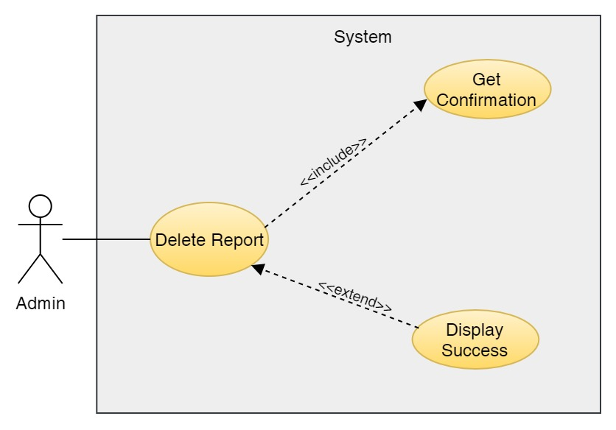

Figure 85: Use Case Diagram – Admin Delete Report

**Collaboration Diagram**

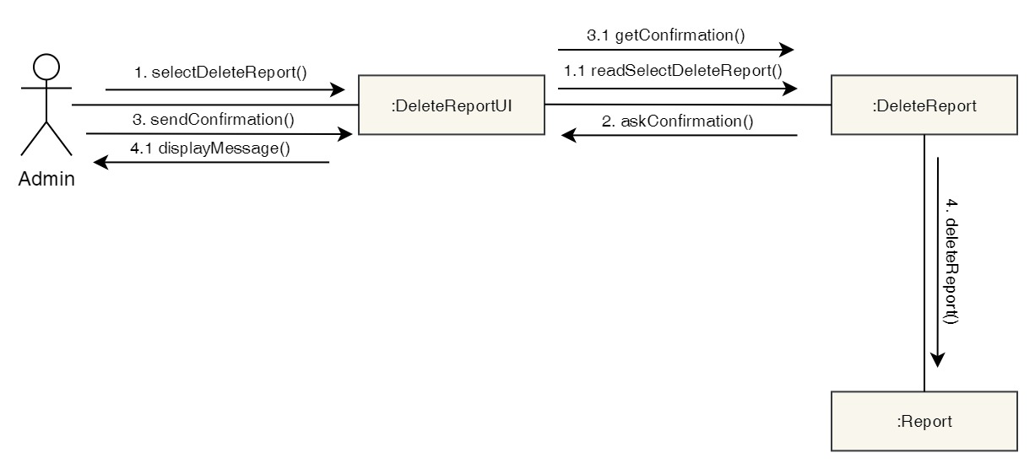

Figure 86: Collaboration Diagram – Admin Delete Report

**Activity Diagram**

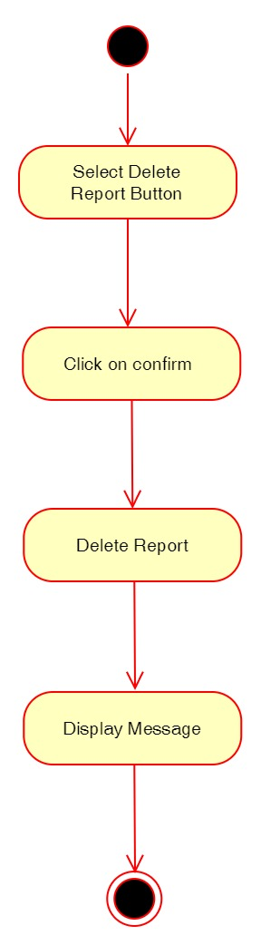

Figure 87: Activity Diagram – Admin Delete Report

**Sequence Diagram**

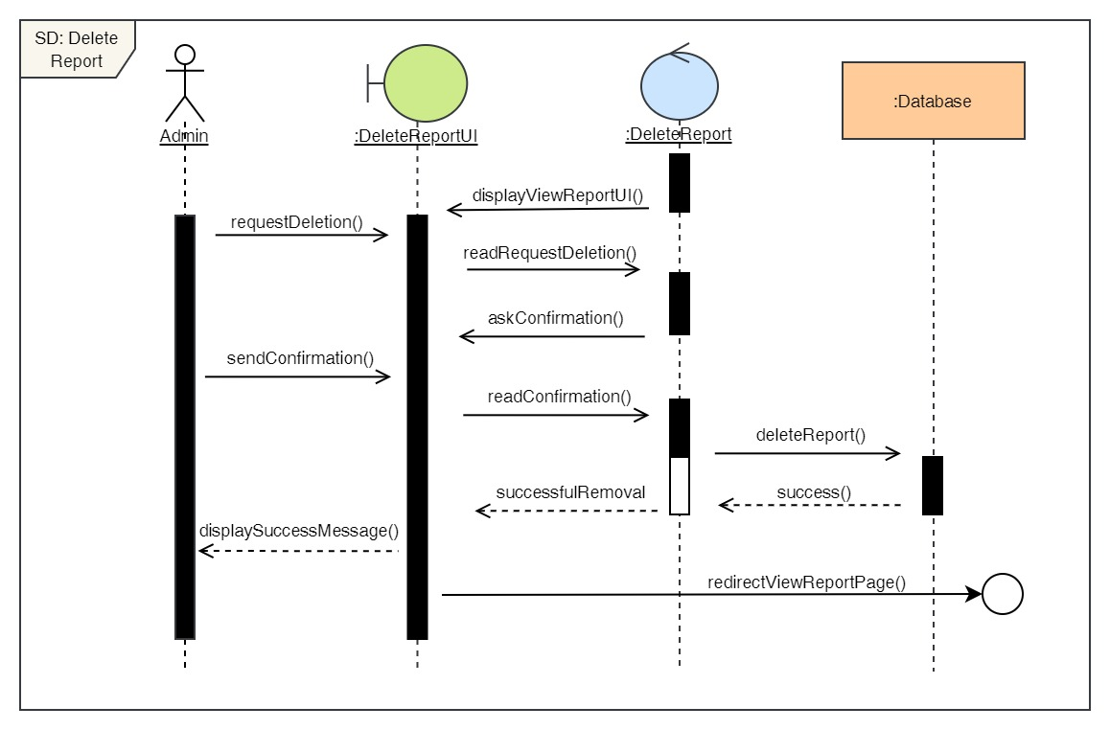

Figure 88: Sequence Diagram – Admin Delete Report

20. Edit reports

**High Level Use Case Description**

|  |  |
| --- | --- |
| **Use Case:** | Edit Reports |
| **Actor:** | Admin |
| **Description:** | Admin can update the details of the existing reports in the system. |

Table 21: High Level Use Case – Admin Edit Report

**Use Case Diagram**

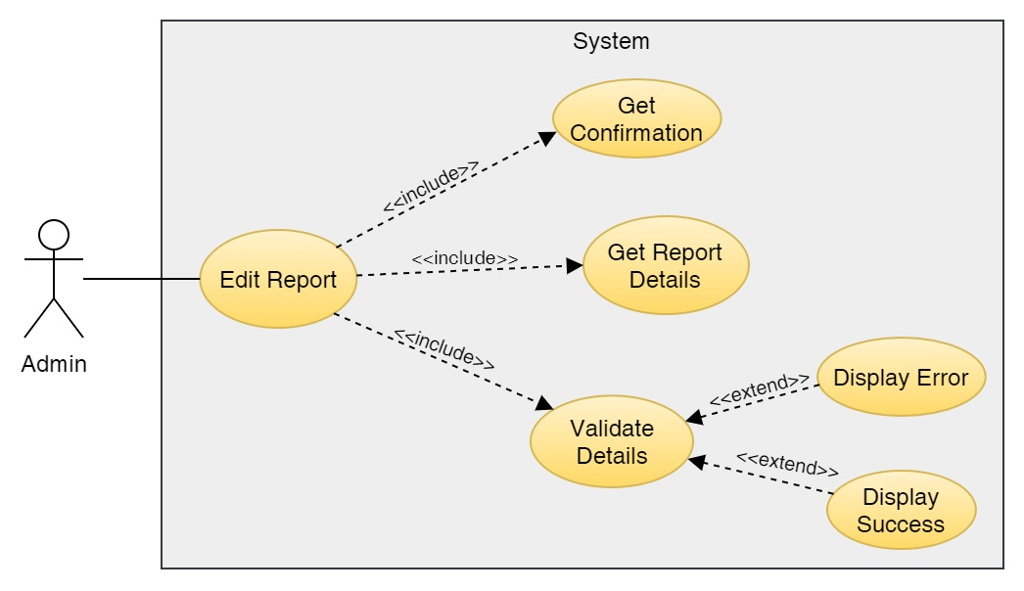

Figure 89: Use Case Diagram – Admin Edit Report

**Collaboration Diagram**

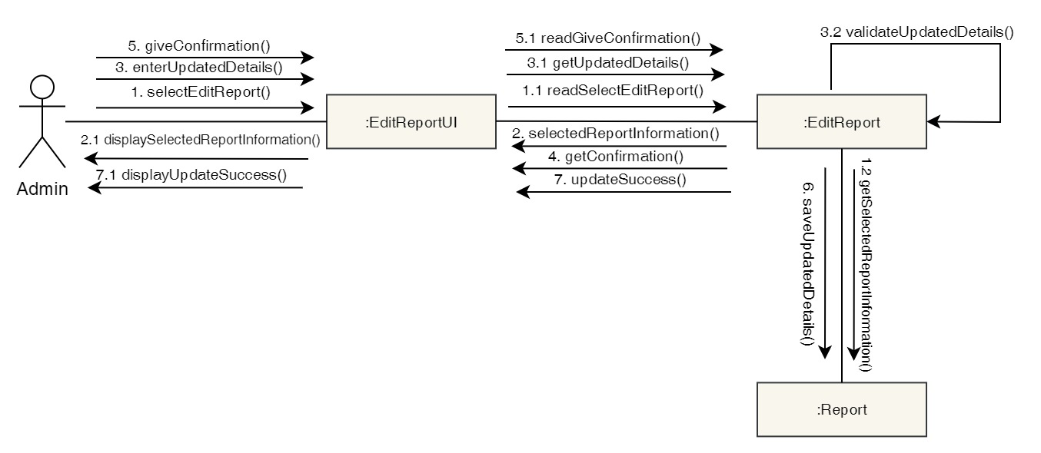

Figure 90: Collaboration Diagram – Admin Edit Report

**Activity Diagram**

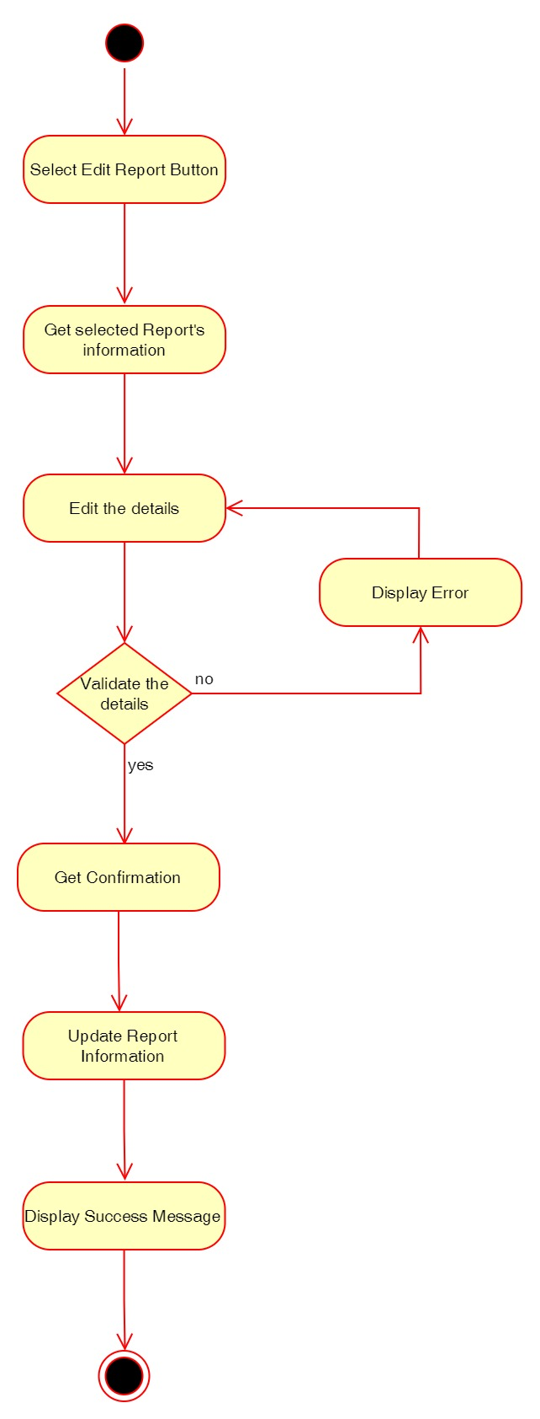

Figure 91: Activity Diagram – Admin Edit Report

**Sequence Diagram**

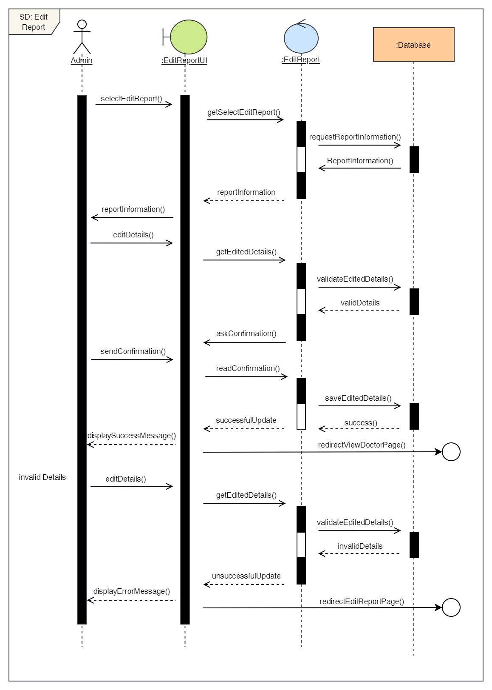

Figure 92: Sequence Diagram – Admin Edit Report

21. View all reports

**High Level Use Case Description**

|  |  |
| --- | --- |
| **Use Case:** | View Reports |
| **Actor:** | Admin |
| **Description:** | Admin can view all the reports of all the users stored in the system. |

Table 22: High Level Use Case – Admin View Reports

**Use Case Diagram**

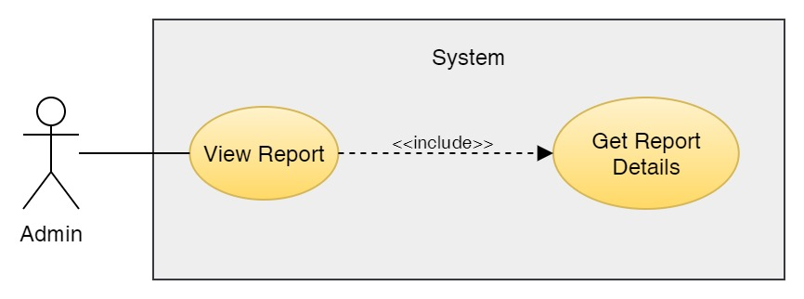

Figure 93: Use Case Diagram – Admin View Reports

**Collaboration Diagram**

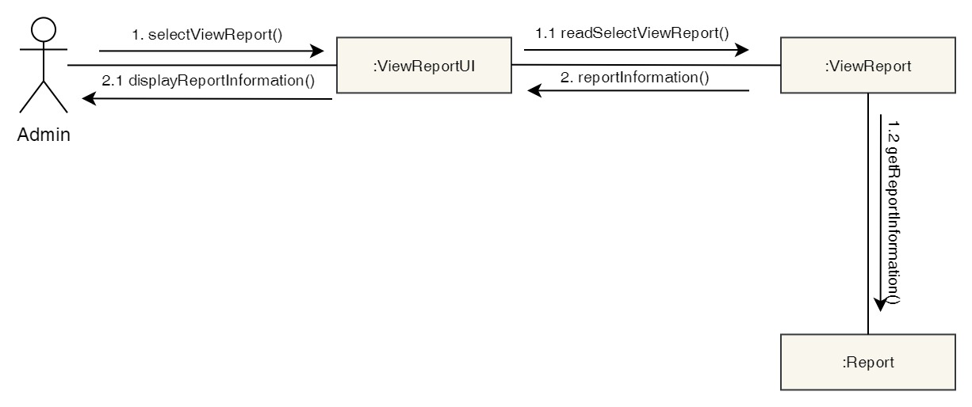

Figure 94: Collaboration Diagram – Admin View Reports

**Activity Diagram**

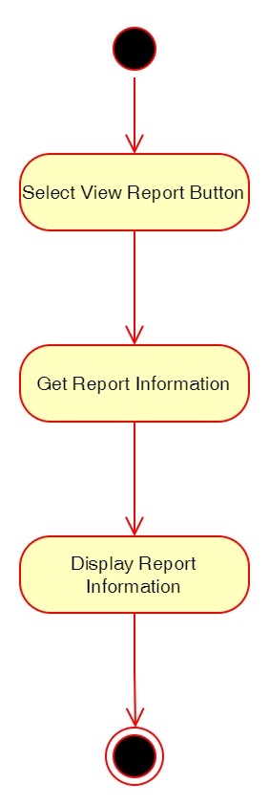

Figure 95: Activity Diagram – Admin View Reports

**Sequence Diagram**

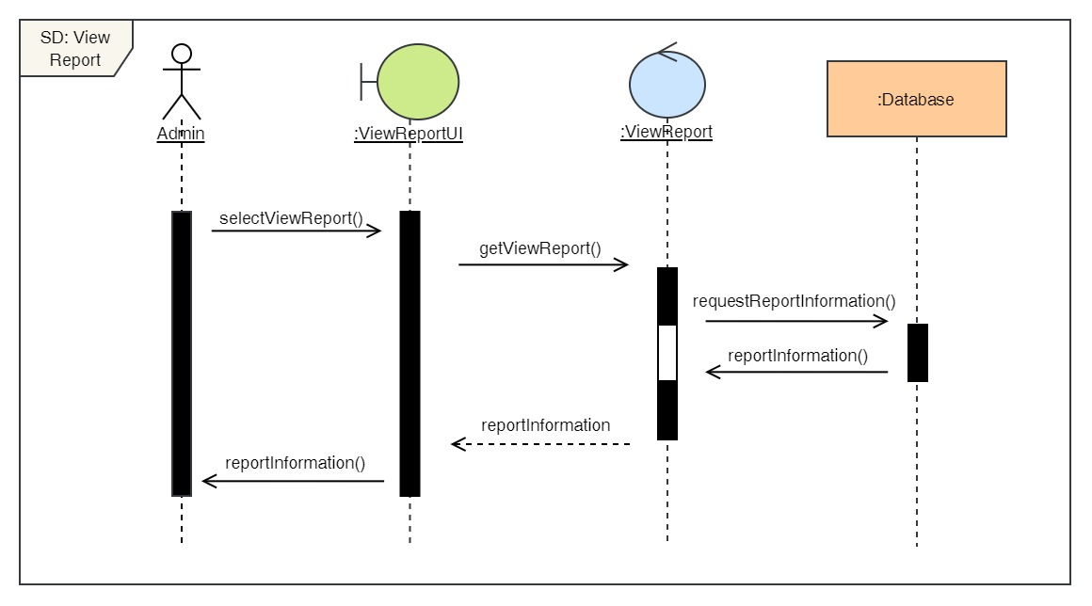

Figure 96: Sequence Diagram – Admin View Reports

22. Book a Dental Appointment

**High Level Use Case Description**

|  |  |
| --- | --- |
| **Use Case:** | Book Appointment |
| **Actor:** | Admin |
| **Description:** | Admin can book appointment for any user and any dental services by selecting the desired date, time, doctor and service. |

Table 23: High Level Use Case – Admin Book Appointment

**Use Case Diagram**

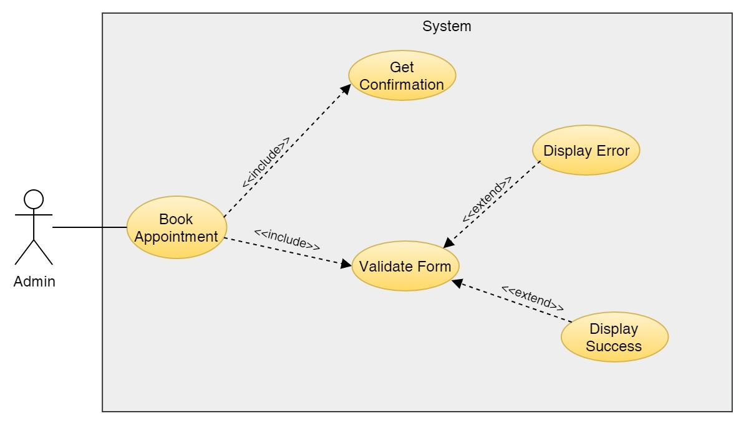

Figure 97: Use Case Diagram – Admin Book Appointment

**Collaboration Diagram**

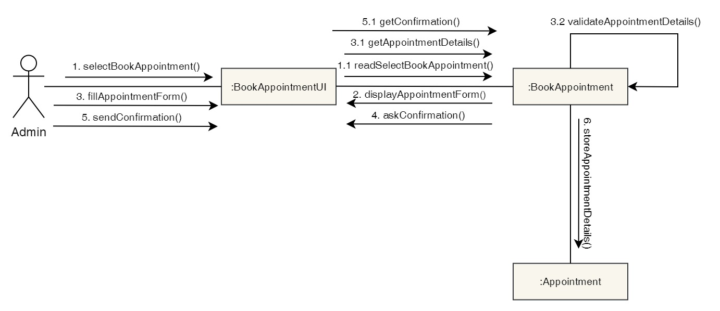

Figure 98: Collaboration Diagram – Admin Book Appointment

**Activity Diagram**

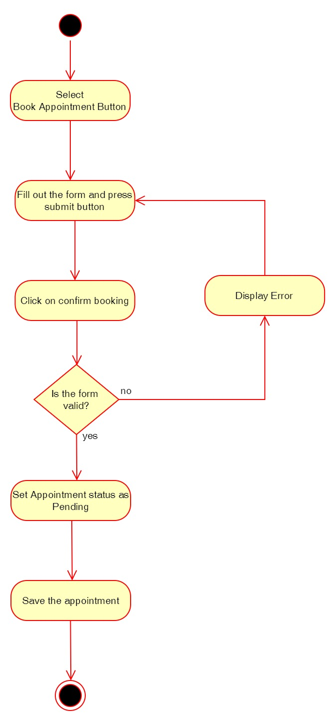

Figure 99: Activity Diagram – Admin Book Appointment

**Sequence Diagram**

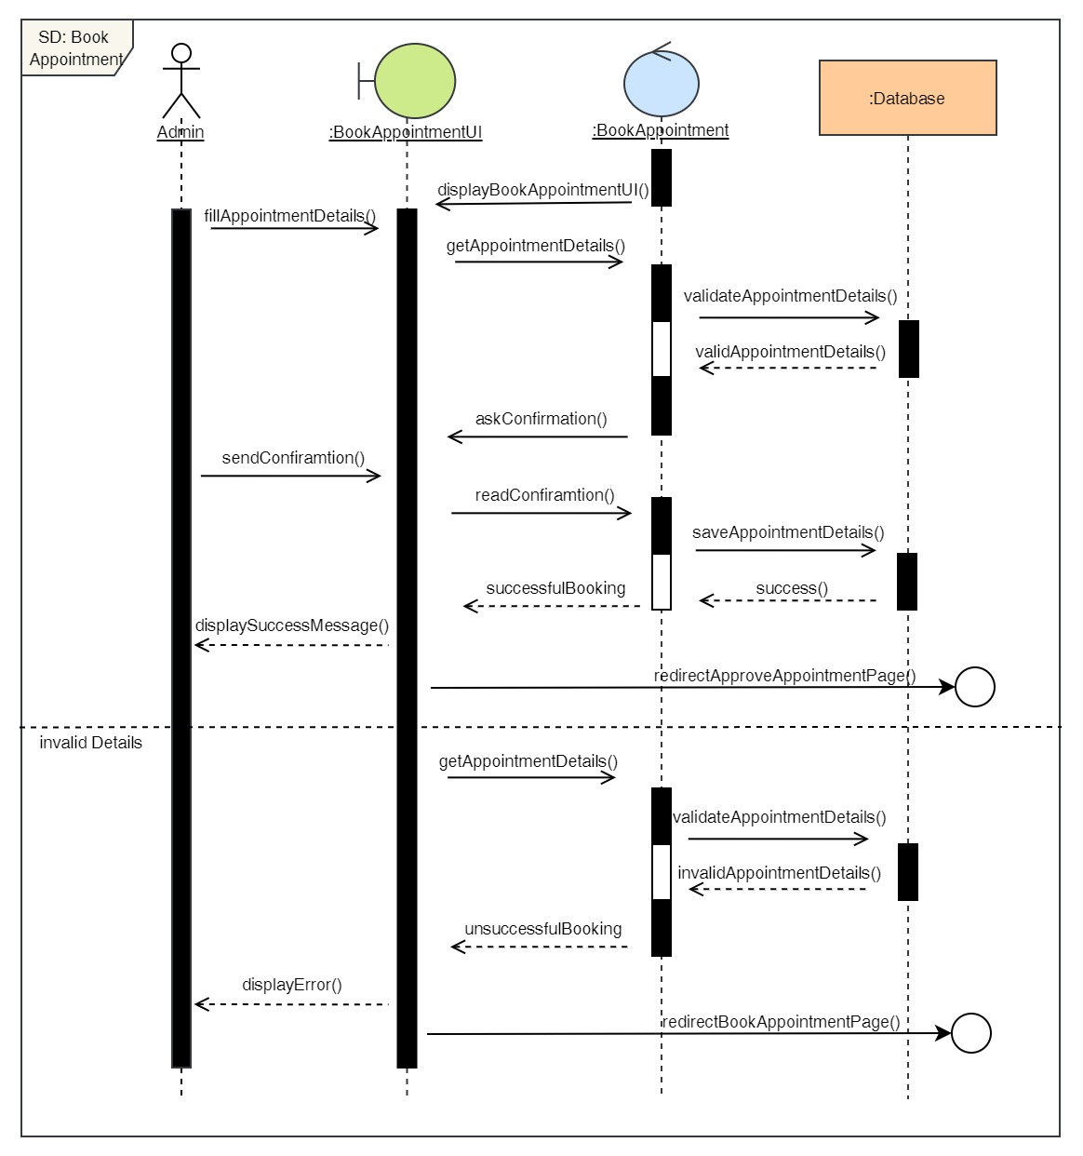

Figure 100: Sequence Diagram – Admin Book Appointment

23. View all appointments

**High Level Use Case Description**

|  |  |
| --- | --- |
| **Use Case:** | View all appointments |
| **Actor:** | Admin |
| **Description:** | Admin can view all the appointments the users have made from the system that is not pending. |

Table 24: High Level Use Case – Admin View Appointments

**Use Case Diagram**

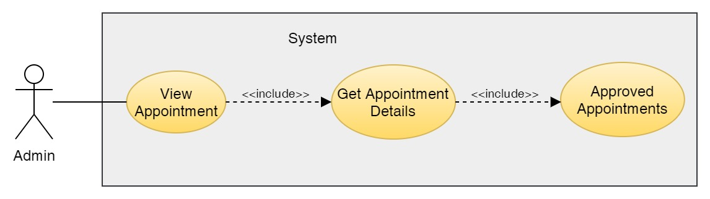

Figure 101: Use Case Diagram – Admin View Appointments

**Collaboration Diagram**

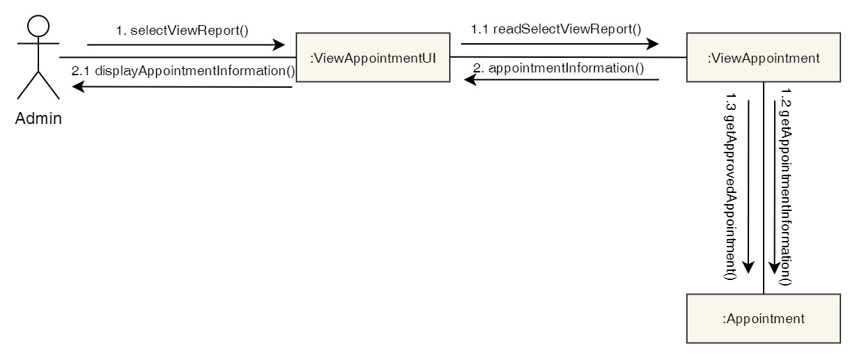

Figure 102: Collaboration Diagram – Admin View Appointments

**Activity Diagram**

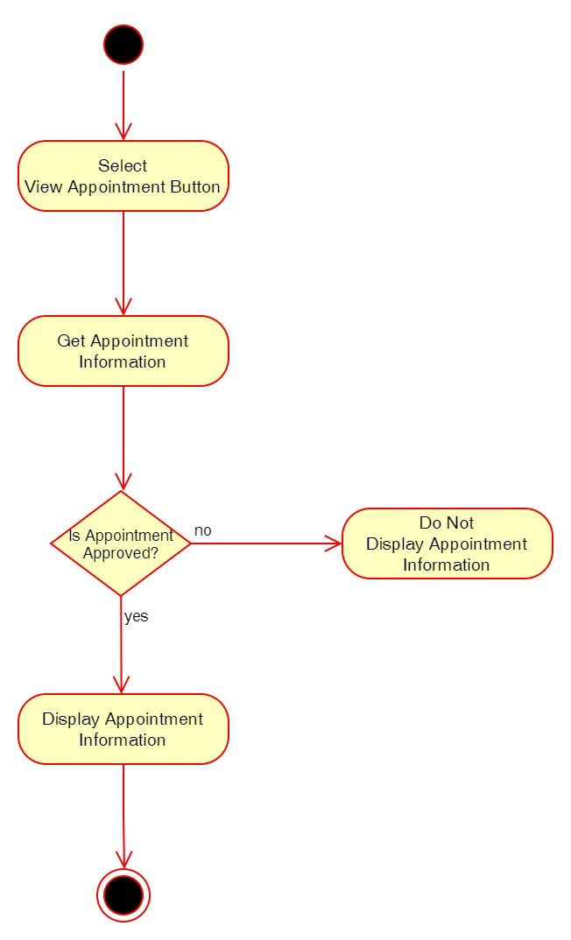

Figure 103: Activity Diagram – Admin View Appointments

**Sequence Diagram**

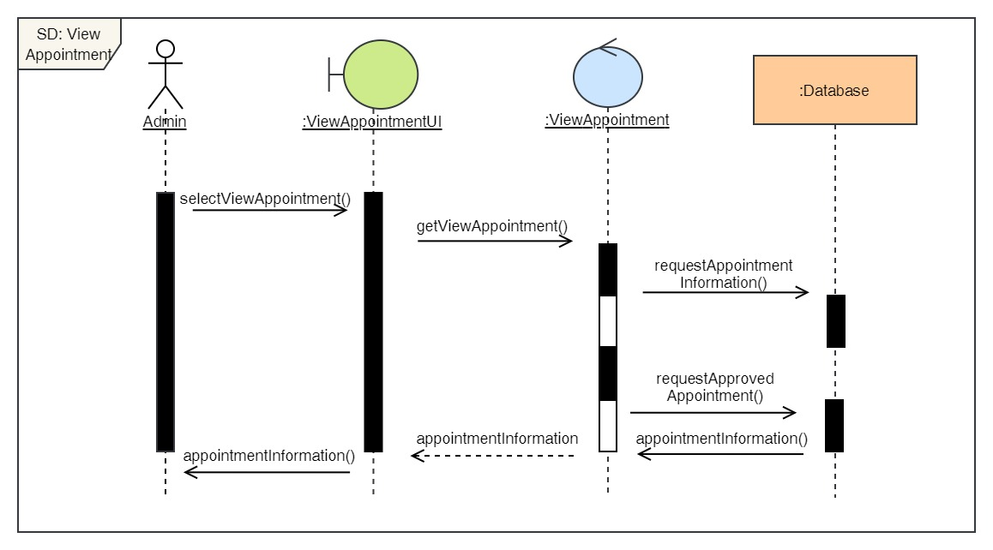

Figure 104: Sequence Diagram – Admin View Appointments

24. Cancel Appointment

**High Level Use Case Description**

|  |  |
| --- | --- |
| **Use Case:** | Cancel Appointment |
| **Actor:** | Admin |
| **Description:** | The admin can cancel appointment of the user's that has already been confirmed. |

Table 25: High Level Use Case – Admin Cancel Appointment

**Use Case Diagram**

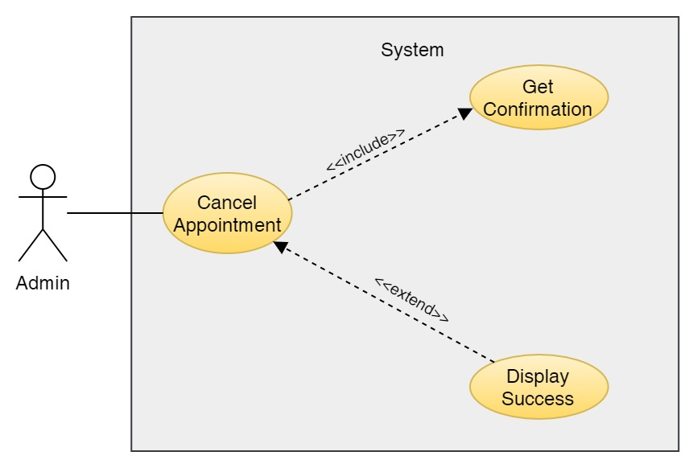

Figure 105: Use Case Diagram – Admin Cancel Appointment

**Collaboration Diagram**

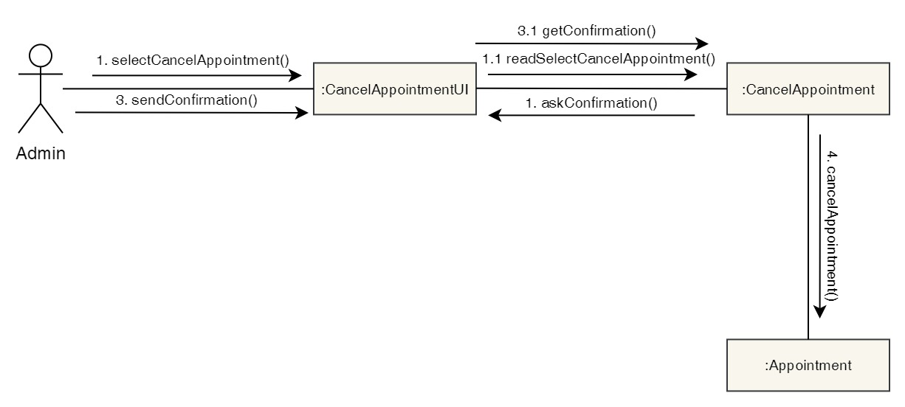

Figure 106: Collaboration Diagram – Admin Cancel Appointment

**Activity Diagram**



Figure 107: Activity Diagram – Admin Cancel Appointment

**Sequence Diagram**

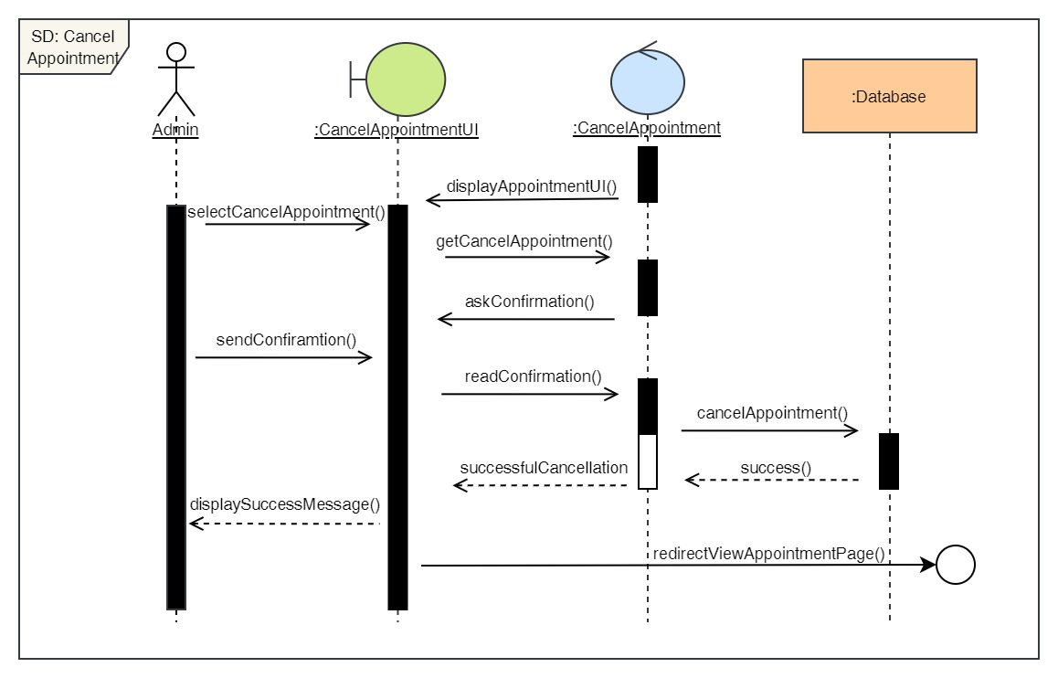

Figure 108: Sequence Diagram – Admin Cancel Appointment

25. Approve Appointment

**High Level Use Case Description**

|  |  |
| --- | --- |
| **Use Case:** | Approve Appointment |
| **Actor:** | Admin |
| **Description:** | When a user books an appointment, it gets in pending stage. The admin then approves the pending appointment and changes the status of the appointment from pending to confirmed. |

Table 26: High Level Use Case – Admin Approve Appointment

**Use Case Diagram**

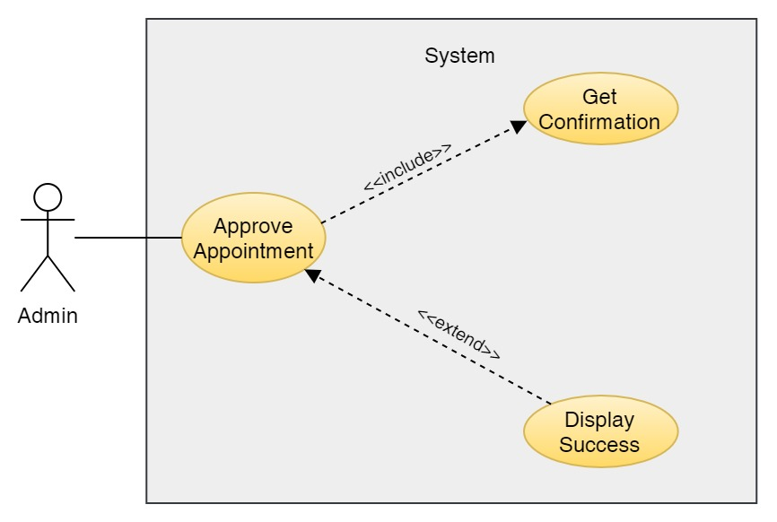

Figure 109: Use Case Diagram – Admin Approve Appointment

**Collaboration Diagram**

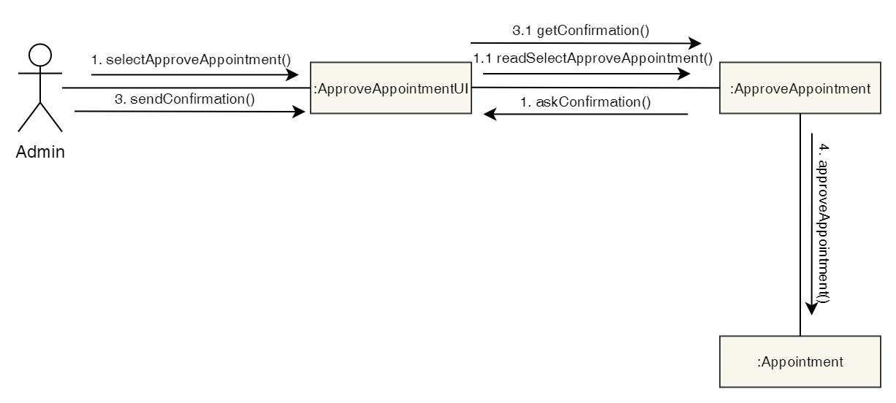

Figure 110: Collaboration Diagram – Admin Approve Appointment

**Activity Diagram**

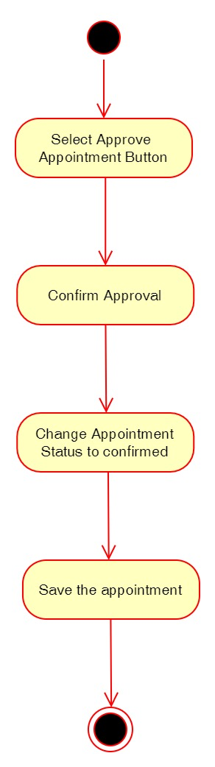

Figure 111: Activity Diagram – Admin Approve Appointment

**Sequence Diagram**

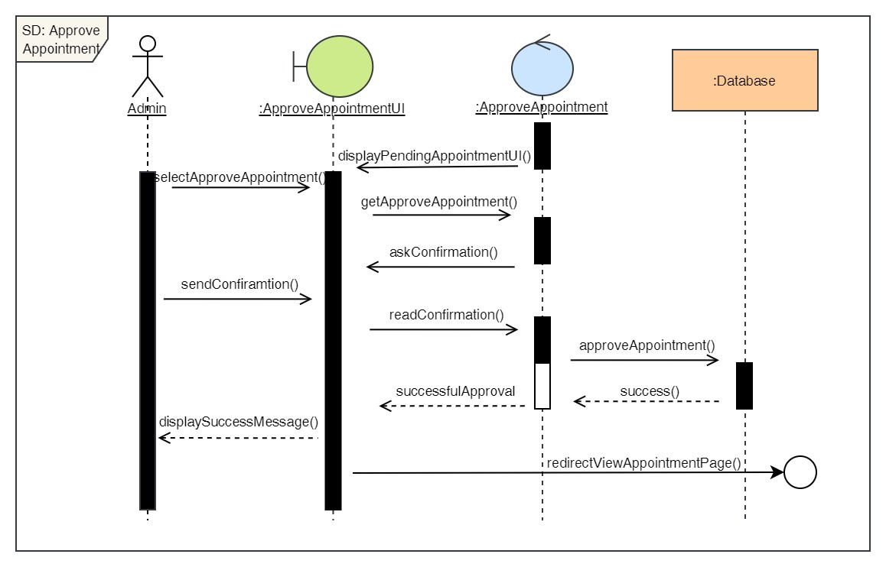

Figure 112: Sequence Diagram – Admin Approve Appointment

26. Reject Appointment

**High Level Use Case Description**

|  |  |
| --- | --- |
| **Use Case:** | Reject Appointment |
| **Actor:** | Admin |
| **Description:** | When a user books an appointment, it gets in pending stage. The admin then rejects the pending appointment if the appointment does not have enough information and changes the status of the appointment from pending to rejected. |

Table 27: High Level Use Case – Admin Reject Appointment

**Use Case Diagram**

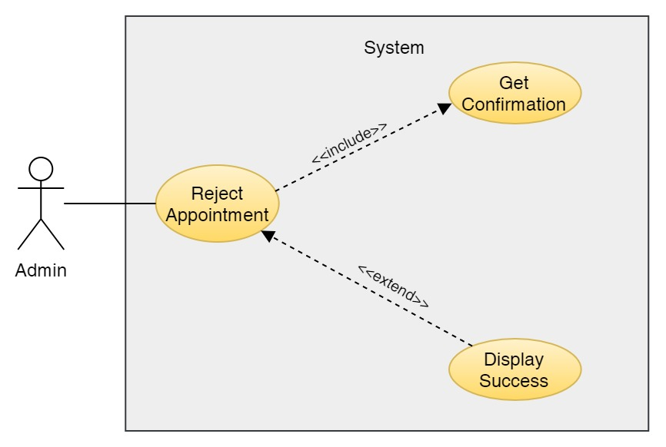

Figure 113: Use Case Diagram – Admin Reject Appointment

**Collaboration Diagram**

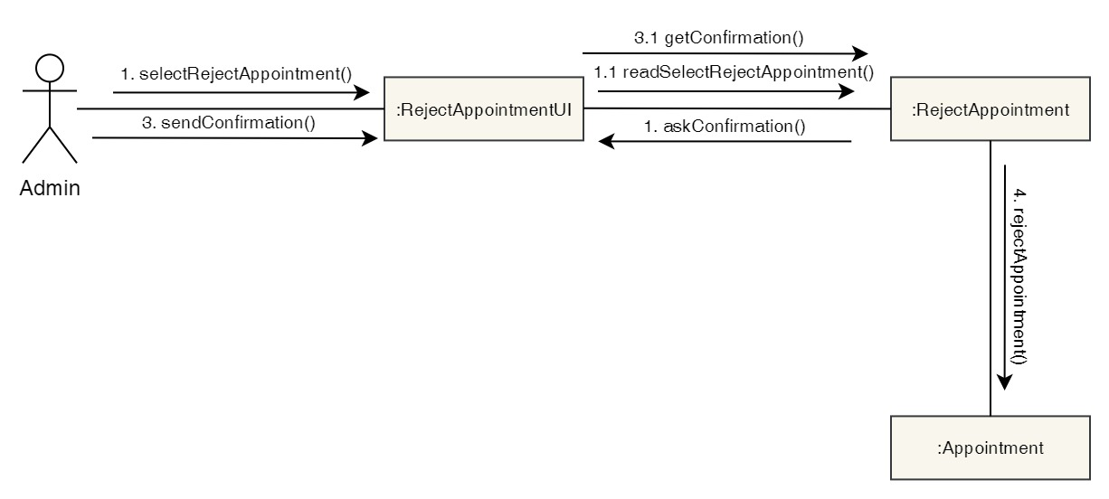

Figure 114: Collaboration Diagram – Admin Reject Appointment

**Activity Diagram**

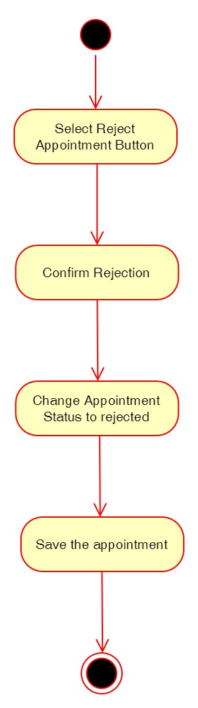

Figure 115: Activity Diagram – Admin Reject Appointment

**Sequence Diagram**

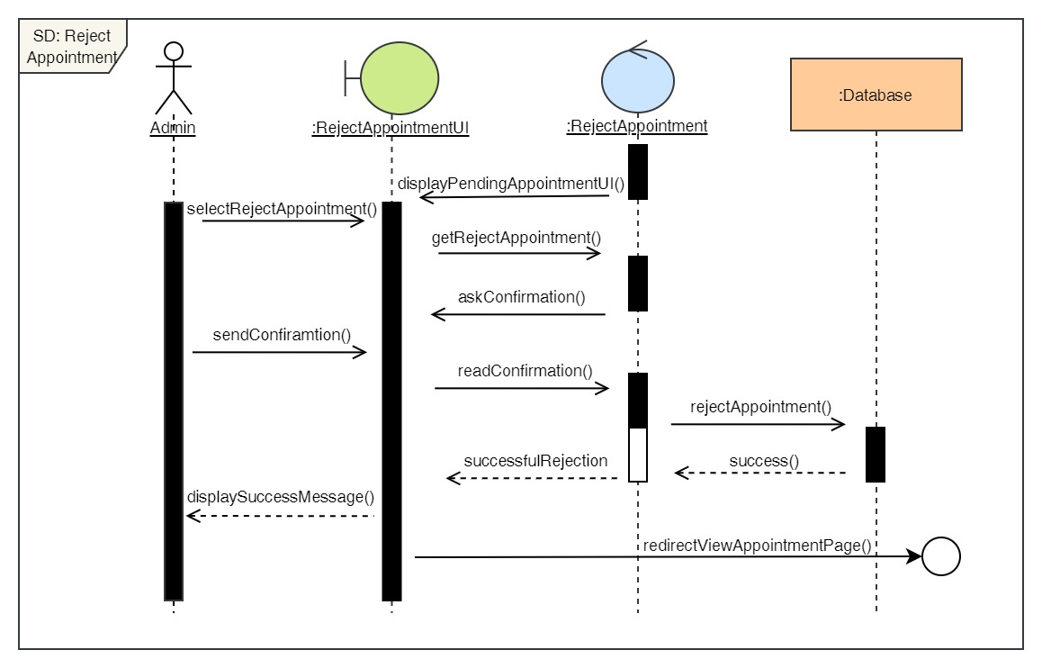

Figure 116: Sequence Diagram – Admin Reject Appointment

27. Finish Appointment

**High Level Use Case Description**

|  |  |
| --- | --- |
| **Use Case:** | Finish Appointment |
| **Actor:** | Admin |
| **Description:** | After the appointment is confirmed, it is in confirmed stage. After the user visits the clinic for their appointment and the appointment is completed, the admin changes the appointment status from confirmed to finished. |

Table 28: High Level Use Case – Admin Finish Appointment

**Use Case Diagram**

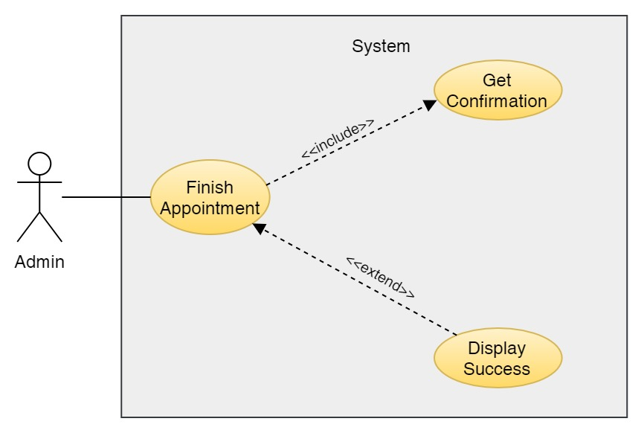

Figure 117: Use Case Diagram – Admin Finish Appointment

**Collaboration Diagram**

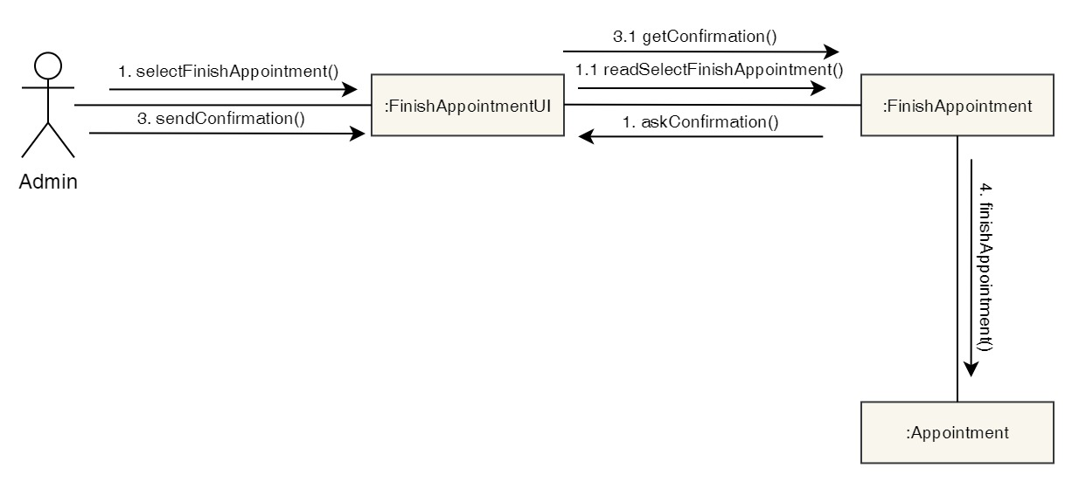

Figure 118: Collaboration Diagram – Admin Finish Appointment

**Activity Diagram**

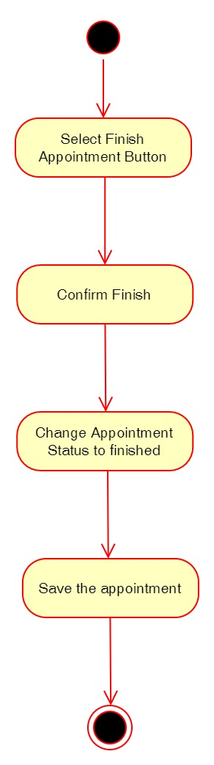

Figure 119: Activity Diagram – Admin Finish Appointment

**Sequence Diagram**

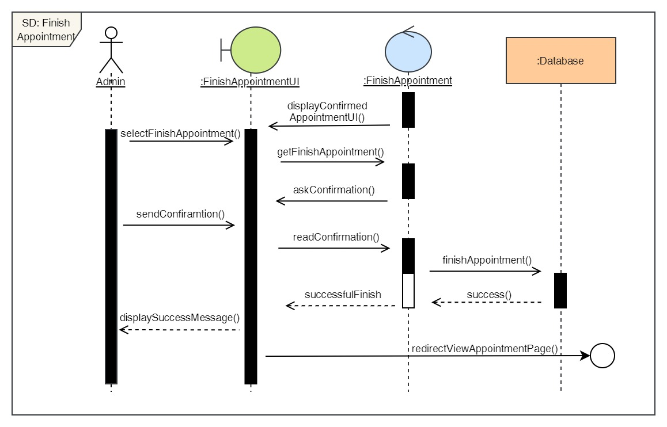

Figure 120: Sequence Diagram – Admin Finish Appointment

28. View all services

**High Level Use Case Description**

|  |  |
| --- | --- |
| **Use Case:** | View Services |
| **Actor:** | Admin |
| **Description:** | Admin can view the list of all the services available along with the cost of it and description. |

Table 29: High Level Use Case – Admin View Services

**Use Case Diagram**

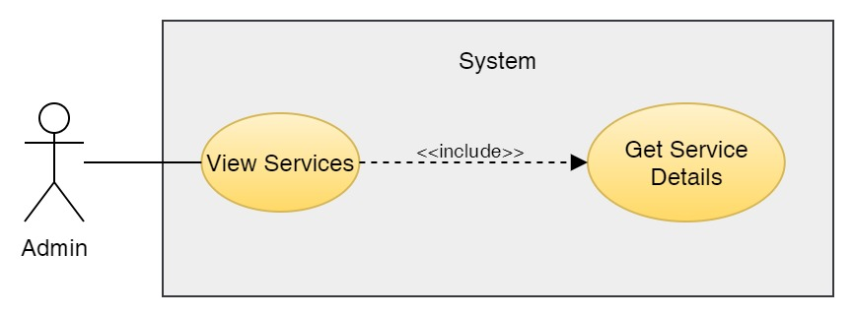

Figure 121: Use Case Diagram – Admin View Services

**Collaboration Diagram**

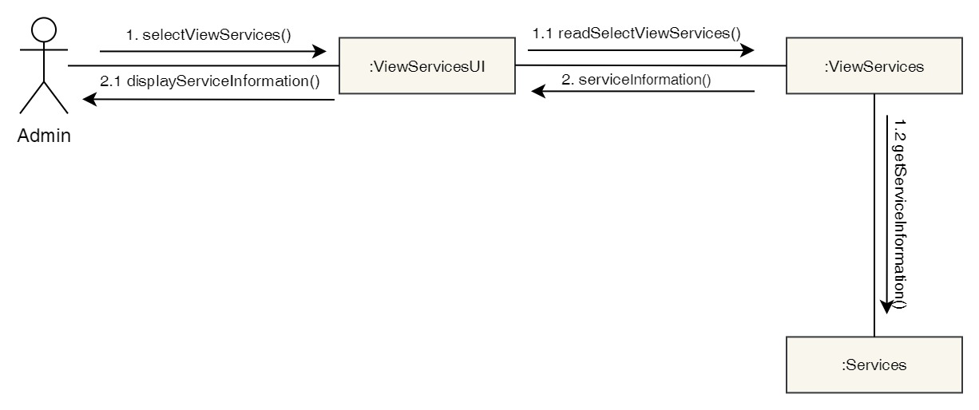

Figure 122: Collaboration Diagram – Admin View Services

**Activity Diagram**



Figure 123: Activity Diagram – Admin View Services

**Sequence Diagram**

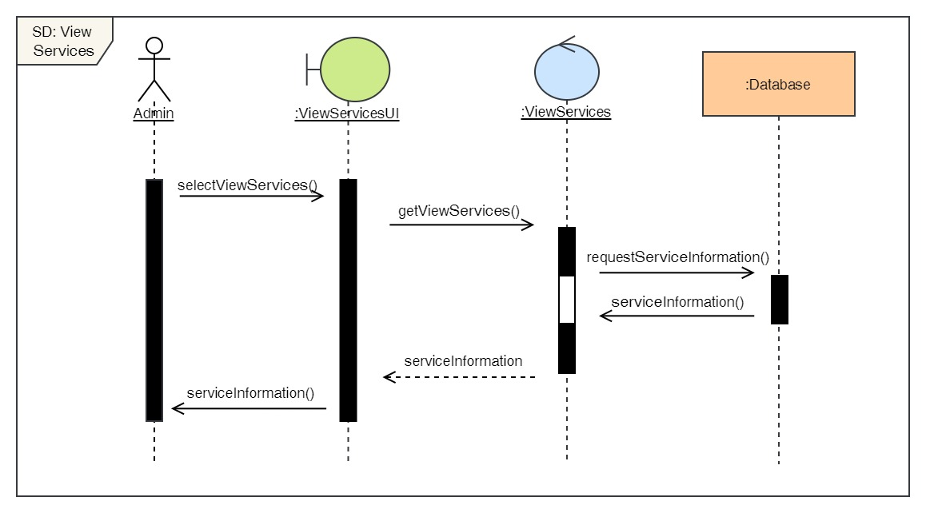

Figure 124: Sequence Diagram – Admin View Services

29. Add services

**High Level Use Case Description**

|  |  |
| --- | --- |
| **Use Case:** | Add services |
| **Actor:** | Admin |
| **Description:** | Admin can add new services in the system. |

Table 30: High Level Use Case – Admin Add Services

**Use Case Diagram**

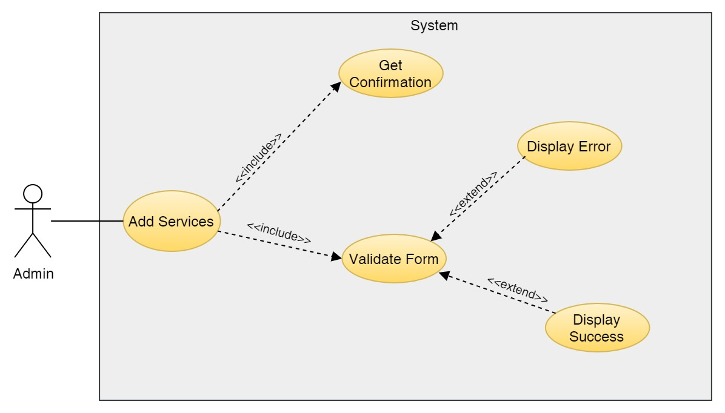

Figure 125: Use Case Diagram – Admin Add Services

**Collaboration Diagram**

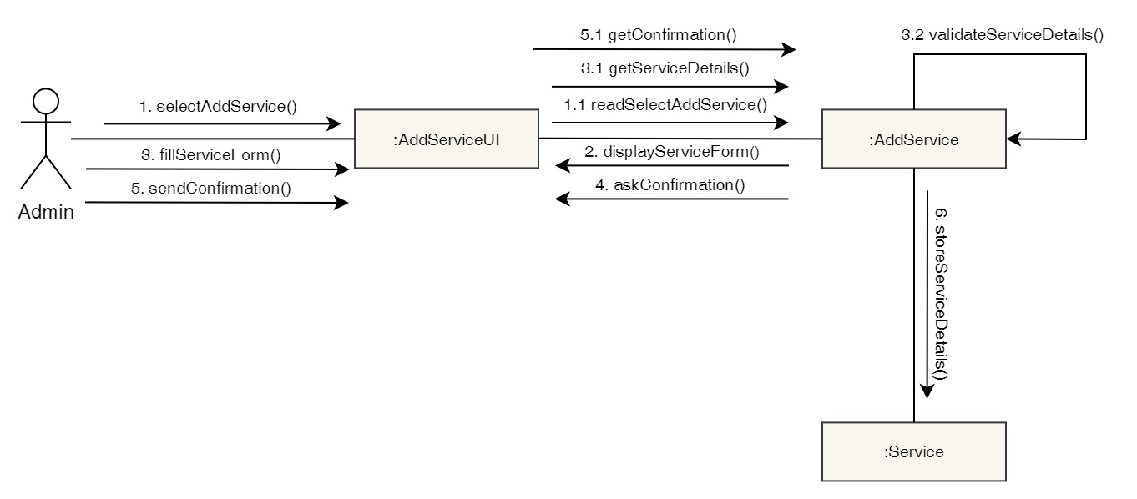

Figure 126: Collaboration Diagram – Admin Add Services

**Activity Diagram**

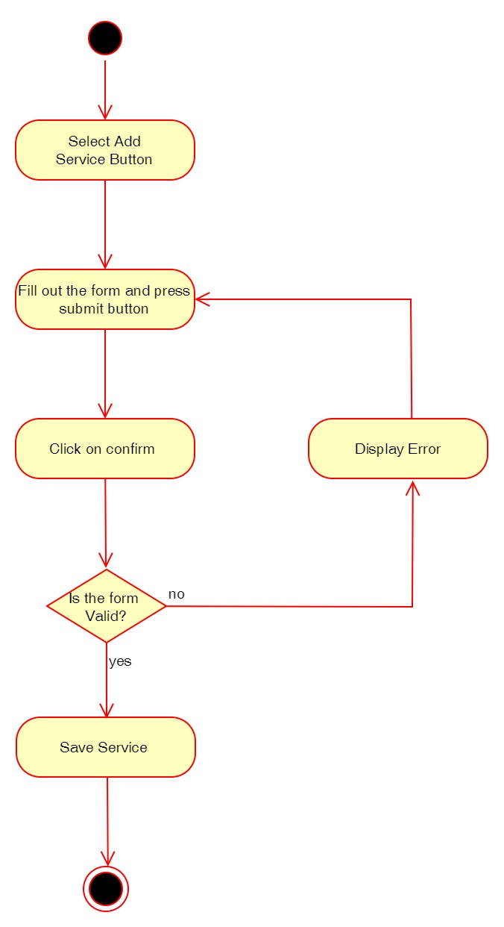

Figure 127: Activity Diagram – Admin Add Services

**Sequence Diagram**

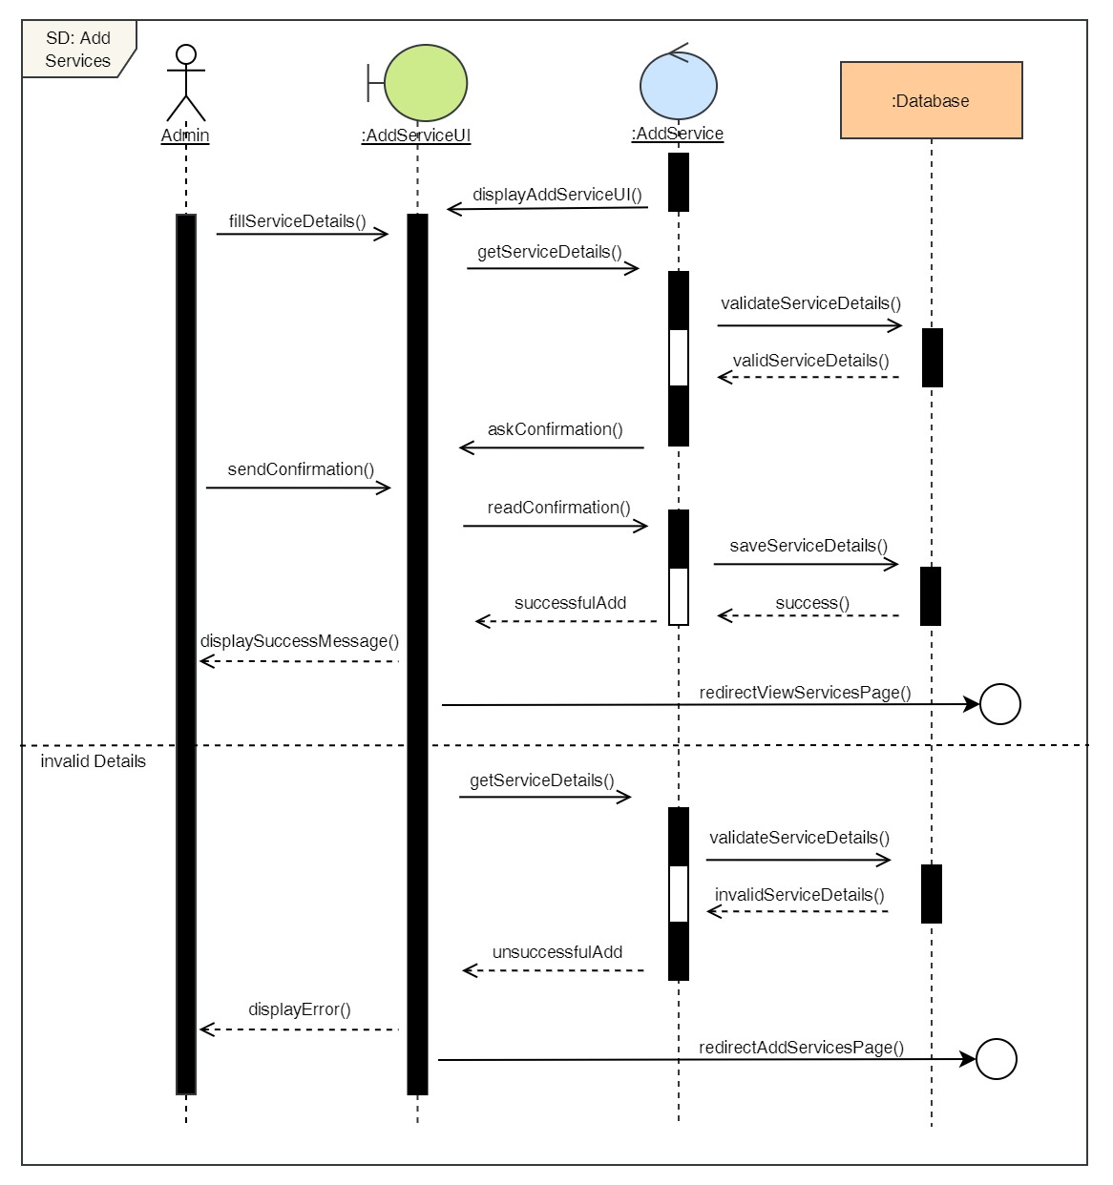

Figure 128: Sequence Diagram – Admin Add Services

30. Delete services

**High Level Use Case Description**

|  |  |
| --- | --- |
| **Use Case:** | Delete services |
| **Actor:** | Admin |
| **Description:** | Admin can add remove existing services from the system. |

Table 31: High Level Use Case – Admin Delete Services

**Use Case Diagram**

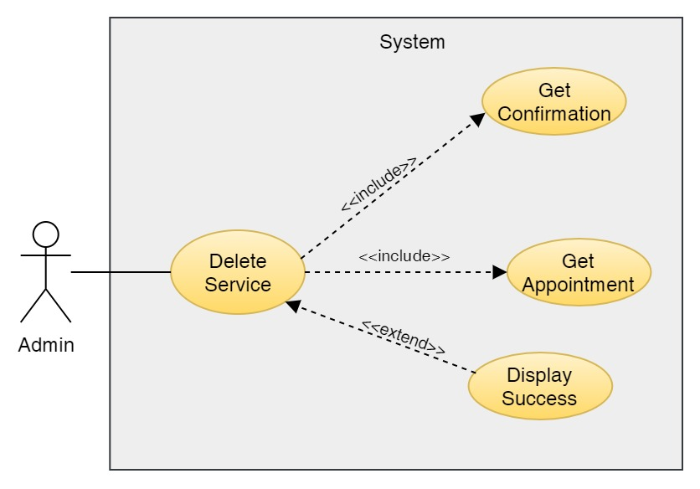

Figure 129: Use Case Diagram – Admin Delete Services

**Collaboration Diagram**

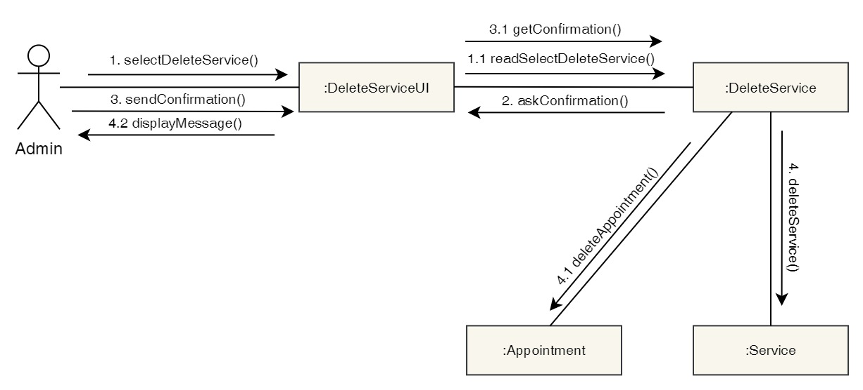

Figure 130: Collaboration Diagram – Admin Delete Services

**Activity Diagram**

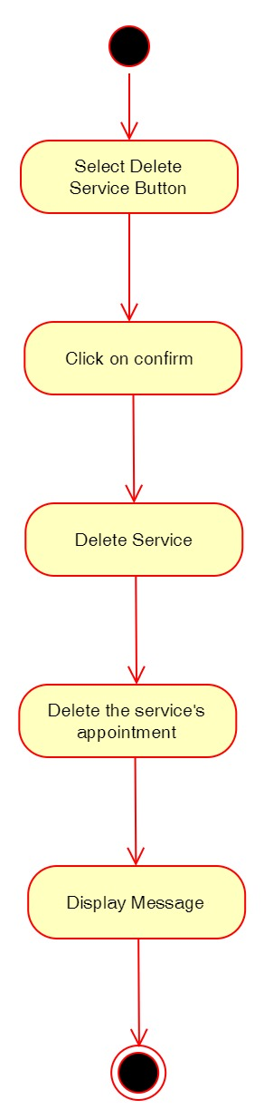

Figure 131: Activity Diagram – Admin Delete Services

**Sequence Diagram**

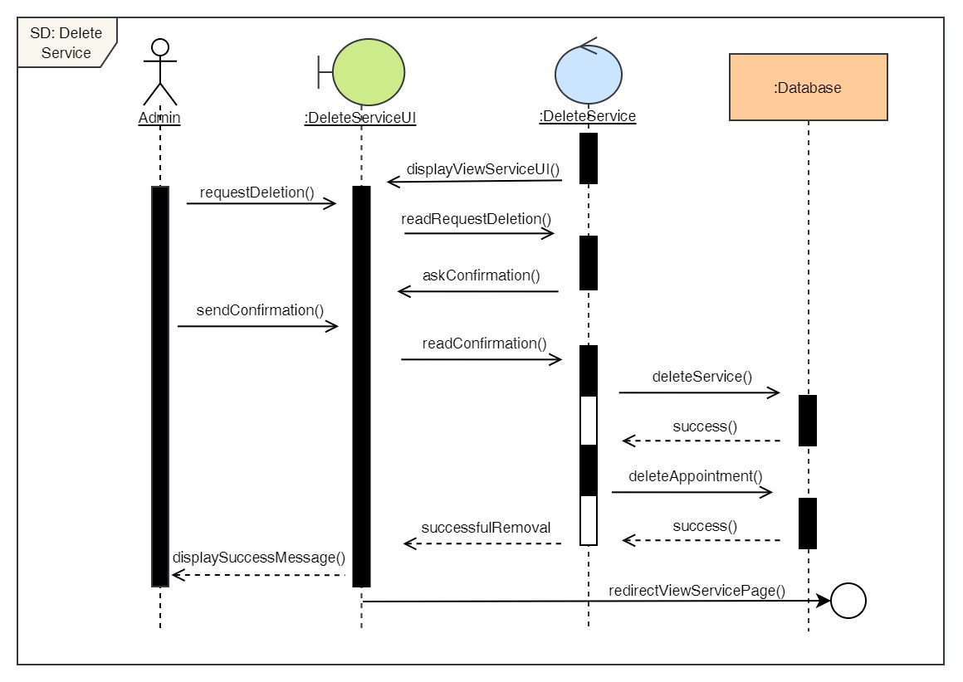

Figure 132: Sequence Diagram – Admin Delete Services

31. Edit services

**High Level Use Case Description**

|  |  |
| --- | --- |
| **Use Case:** | Edit services |
| **Actor:** | Admin |
| **Description:** | Admin can update the details of the existing services in the system. |

Table 32: High Level Use Case – Admin Edit Services

**Use Case Diagram**

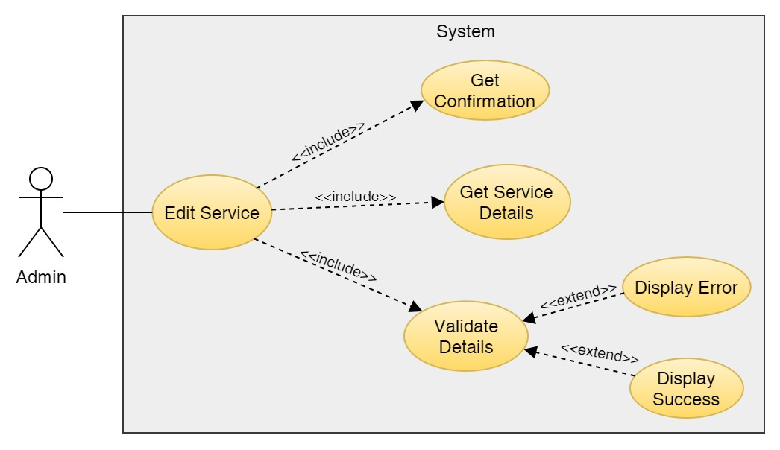

Figure 133: Use Case Diagram – Admin Edit Service

**Collaboration Diagram**

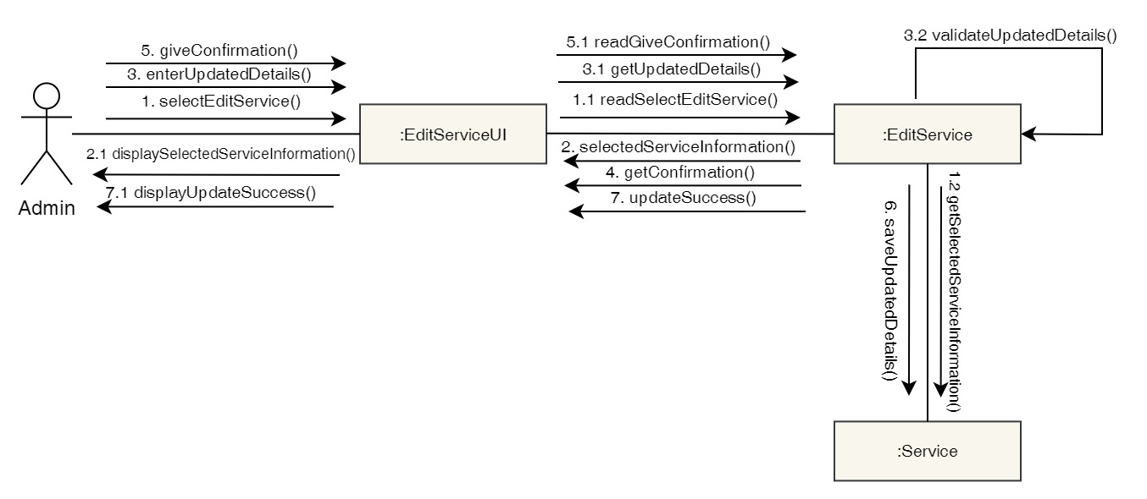

Figure 134: Collaboration Diagram – Admin Edit Service

**Activity Diagram**

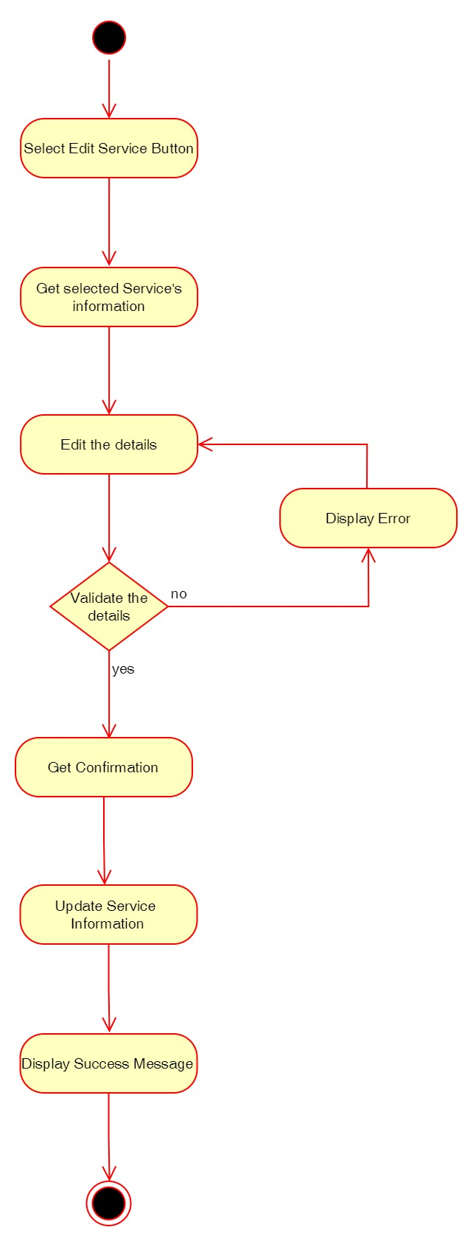

Figure 135: Activity Diagram – Admin Edit Service

**Sequence Diagram**

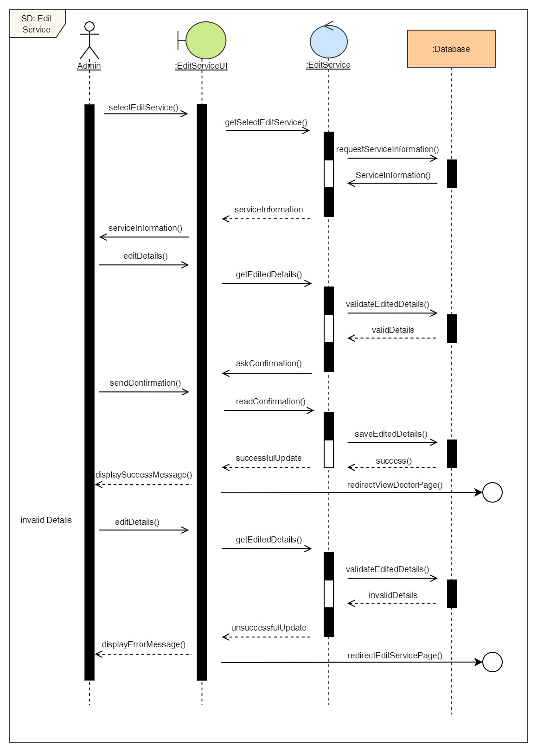

Figure 136: Sequence Diagram – Admin Edit Service

## 3.7 Implementation

### 3.7.1 System Architecture

A system architecture is a conceptual model that describes a system's structure and behaviour. This project is done on Django Framework which is based on MVT (Model-View-Template) Architecture. MVT is a web application development software design pattern. It has three major components, which are listed as follows:

**Model**: The model is going to be your data's interface. It is in charge of data management. The database (SQLite3) represents the logical data structure that underpins the whole program.

**View**: It is the user interface that we see in our browser when we render a website. HTML/CSS/JavaScript/Bootstrap are used to represent it.

**Template:** It is made up of both static sections of the desired HTML output and specific syntax that describes how dynamic information will be included.

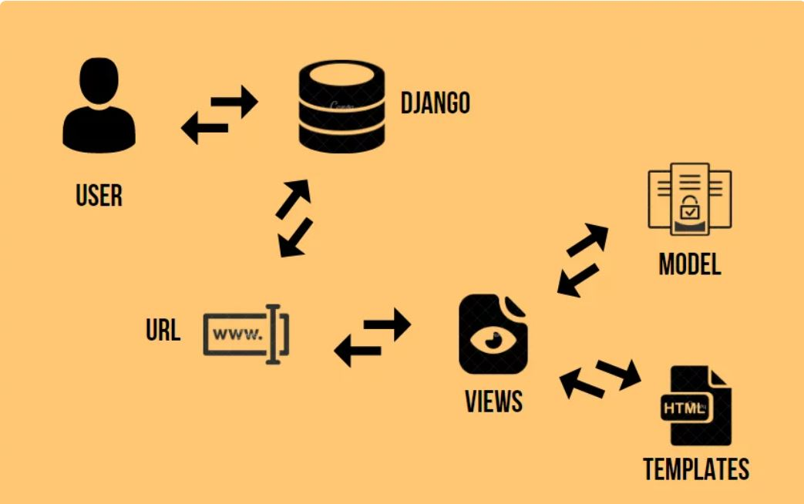

Figure 137: System Architecture (AskPython, 2022)

In the above image, we can see the control flow of the MVT Architecture in Django. The user first sends a URL request for a resource to Django. Then the Django framework searches up the URL resource. If the URL path points to a certain View, that View is called. After that, the View will communicate with the Model and obtain the necessary data from the database. The View then returns to the user with an appropriate template and the obtained data. In this way, the MVT Architecture works in Django Framework.

### 3.7.2 Database Implementation

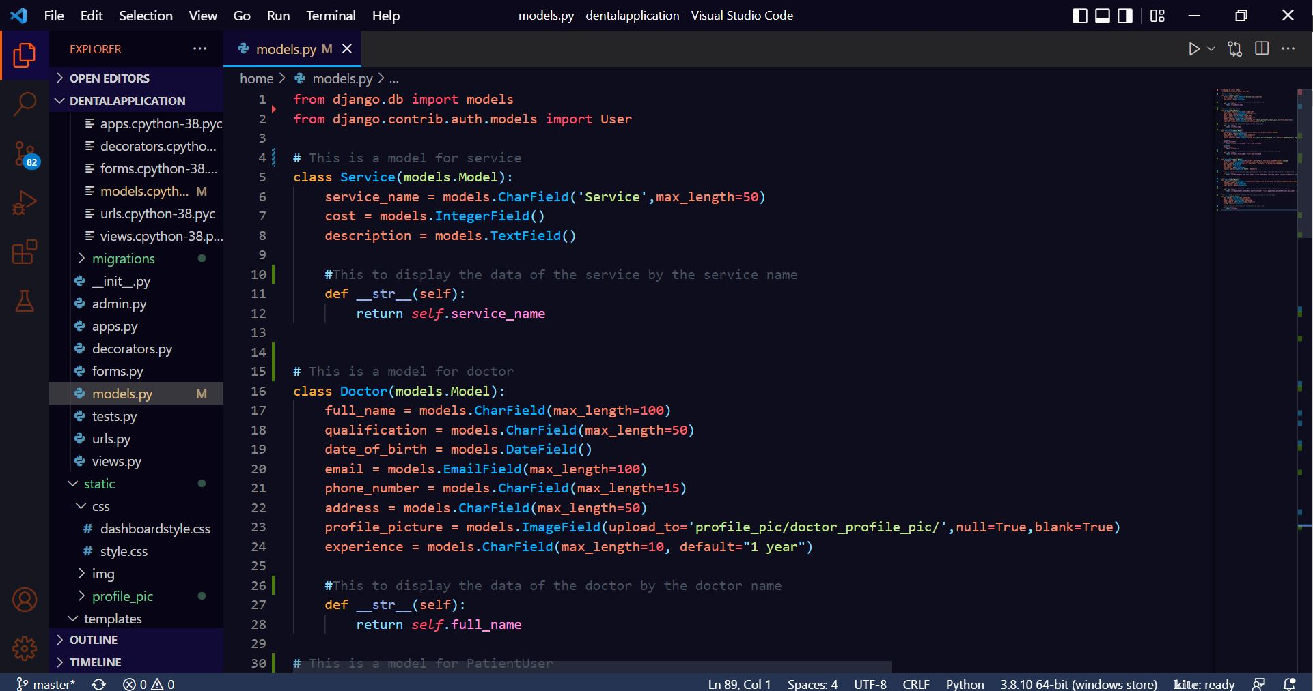

Figure 138: Database Implementation Code – 1

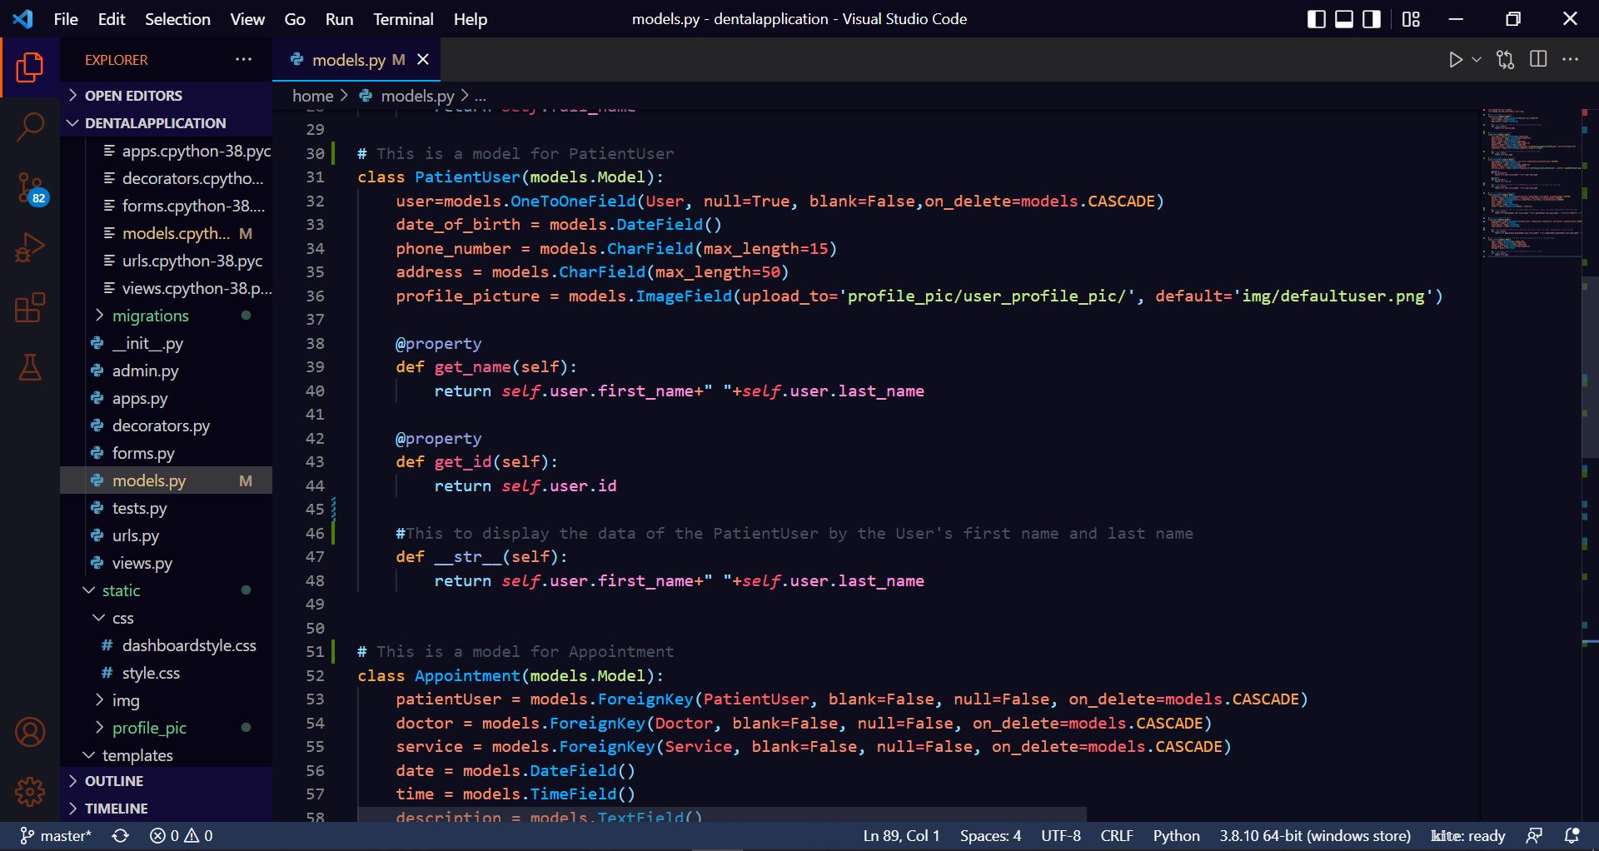

Figure 139: Database Implementation Code - 2

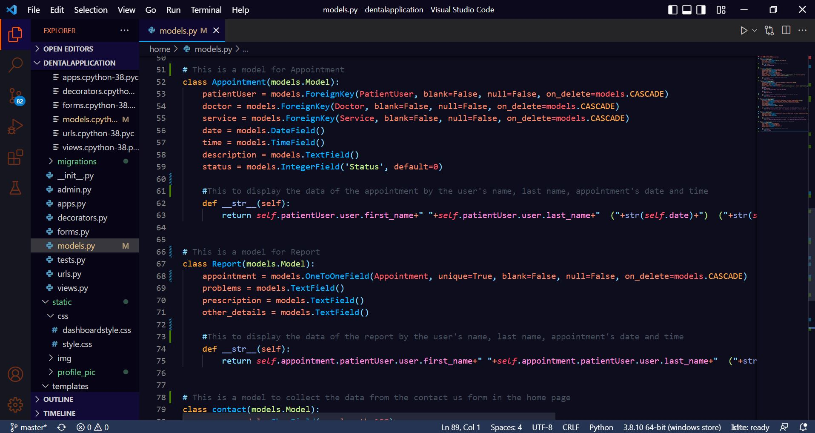

Figure 140: Database Implementation Code – 3

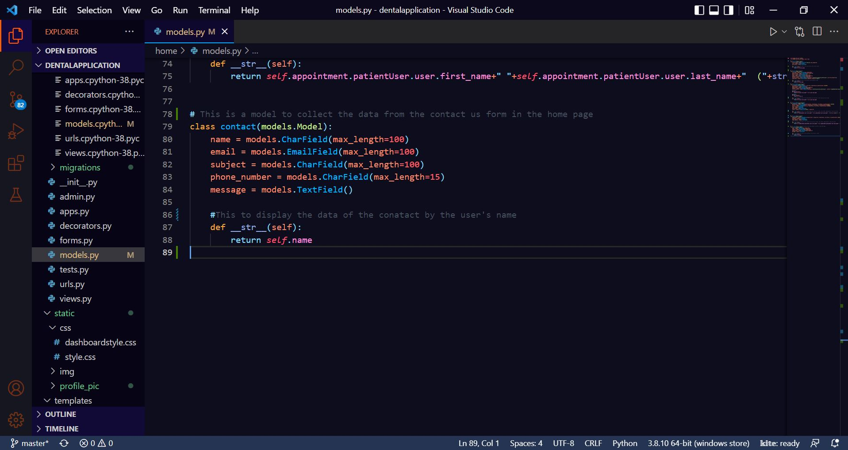

Figure 141: Database Implementation Code – 4

# 4. Testing and analysis

## 4.1 Test Plan

### 4.1.1 Unit Testing, Test Plan

### 4.1.2 System Testing, Test Plan

## 4.2 Unit Testing

## 4.3 System Testing

## 4.4 Critical Analysis

# 5. Conclusion

The following project included a variety of tasks and obstacles that involved relentless determination and a large number of errors to be dealt with when working. Both our internal and external supervisors offered invaluable guidance and assistance, and the provided instructions made the task simple to complete. However, in order to achieve correct output with good presentation, the rational solution of the problems, as well as the project documents, had to be carried out in a well-mannered manner.

The following project is web-based dental appointment system, which required knowledge of a variety of Front-end, Backend and Database concepts. This project helped me gain knowledge on variety of topics like HTML, Bootstrap, Python, Django, MVT Architecture, Database, Incremental Methodology and many more. There were a number of obstacles while doing this coursework. However, with the help of our supervisors, all of the doubts and misunderstandings were cleared leading to the completion of this project. This project helped in gaining knowledge of how real life applications are made. The project also had a client for whom the project was made. The interaction with the client made me one step closer to the real life software developer. Finally, a detailed report was made covering all of the topic from scratch to testing the application.

To summarize, this project was created after extensive research, hard work and dedication. Since the project had to be done alone, it was quiet challenging but with the help of resources available in the internet and the guidance of the supervisors, the final year project was finally completed.

## 5.1 Legal, Social and Ethical Issues

### 5.1.1 Legal Issues

Legal issues are those that are connected to a country's legislation, and breaching such laws leads to legal action, the decision of which is made by the court of justice itself. This project as a whole does not violate any laws that might result in legal consequence. The documentation lists all of the materials and resources utilized in the creation of this project, and they are all available online. The Dental Appointment System application is a straightforward online appointment system for user's dental issues. The data contained in this application, which includes all of the users' personal information, should not be used for personal purposes. This application ensures the confidentiality and privacy of the user's information. As a consequence, no legal difficulties arose throughout the creation of this application.

### 5.1.2 Social Issues

Social issues are those that influence individuals or groups of individuals living in a society. This project as a whole does not raise any kind of social issues in the society. This web application does not reflect or appear to represent any type of discrimination because it is accessible to persons of all caste, religion and ethnicity. Since every people can face dental issues and might need a dental check-up, anyone can use this application. As a result, this project has no negative consequences for society and is accessible to everyone.

### 5.1.3 Ethical Issues

Ethical issues are those that involve deciding whether a certain task is proper or incorrect. There are no such ethical issues that are being raised in this project. The entire project was created by me, and the code was not taken from the internet. Because this is a server-based application with sensitive information kept in a database, there are ethical concerns regarding the appointment system leaking and exploiting the user's data. The privacy and information of users will be maintained, and the data will not be made public or exploited.

## 5.2 Advantages

There are several advantages that the dental appointment system provides. Some of them are listed below:

* This application helps user to easily book their dental appointment.
* The user can update their profile accordingly as well.
* Users can view the details and the qualification of the doctors available and avoid any kind of uncertainty.
* User can select the doctor they want to for their appointment.
* User can view the list of services available in the clinic along with their prices and description. This makes it easy for user to manage their costs accordingly.
* The user can cancel their appointment any time before their appointment if the need arises.
* People can avoid the crowd and avoid staying in lines which saves a significant amount of time and resource. Especially in times of Covid, it helps avoid crowd and reduces the possibility of transmissions of viruses.
* User can view their report of their visit online as well. This avoids user to ever lose their report again which makes it easier for their next dental check-up anywhere in the world.
* User can search their appointment and reports and sort them accordingly as well.

## 5.3 Limitations

Every applications have their advantages and limitations. Similarly, this application also has its limitations in addition to the advantages above. The limitations of the application are as follows:

* The application only works when connected to the internet.
* There is no payment system integrated in to the application.
* Email verification is not implemented in the system.
* The application is only limited to one clinic i.e. Phulchowki Dental Clinic.

## 5.4 Future Work

The features and functions in the application is done as per the requirements of the client. However, this application can be scaled further and new features can be added to it. Some of the features that can be added to make this application even better is listed as follows:

* Payment system to confirm the booking.
* Chat-bot to address simple issues of the users.
* Chat system with the doctor so that user can avoid simple confusions.
* Email verification system.
* Notification system to remind user of their appointment status.

# 6. Reference

AskPython, 2022. *AskPython.* [Online]   
Available at: https://www.askpython.com/django/django-mvt-architecture  
[Accessed 12 4 2022].

Gantt.com, 2022. *Gantt.com.* [Online]   
Available at: https://www.gantt.com/  
[Accessed 12 4 2022].

GeeksForGeeks, 2019. *GeeksForGeeks.* [Online]   
Available at: https://www.geeksforgeeks.org/software-engineering-incremental-process-model/  
[Accessed 10 12 2021].

Ghahrai, A., 2016. *DevQA.* [Online]   
Available at: https://devqa.io/software-development-methodologies/  
[Accessed 11 12 2021].

Guilizzoni, P., 2022. *Balsamiq.* [Online]   
Available at: https://balsamiq.com/learn/articles/what-are-wireframes/  
[Accessed 12 4 2022].

Lewis, S., 2019. *TechTarget.* [Online]   
Available at: https://www.techtarget.com/searchsoftwarequality/definition/collaboration-diagram  
[Accessed 11 4 2022].

Lucid, 2022. *LucidChart.* [Online]   
Available at: https://www.lucidchart.com/blog/types-of-UML-diagrams  
[Accessed 11 4 2022].

Martin, M., 2021. *Guru99.* [Online]   
Available at: https://www.guru99.com/software-engineering-prototyping-model.html  
[Accessed 10 12 2021].

Mukherjee, P., 2021. *GeeksForGeeks.* [Online]   
Available at: https://www.geeksforgeeks.org/what-is-a-flowchart-and-its-types/  
[Accessed 13 4 2022].

Organ, C., 2022. *Forbes.* [Online]   
Available at: https://www.forbes.com/advisor/business/what-is-work-breakdown-structure/#:~:text=A%20work%20breakdown%20structure%2C%20or,deliverables%20into%20a%20single%20tool.  
[Accessed 12 4 2022].

Paradigm, V., 2022. *Visual Paradigm.* [Online]   
Available at: https://www.visual-paradigm.com/guide/uml-unified-modeling-language/what-is-activity-diagram/  
[Accessed 11 4 2022].

Paradigm, V., 2022. *Visual Paradigm.* [Online]   
Available at: https://www.visual-paradigm.com/guide/uml-unified-modeling-language/what-is-class-diagram/  
[Accessed 12 4 2022].

Paradigm, V., 2022. *Visual Paradigm.* [Online]   
Available at: https://www.visual-paradigm.com/guide/uml-unified-modeling-language/what-is-sequence-diagram/  
[Accessed 12 4 2022].

Peterson, R., 2022. *guru99.* [Online]   
Available at: https://www.guru99.com/er-diagram-tutorial-dbms.html  
[Accessed 12 4 2022].

Programiz, 2022. *Programiz.* [Online]   
Available at: https://www.programiz.com/dsa/algorithm  
[Accessed 13 4 2022].

Raman, 2019. *GeeksForGeeks.* [Online]   
Available at: https://www.geeksforgeeks.org/software-engineering-work-breakdown-structure/  
[Accessed 12 4 2022].

TechTarget, 2020. *TechTarget.* [Online]   
Available at: https://www.techtarget.com/whatis/definition/use-case-diagram  
[Accessed 11 4 2022].

TestBytes, 2019. *TestBytes.* [Online]   
Available at: https://www.testbytes.net/blog/rational-unified-process/  
[Accessed 10 12 2021].

TutorialsPoint, 2022. *TutorialsPoint.* [Online]   
Available at: https://www.tutorialspoint.com/data_structures_algorithms/bubble_sort_algorithm.htm  
[Accessed 13 4 2022].

# 7. Appendix

## 7.1 Appendix A: Pre-Survey

**Survey Link**: <https://forms.gle/kWVfupLMvfYjMeEs5>

**Pre-Survey for Dental Appointment System**

**Project Name**: Dental Appointment System

**Description of Project**: Dental Appointment System is an online appointment system that helps people to save their time by scheduling an appointment for their dental check-up using a web application. This project is all about reducing the problem that people face when they have to get a dental appointment.

### 7.1.1 Pre-Survey Form

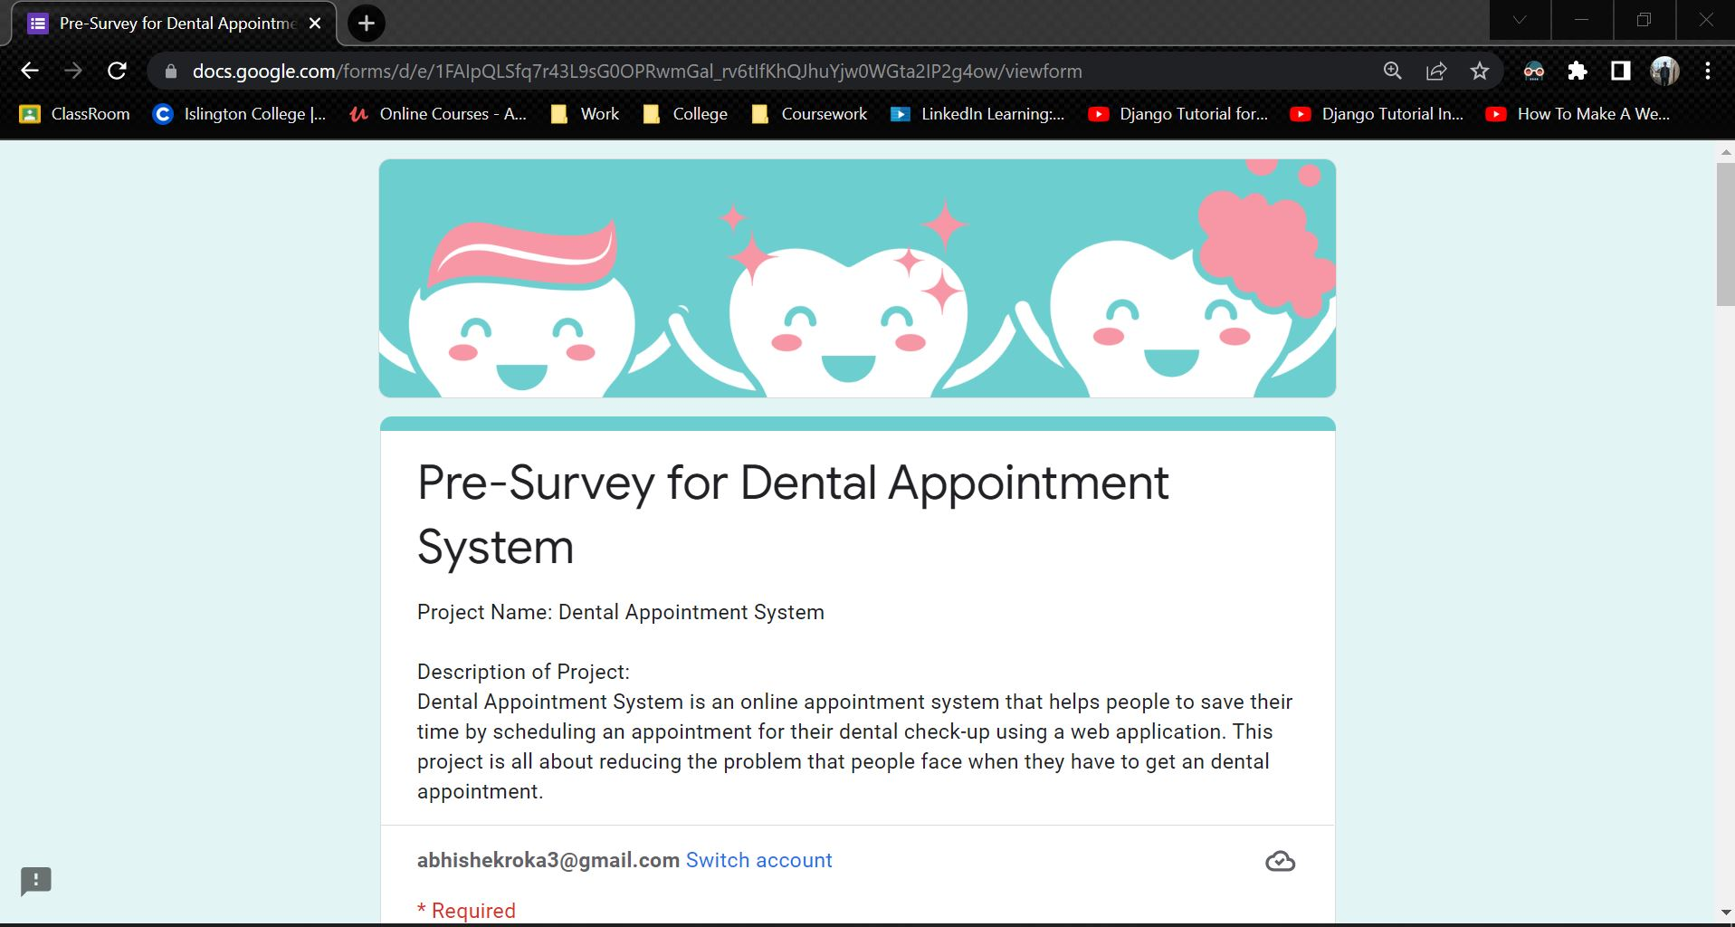

Figure 142: Pre-Survey Form - 1

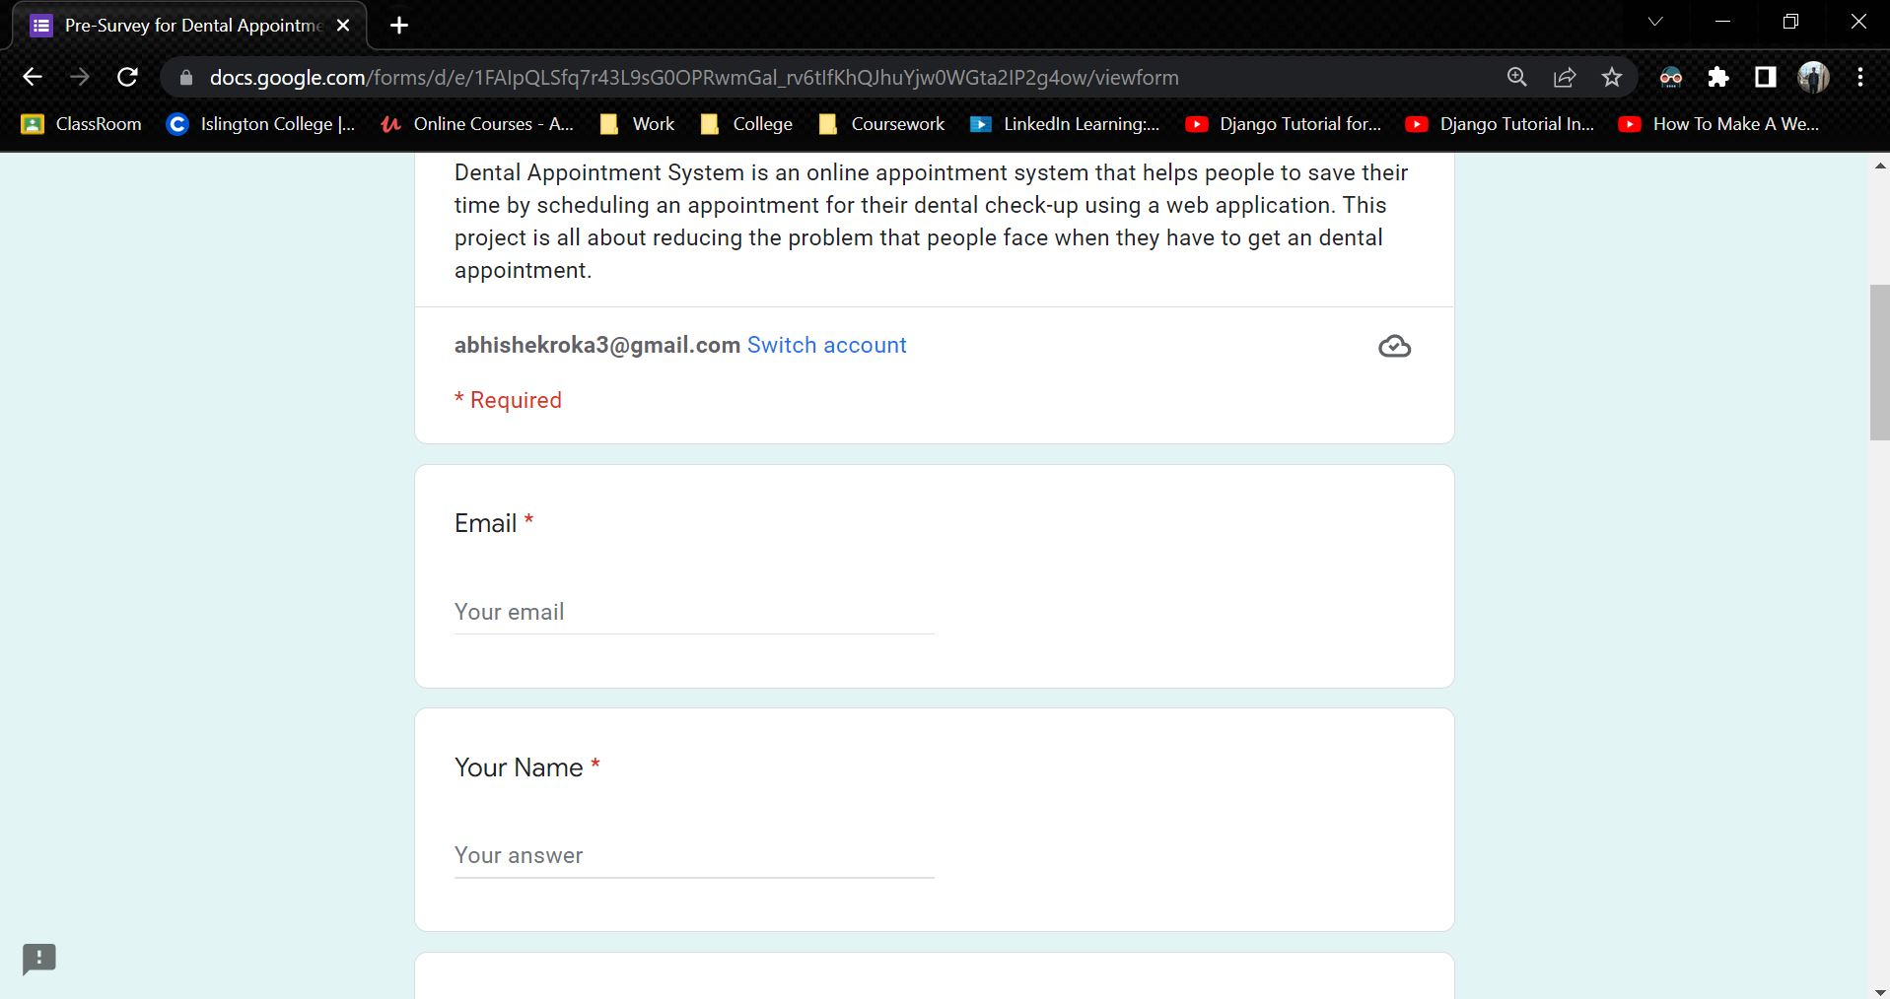

Figure 143: Pre-Survey Form - 2

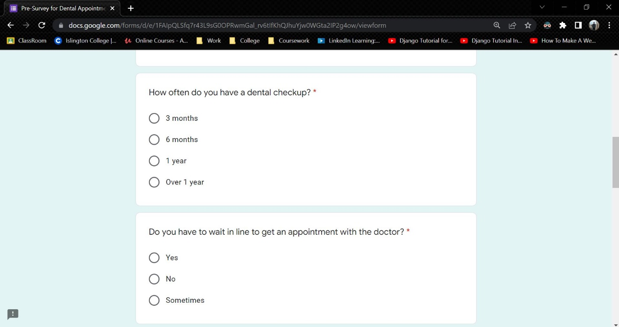

Figure 144: Pre-Survey Form - 3

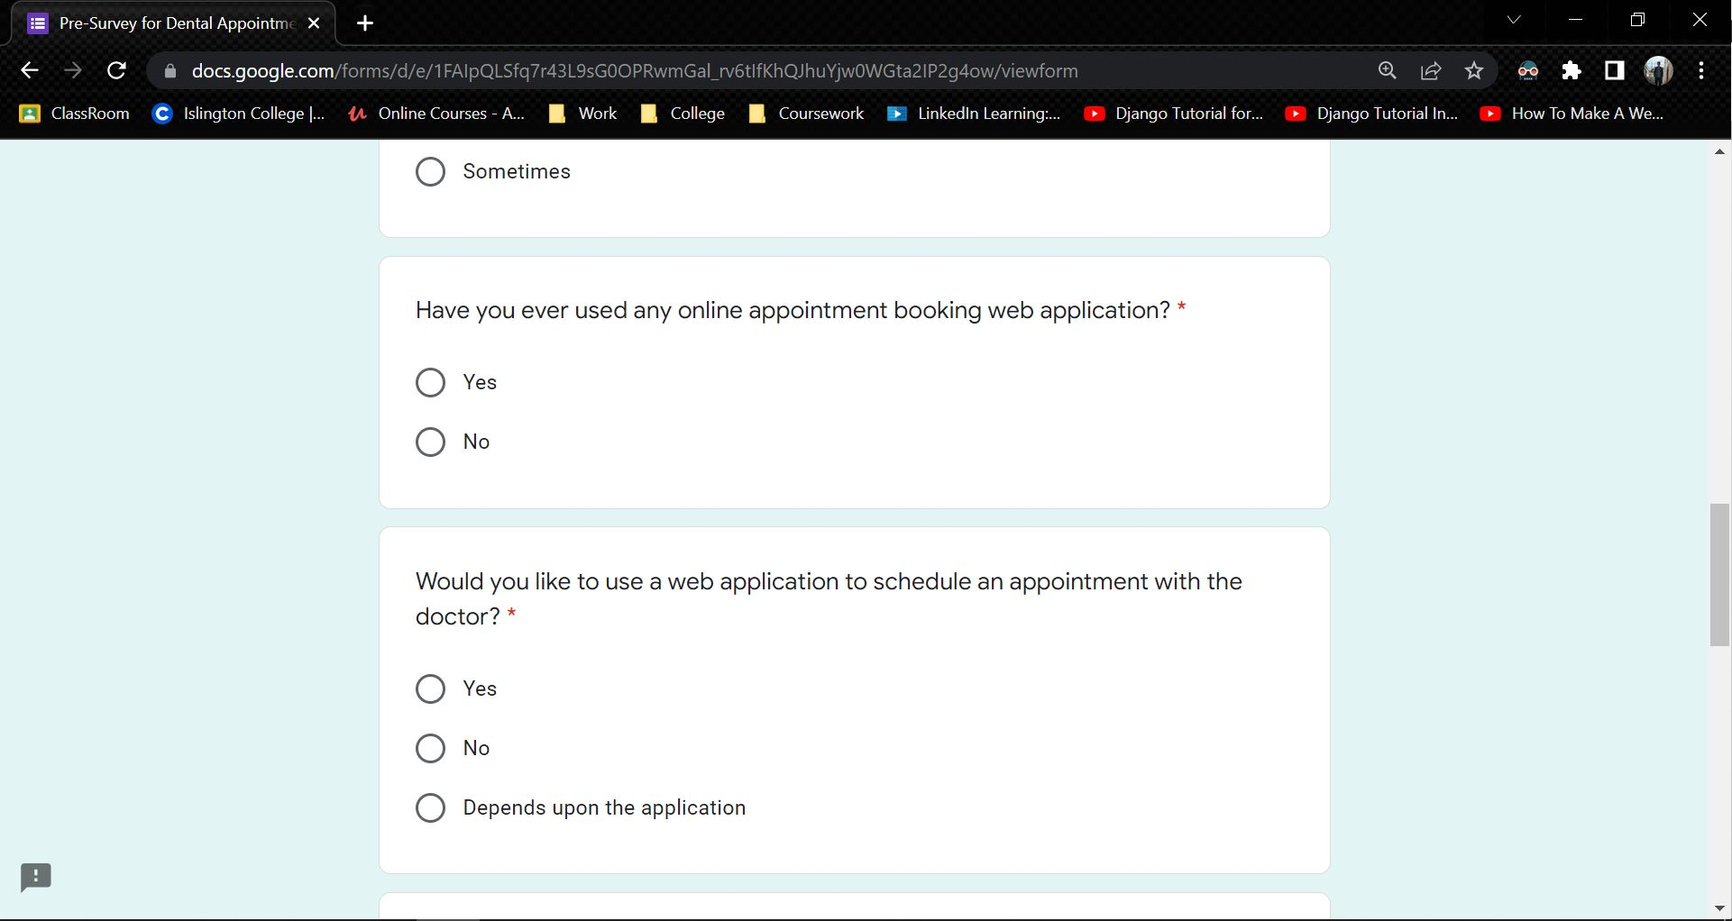

Figure 145: Pre-Survey Form - 4

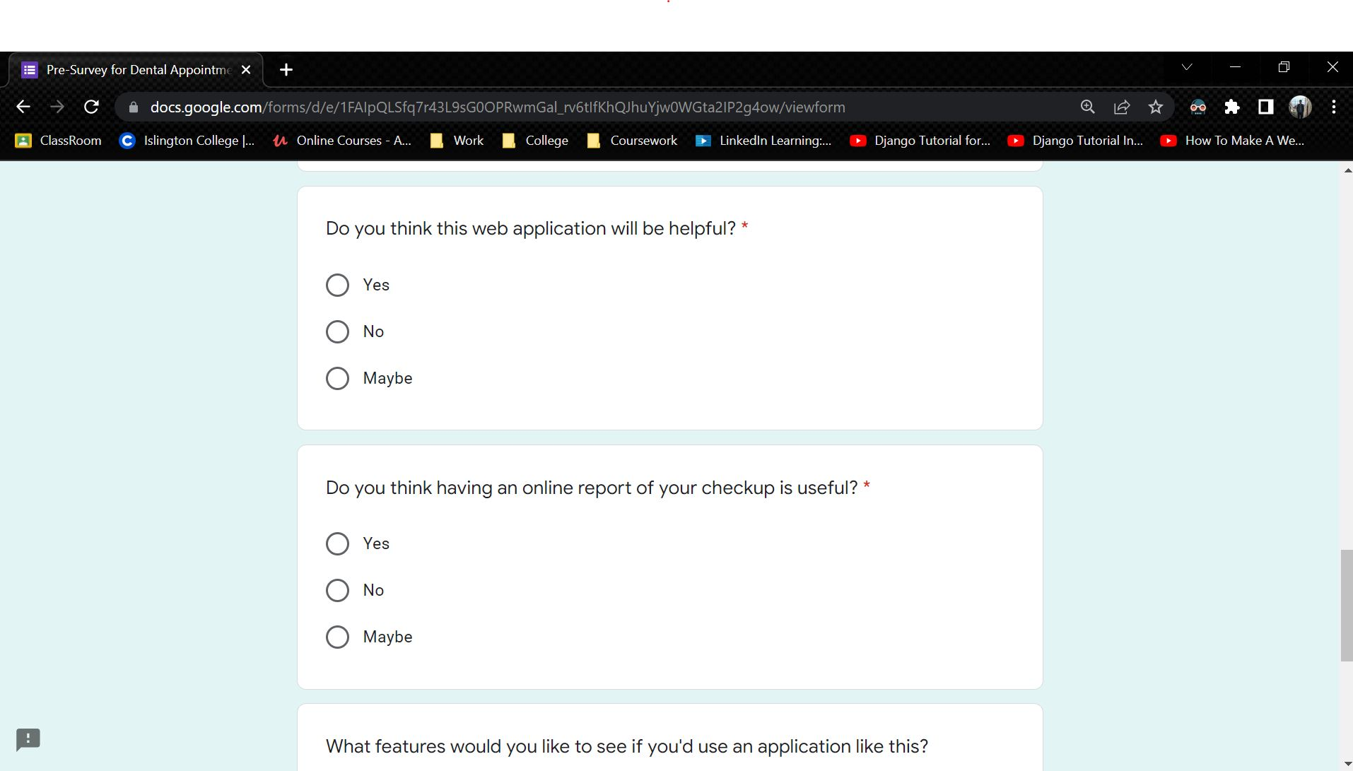

Figure 146: Pre-Survey Form - 5

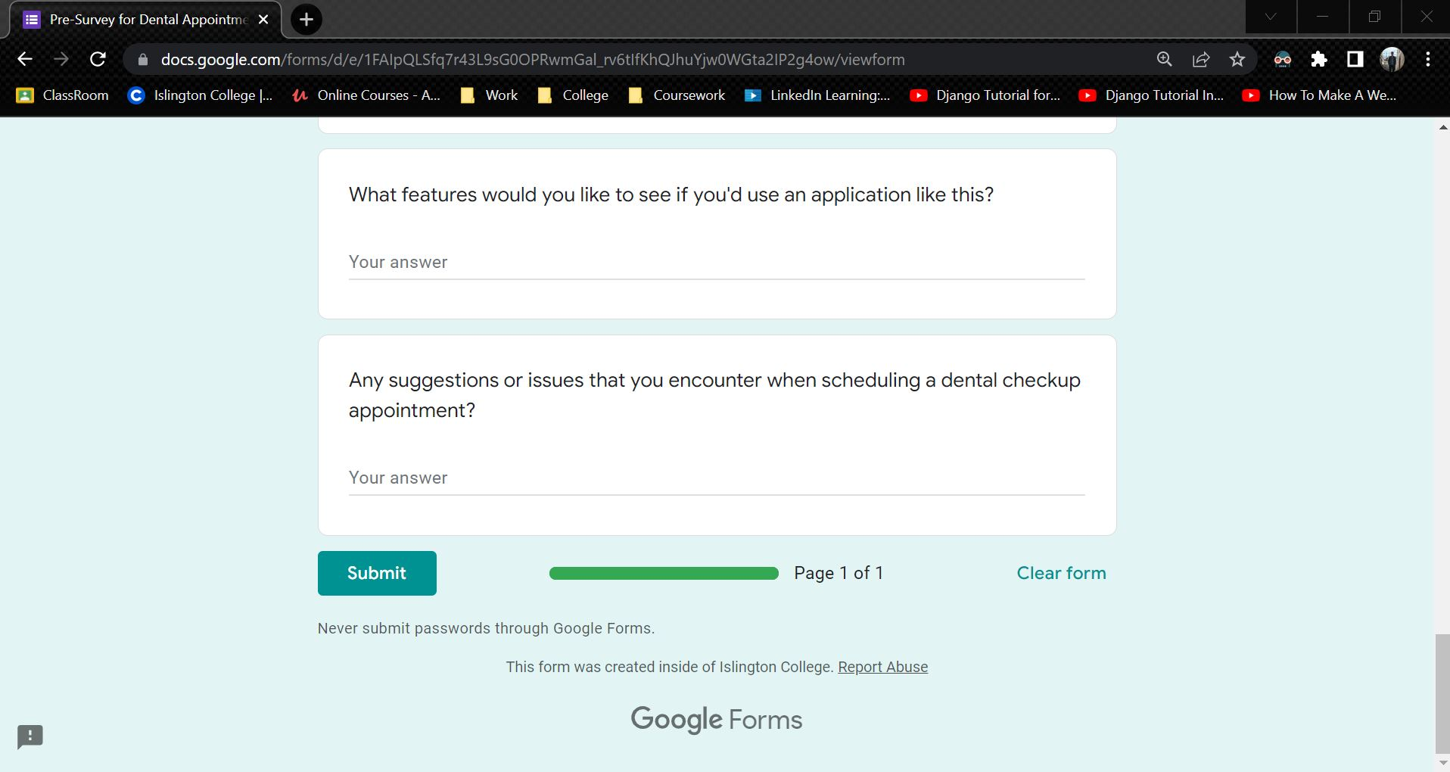

Figure 147: Pre-Survey Form - 6

### 7.1.2 Sample of filled pre-survey forms

**Sample 1**

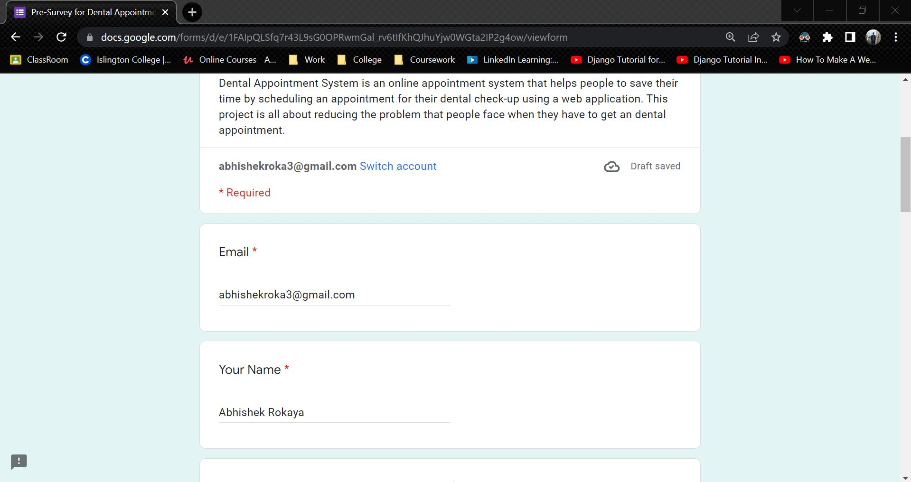

Figure 148: Sample 1 of pre-survey form - 1

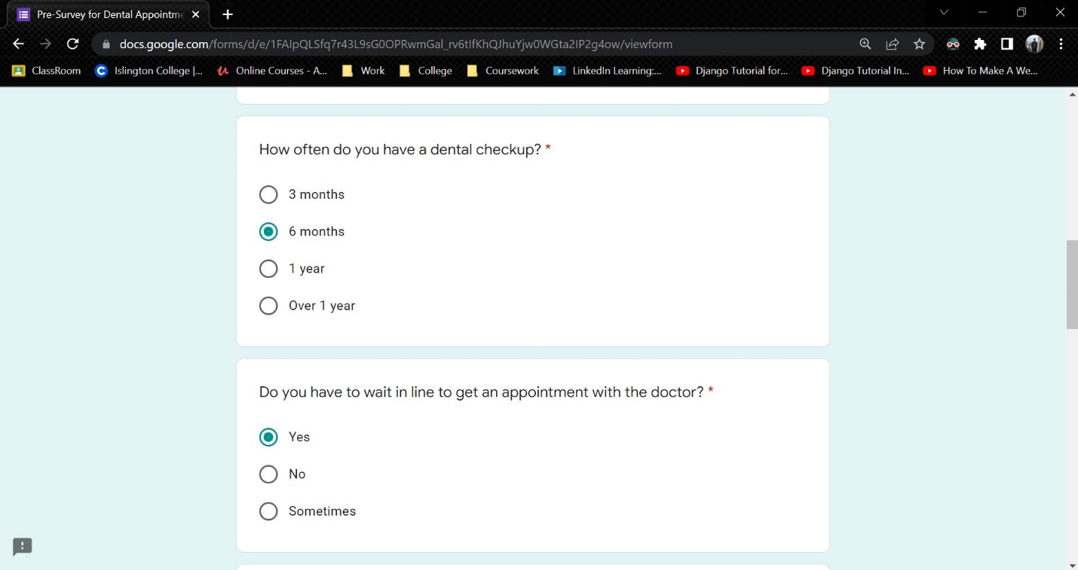

Figure 149: Sample 1 of pre-survey form - 2

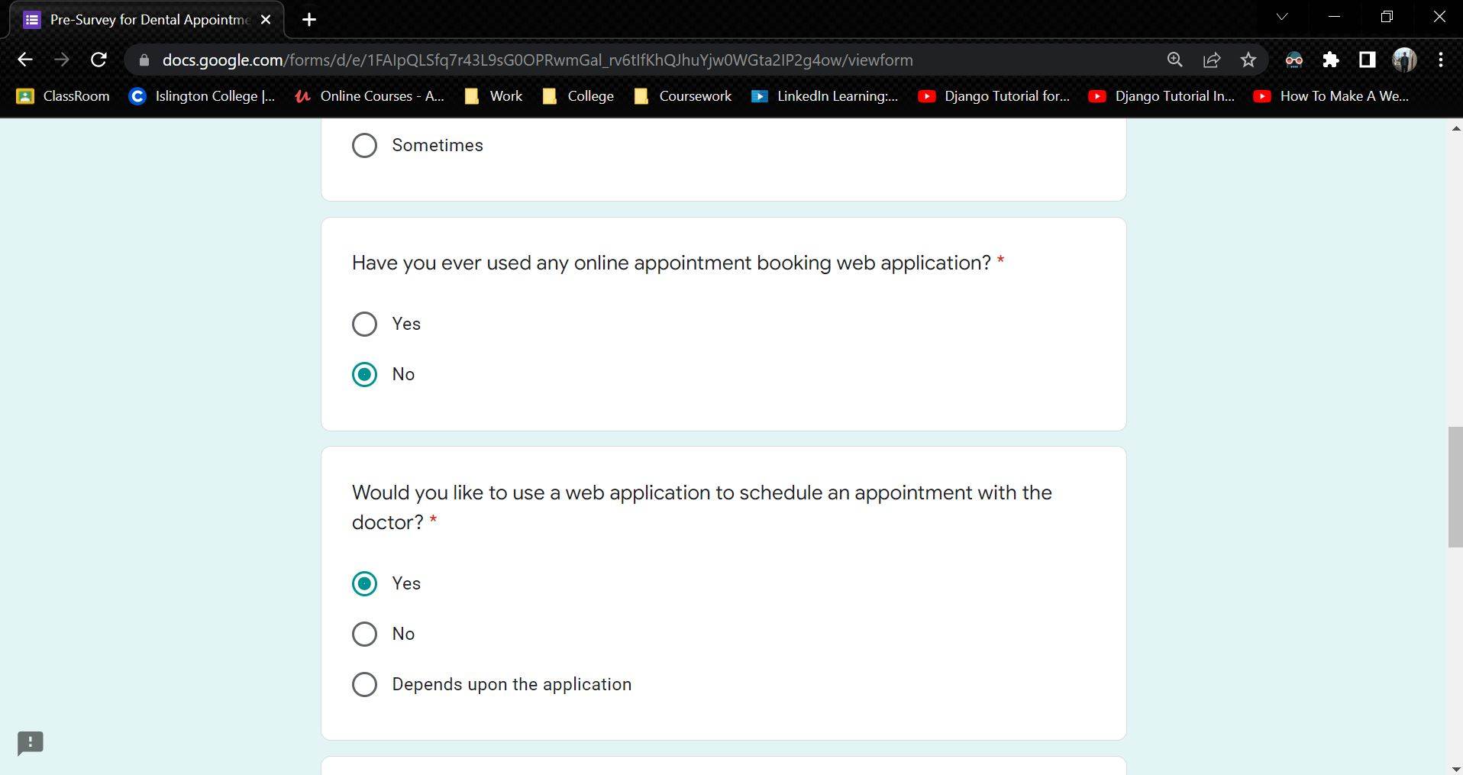

Figure 150: Sample 1 of pre-survey form - 3

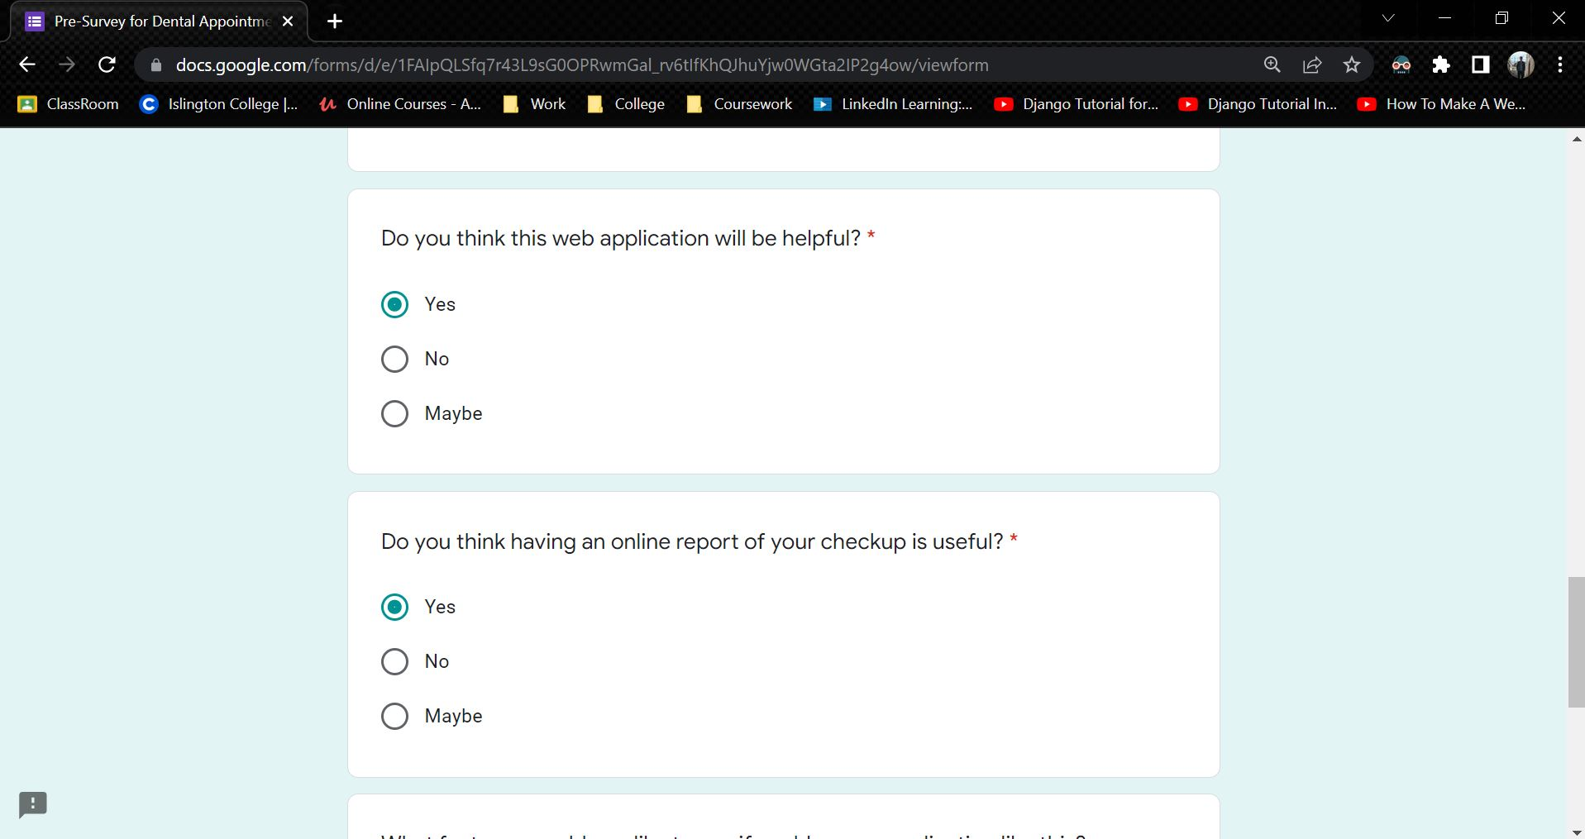

Figure 151: Sample 1 of pre-survey form - 4

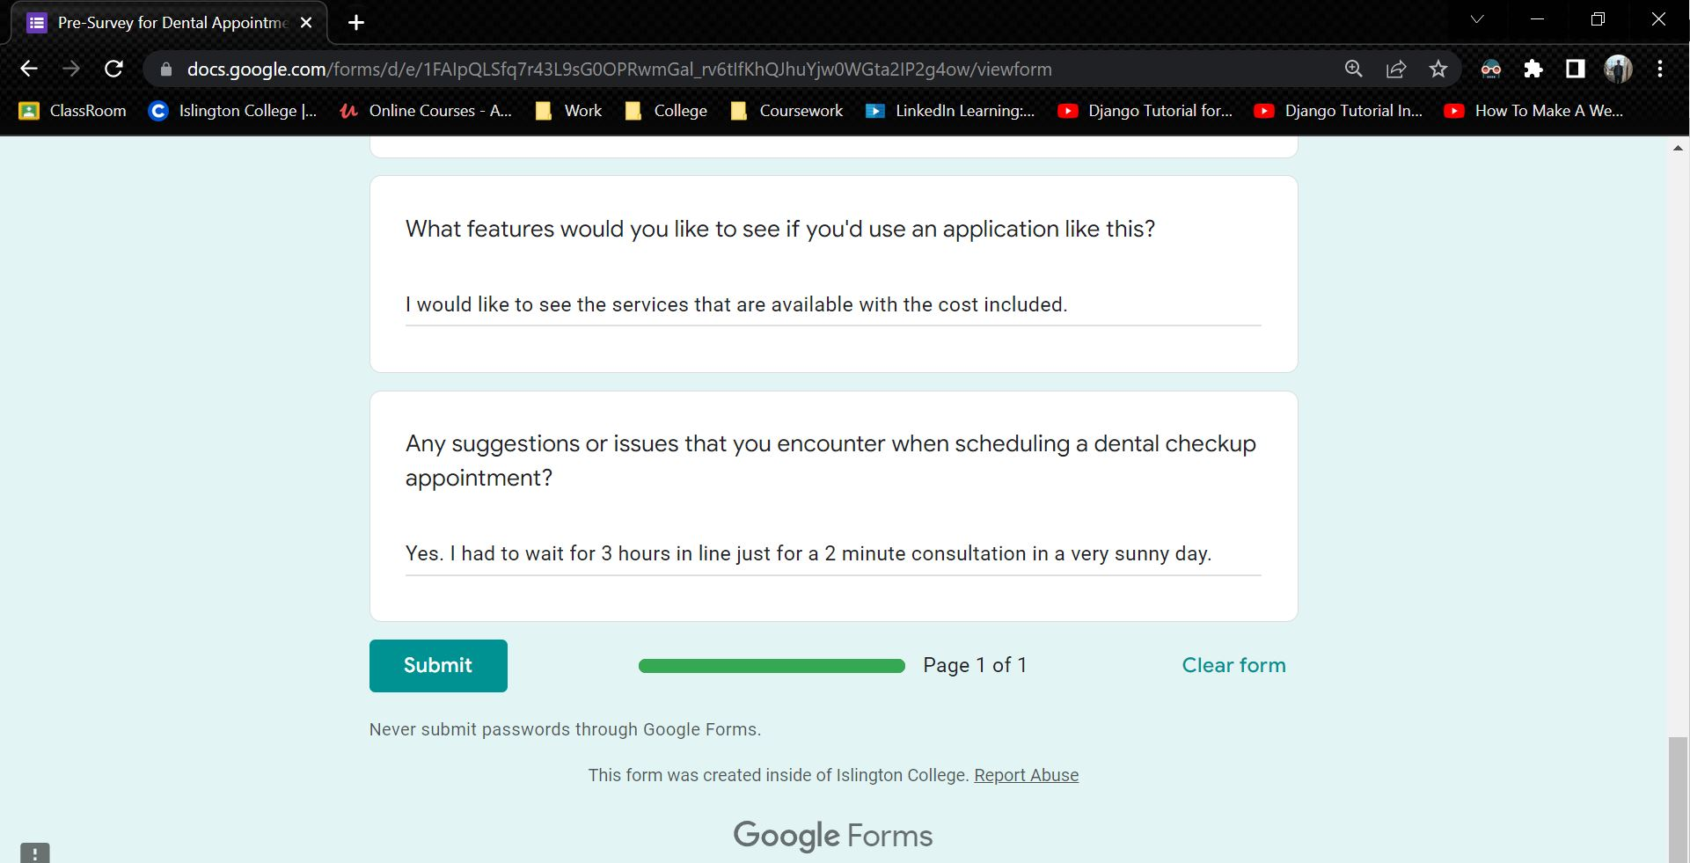

Figure 152: Sample 1 of pre-survey form - 5

**Sample 2**

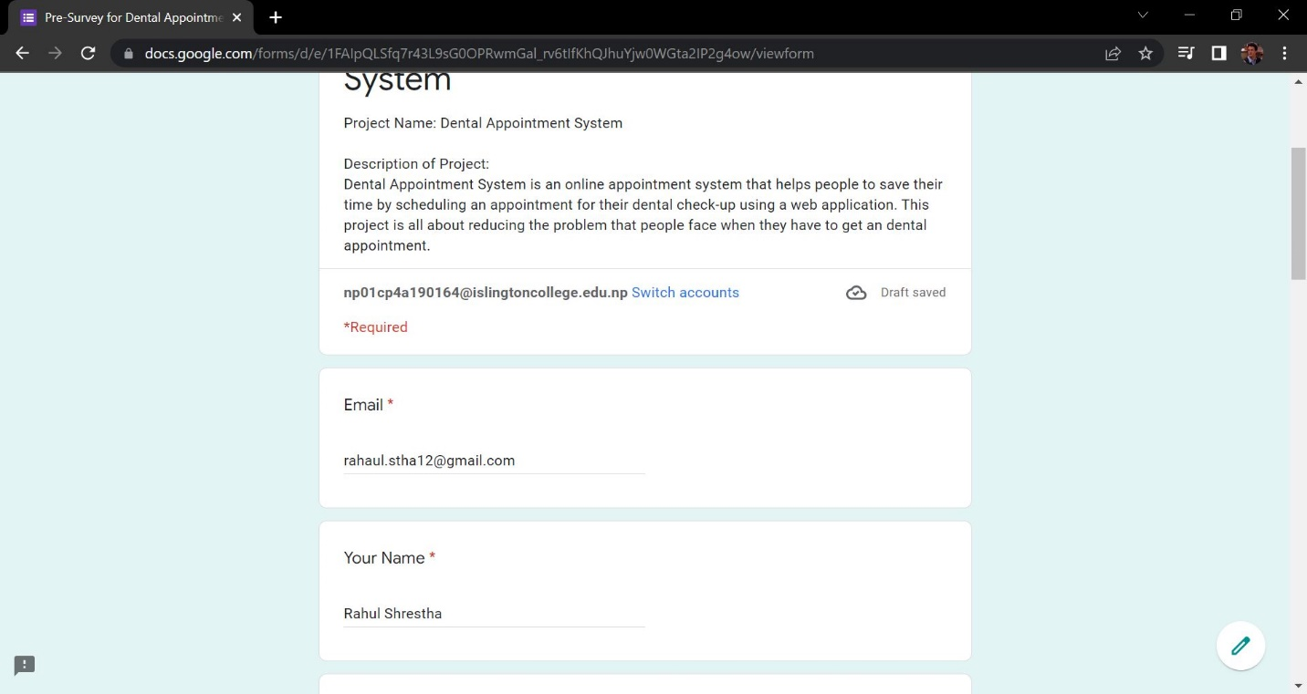

Figure 153: Sample 2 of pre-survey form - 1

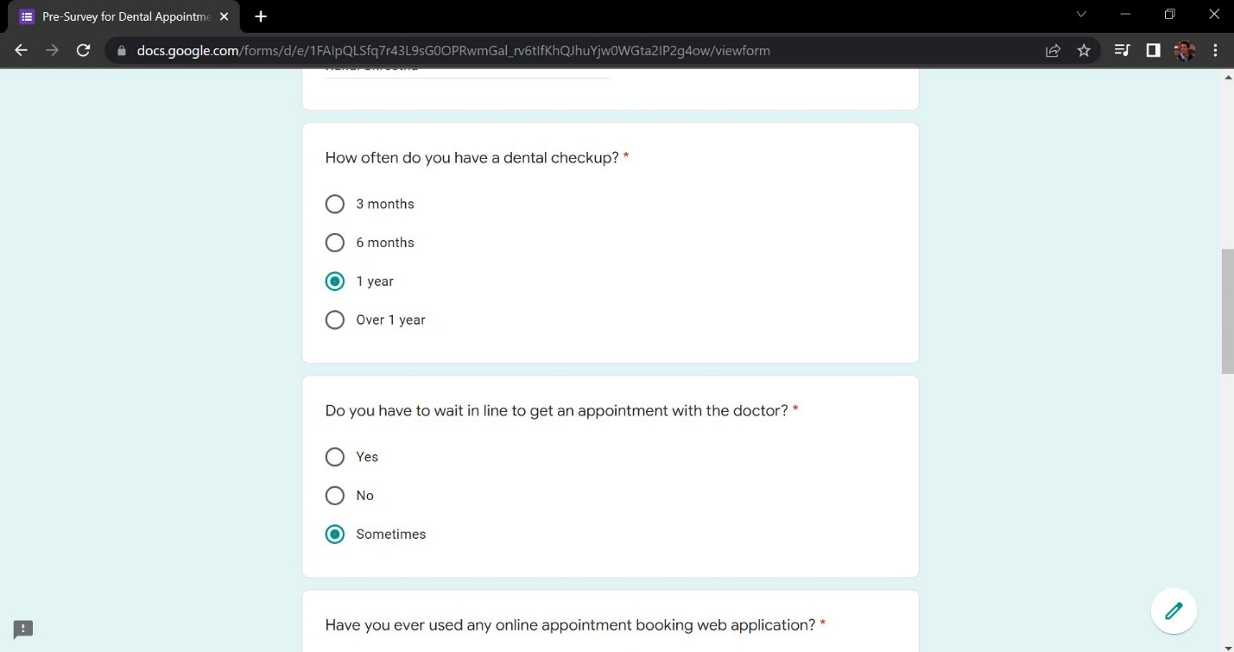

Figure 154: Sample 2 of pre-survey form - 2

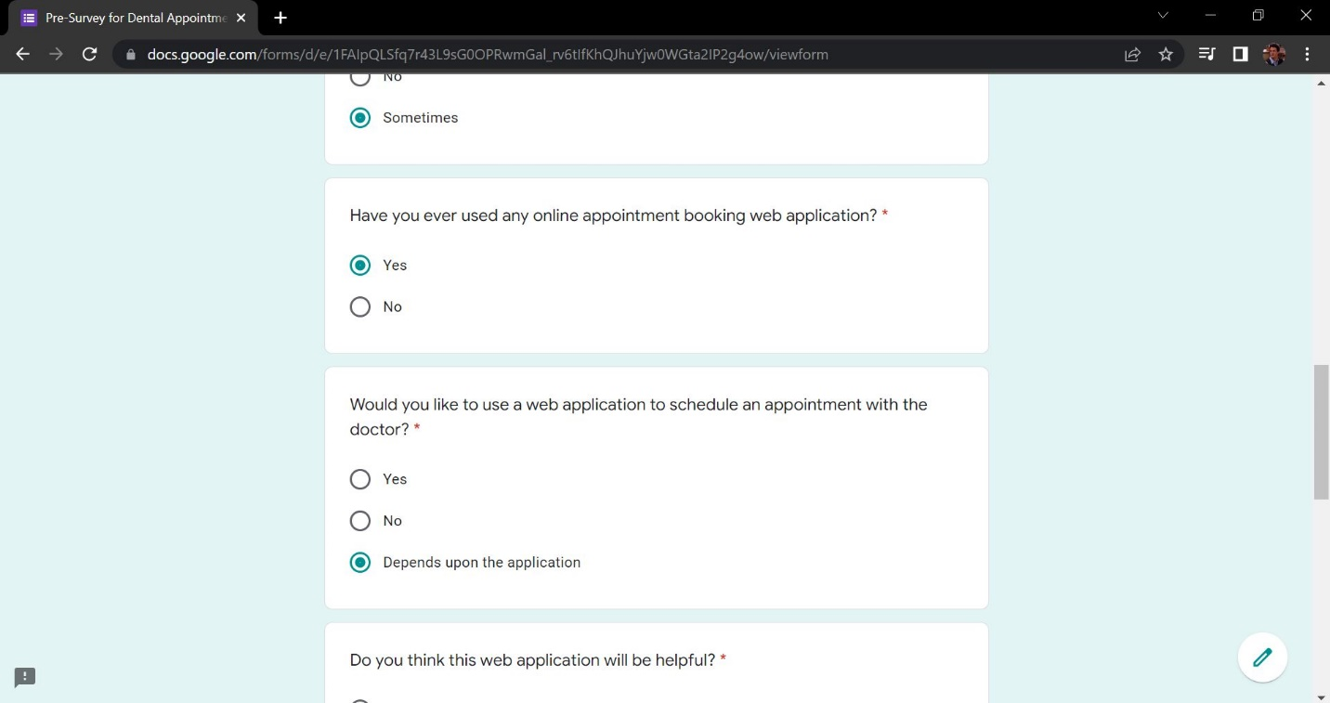

Figure 155: Sample 2 of pre-survey form - 3

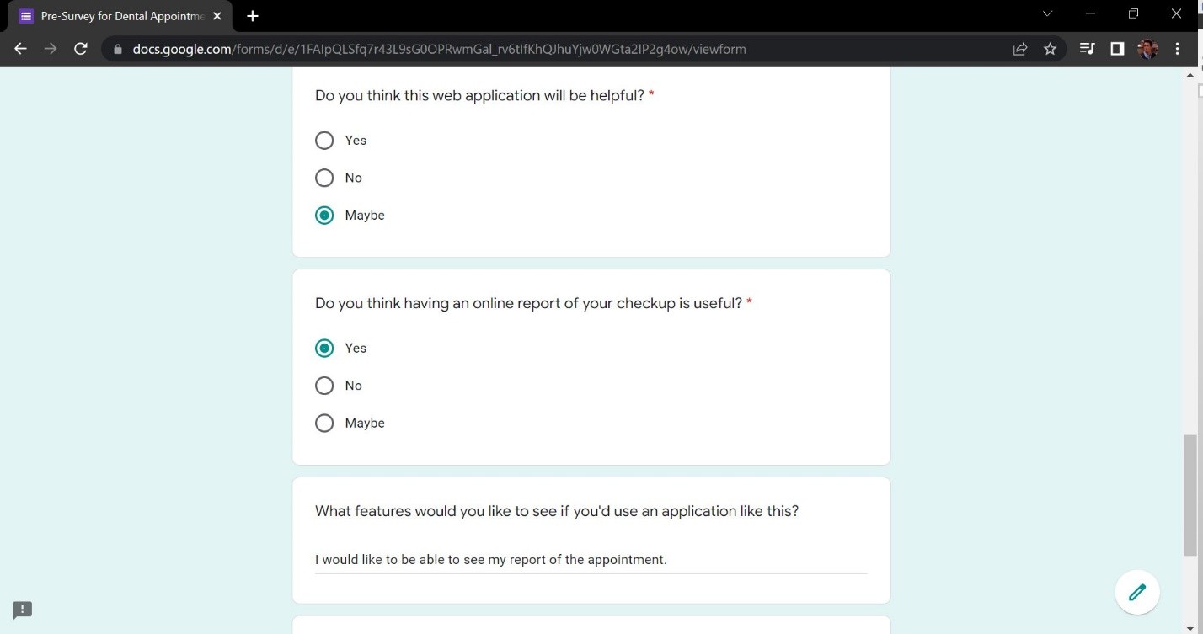

Figure 156: Sample 2 of pre-survey form - 4

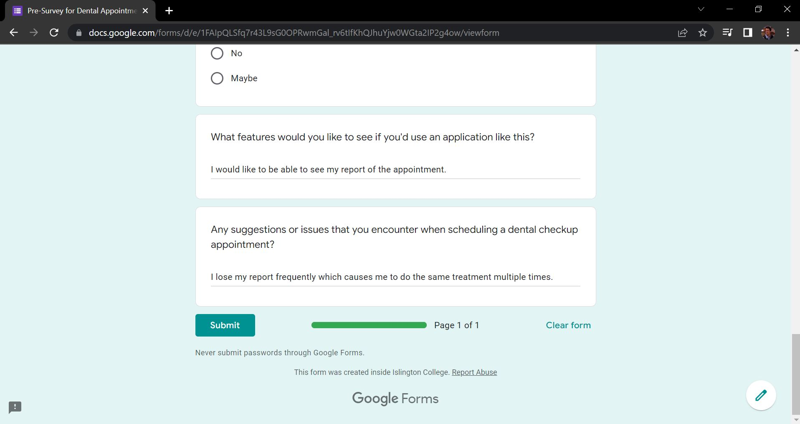

Figure 157: Sample 2 of pre-survey form - 5

**Sample 3**

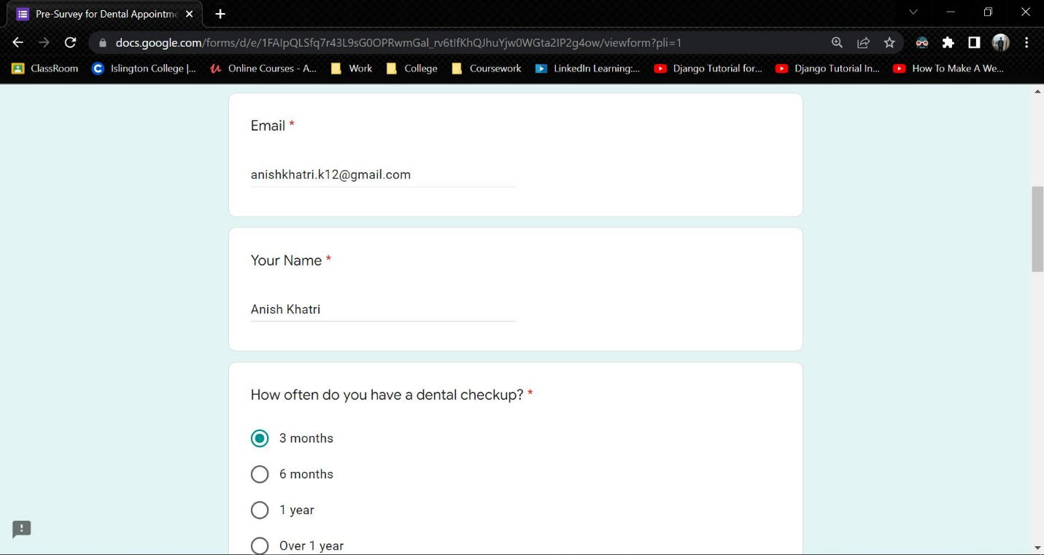

Figure 158: Sample 3 of pre-survey form - 1

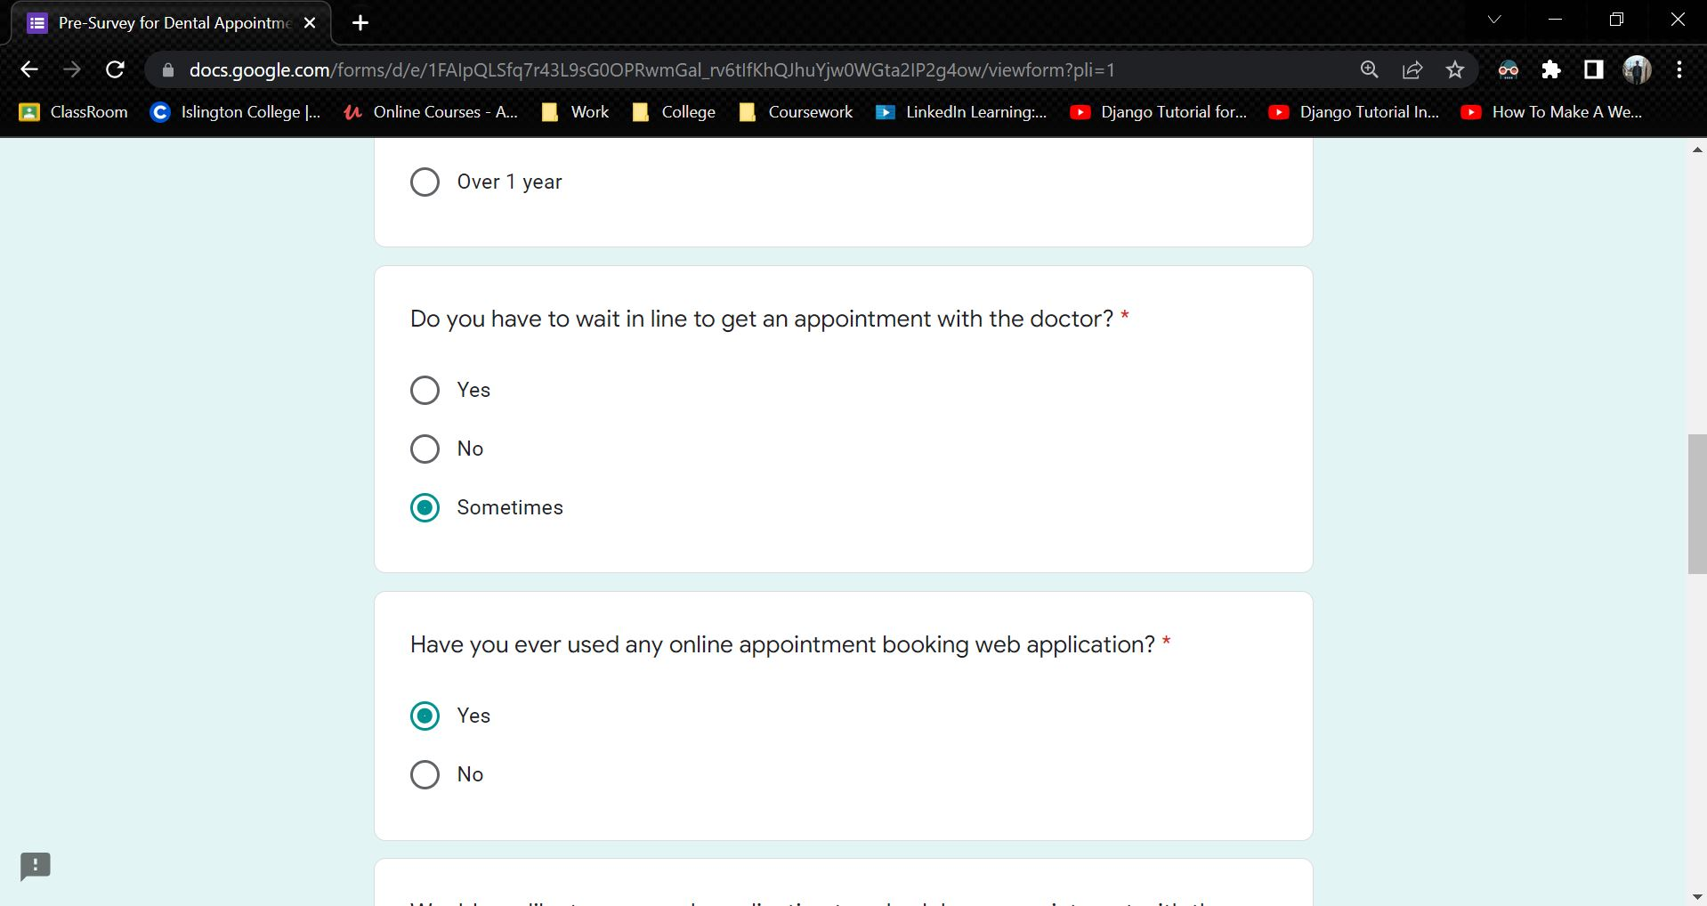

Figure 159: Sample 3 of pre-survey form - 2

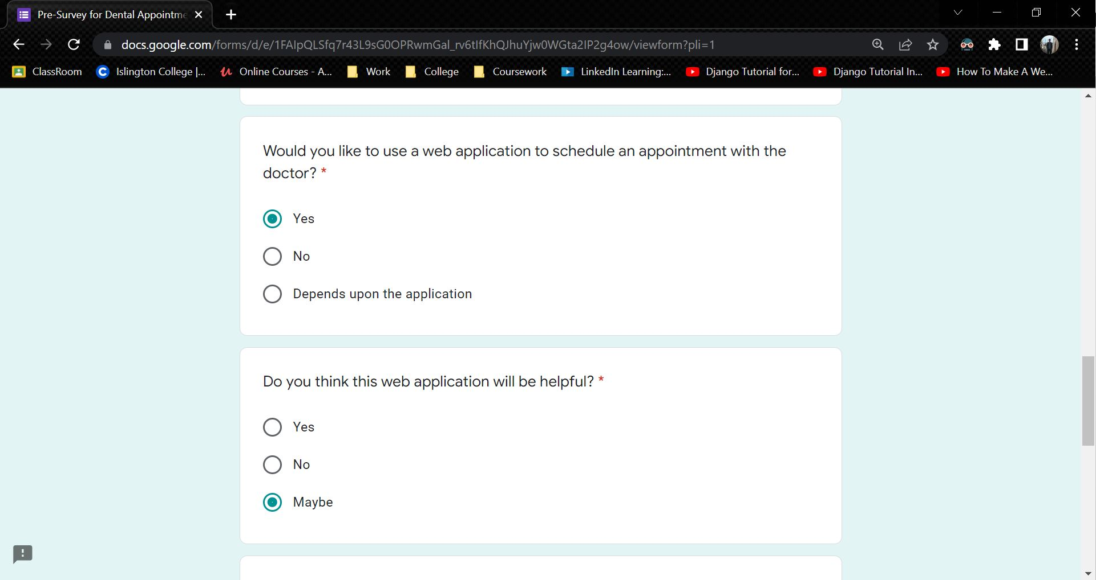

Figure 160: Sample 3 of pre-survey form - 3

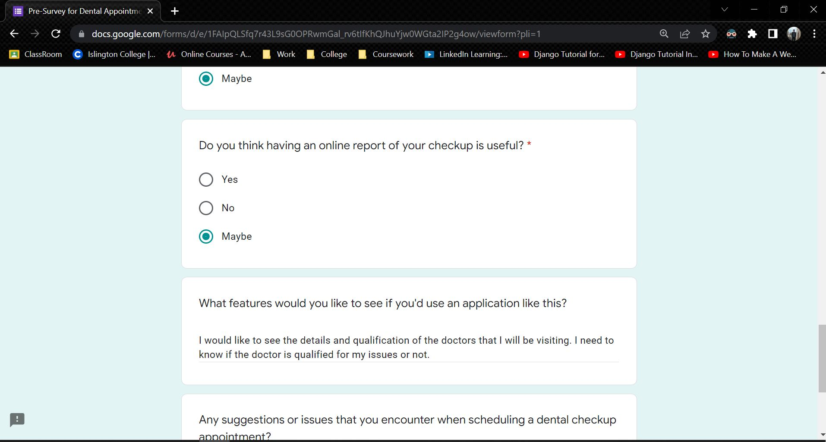

Figure 161: Sample 3 of pre-survey form - 4

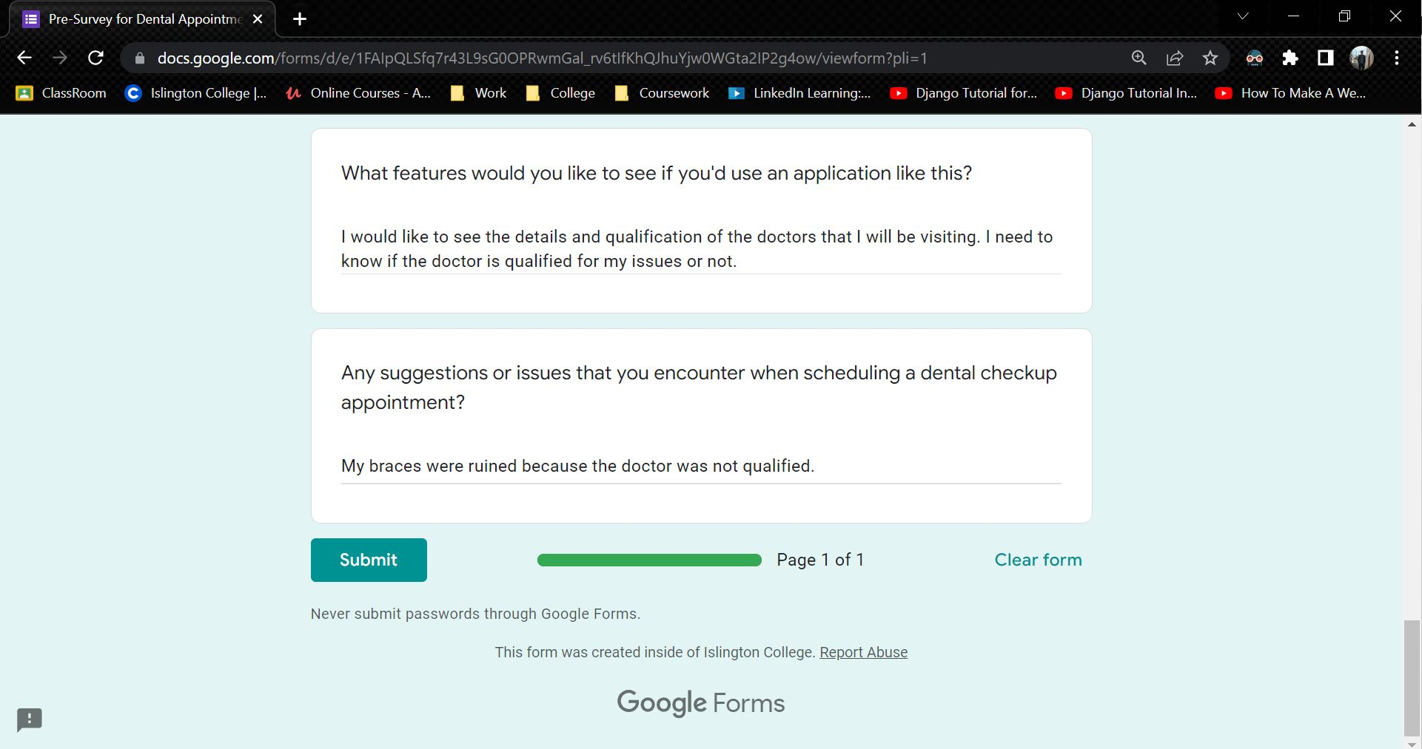

Figure 162: Sample 3 of pre-survey form - 5

### 7.1.3 Pre-Survey Result

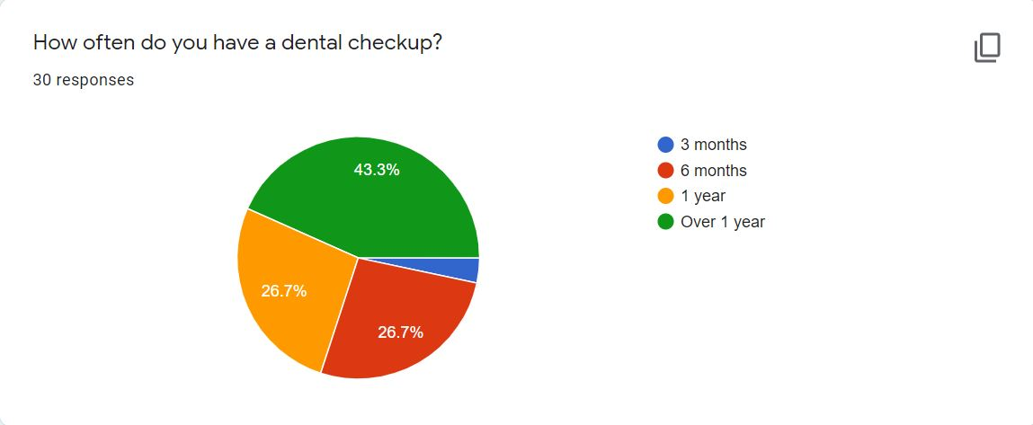

Figure 163: Pre-Survey Result – 1



Figure 164: Pre-Survey Result - 2

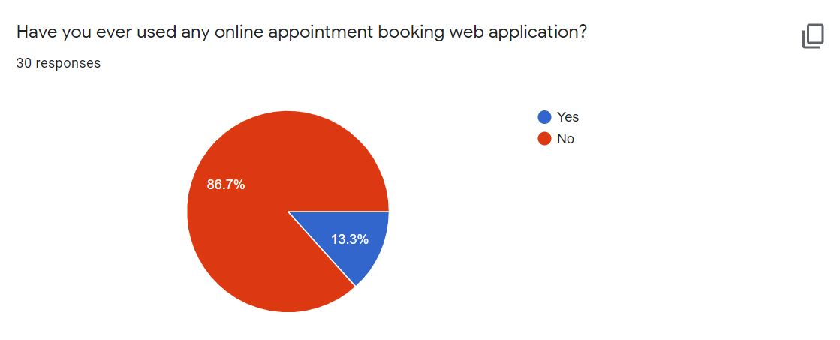

Figure 165: Pre-Survey Result – 3



Figure 166: Pre-Survey Result - 4



Figure 167: Pre-Survey Result - 5

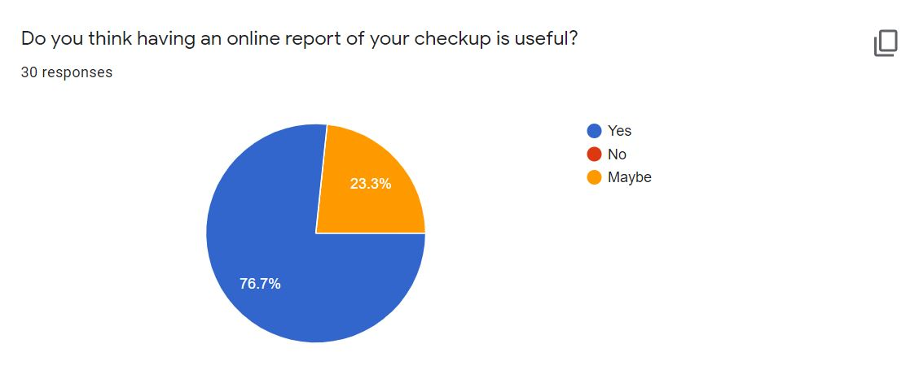

Figure 168: Pre-Survey Result - 6

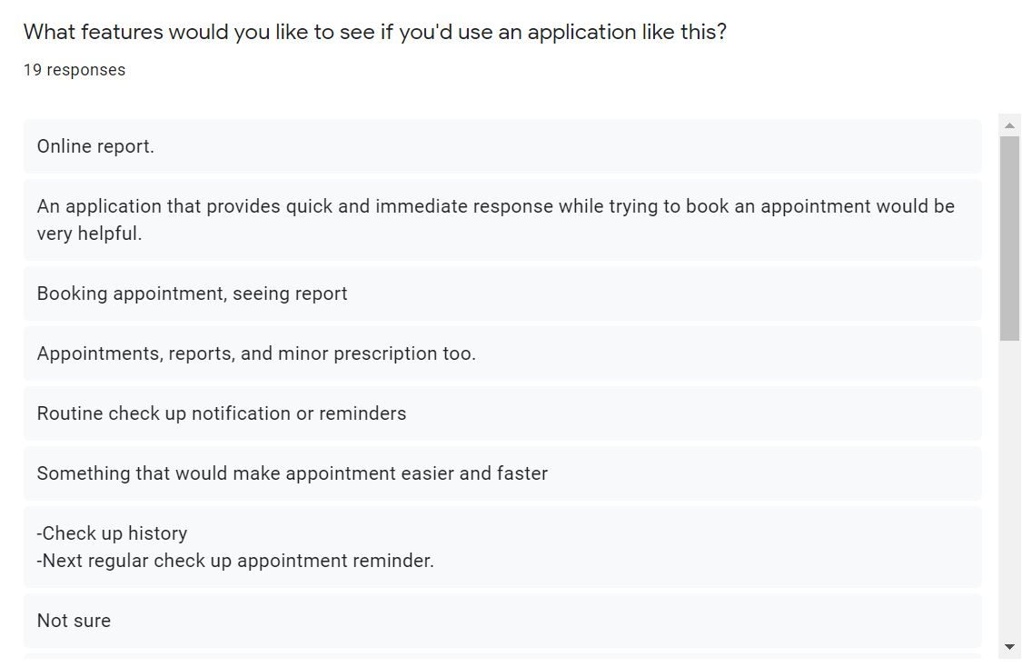

Figure 169: Pre-Survey Result - 7

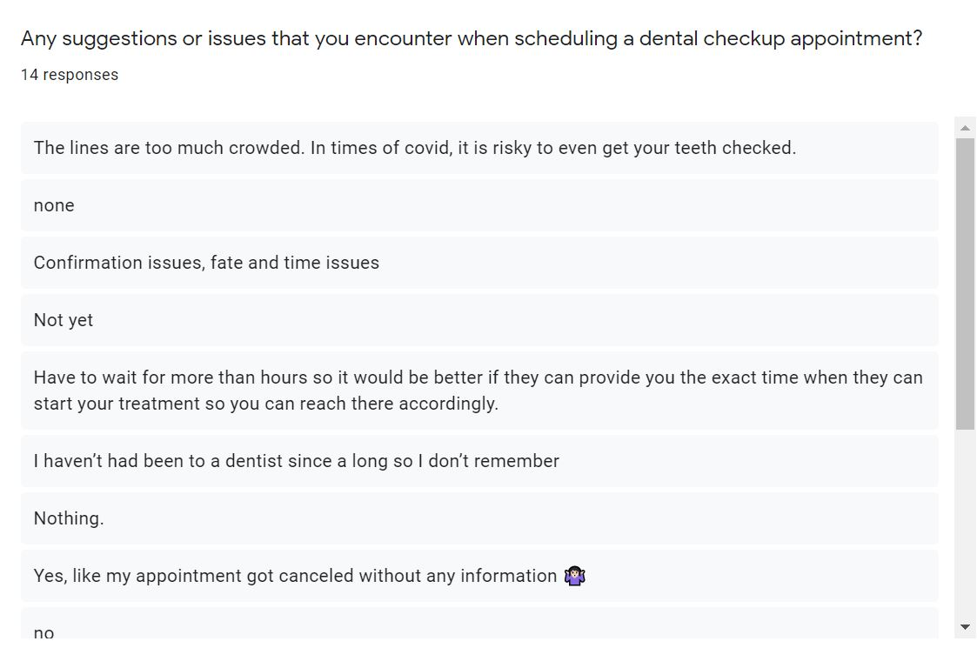

Figure 170: Pre-Survey Result - 8

## 7.2 Appendix B: Post-Survey

**Survey Link**: <https://forms.gle/jkz5EsW85t98Qohf9>

**Post-Survey for Dental Appointment System**

**Project Name**: Dental Appointment System

**Description of Project**: Dental Appointment System is an online appointment system that helps people to save their time by scheduling an appointment for their dental check-up using a web application. This project is all about reducing the problem that people face when they have to get a dental appointment.

### 7.2.1 Post-Survey Form

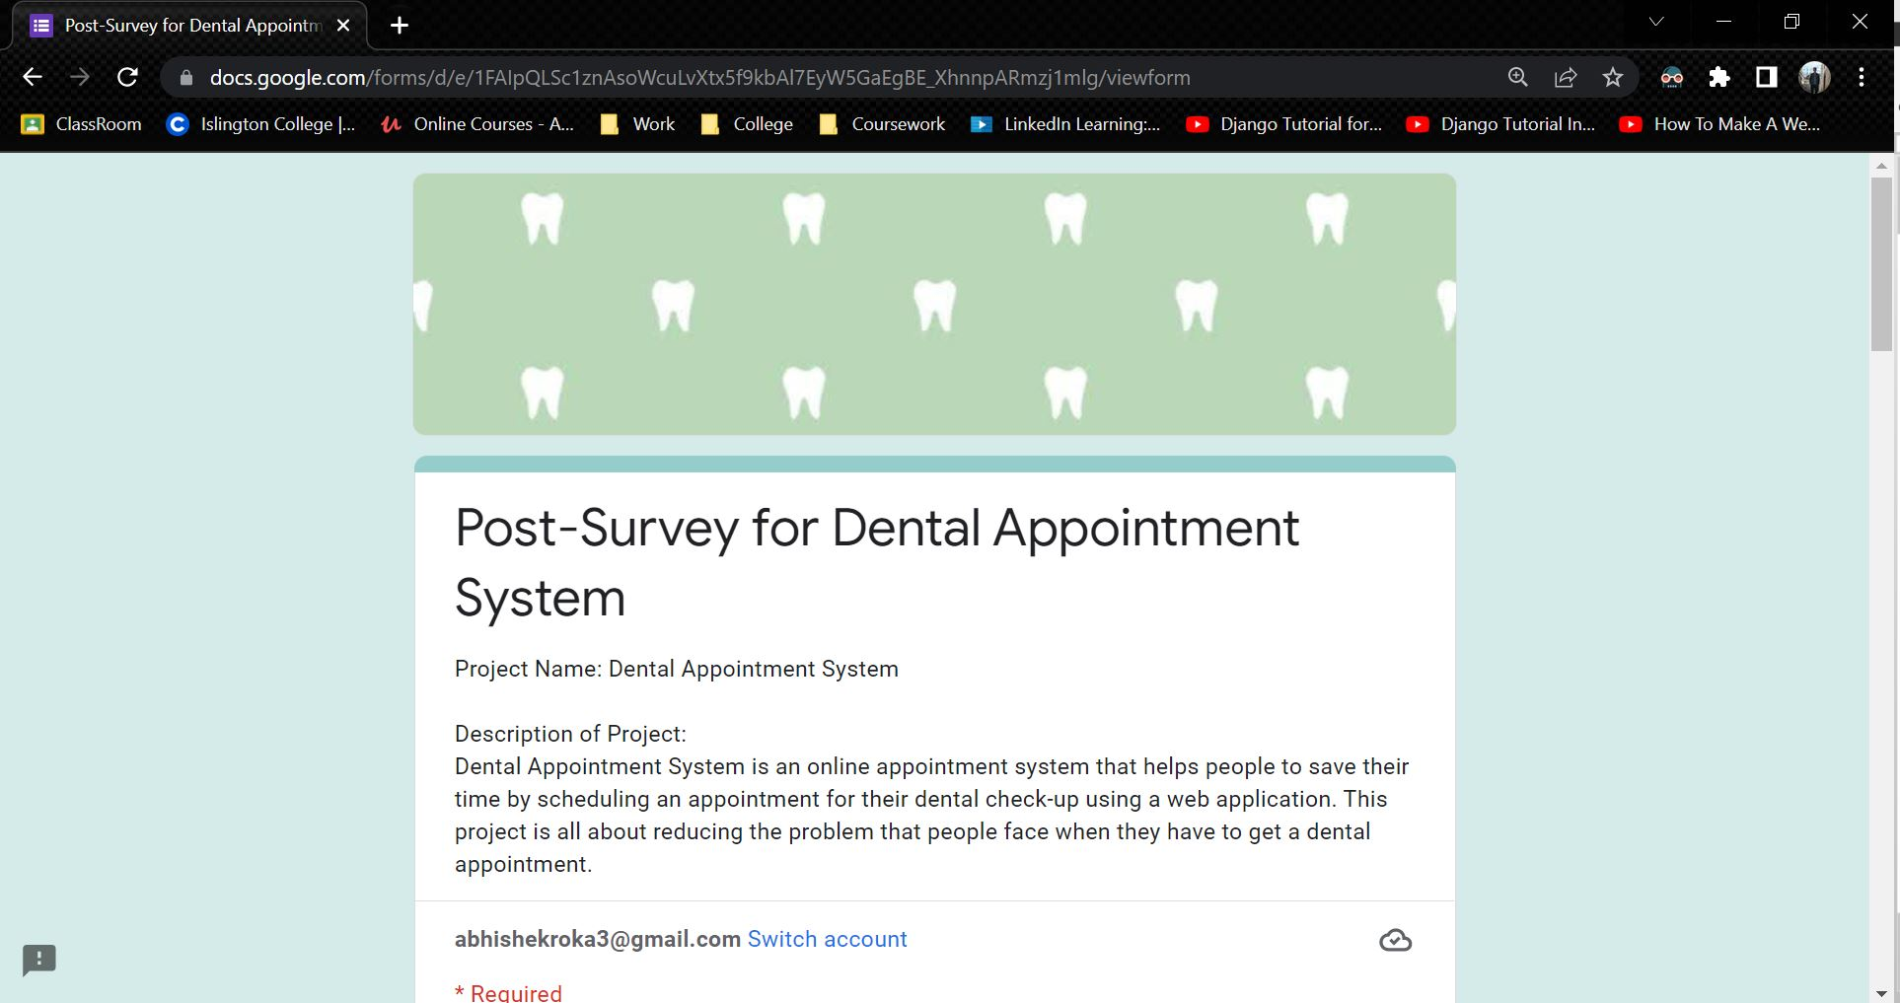

Figure 171: Post-Survey Form - 1

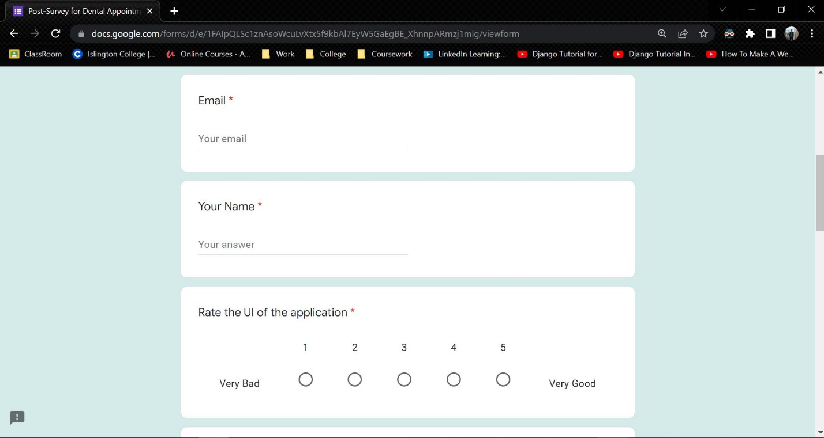

Figure 172: Post-Survey Form - 2

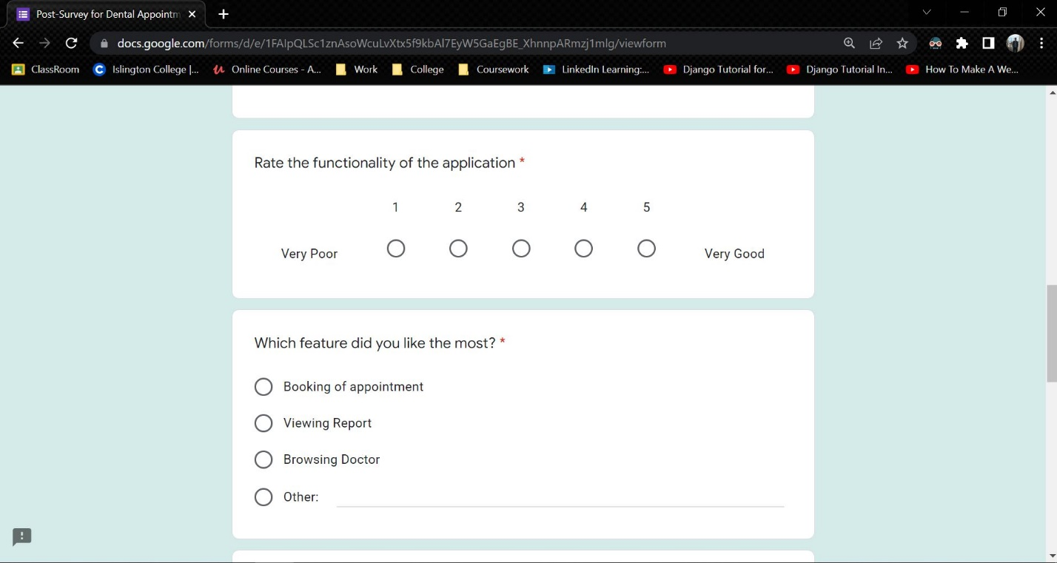

Figure 173: Post-Survey Form - 3

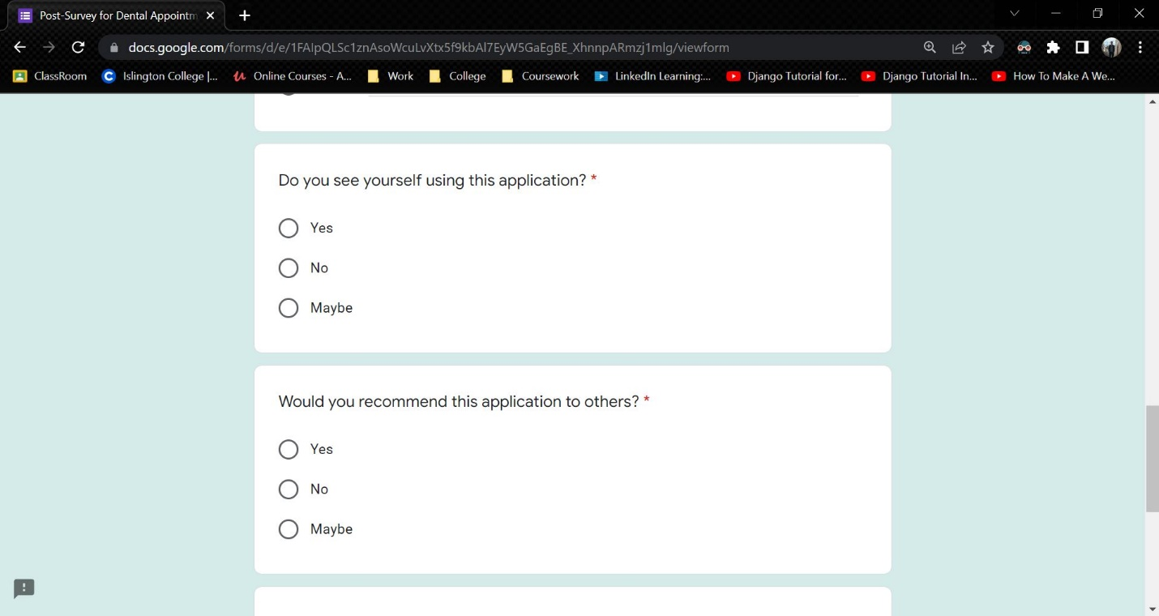

Figure 174: Post-Survey Form - 4

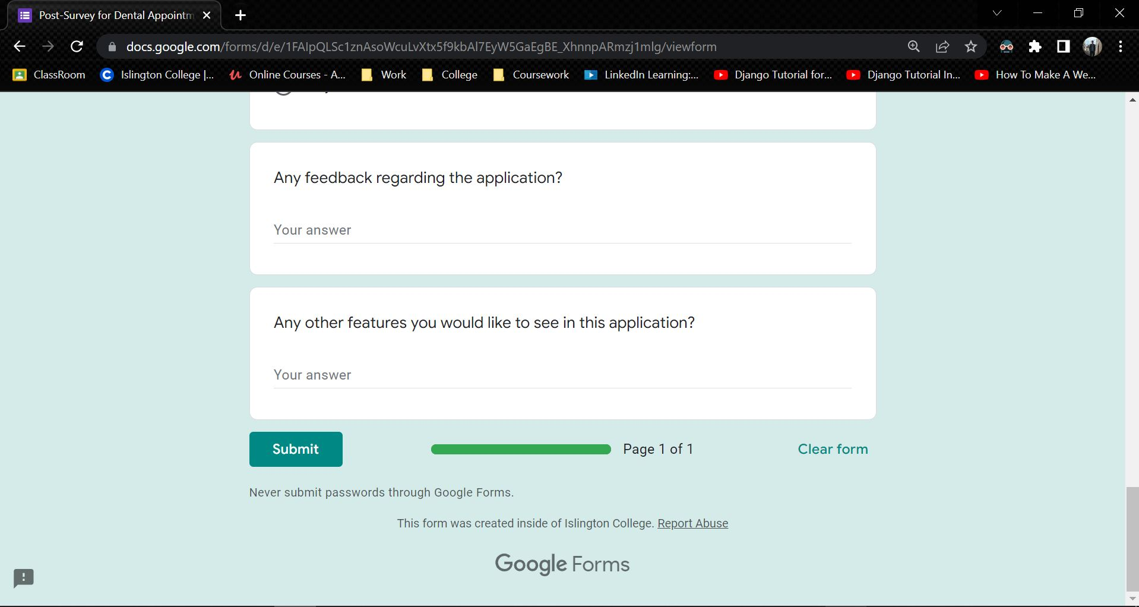

Figure 175: Post-Survey Form - 5

### 7.2.2 Sample of Filled Post-Survey Forms

**Sample 1**

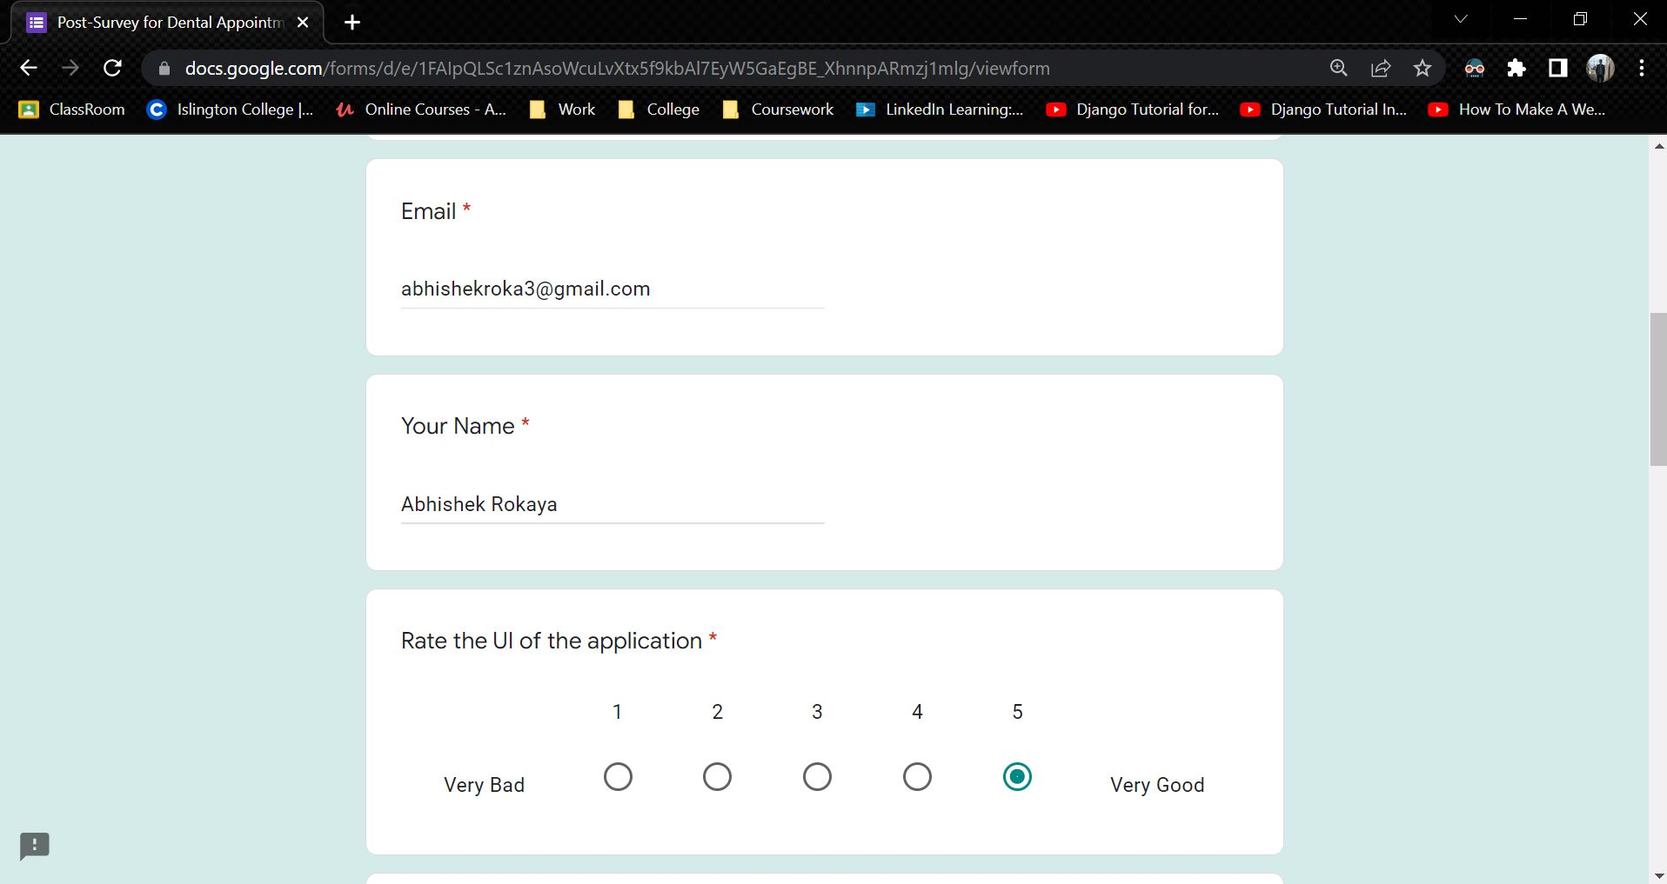

Figure 176: Sample 1 of post-survey form - 1

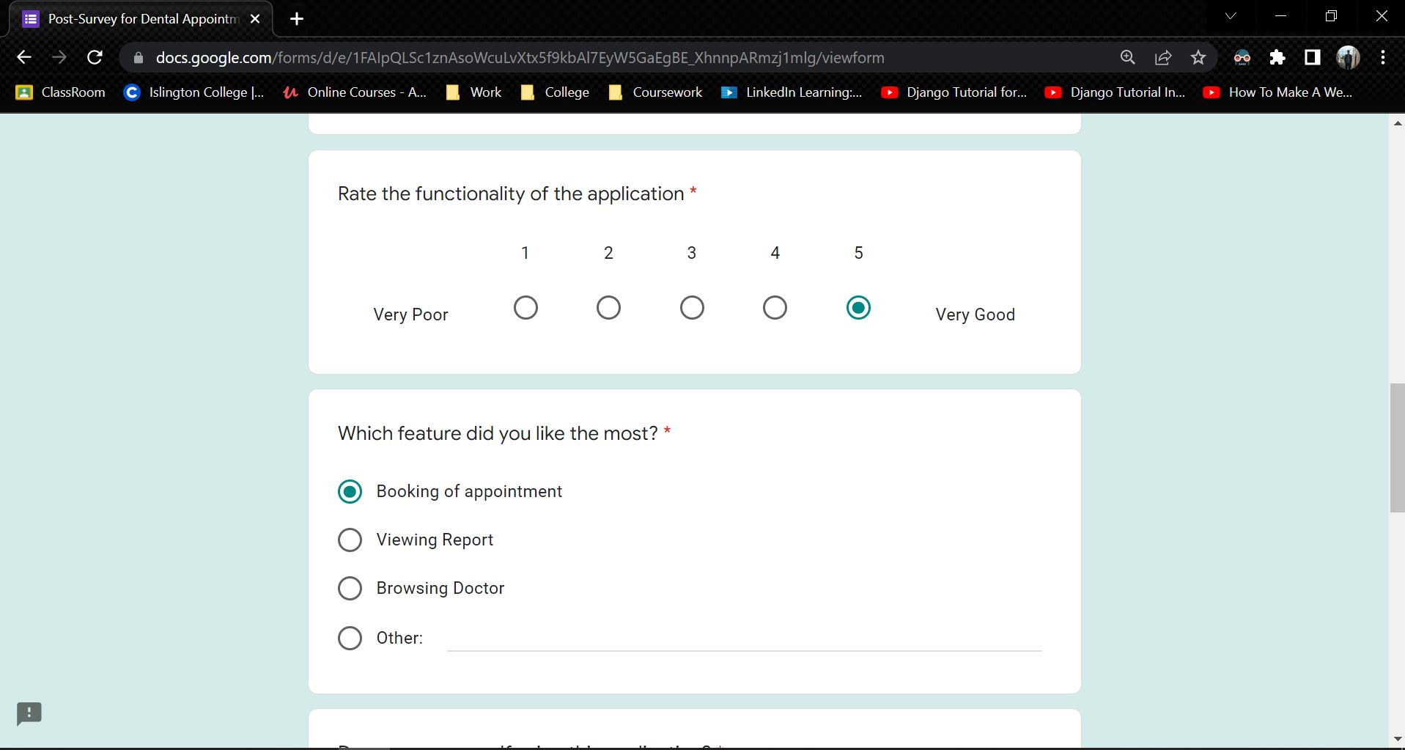

Figure 177: Sample 1 of post-survey form - 2

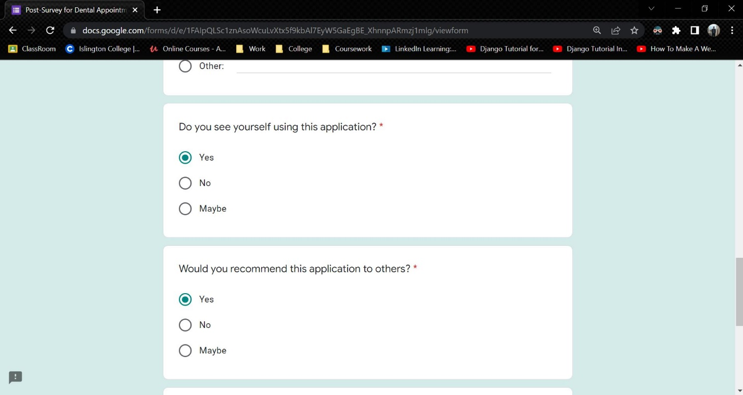

Figure 178: Sample 1 of post-survey form - 3

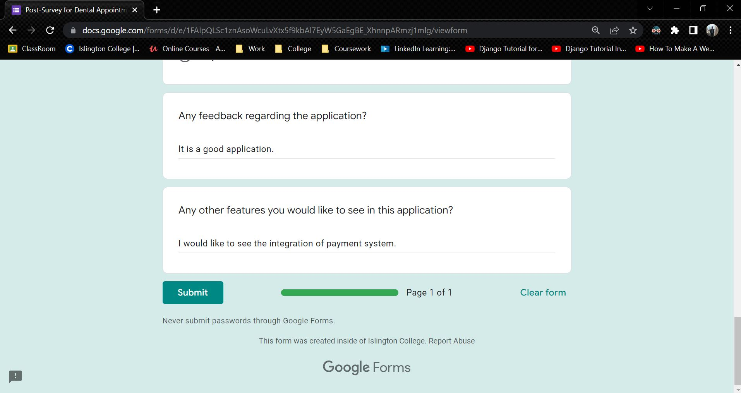

Figure 179: Sample 1 of post-survey form - 4

**Sample 2**

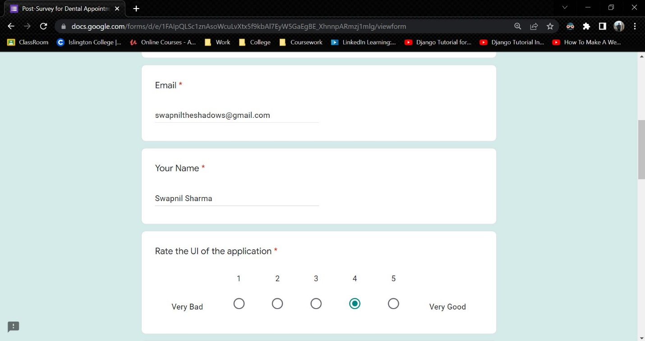

Figure 180: Sample 2 of post-survey form - 1

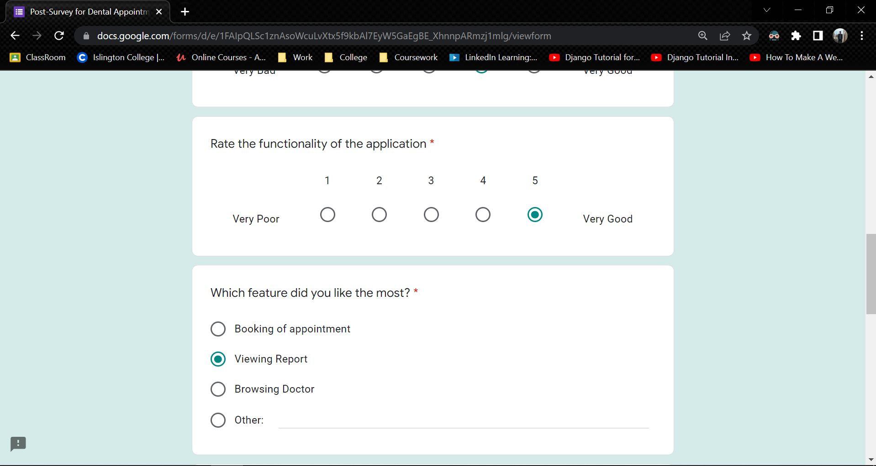

Figure 181: Sample 2 of post-survey form - 2

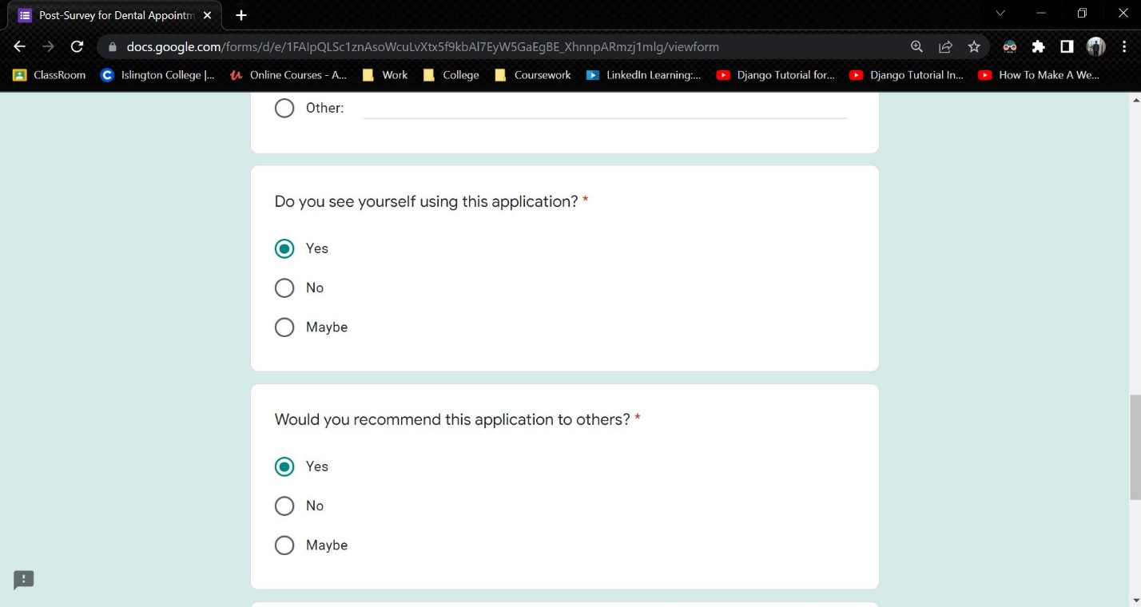

Figure 182: Sample 2 of post-survey form - 3

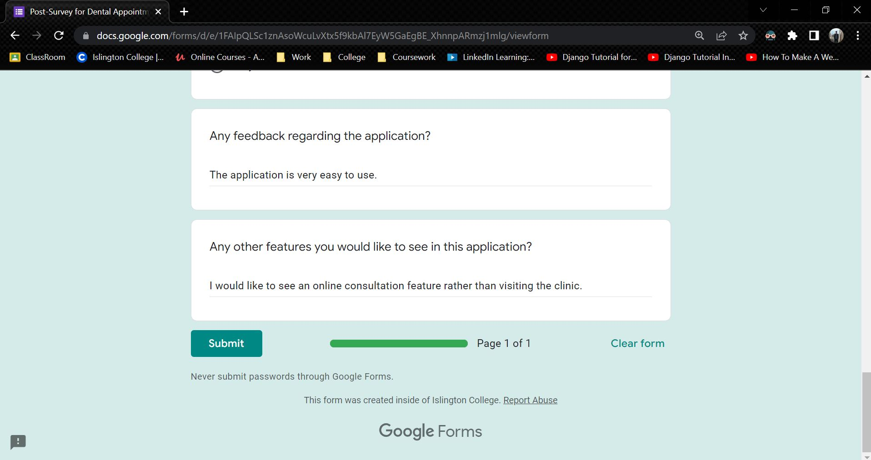

Figure 183: Sample 2 of post-survey form - 4

**Sample 3**

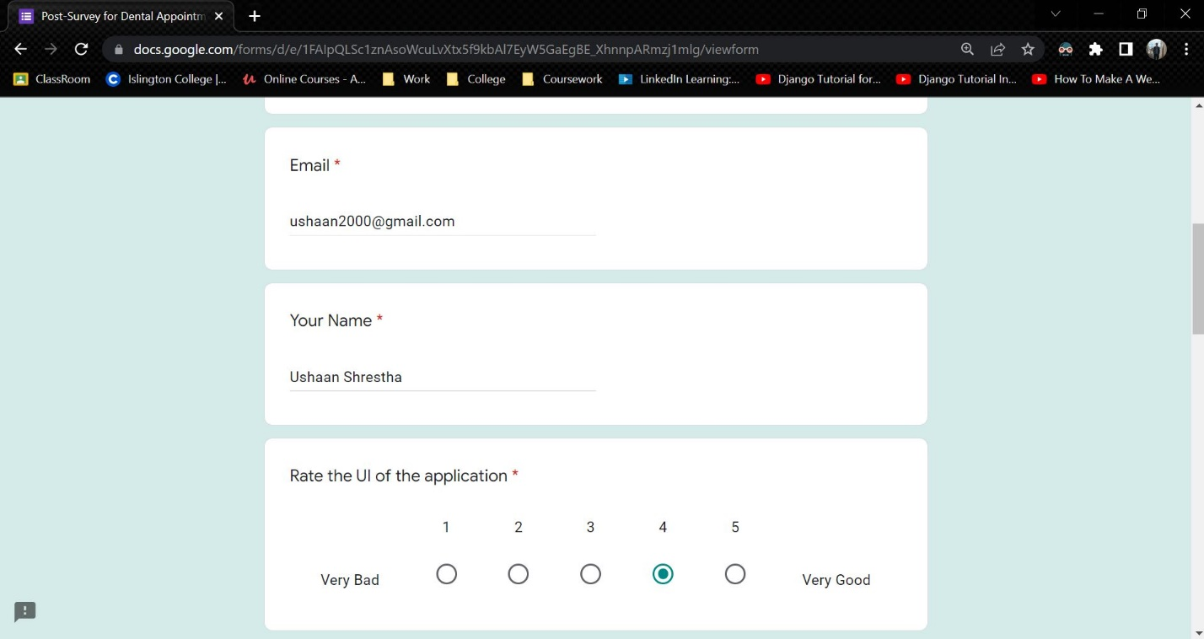

Figure 184: Sample 3 of post-survey form - 1

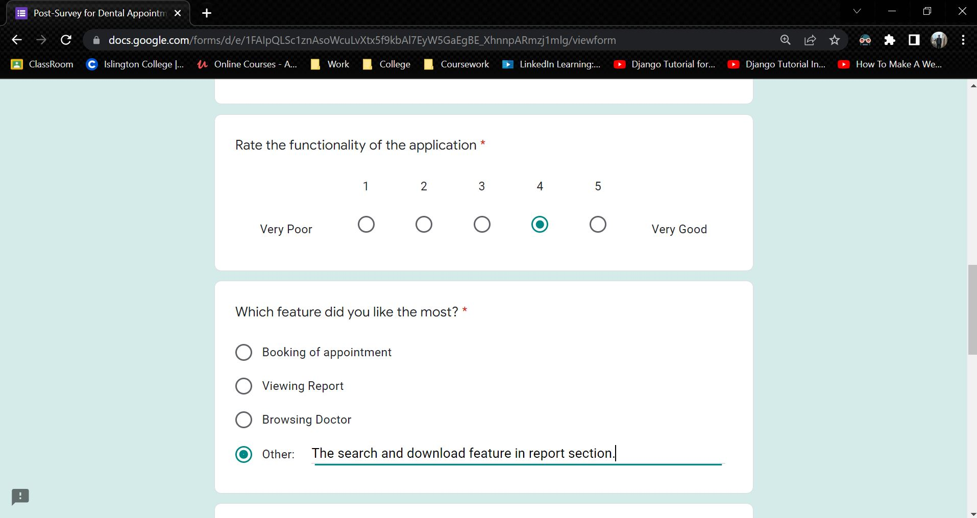

Figure 185: Sample 3 of post-survey form - 2

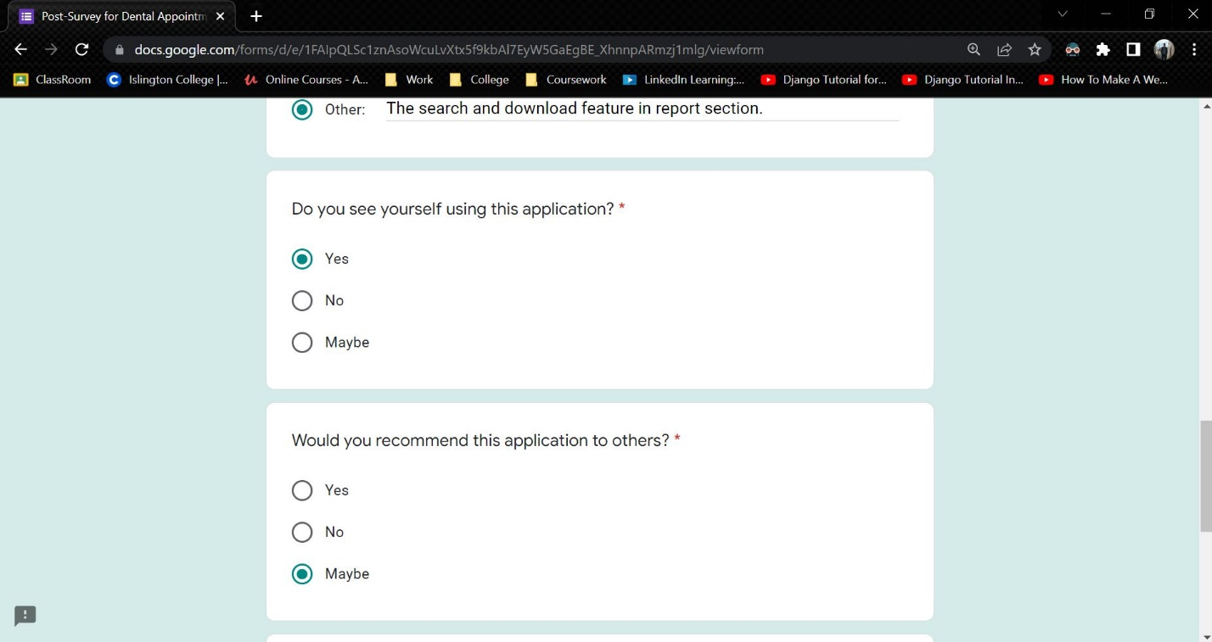

Figure 186: Sample 3 of post-survey form - 3

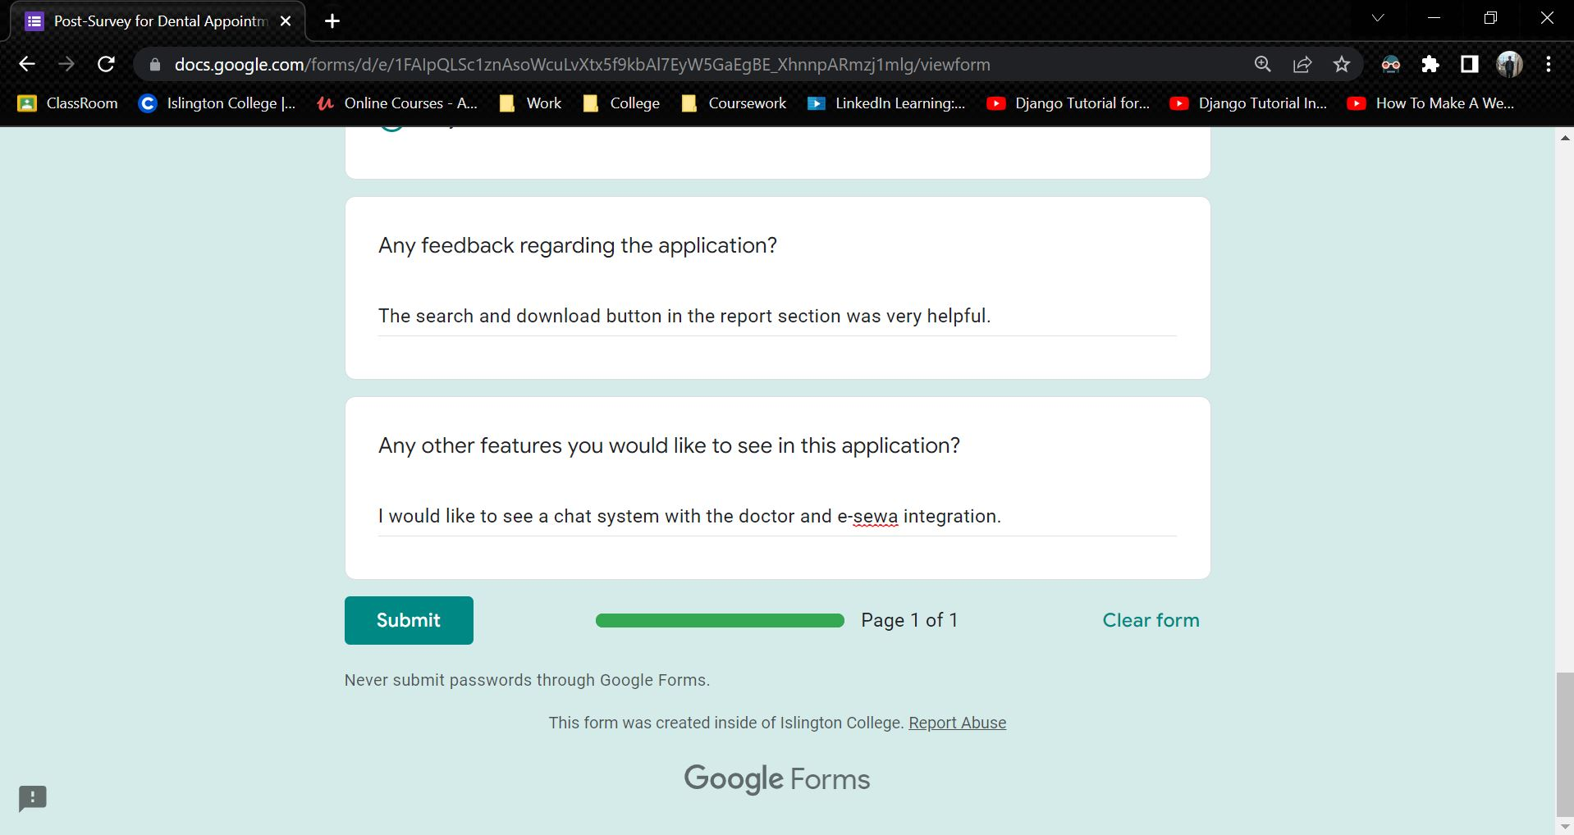

Figure 187: Sample 3 of post-survey form - 4

### 7.2.3 Post-Survey Result

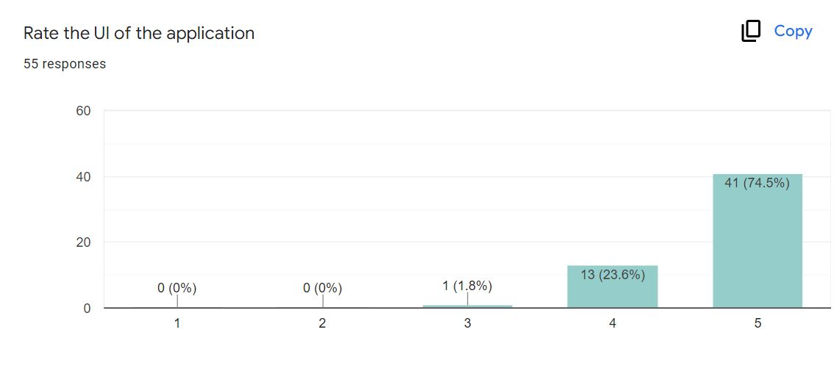

Figure 188: Post-Survey Result – 1

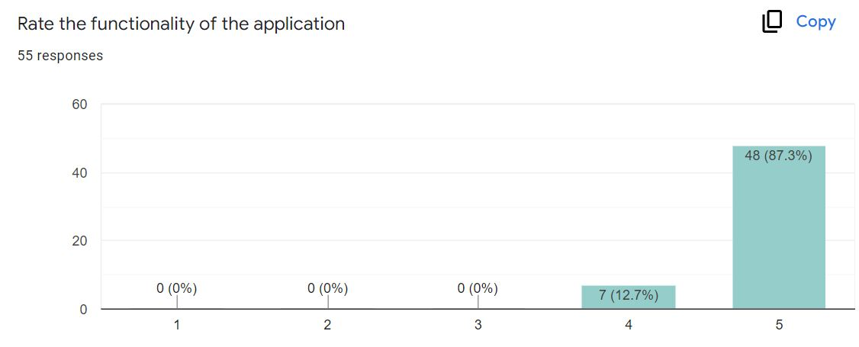

Figure 189: Post-Survey Result - 2

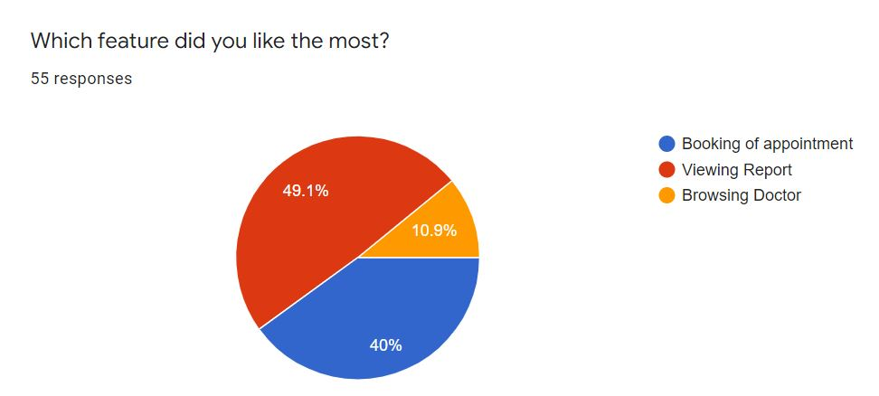

Figure 190: Post-Survey Result - 3

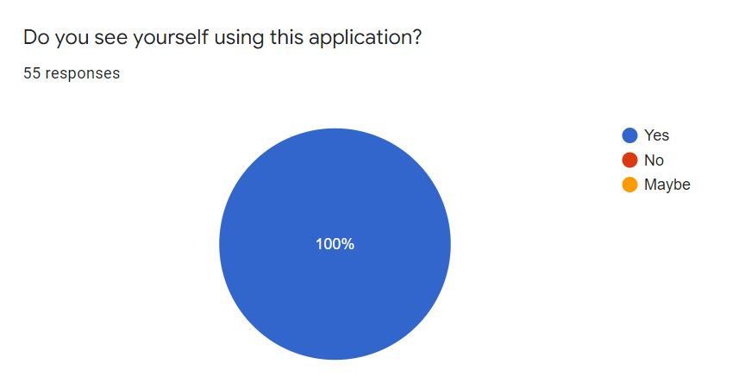

Figure 191: Post-Survey Result - 4

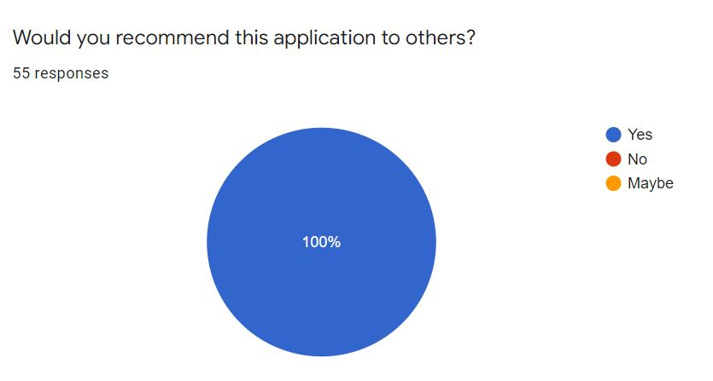

Figure 192: Post-Survey Result - 5

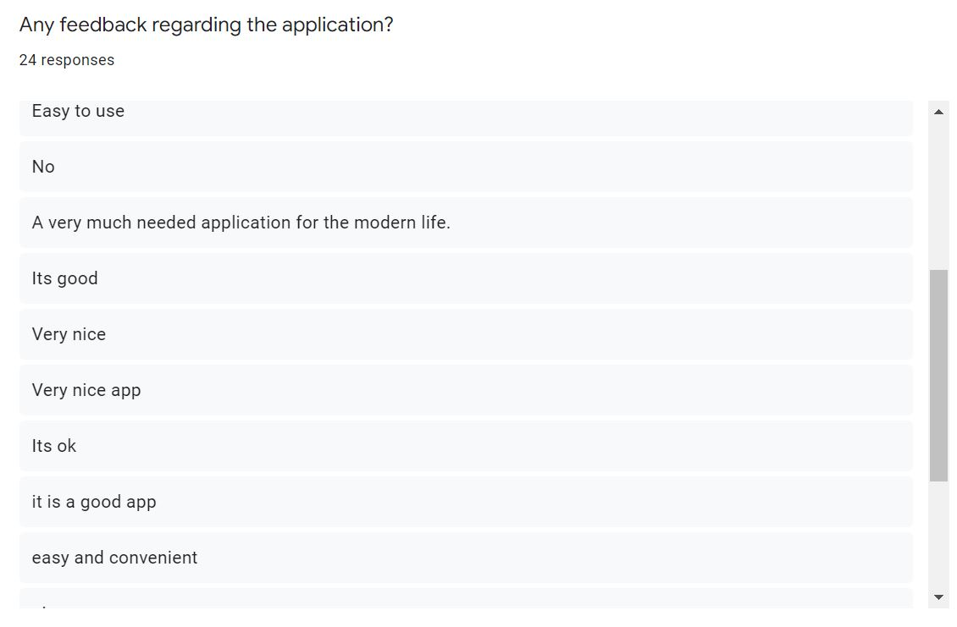

Figure 193: Post-Survey Result - 6

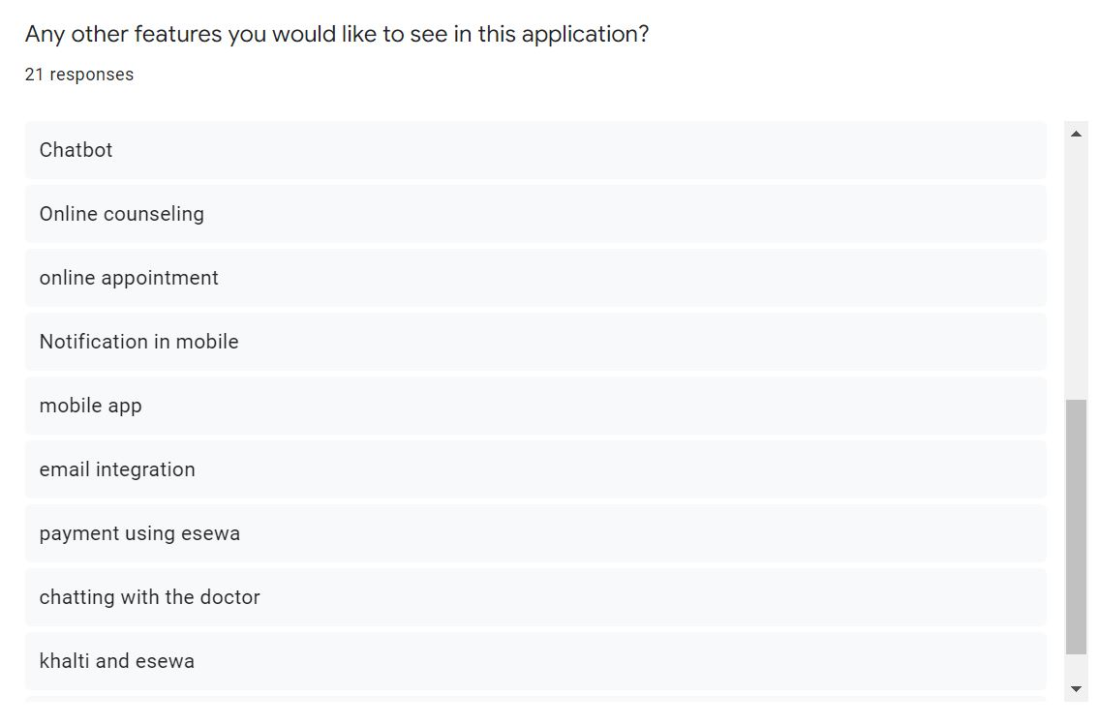

Figure 194: Post-Survey Result - 7

## 7.3 Appendix C: Sample Codes

### 7.3.1 Sample code of the UI

### 7.3.2 Sample code for the Automation Script

## 7.4 Appendix D: Designs

### 7.4.1 Gantt Chart

A Gantt chart, commonly used in project management, is one of the most popular and useful ways of showing activities (tasks or events) displayed against time. (Gantt.com, 2022) The revised Gantt chart for the following Dental Appointment System is given below:

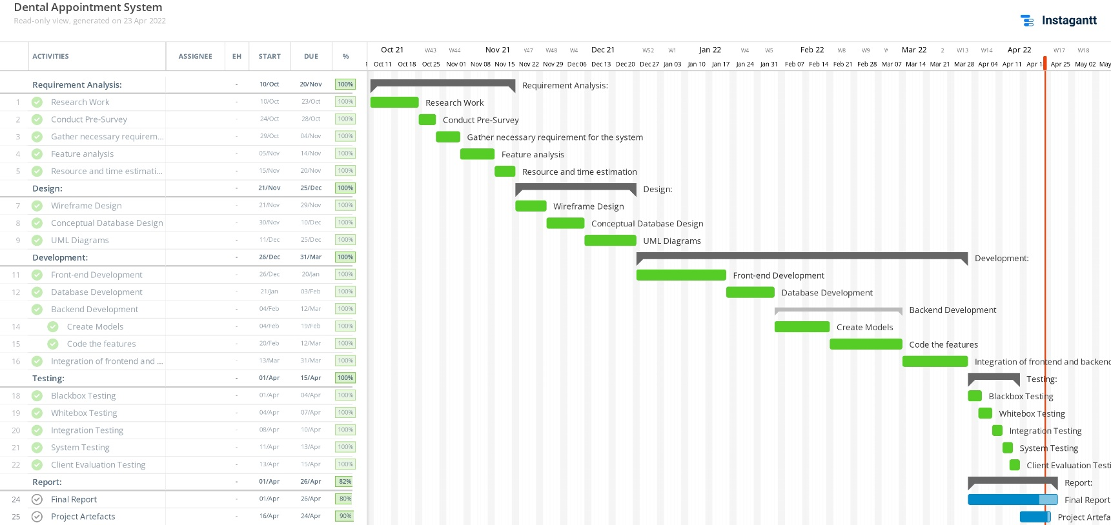

Figure 195: Gantt chart

Here, we can see the tasks according to the methodology. The Requirement Analysis, Design, Development and Testing are the four phases of the incremental methodology. The development portion has already been completed and the report part is still ongoing while the Gantt chart was created.

### 7.4.2 Work Breakdown Structure

A work breakdown structure, or WBS, is a project management tool that takes a step-by-step approach to complete large projects with several moving pieces. (Organ, 2022) A Work Breakdown Structure entails breaking down a huge, complicated project into smaller, more manageable, and self-contained jobs. The Project name is used to designate the root of this tree (structure). Each node is recursively divided into smaller sub-activities for the purpose of developing a work breakdown structure, until the activities become undividable and autonomous at the leaf level. It follows a Top-Down strategy. (Raman, 2019) The Work Breakdown Structure for the Dental Appointment System is given below:

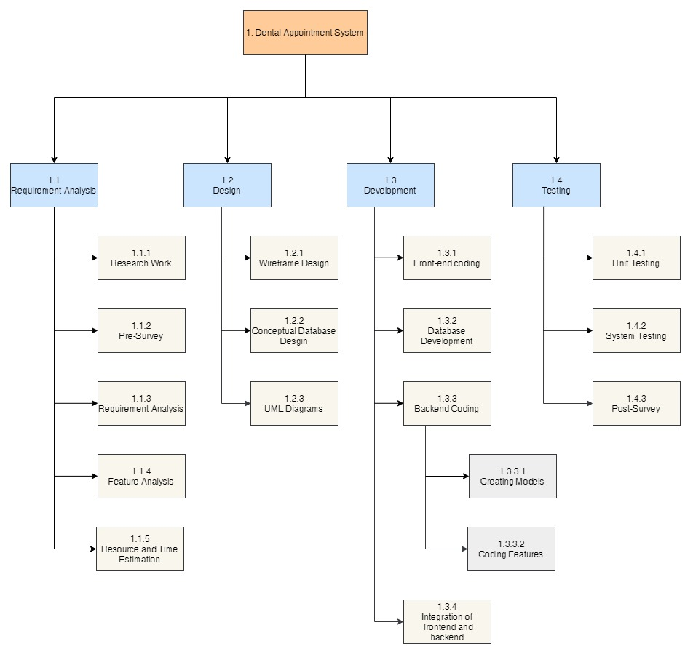

Figure 196: Work Breakdown Structure

### 7.4.3 Algorithms and Flowcharts

**7.4.3.1 Algorithm**

In computer programming terms, an algorithm is a set of well-defined instructions to solve a particular problem. It takes a set of input and produces a desired output. (Programiz, 2022) In this application, the bubble sort algorithm has been used to sort the data that has been used to display in the table. The algorithm was used to sort the details of the doctor, appointment, report, services and users data to display.

Bubble sort is a very simple algorithm that used for sorting. This sorting algorithm is comparison-based algorithm in which each pair of adjacent elements is compared and the elements are swapped if they are not in order.  (TutorialsPoint, 2022)

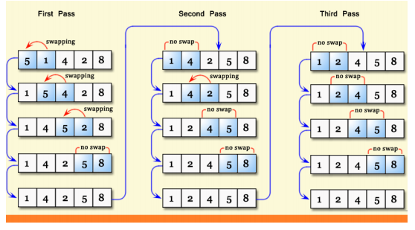

Figure 197: Bubble Sort Algorithm

The image above shows how the bubble sort algorithm works. It repeatedly swaps the adjacent elements if they are in wrong order and keeps on doing it until the elements are in correct order.

The pseudocode for the bubble sort algorithm is given below:

procedure bubbleSort( list : array of items )

loop = list.count;

for i = 0 to loop-1 do:

swapped = false

for j = 0 to loop-1 do:

/* compare the adjacent elements */

if list[j] > list[j+1] then

/* swap them */

swap( list[j], list[j+1] )

swapped = true

end if

end for

/*if no number was swapped that means

array is sorted now, break the loop.*/

if(not swapped) then

break

end if

end for

end procedure return list

**7.4.3.2 Flowchart**

Flowcharts are simply graphical representations of data or algorithms for a better visual comprehension of the code.  It shows how to solve an issue, algorithm, or procedure step by step. It is a pictorial way of representing steps that are preferred by most beginner-level programmers to understand algorithms of computer science, thus it contributes to troubleshooting the issues in the algorithm. (Mukherjee, 2021)

The overall flowchart diagram based only on the user side experience is given below:

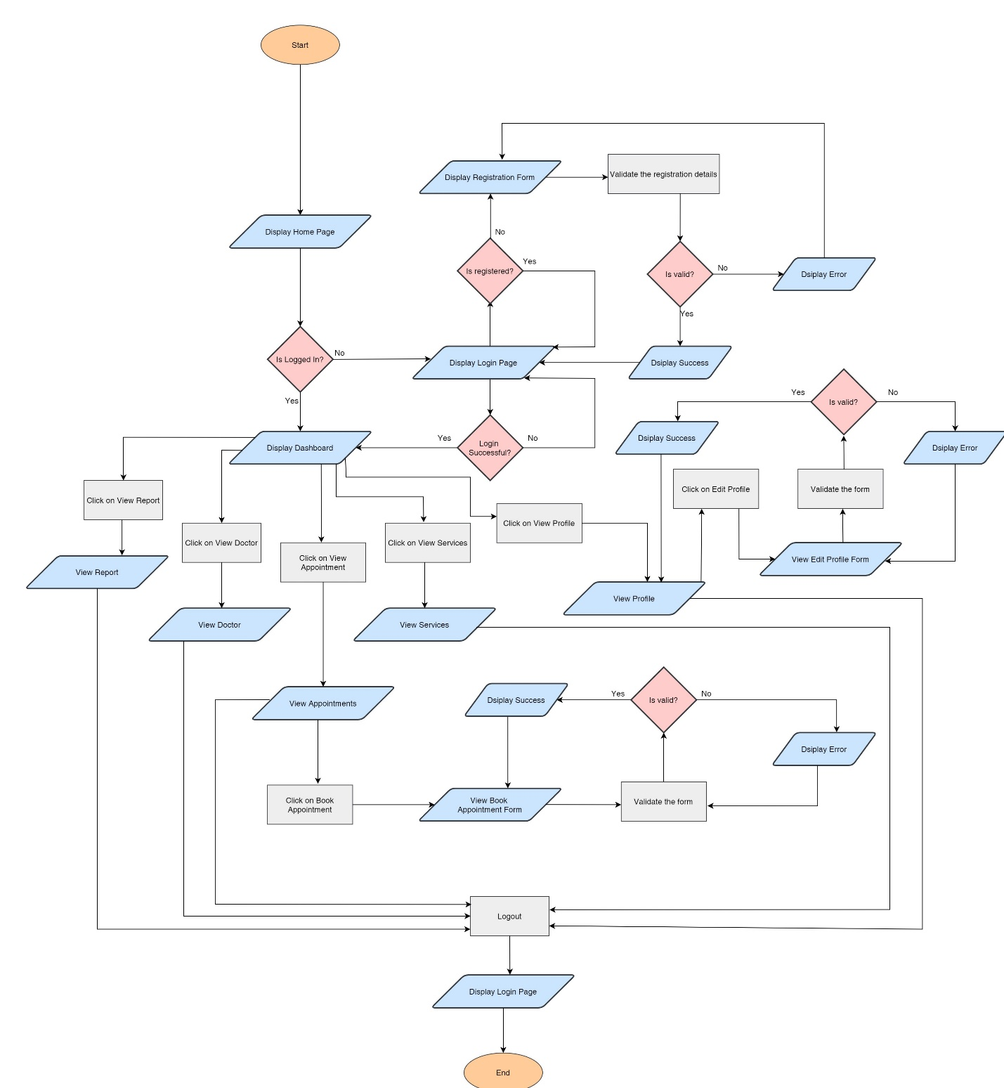

Figure 198: Flowchart of the overall system

### 7.4.4 ER Diagram Creation Process

The ERD creation process is elaborated below:

**1. Possible Entities**

The possible entities for Dental Appointment System as:

i. User – To store information about the users/admin for authentication.

ii. patientUser – To store additional information about the users.

iii. Appointments – To store the details about the appointment done by user.

iv. Services – To store the details about the services available.

v. Doctors – To store the details about the doctor.

vi. Report – To store the report of the appointment.

**2. Relationship Between Entities**

i. User and patientUser:

All the patientUser must be a User but a User can either be a patientUser or not. They can also be an admin who does not have extra fields. So, the relation between User and patientUser will be one mandatory to one optional. The entity along with relation is shown below:

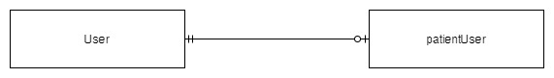

Figure 199: User-patientUser Relation

ii. patientUser and Appointment:

A user can have multiple appointment but an appointment can only belong to one patientUser. So the relation between patientUser and Appointment is One Mandatory to Many.

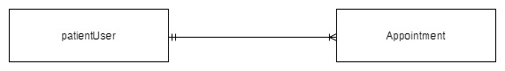

Figure 200: patientUser-Appointment Relation

iii. Report and Appointment:

A report can only belong to one appointment and an appointment can only have one report. So, the relation between report and appointment will be one mandatory to one mandatory.

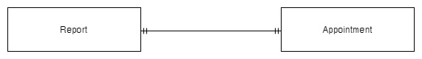

Figure 201: Report-Appointment Relation

iv. Doctor and Appointment

A doctor can oversee many appointments but an appointment can only have one doctor. So, the relation between Doctor and Appointment will be one mandatory to many.

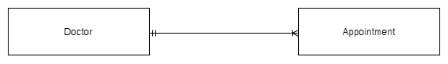

Figure 202: Doctor-Appointment Relation

v. Service and Appointment

An appointment can only be made for one services but a service can have multiple appointments. So, the relation between Services and Appointment will aslo be one mandatory to many.

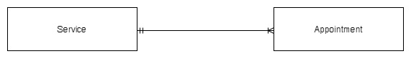

Figure 203: Service-Appointment Relation

**3. Attributes**

i. User

|  |  |  |
| --- | --- | --- |
| **Attributes** | **Data Type** | **Others** |
| ID | Integer | Primary Key, Not Null, Auto Increment |
| First_name | Varchar(150) | Not Null |
| Last_name | Varchar(150) | Not Null |
| Email | Varchar(254) | Not Null, Unique |
| Username | Varchar(150) | Not Null, Unique |
| Password | Varchar(128) | Not Null |

Table 33: User Attributes

ii. patientUser

|  |  |  |
| --- | --- | --- |
| **Attributes** | **Data Type** | **Others** |
| ID | Integer | Primary Key, Not Null, Auto Increment |
| Date_of_birth | Date | Not Null |
| Phone_number | Varchar(15) | Not Null |
| Profile_picture | Varchar(100) | Not Null, Default="img/defaultuser.png" |
| User_id | Integer | Foreign Key, Unique |

Table 34: patientUser Attributes

iii. Doctor

|  |  |  |
| --- | --- | --- |
| **Attributes** | **Data Type** | **Others** |
| ID | Integer | Primary Key, Not Null, Auto Increment |
| Full_name | Varchar(100) | Not Null |
| Qualification | Varchar(50) | Not Null |
| Date_of_birth | Date | Not Null |
| Email | Varchar(100) | Not Null |
| Phone_number | Varchar(15) | Not Null |
| Address | Varchar(50) | Not Null |
| Experience | Varchar(10) | Not Null, Default="1 year" |
| Profile_picture | Varchar(100) |  |

Table 35: Doctor Attribute

iv. Service

|  |  |  |
| --- | --- | --- |
| **Attributes** | **Data Type** | **Others** |
| ID | Integer | Primary Key, Not Null, Auto Increment |
| Service_name | Varchar(50) | Not Null |
| description | Text | Not Null |
| Cost | Integer | Not Null |

Table 36: Service Attribute

v. Appointment

|  |  |  |
| --- | --- | --- |
| **Attributes** | **Data Type** | **Others** |
| ID | Integer | Primary Key, Not Null, Auto Increment |
| Date | Date | Not Null |
| Time | Time | Not Null |
| Description | Text | Not Null |
| Doctor_id | BIGINT | Foreign Key, Not Null |
| patient ser_id | BIGINT | Foreign Key, Not Null |
| Service_id | BIGINT | Foreign Key, Not Null |
| Status | Integer | Not Null, Default="1" |

Table 37: Appointment attribute

vi. Report

|  |  |  |
| --- | --- | --- |
| **Attributes** | **Data Type** | **Others** |
| ID | Integer | Primary Key, Not Null, Auto Increment |
| Problems | Text | Not Null |
| Prescription | Text | Not Null |
| Other_details | Text | Not Null |
| Appointment_id | BIGINT | Foreign Key, Not Null, Unique |

Table 38: Report attribute

Click here to see the final ERD.

### 7.4.5 Software Requirement Specification (SRS)

**7.4.5.1 Introduction**

**Project**: Dental Appointment System

**Category**: Web Application

**7.4.5.1.1 Purpose**

The primary purpose of this document is to provide a full description of the Dental Appointment System. It will explain the system's goal and characteristics, as well as the system's interfaces, what the system will perform, and the limitations under which it must operate. It provides a thorough explanation of the system's objectives, functionality, and user interface. It outlines how the application (system) will operate. This paper is designed for both system users and system developers.

**7.4.5.1.2 Intended Audience**

The intended audience for this system is the general public. Everyone has their dental needs that to be treated or cleaned. But not everyone has the time to go to the clinic and wait in line for hours. So, this system in intended for those people who do not wish to wait for hours for their check-up rather be more convenient and visit the clinic when they have the appointment time,

The SRS (Software requirement specification) is intended for:

* Client/User
* Developer
* Tester

**7.4.5.1.3 Project Scope**

The primary goal of this system is to manage users' appointments and to build a user-friendly application for booking appointments. This program assists users in connecting to a database server and logging into the system. Above all, we believe in providing excellent service at a reasonable cost. This application will help to schedule an appointment and manage the work efficiently It is a booking system that the user uses to schedule an appointment. The user can also view the doctors and services available along with the costs of services and the details of the doctors. Furthermore, users can view their report after their visit to the clinic. This helps avoid the loss of report that will be useful for the next meeting. This application is intended for a particular clinic only i.e. Phulchowki Dental Clinic.

The terms present in the documentations are:

* Admin: The person who is responsible for managing the whole system.
* User: A person who is using the application with limited privilege.
* Database: A server for the storing information of this system.

**7.4.5.2 Overall Description**

**7.4.5.2.1 System Perspective**

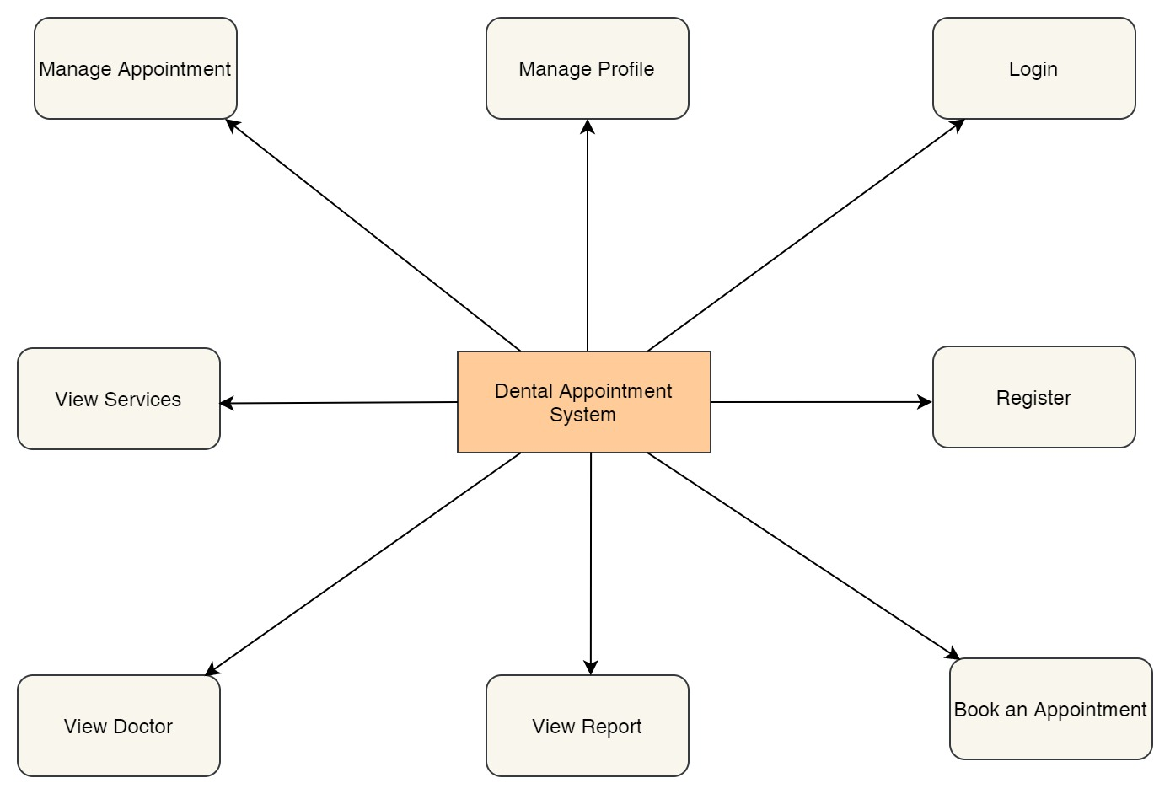

Figure 204: System Perspective Diagram

The features of the web based application are as mentioned below:

SP1: Register

SP2: Login

SP3: Book an appointment

SP4: View Report

SP5: View Doctor

SP6: View Services

SP7: Manage Appointment

SP8: Manage Profile

**Use Case of the Overall System**



Figure 205: Overall Use Case of the System

**7.4.5.2.2 System Features**

**SF1: Register**

**Description:** New users who have not yet been registered to the system registers into it using the web browser. The registration details entered by the user is then verified by the system.

**SF2: Login**

**Description:** Registered Users can proceed to login to the system to use the features using the web browser. The login details entered by the customer is then verified by the system.

**SF3: Book an Appointment**

**Description:** Users can book an appointment for their dental requirements. The appointment is then reviewed by the admin.

**SF4: View Report**

**Description:** Users can view the report for their appointment only after it has been finished.

**SF5: View Doctor**

**Description:** Users can view the list of doctors available in the clinic along with their description and select the one they want to book an appointment with.

**SF: View Services**

**Description:** Users can view the list of services available in the clinic along with the cost and description of it.

**SF7: Manage Appointment**

**Description:** Users can view the list of their appointments and cancel their pending as well confirmed appointment if the need arises to.

**SF8: Manage Profile**

**Description:** Users can view their profile and edit their details that they previously entered while registering. However, they cannot change their username.

**7.4.5.2.3 User Class and Characteristics**

The following are the classes for users who will be using the Dental Appointment System application with their roles:

**UC1: Patient User**

**UC1.1**: Book an appointment for their dental requirements

**UC1.2**: Browse doctors available in the clinic

**UC1.3**: View services available in the clinic

**UC1.4**: Manage their appointment

**UC1.5**: Manage their profile

**UC1.6**: View the reports of their appointment visit

**UC2: Admin User**

**UC2.1**: Manage appointments booked by the patient users like approving, rejecting, finishing and cancelling the appointments of the users.

**UC2.2**: Manage the reports of the user's appointments like adding, updating and deleting.

**UC2.3**: Manage the doctors in the clinic like adding new doctors, updating and deleting the existing ones if the need arises.

**UC2.4**: Manage the services in the clinic like adding new services, updating and deleting the existing ones if the need arises.

**UC2.5**: Manage users and deleting them if needed.

**UC3: Client**

**UC3.1**: Requirement analysis and finalization

**UC3.2**: Check whether the requirements are met or not at the time of delivery

**UC3.3**: Provide funding, resources and further information if needed

**UC4: Developer**

**UC4.1**: Check for errors and fix the bugs

**UC4.2**: Add additional features

**UC4.3**: Provide progress to the client

**UC4.4**: Manage the databases

**7.4.5.2.4 Operating Environment**

**OE1:** Currently the dental appointment system web application is available in any web browser like Google Chrome, Microsoft Edge, Mozilla Firefox, etc. In the near future, the application will also run on other platforms such as Android and iOS.

**7.4.5.2.5 Design and implementation constraints**

**CO1:** Only registered users can book the appointment.

**CO2:** Reports can only be made of appointments that are marked as finished by the admin.

**CO3:** User can only view their appointment, report and profile.

**CO4:** User can view all the doctors and services.

**CO5:** User cannot access the admin's panel.

**CO6:** User can only cancel their pending and confirmed appointments.

**CO7:** Only admin can approve, reject and finish the user's appointments.

**CO8:** Only admin can manage the doctor, reports and services

**CO8:** The appointment can only be taken from 9am – 5pm any day of the week.

**7.4.5.2.6 Assumptions and Dependencies**

**AS1**: This application is target mainly for those who have to visit dental clinic for their dental check-ups.

**AS2**: The application will be connected with the database.

**AS3**: The documentation and reports of the system are only accessible to limited people like the client and developers.

**AS4**: The users can book any number of appointment they may like to. However, they may only choose one service at a time but can include other services at the same time by mentioning in the description.

**7.4.5.3 Functional Requirement**

**7.4.5.3.1 Login Feature**

|  |  |  |  |
| --- | --- | --- | --- |
| **Req.ID** | **Requirement Description** | **Priority** | **Complexity** |
| **FR1** | All users will be able to access the login page   |  |  | | --- | --- | | **System Requirement** | | | **SR1** | On opening the application, the user will be directed to the home/landing page. | | **SR2** | When the user click the ‘Login’ button, they will be directed to the login page | | **SR3** | The user needs to enter their login details i.e. username and password in order to log in to the application. If the credentials are correct, they will be redirected towards the user dashboard page. | | Most | High |

Table 39: Functional Requirement 1

**7.4.5.3.2 Register Feature**

|  |  |  |  |
| --- | --- | --- | --- |
| **Req.ID** | **Requirement Description** | **Priority** | **Complexity** |
| **FR2** | All users will be able to access the register page   |  |  | | --- | --- | | **System Requirement** | | | **SR4** | When the user click the ‘Register' button, they will be directed to the register page | | **SR5** | The user needs to fill the registration form. The details are then verified by the system and the user will be registered in to the system. The user can then log in using their username and password. | | Most | High |

Table 40: Functional Requirement 2

**7.4.5.3.3 Booking an appointment and manage appointment**

|  |  |  |  |
| --- | --- | --- | --- |
| **Req.ID** | **Requirement Description** | **Priority** | **Complexity** |
| **FR3** | All users who are registered and logged in will be able to use this feature.   |  |  | | --- | --- | | **System Requirement** | | | **SR6** | After logging in, the users will be directed to their dashboard page. | | **SR7** | When the user clicks the ‘Book Appointment’ button, they will be directed to the book appointment page. | | **SR8** | The user needs to fill the form and click submit. If the details are valid, the appointment is then viewed by admin for approval. | | Most | High |
| **FR4** | All users who have at least one appointment can use this feature.   |  |  | | --- | --- | | **System Requirement** | | | **SR9** | When the user clicks the ‘View Appointment’ button, they will be directed to the view appointment page. | | **SR10** | The user can cancel their pending or confirmed appointment by clicking the 'cancel' button. | | Most | High |

Table 41: Functional Requirement 3

**7.4.5.3.4 View Report**

|  |  |  |  |
| --- | --- | --- | --- |
| **Req.ID** | **Requirement Description** | **Priority** | **Complexity** |
| **FR5** | The user must have at least one appointment marked as finished to view the reports.   |  |  | | --- | --- | | **System Requirement** | | | **SR11** | After logging in, the users will be directed to their dashboard page. | | **SR12** | When the user clicks the ‘View Report’ button, they will be directed to the view report page. | | **SR13** | The user will be able to view the report details of the appointment that they have finished. The admin upload the report and the user can view it. | | Most | High |

Table 42: Functional Requirement 4

**7.4.5.3.5 View Doctor**

|  |  |  |  |
| --- | --- | --- | --- |
| **Req.ID** | **Requirement Description** | **Priority** | **Complexity** |
| **FR6** | The user must be registered and logged in to view this feature.   |  |  | | --- | --- | | **System Requirement** | | | **SR14** | After logging in, the users will be directed to their dashboard page. | | **SR15** | When the user clicks the ‘View Doctor' button, they will be directed to the view doctor page. | | **SR16** | The user will be able to view the doctors along with their details. | | Most | Normal |

Table 43: Functional Requirement 5

**7.4.5.3.6 View Services**

|  |  |  |  |
| --- | --- | --- | --- |
| **Req.ID** | **Requirement Description** | **Priority** | **Complexity** |
| **FR7** | The user must be registered and logged in to view this feature.   |  |  | | --- | --- | | **System Requirement** | | | **SR17** | After logging in, the users will be directed to their dashboard page. | | **SR18** | When the user clicks the ‘View Services' button, they will be directed to the view services page. | | **SR19** | The user will be able to view the services along with their details. | | Most | Normal |

Table 44: Functional Requirement 6

**7.4.5.3.7 Manage Profile**

|  |  |  |  |
| --- | --- | --- | --- |
| **Req.ID** | **Requirement Description** | **Priority** | **Complexity** |
| **FR8** | The user must be registered and logged in to view this feature.   |  |  | | --- | --- | | **System Requirement** | | | **SR20** | After logging in, the users will be directed to their dashboard page. | | **SR21** | When the user clicks the ‘View Profile' button, they will be directed to the view profile page. | | **SR22** | The user will be able to view their details. | | Most | Medium |
| **FR9** | The user must be registered and logged in to view this feature.   |  |  | | --- | --- | | **System Requirement** | | | **SR23** | When the user clicks the ‘Edit Profile' button, they will be directed to the view services page. | | **SR24** | When the user clicks the ‘View Profile' button, they will be directed to the edit profile page. | | **SR25** | The user will be able to update their details and if the details are valid, the details of the users will be updated. | | Most | High |

Table 45: Functional Requirement 7

**7.4.5.4 External Interface Requirement**

**7.4.5.4.1 User Interfaces**

The project's user interface will be intended to be clean and simple to use. Simple phrases will be used, and page titles will be assigned based on the objective of the page. The application will make use of appropriate colour schemes and fonts. Similarly, the photos in the program will be retained in order to deliver a relevant message to the users. User testing will be done on a regular basis to ensure maximum effort and happiness.

The home page was made as a one page website. The screenshot of the home page UI is shown below:

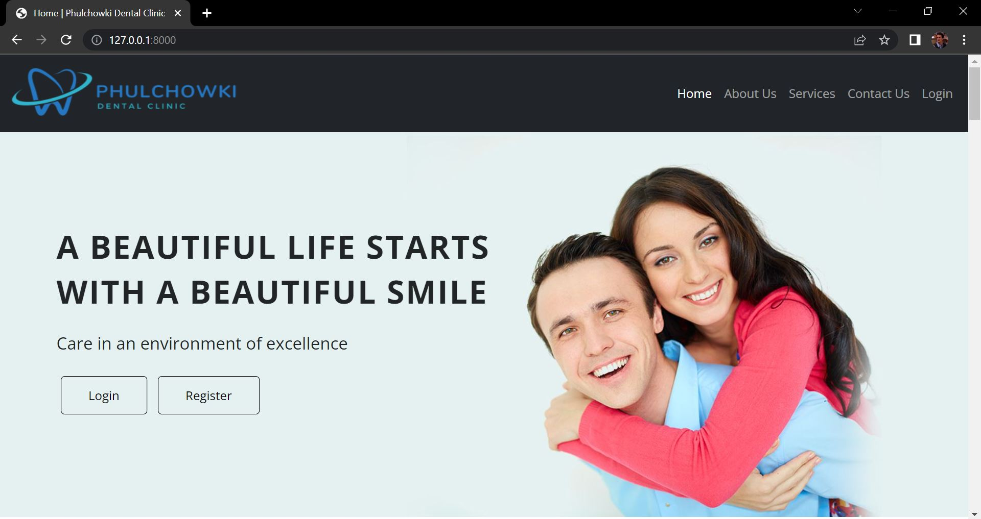

Figure 206: UI of Home Page 1

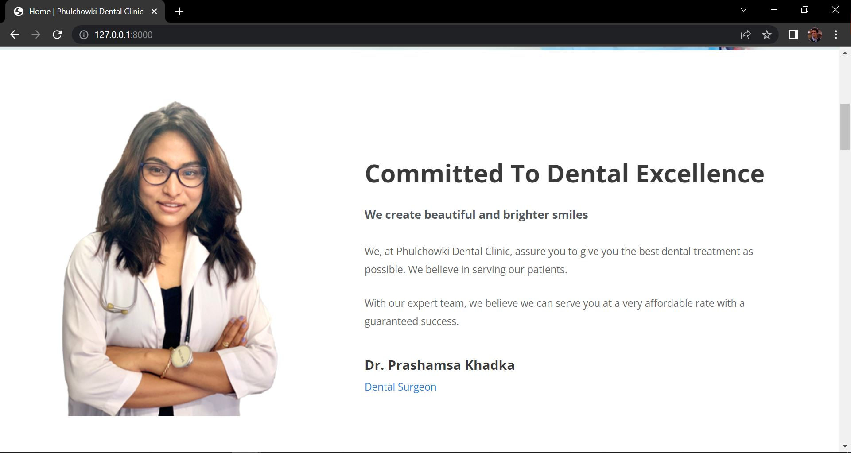

Figure 207: UI of Home Page 2

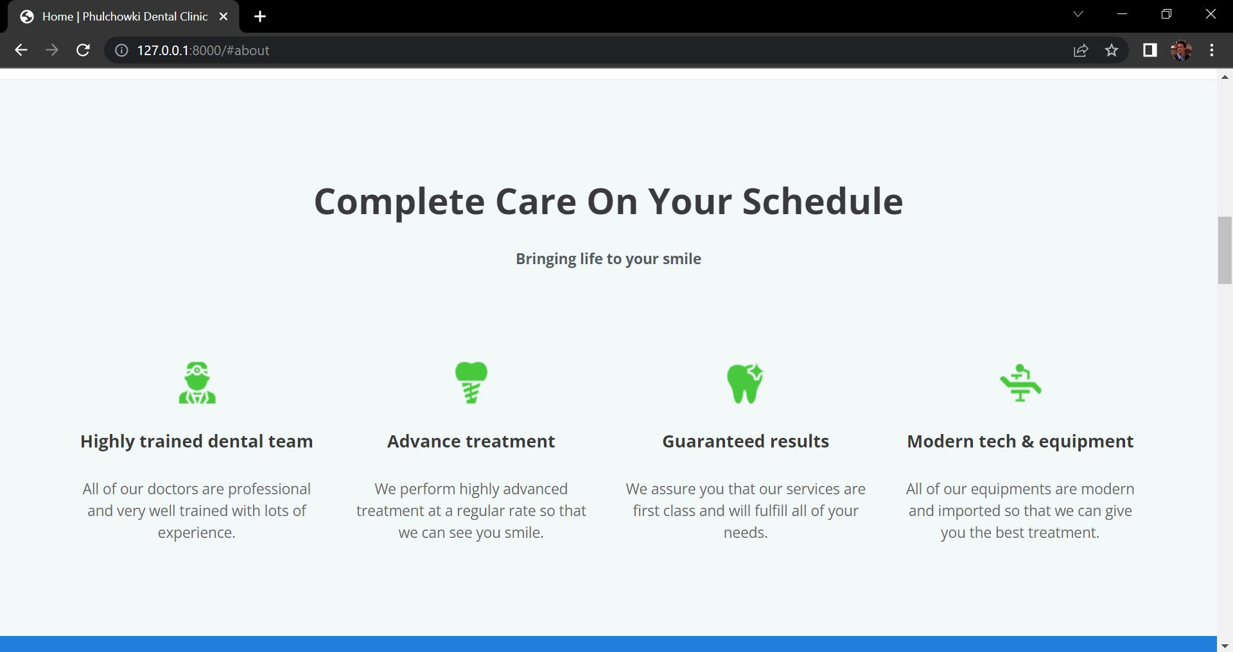

Figure 208: UI of Home Page 3

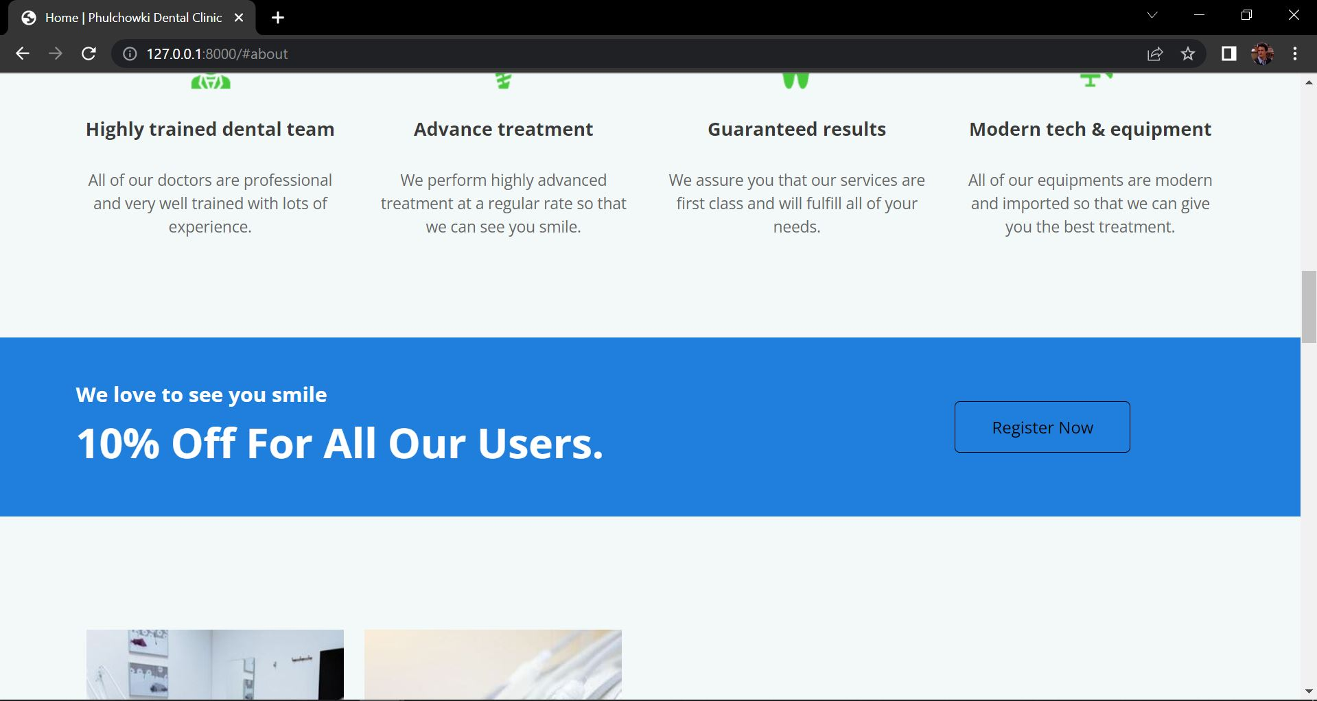

Figure 209: UI of Home Page 4

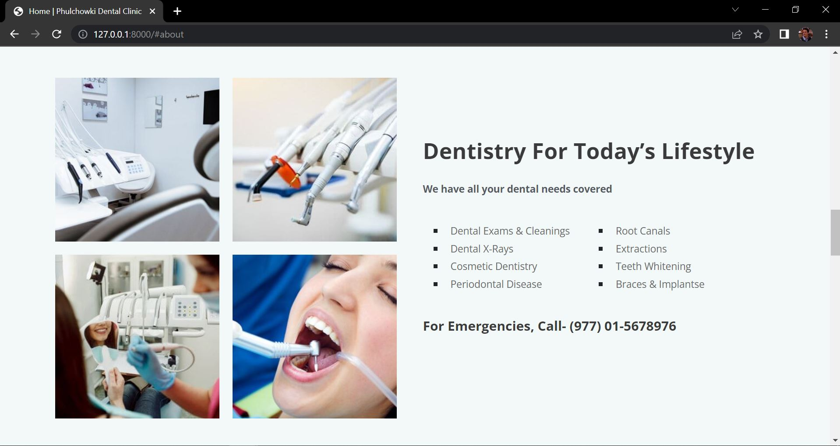

Figure 210: UI of Home Page 5

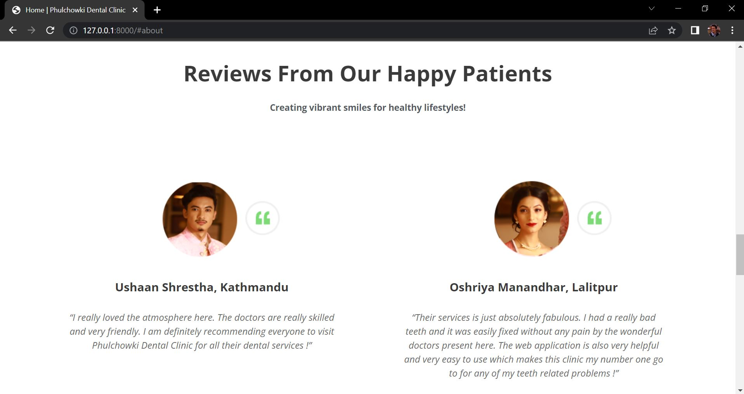

Figure 211: UI of Home Page 6

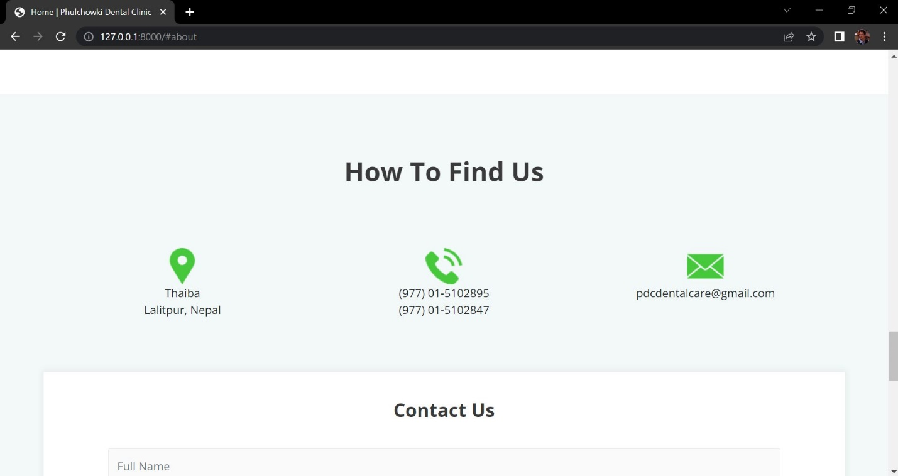

Figure 212: UI of Home Page 7

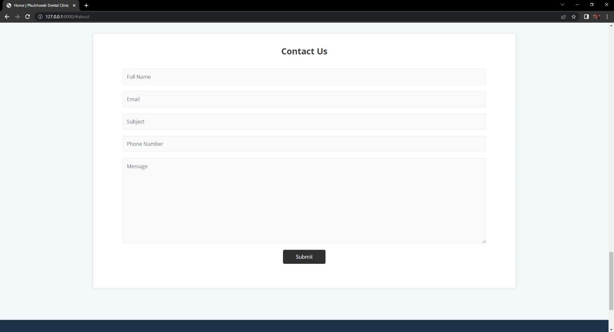

Figure 213: UI of Home Page 8

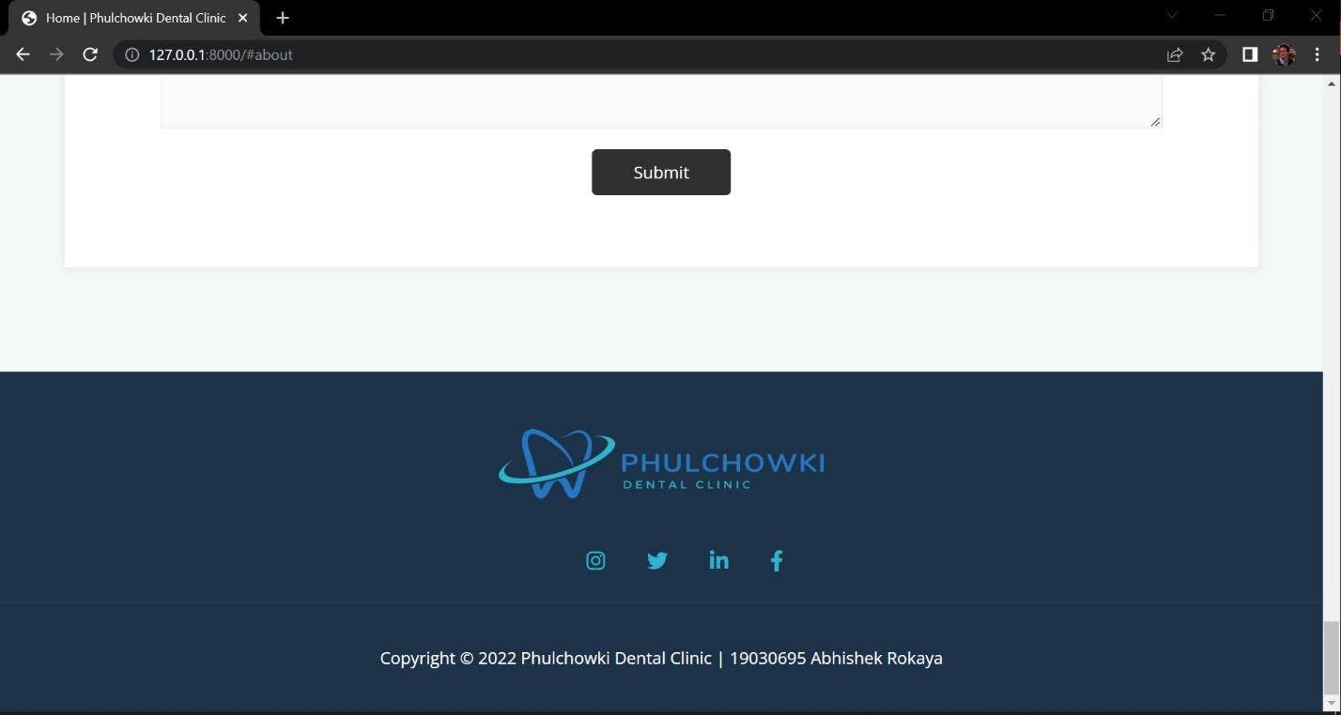

Figure 214: UI of Home Page 9

**7.4.5.4.2 Hardware Interfaces**

Since this is a web application, there are no such hardware requirements. This application can be executed on any functional machine with an internet connection.

**7.4.5.4.3 Software Interfaces**

The software interface for the application is as mentioned below:

* **Programming Language**: Python
* **Framework**: Django
* **IDE**: Visual Studio Code
* **Database**: SQLite3

**7.4.5.4.4 Communication Interfaces**

This system's communication interface will use the HTTP protocol for internet communication and the TCP/IP protocol suite for intranet communication.

**7.4.5.5 Non-Functional Requirements**

Non-functional requirements are those that are used to assess the application's quality. This section contains a comprehensive description of the application's non-functional needs.

**7.4.5.5.1 Performance Requirements**

|  |  |  |  |
| --- | --- | --- | --- |
| **Req. ID** | **Requirement Description** | **Priority** | **Complexity** |
| **PR1** | The system should be fast and easy to use. | Should | Medium |
| **PR2** | The system should be reliable meaning the function should work properly. | Should | Normal |
| **PR3** | The system should be user friendly. | Should | Normal |

Table 46: Performance Requirement

**7.4.5.5.2 Safety Requirements**

|  |  |  |  |
| --- | --- | --- | --- |
| **Req. ID** | **Requirement Description** | **Priority** | **Complexity** |
| **SR1** | The program shall not install any type of malware or spyware in the background without notifying the users. | Should | Medium |
| **SR2** | The system must keep track of the session to guarantee that the login and logout are secure. | Should | High |
| **SR3** | A user category must not have access to the profiles of other user categories, i.e. a user (patient) must not be able to access the admin panel. | Should | Medium |

Table 47: Safety Requirement

**7.4.5.5.3 Other Software Quality Attributes**

|  |  |  |  |
| --- | --- | --- | --- |
| **Req. ID** | **Requirement Description** | **Priority** | **Complexity** |
| **SQA1** | The system must be scalable, which means that it should be able to incorporate new features in the future. | Could | Medium |
| **SQA2** | All users must be able to quickly access the program. | Should | Normal |
| **SQA3** | The system must be user-friendly, and even non-technical users should be able to utilize it with ease. | Should | Normal |
| **SQA4** | The program must be interoperable, which means it must act consistently across browsers. | Could | Normal |

Table 48: Other Software Quality Attributes

### 7.4.6 Wireframes

A wireframe is a schematic or blueprint that is useful for helping you, your programmers and designers think and communicate about the structure of the software or website you're building. (Guilizzoni, 2022) The wireframes are created using Balsamiq. It is a desktop application that is used to create various kinds of wireframes for different web as well as mobile based applications. Wireframes are needed in a software development. It creates a blueprint for the application we are developing. It helps in the development phase to create a design by looking at the wireframes.

The wireframes for the dental appointment system application are as follows:

1. Home Page (Landing Page)

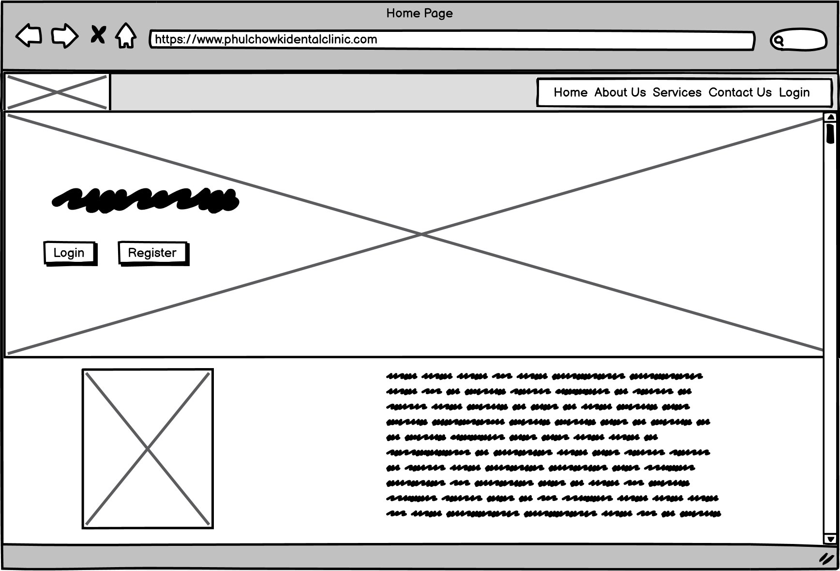

Figure 215: Wireframe - Home Page

2. User Registration Page

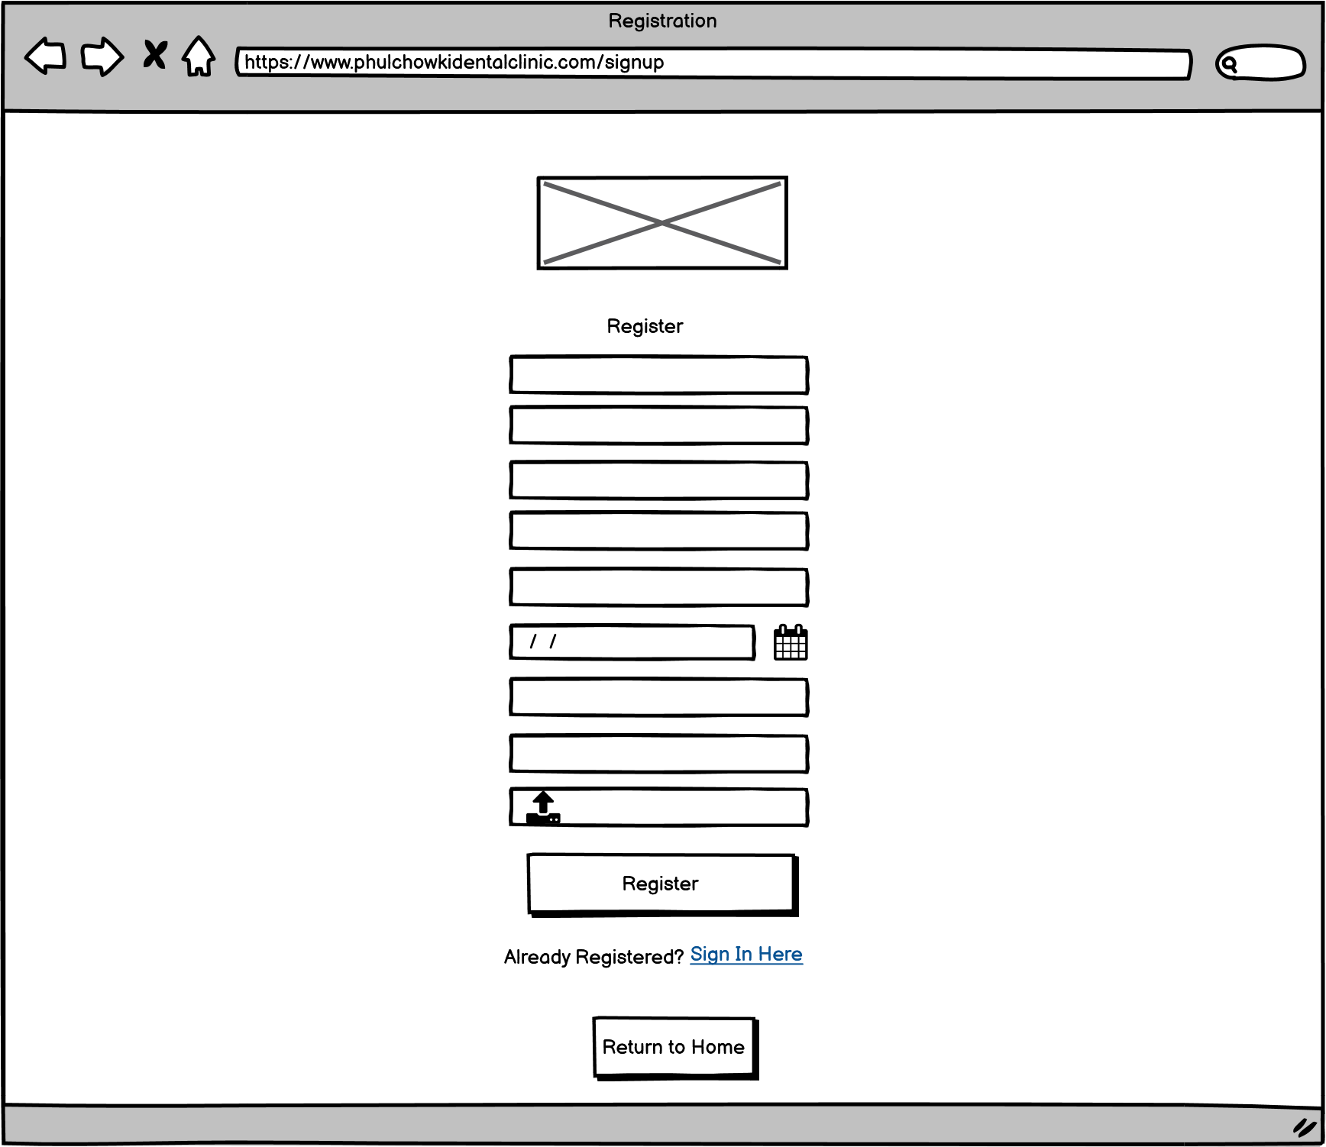

Figure 216: Wireframe - User Registration

3. User Login Page

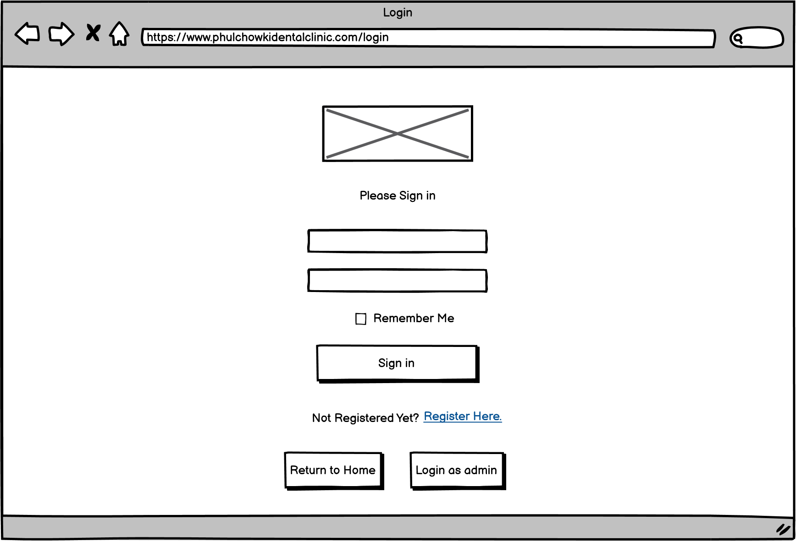

Figure 217: Wireframe - User Login

4. Admin Login Page

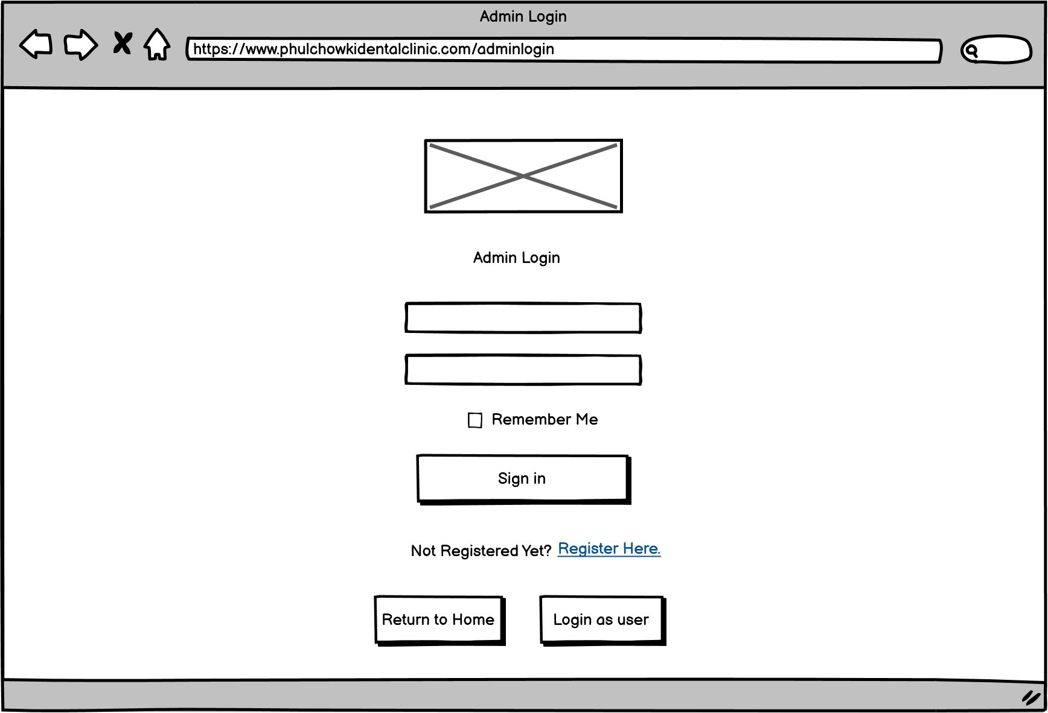

Figure 218: Wireframe - Admin Login

5. User Dashboard Page

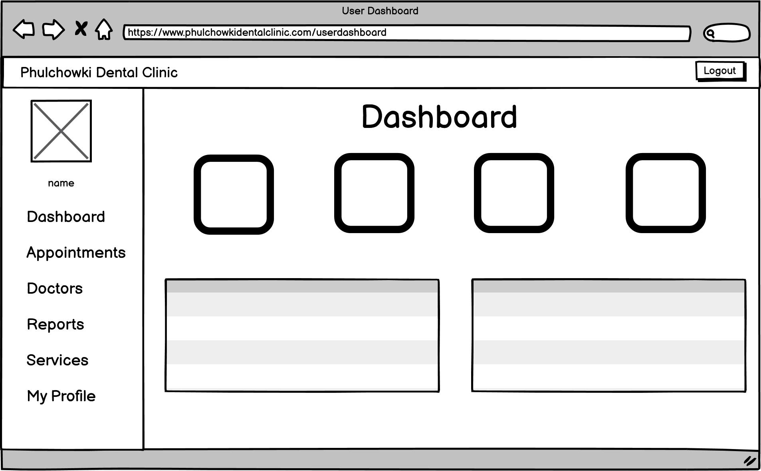

Figure 219: Wireframe - User Dashboard

6. User View Appointment Page

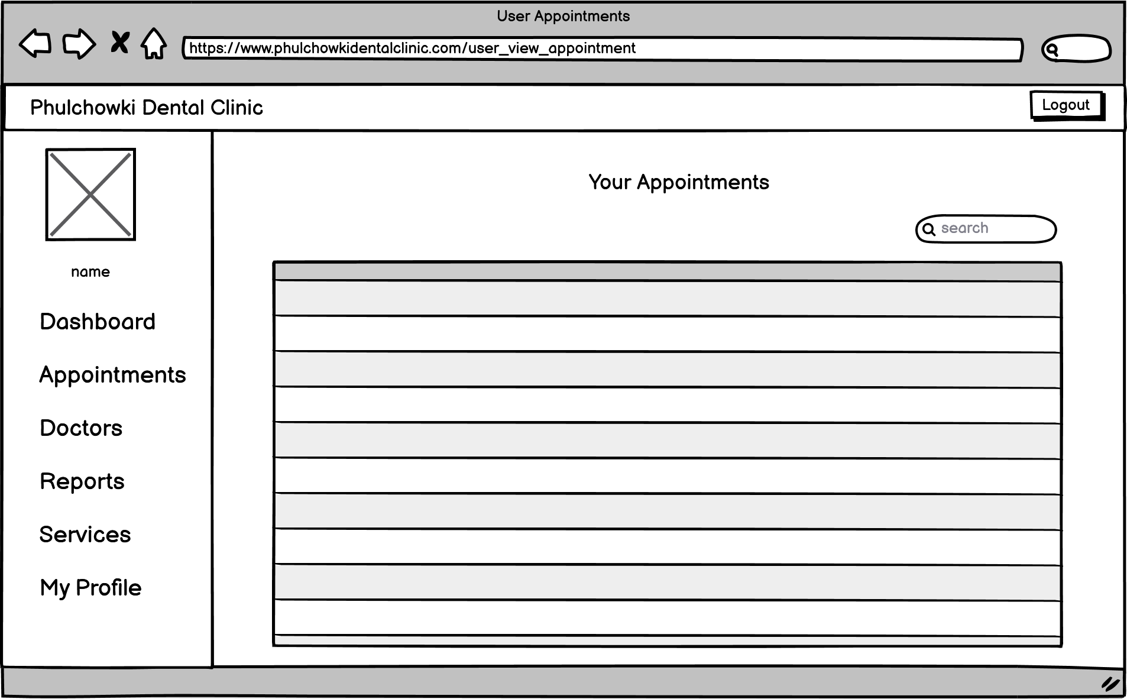

Figure 220: Wireframe - User View Appointment

7. User Book Appointment Page

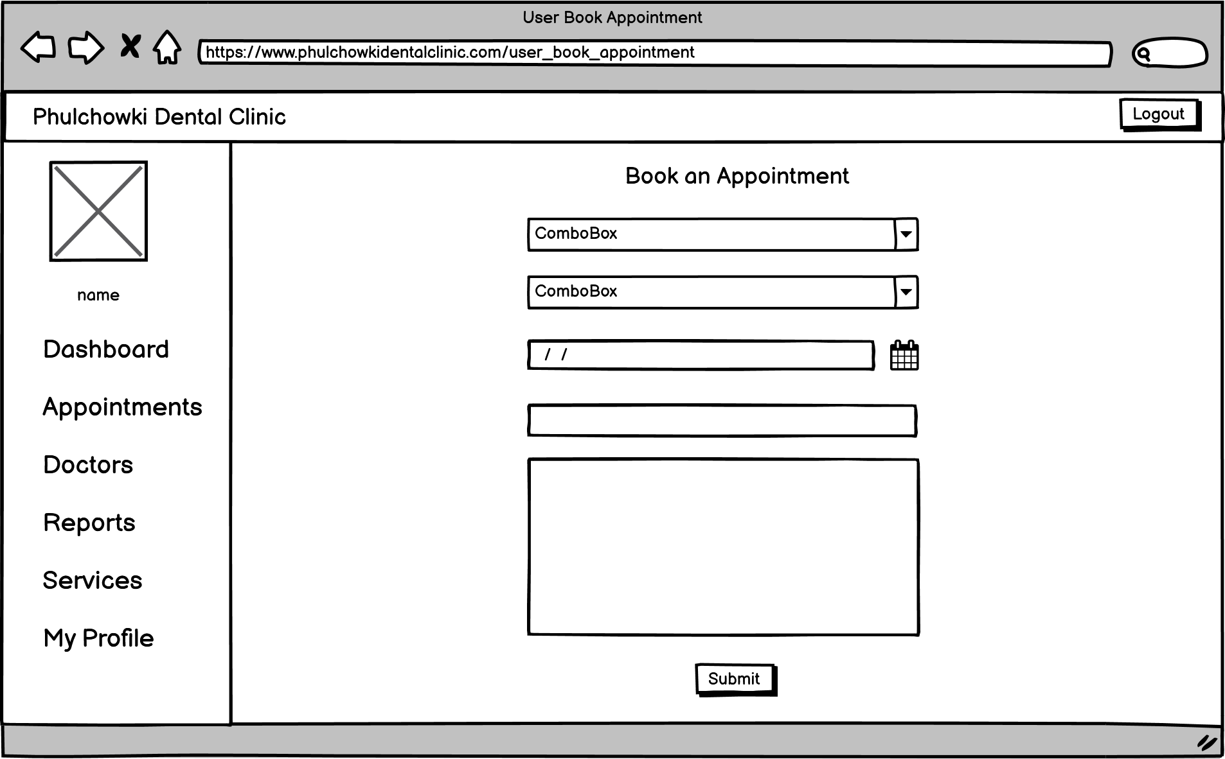

Figure 221: Wireframe - User Book Appointment

8. User View Doctor Page

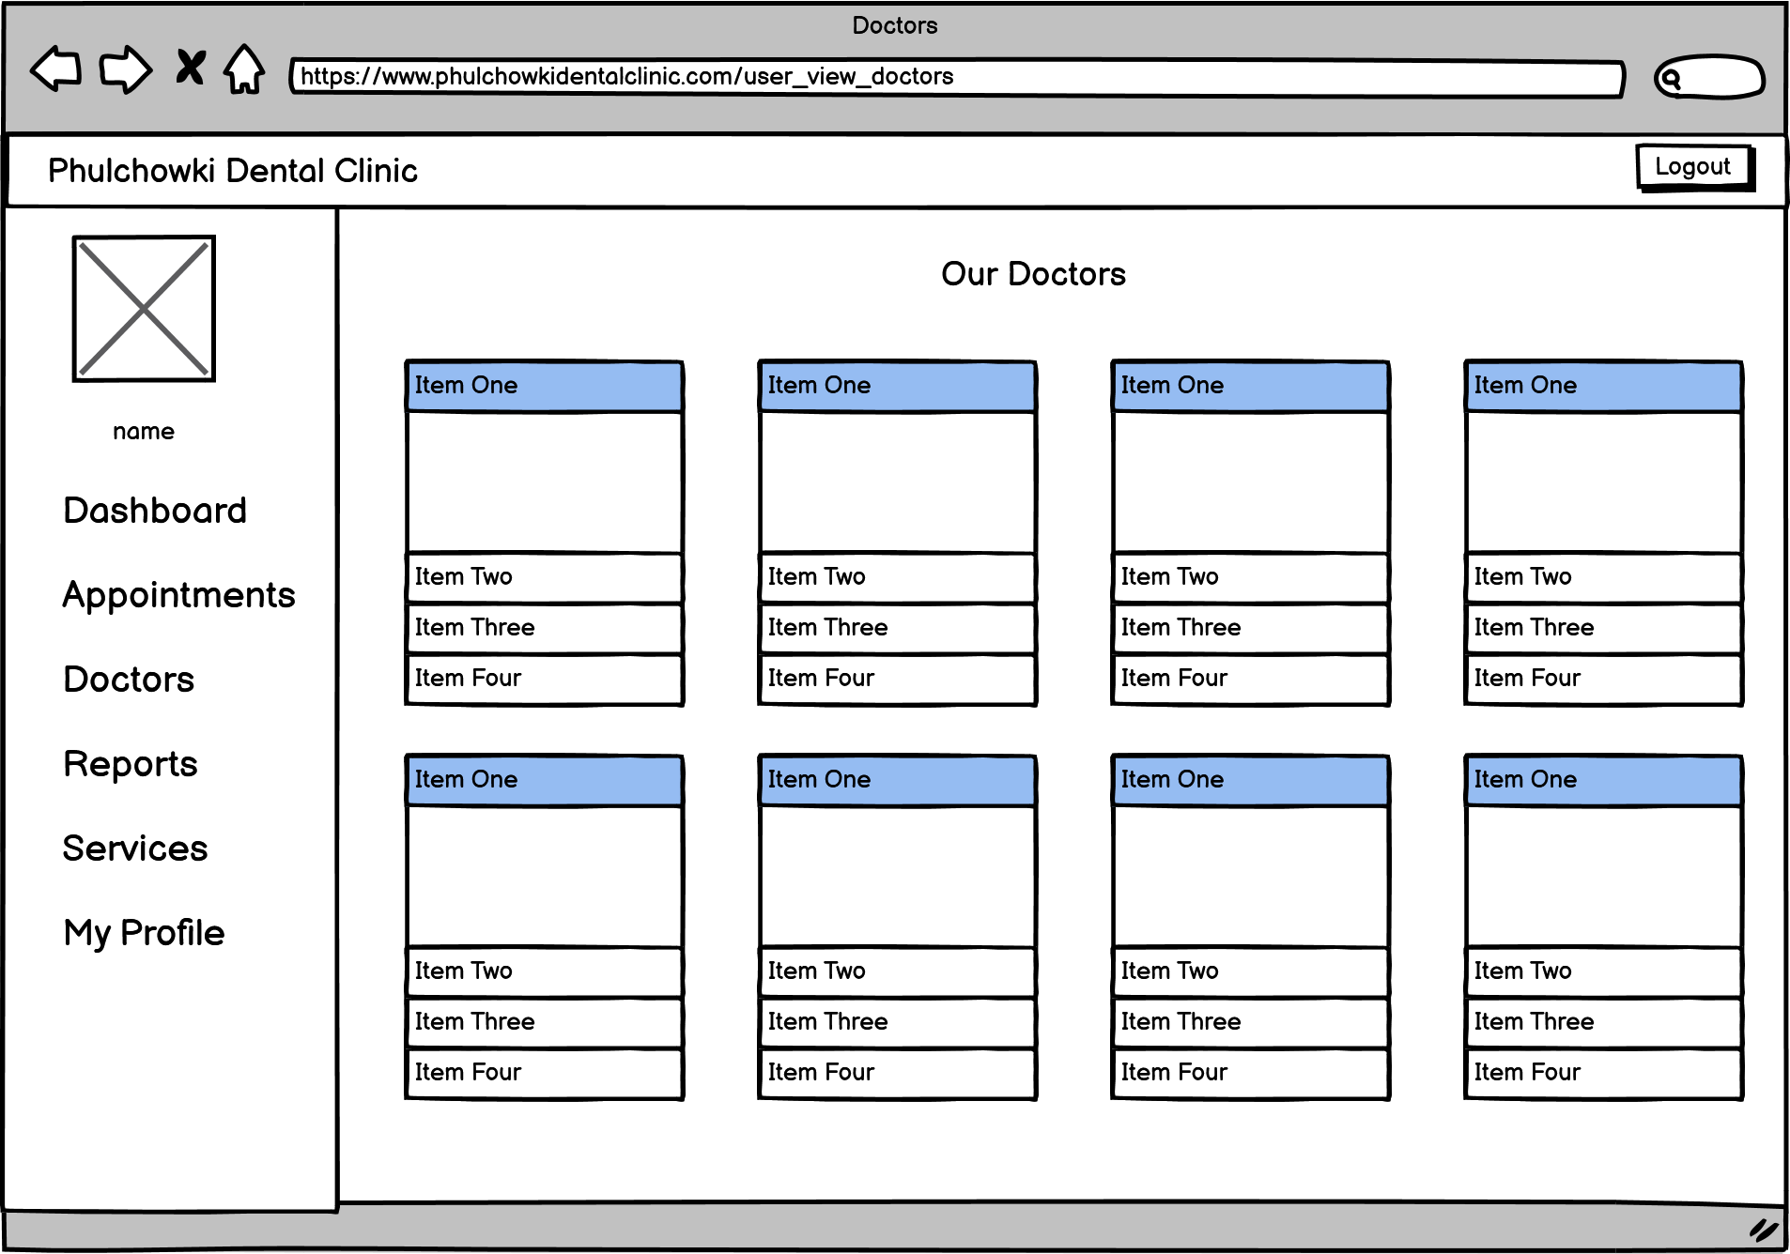

Figure 222: Wireframe - User View Doctor

9. User View Report Page

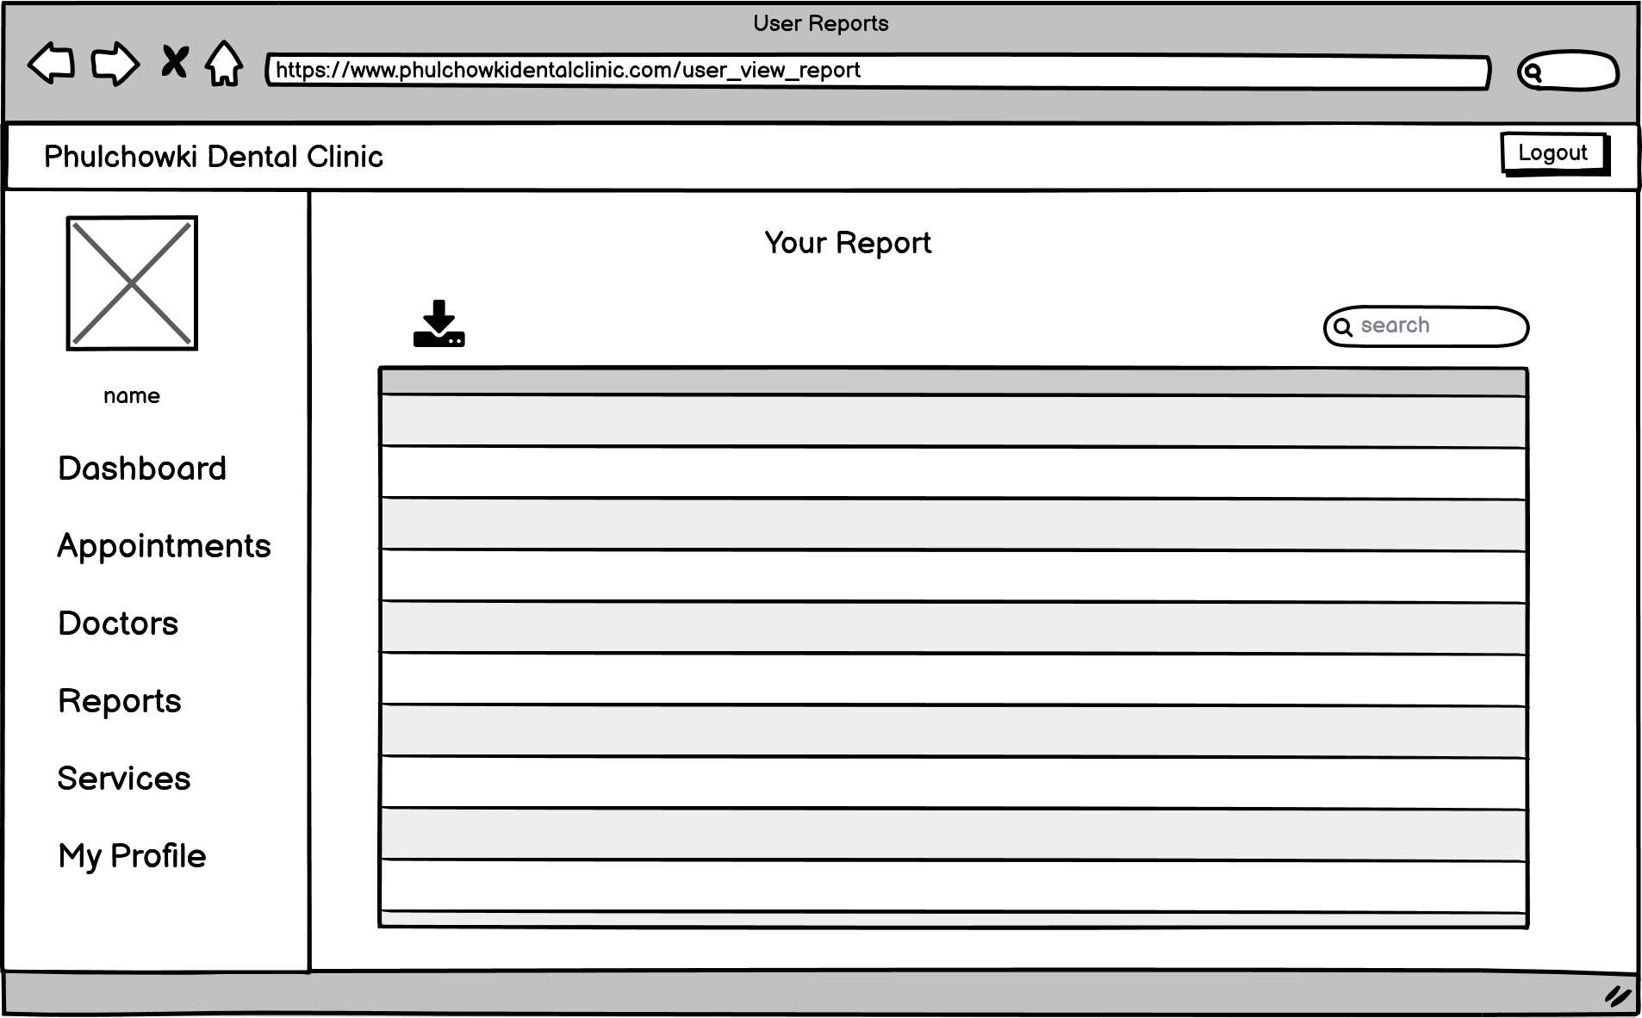

Figure 223: Wireframe - User View Report

10. User View Service Page

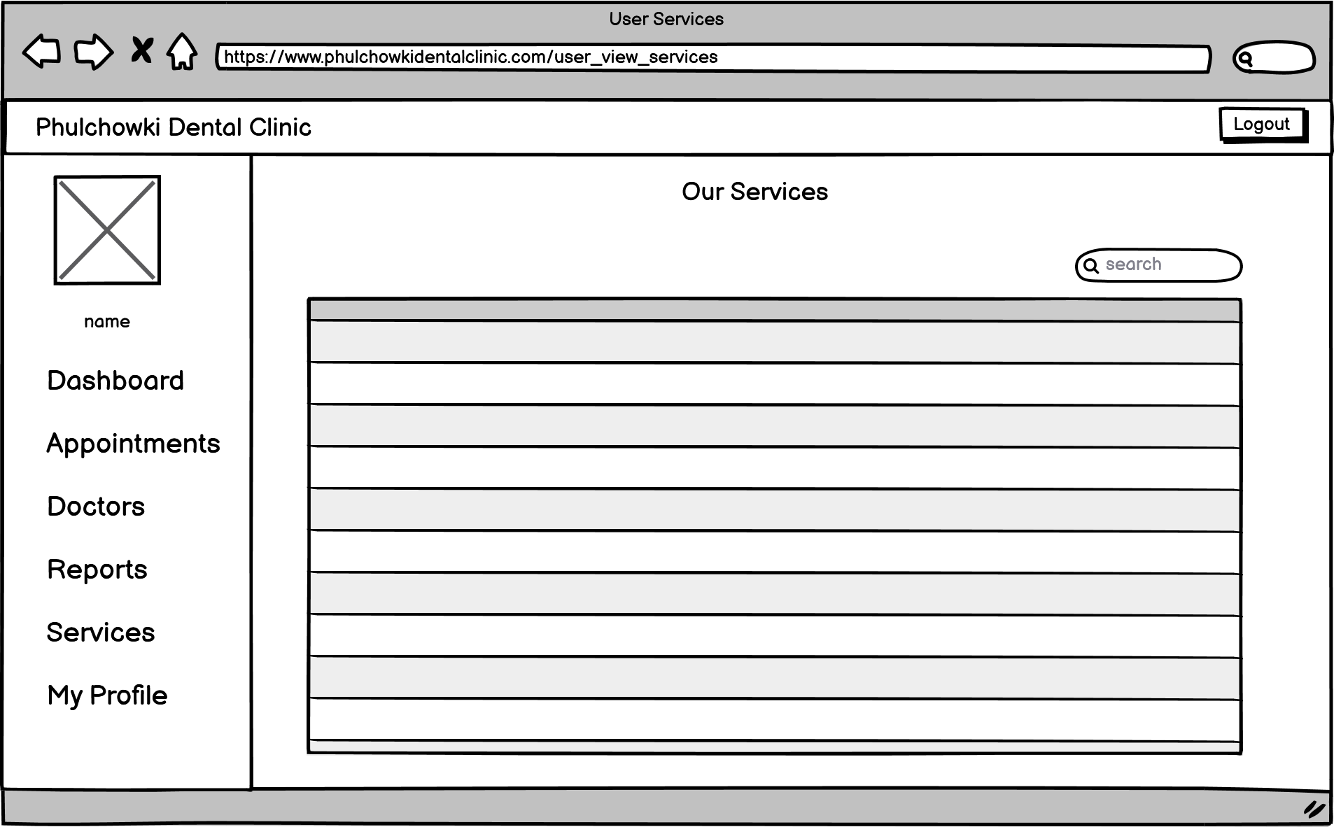

Figure 224: Wireframe - User View Service

11. User View Profile Page

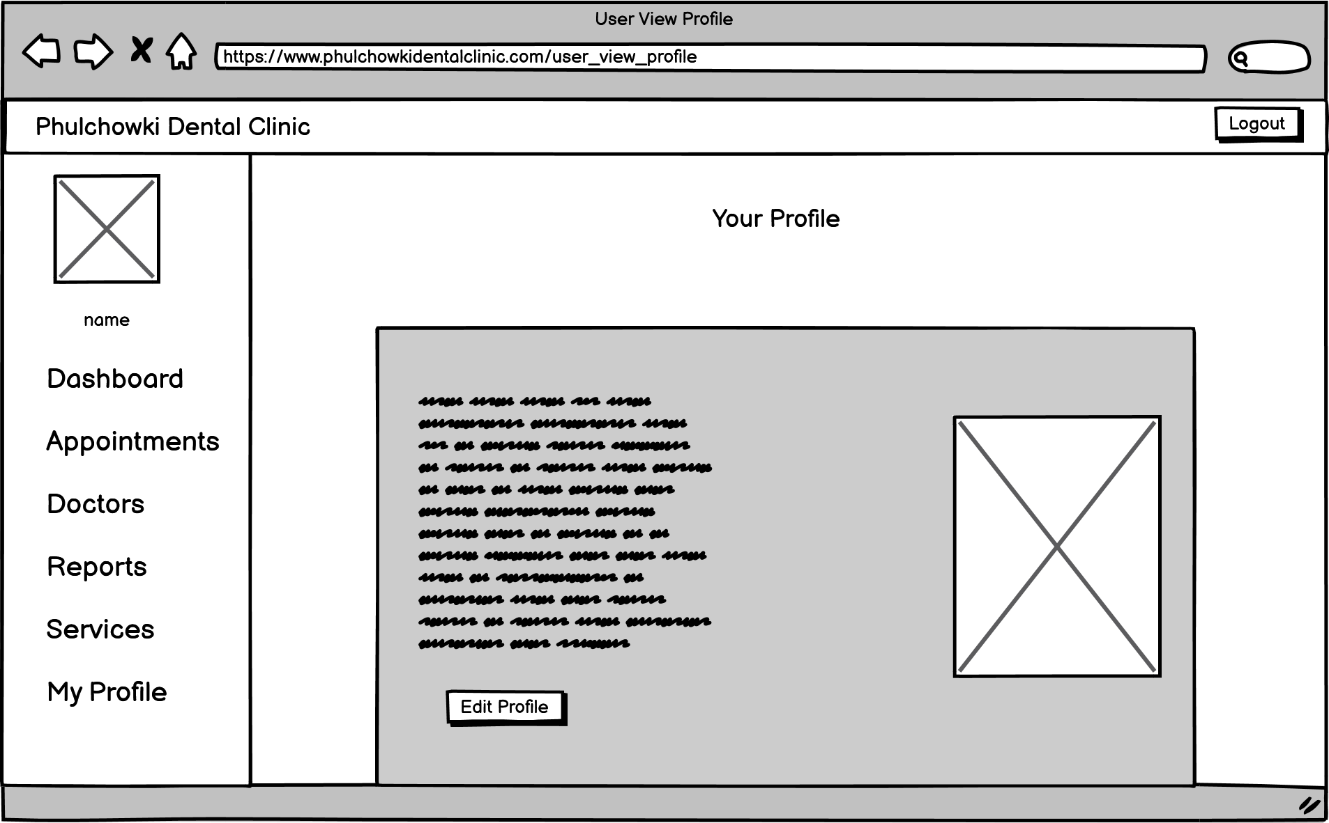

Figure 225: Wireframe - User View Profile

12. User Edit Profile Page

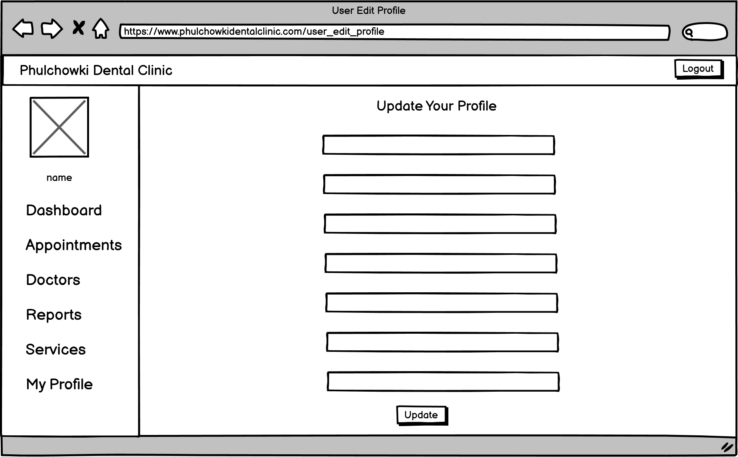

Figure 226: Wireframe - User Edit Profile

13. Admin Dashboard Page

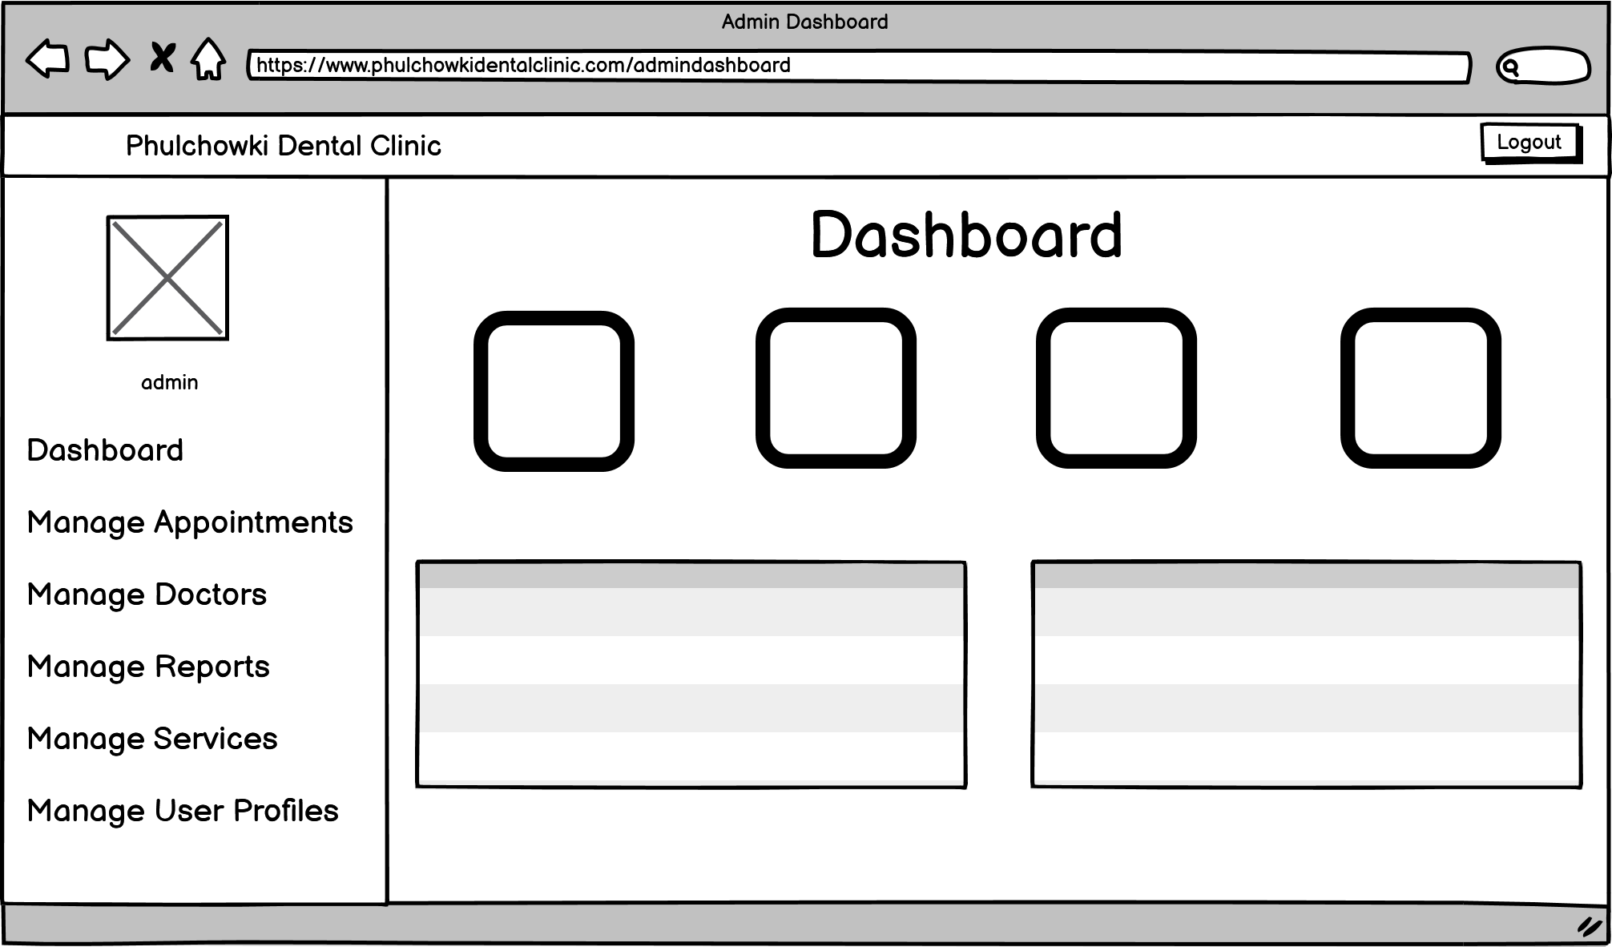

Figure 227: Wireframe - Admin Dashboard

14. Admin View Appointment Page

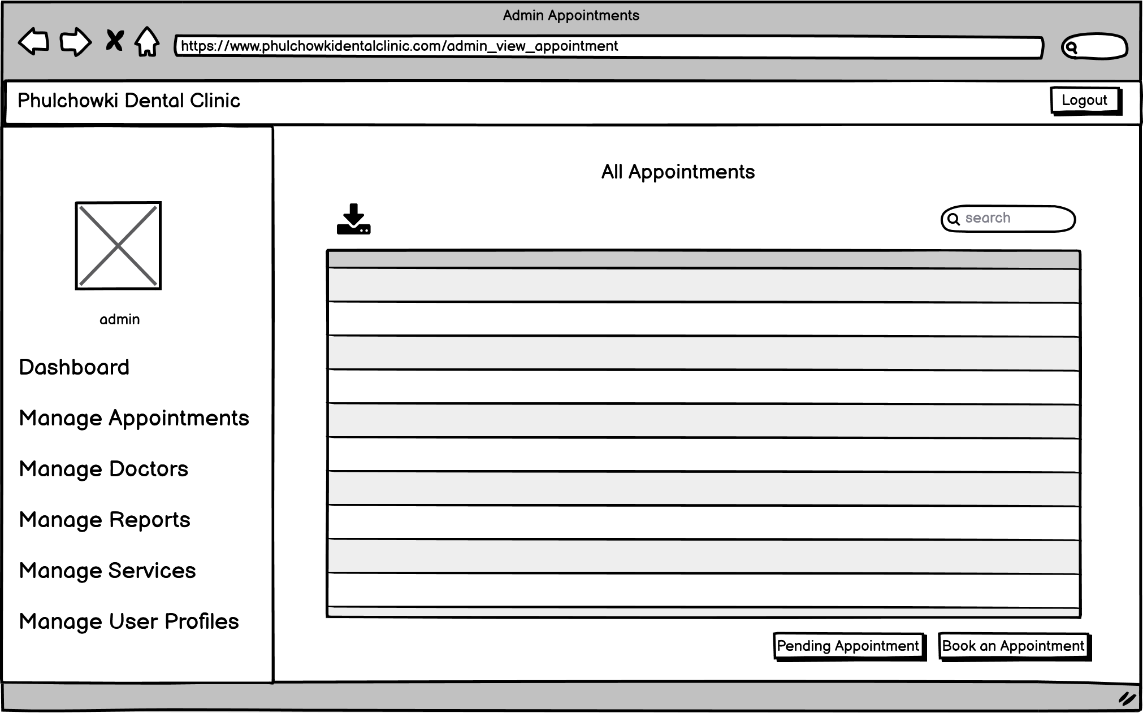

Figure 228: Wireframe - Admin View Appointment

15. Admin Approve Appointment Page

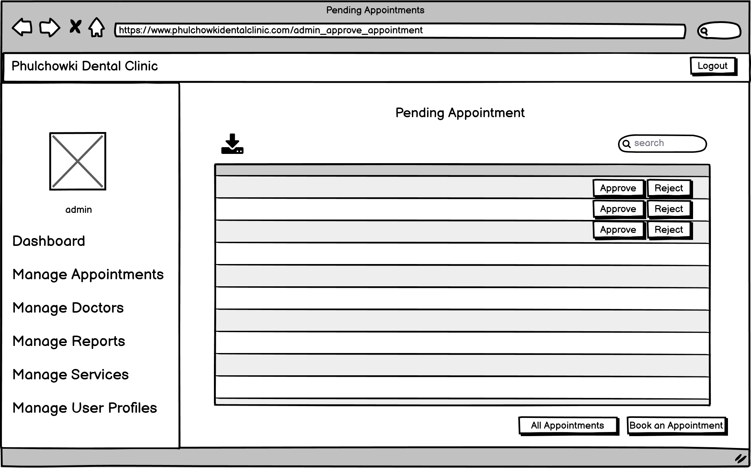

Figure 229: Wireframe - Admin Approve Appointment

16. Admin Book Appointment Page

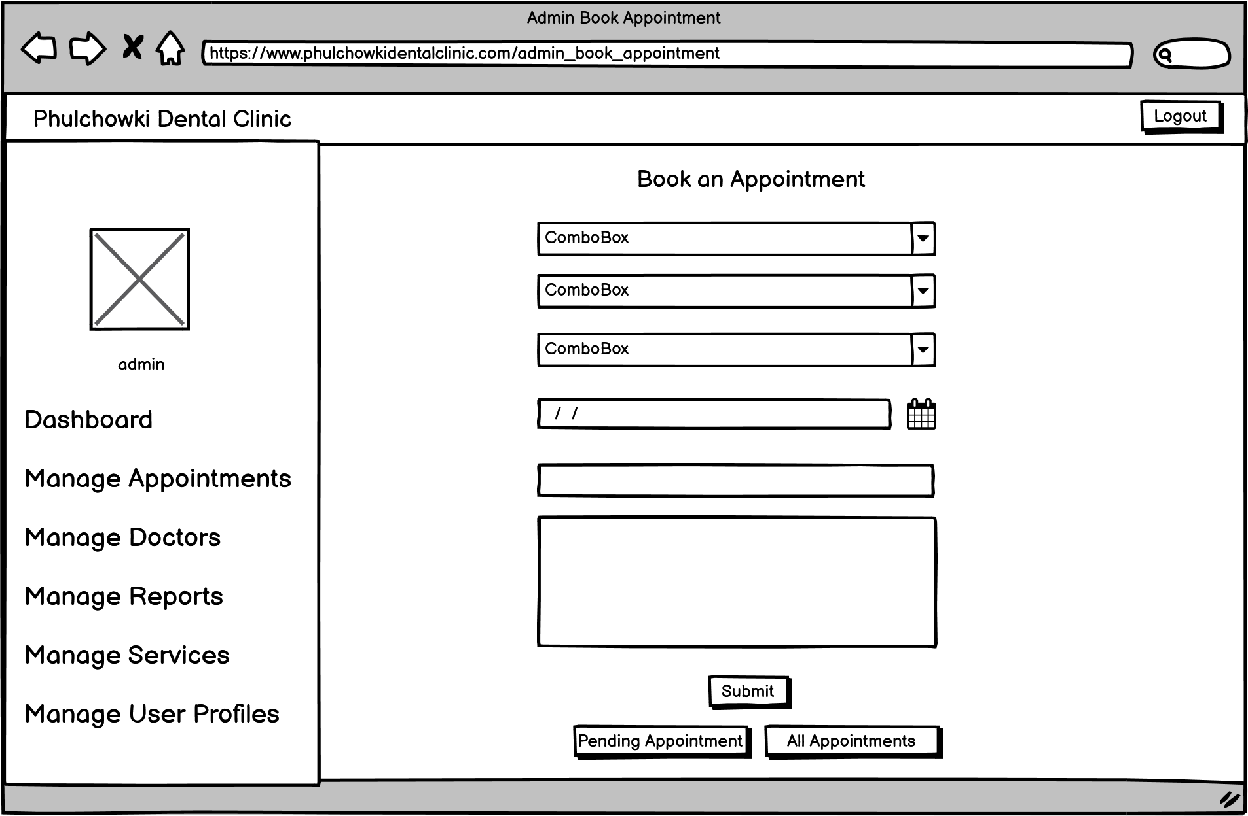

Figure 230: Wireframe - Admin Book Appointment

17. Admin View Doctor Page

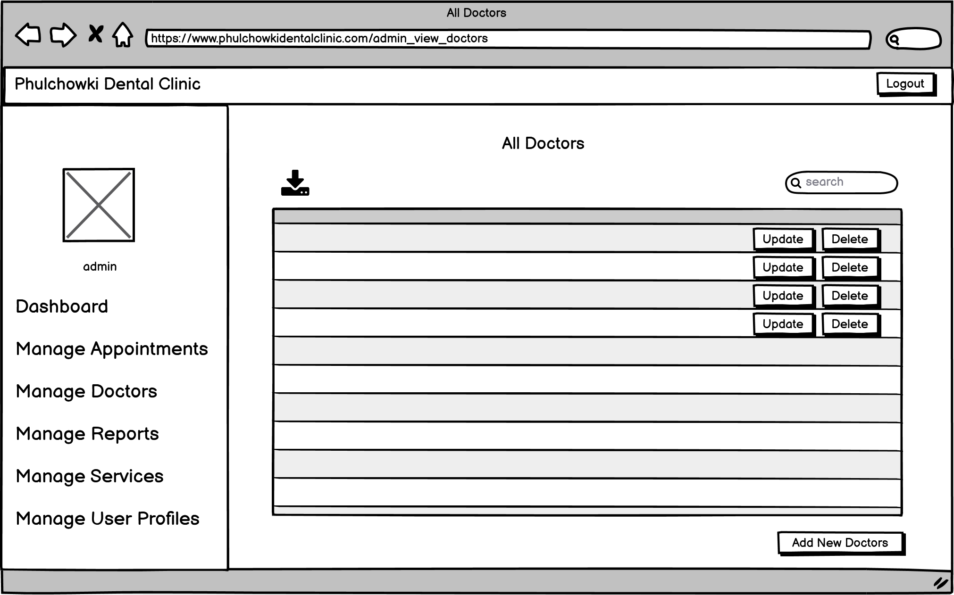

Figure 231: Wireframe - Admin View Doctor

18. Admin Add Doctor Page

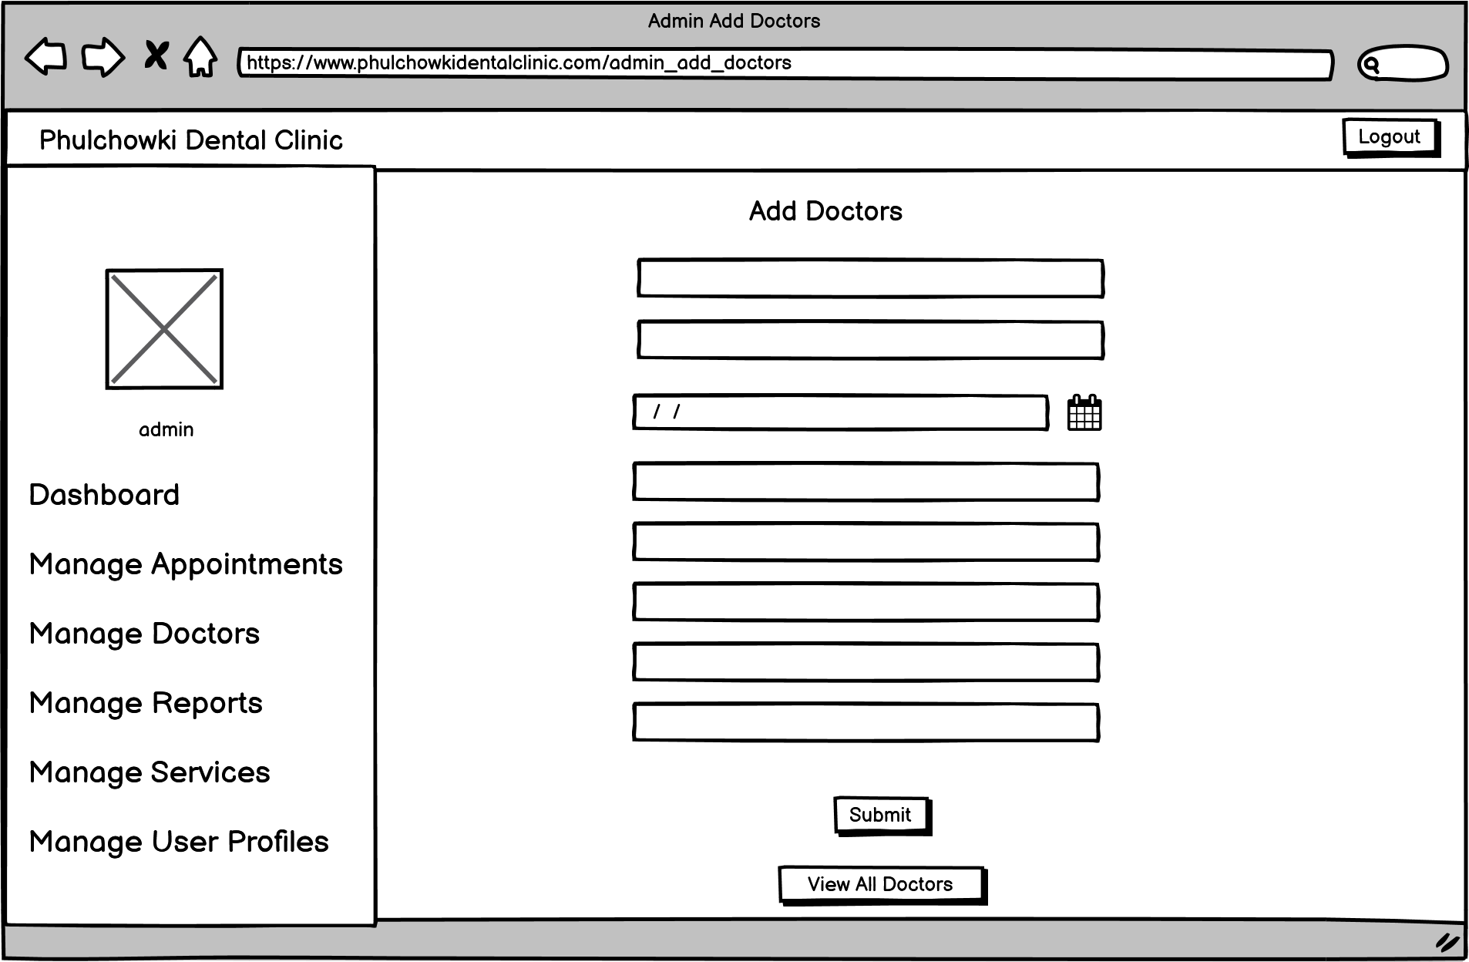

Figure 232: Wireframe - Admin Add Doctor

19. Admin View Report Page

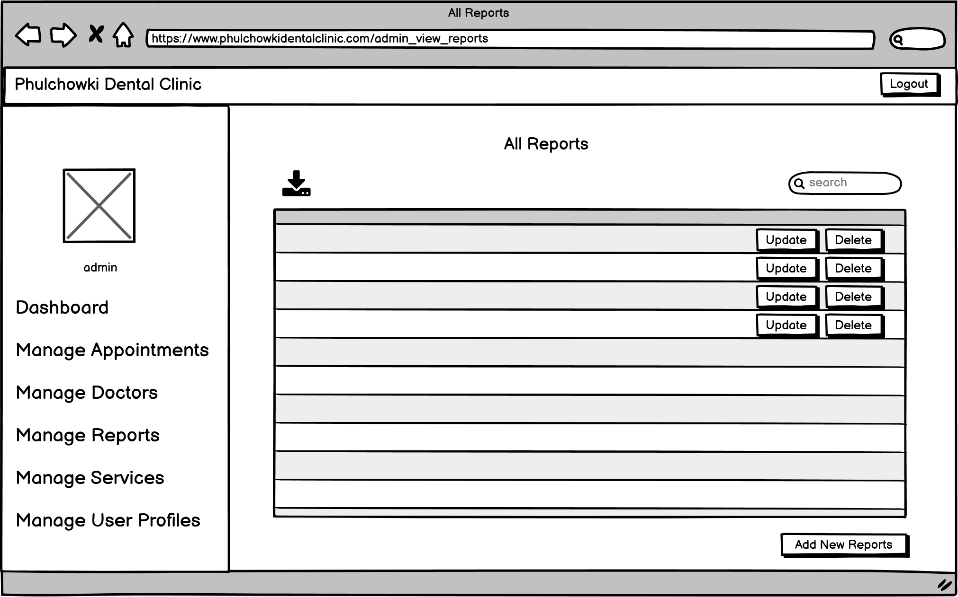

Figure 233: Wireframe - Admin View Report

20. Admin Add Report Page

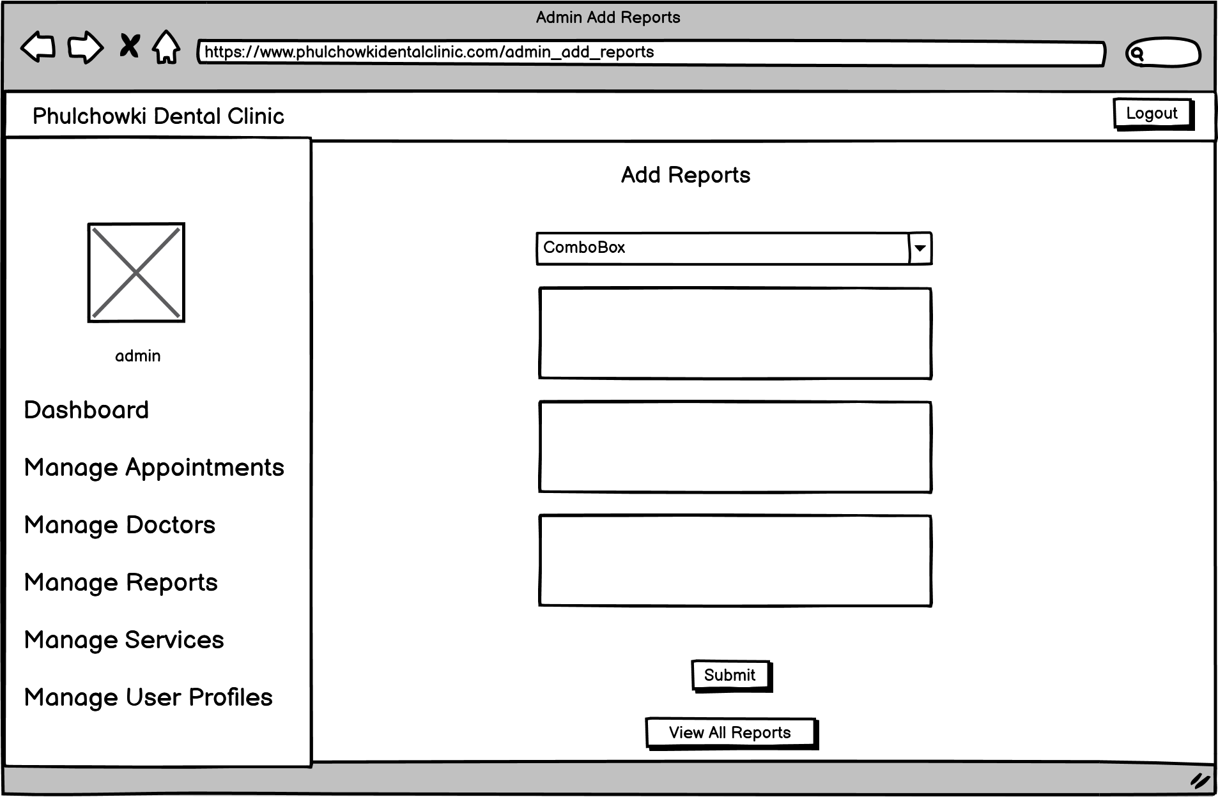

Figure 234: Wireframe - Admin Add Report

21. Admin View Service Page

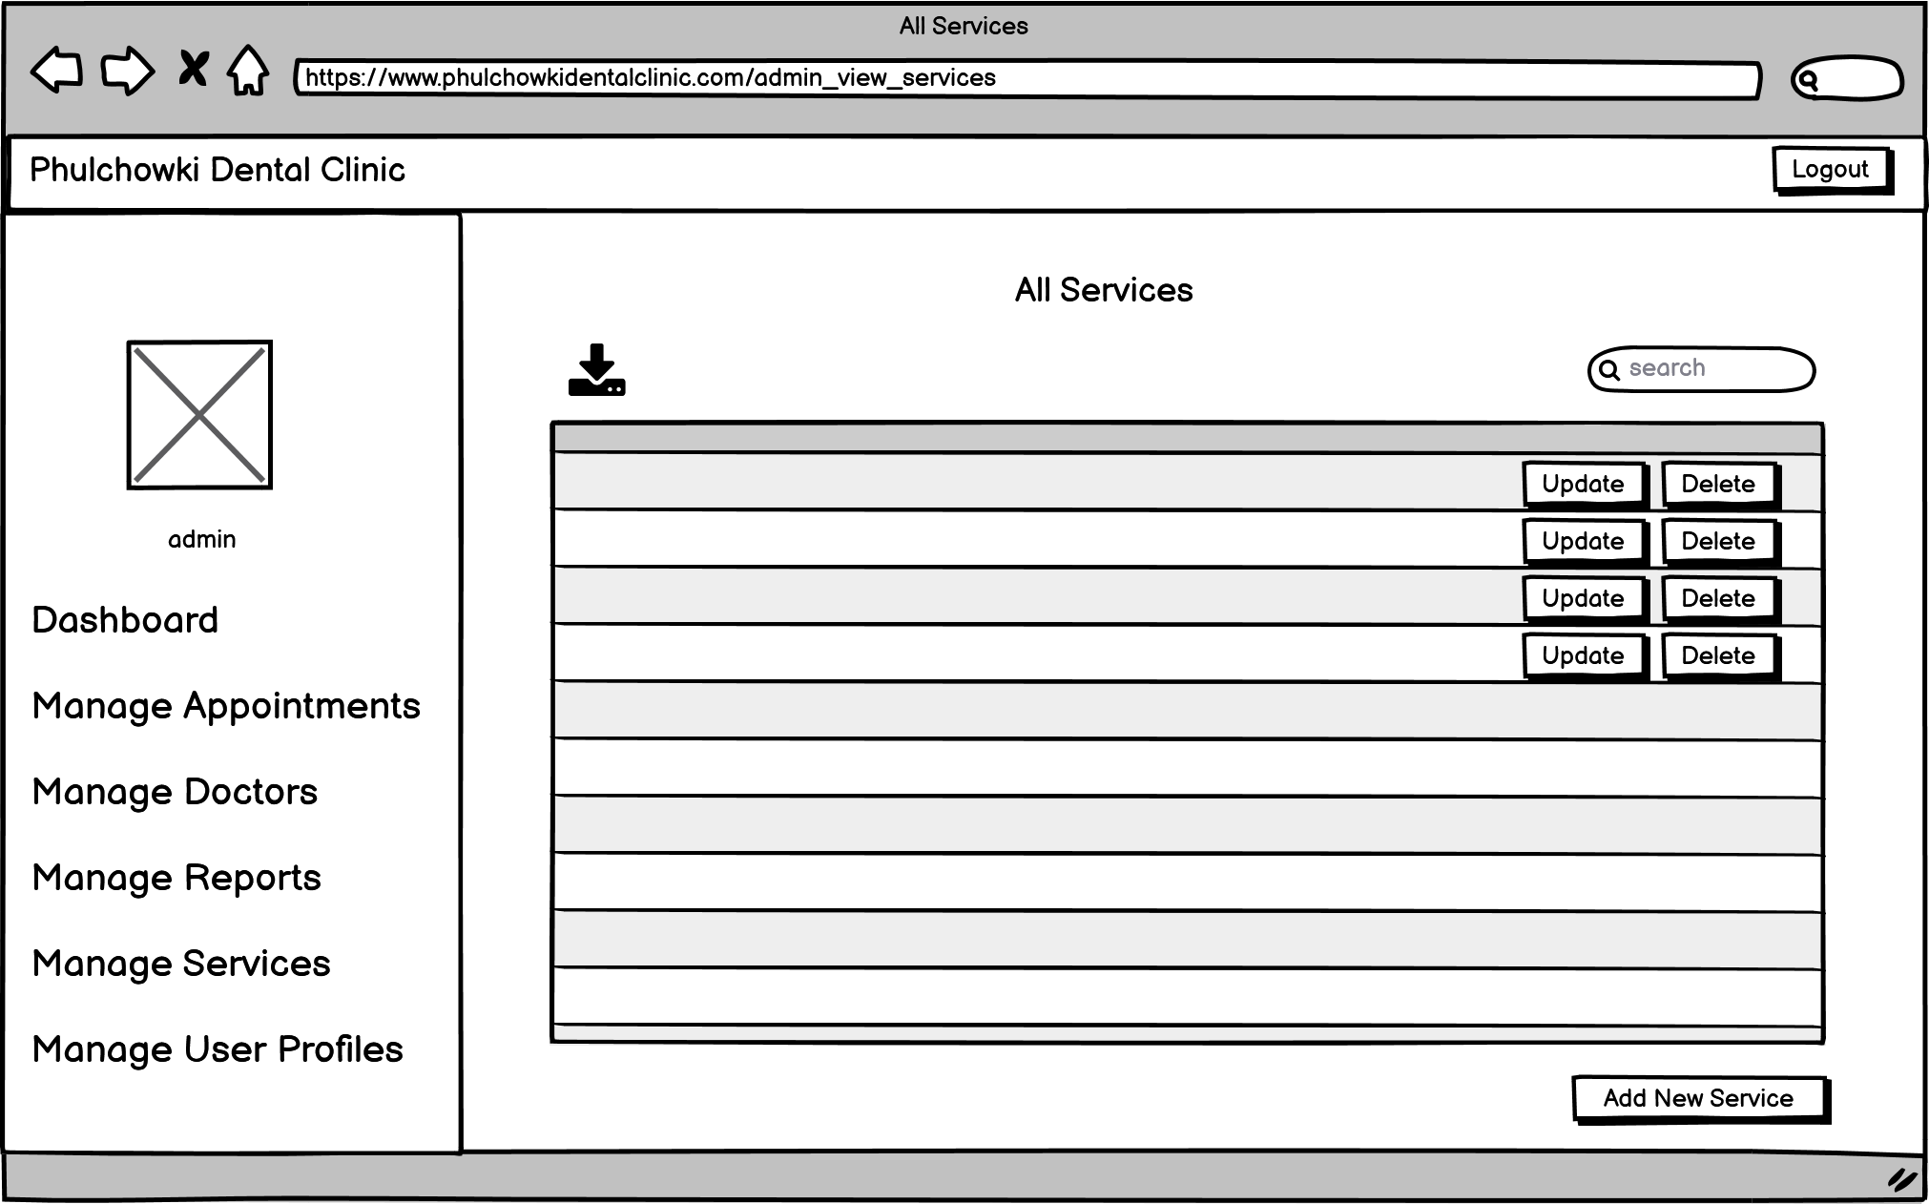

Figure 235: Wireframe - Admin View Service

22. Admin Add Service Page

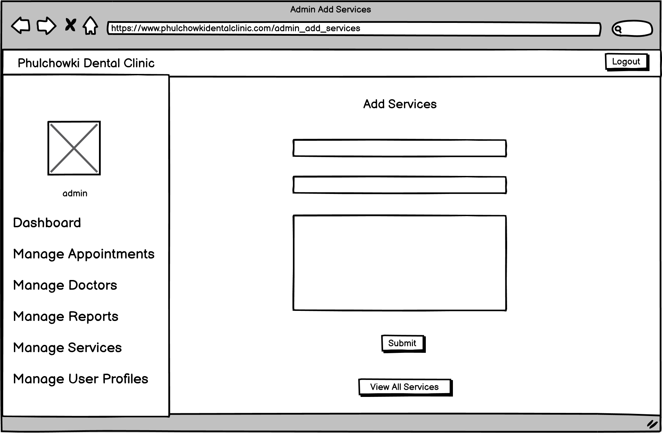

Figure 236: Wireframe - Admin Add Service

23. Admin View Users Page

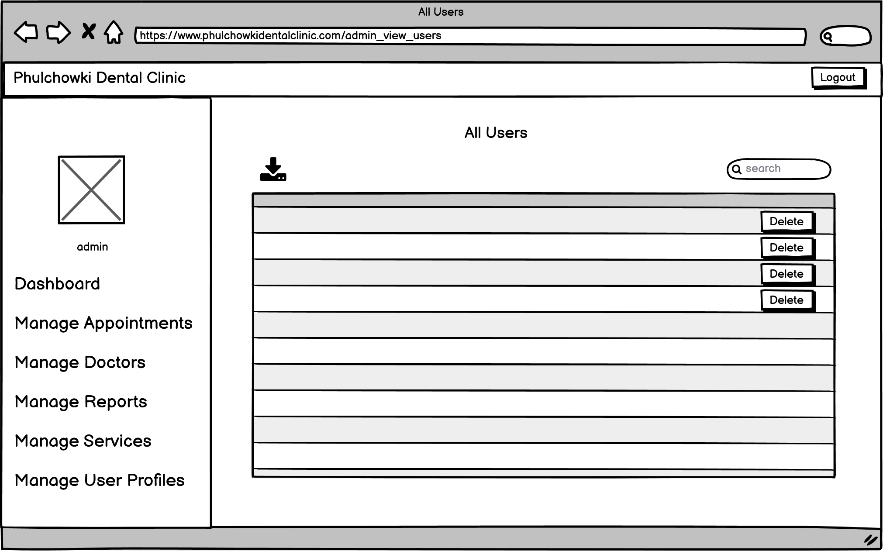

Figure 237: Wireframe - Admin View Users

## 7.5 Appendix E: Screenshots of the System

**Landing Home Page**



















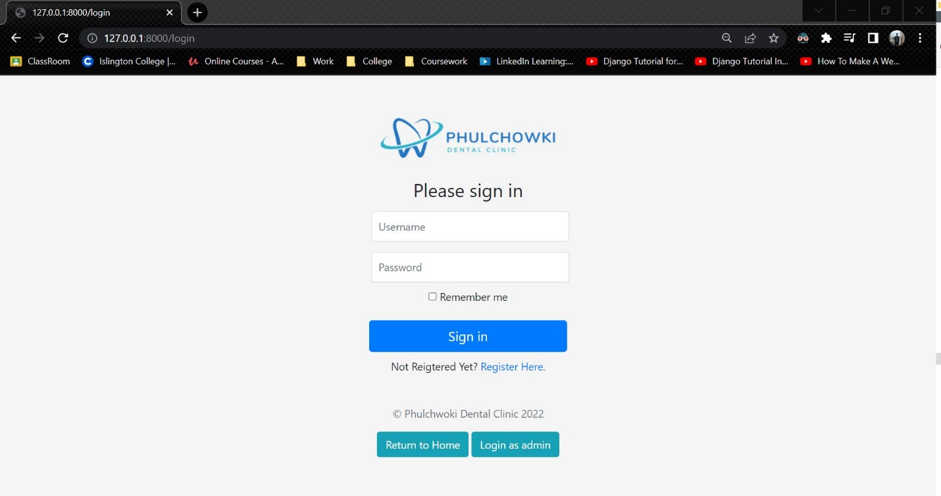

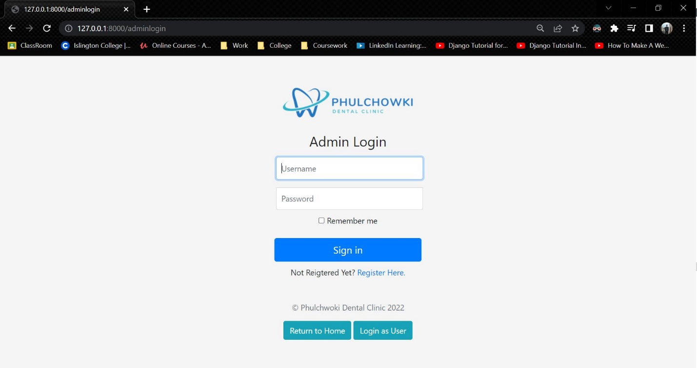

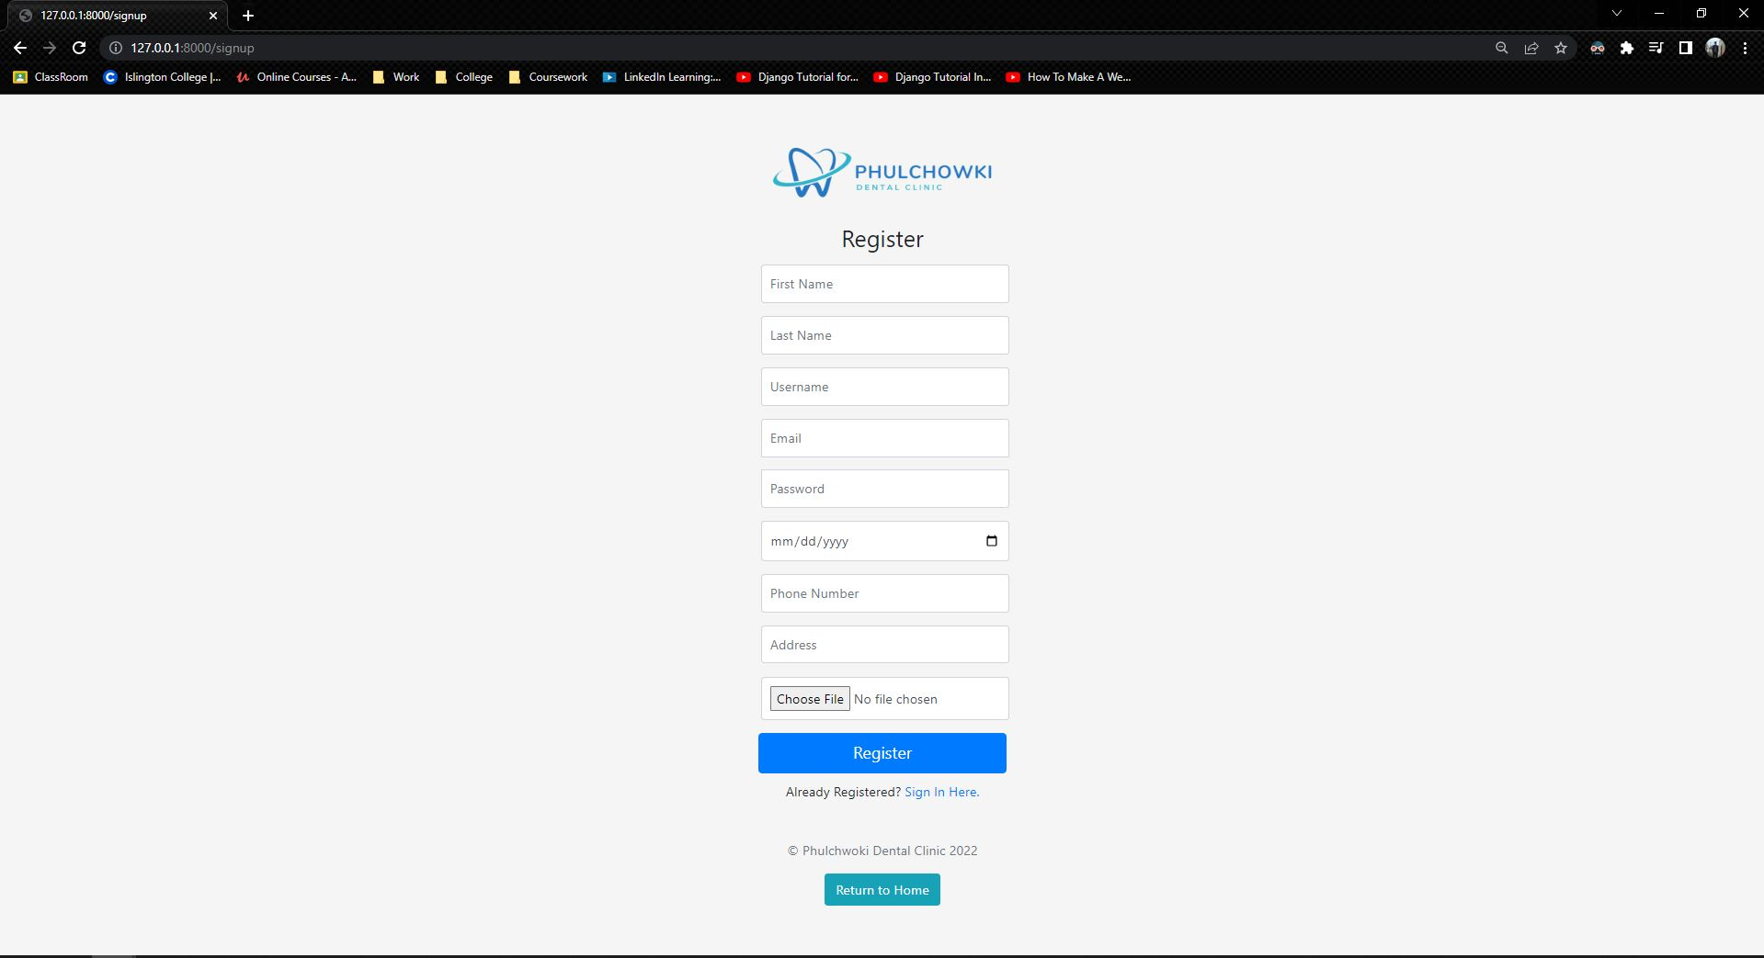

**User Side UI**

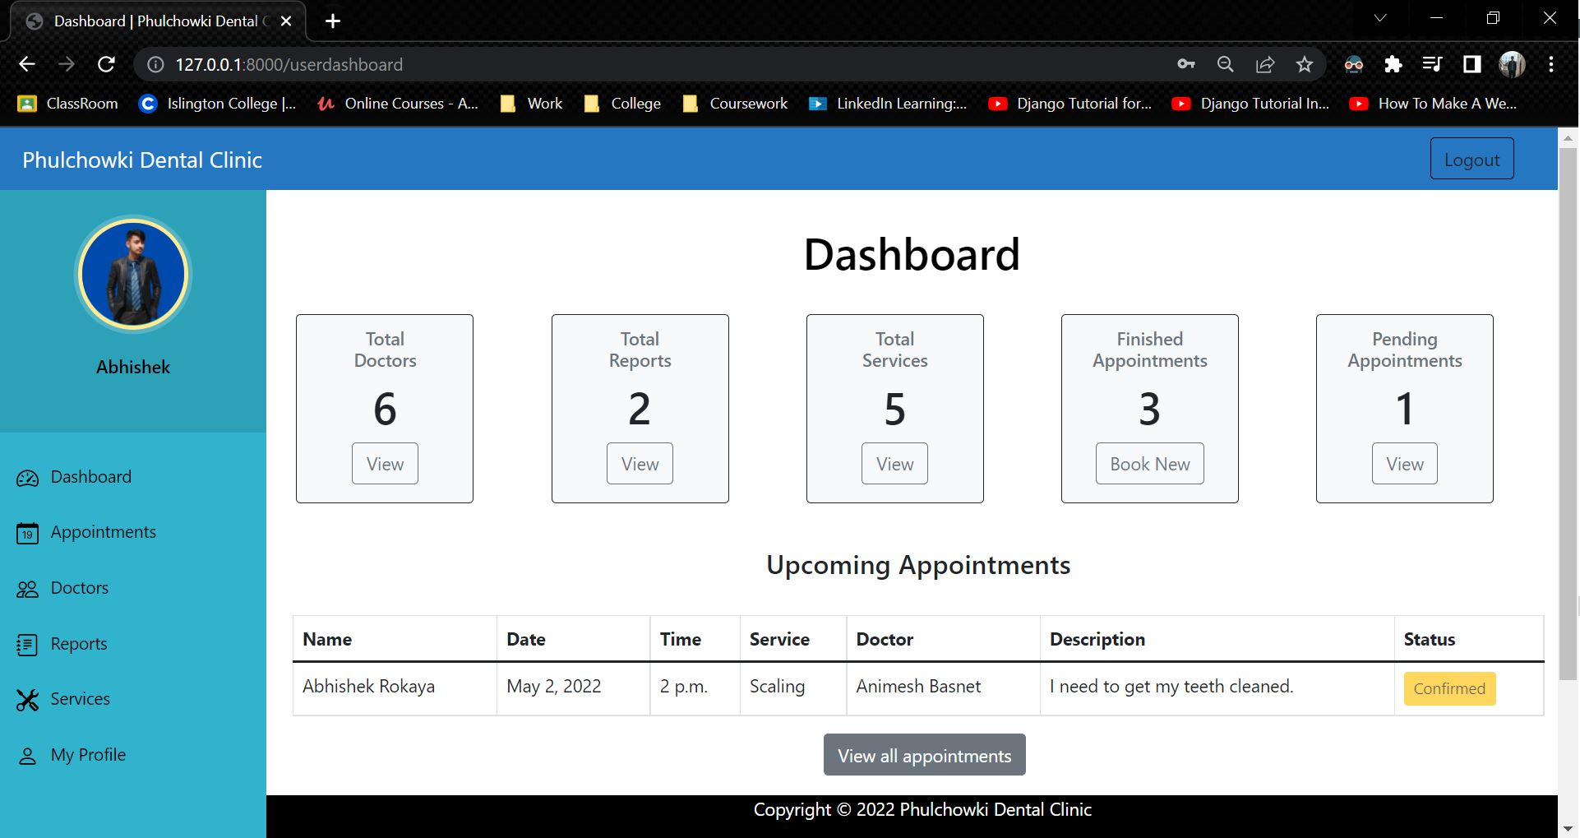

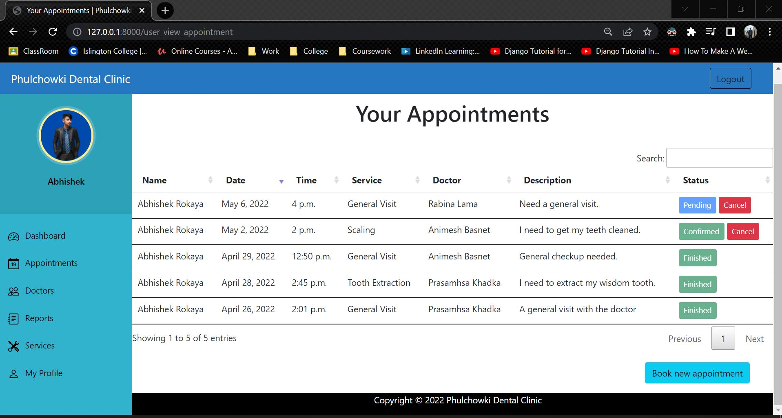

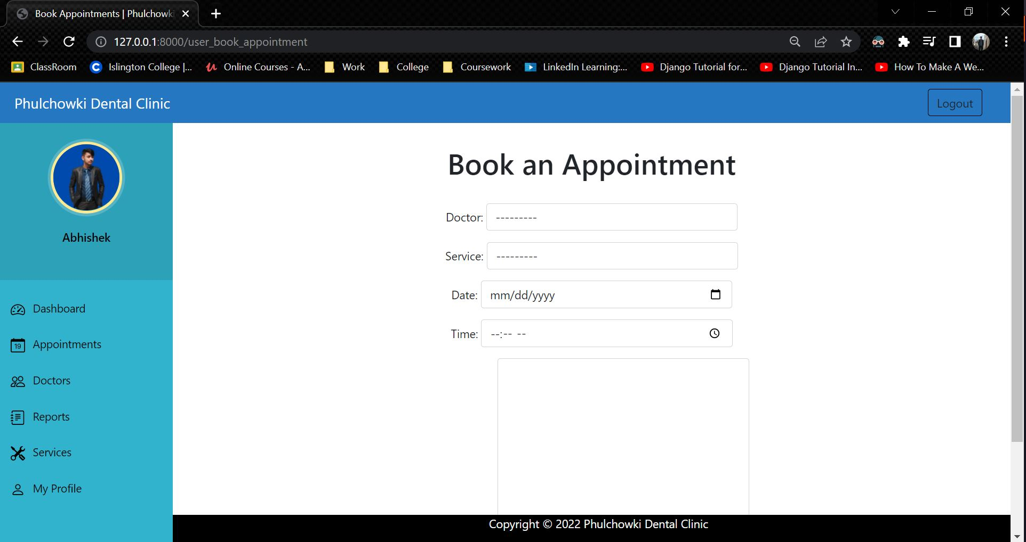

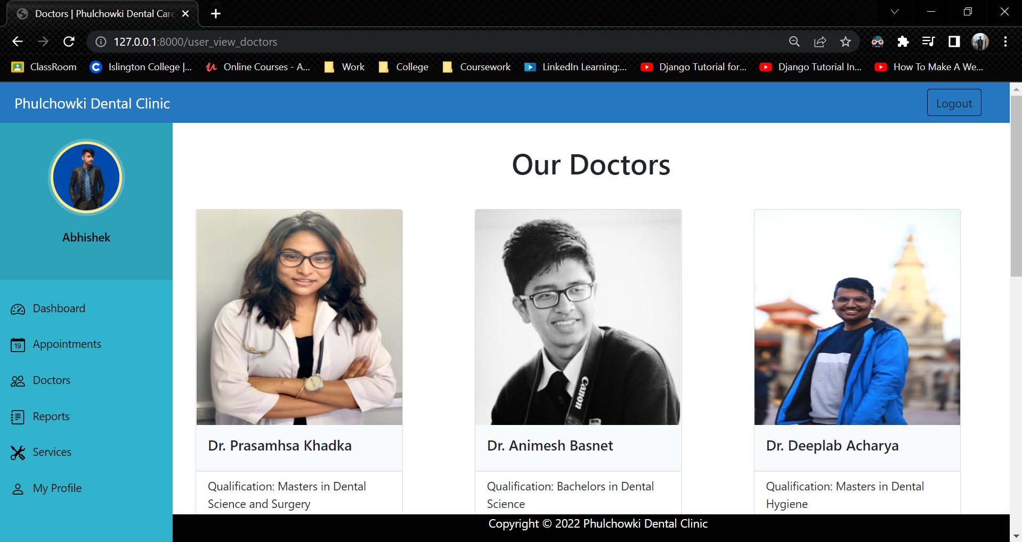

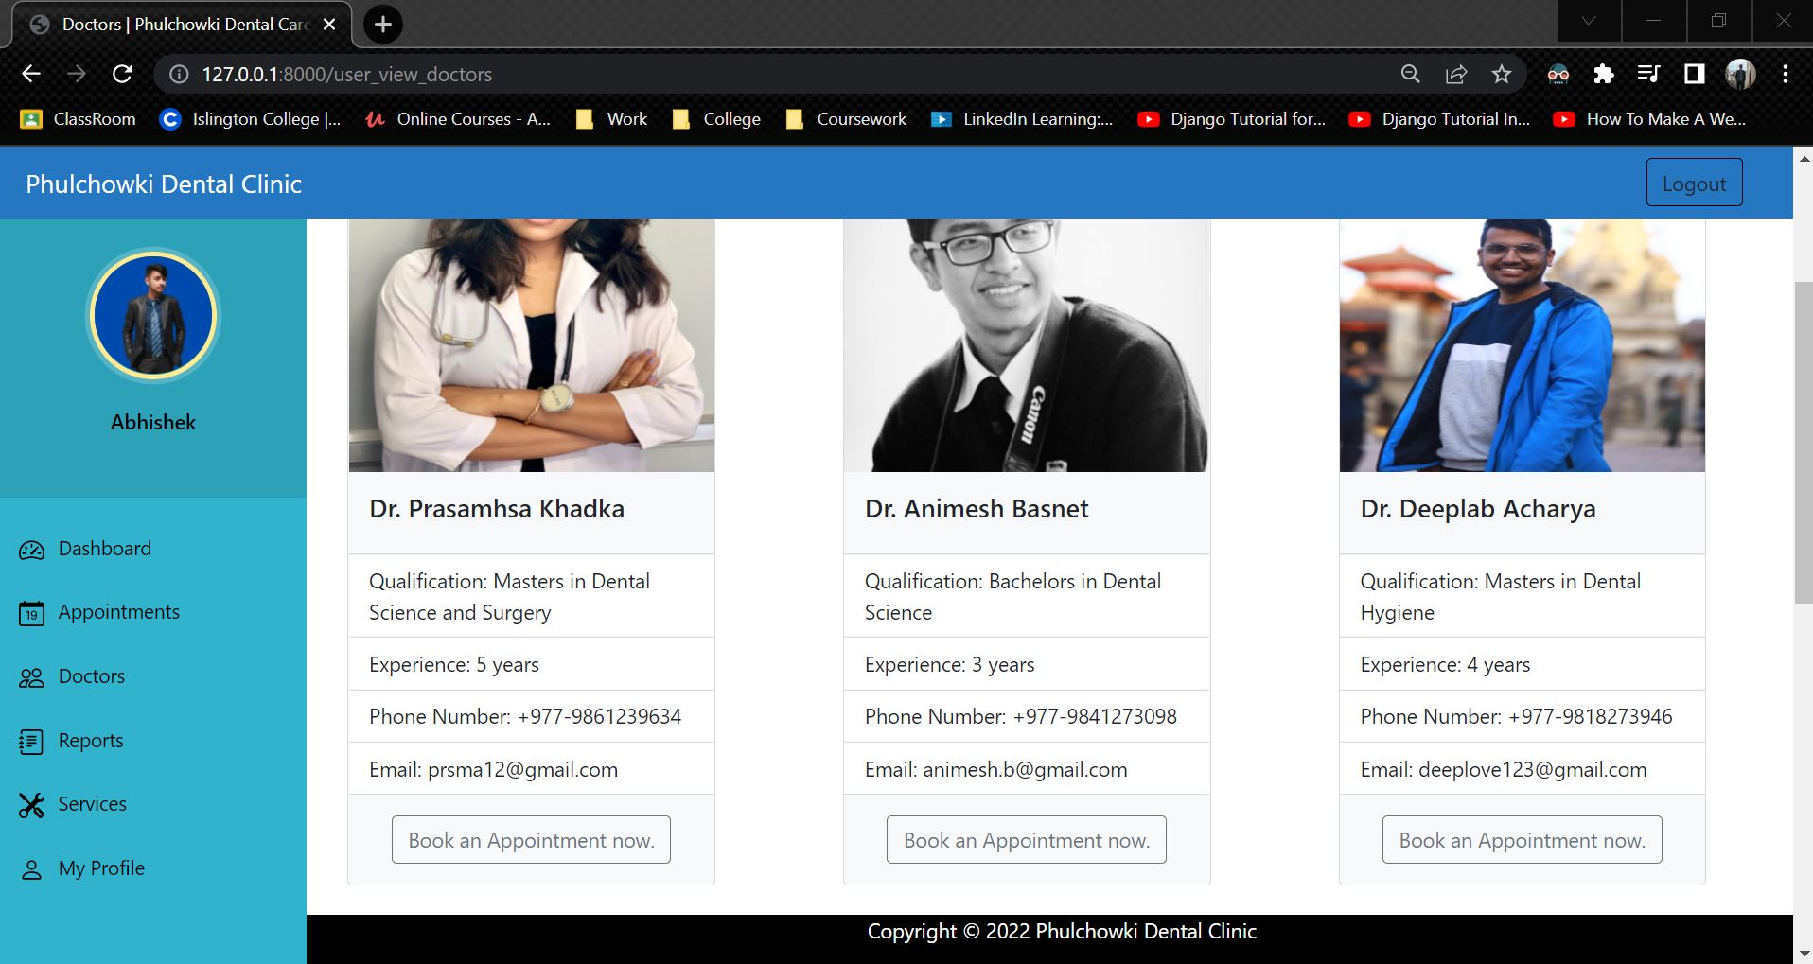

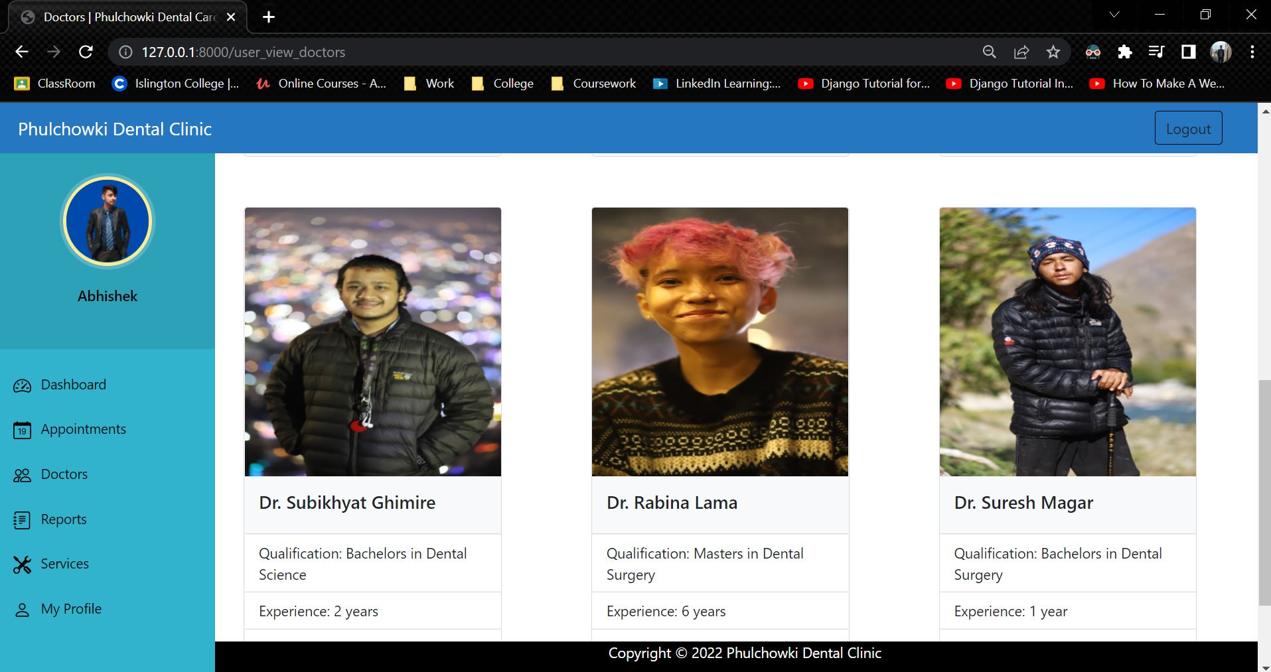

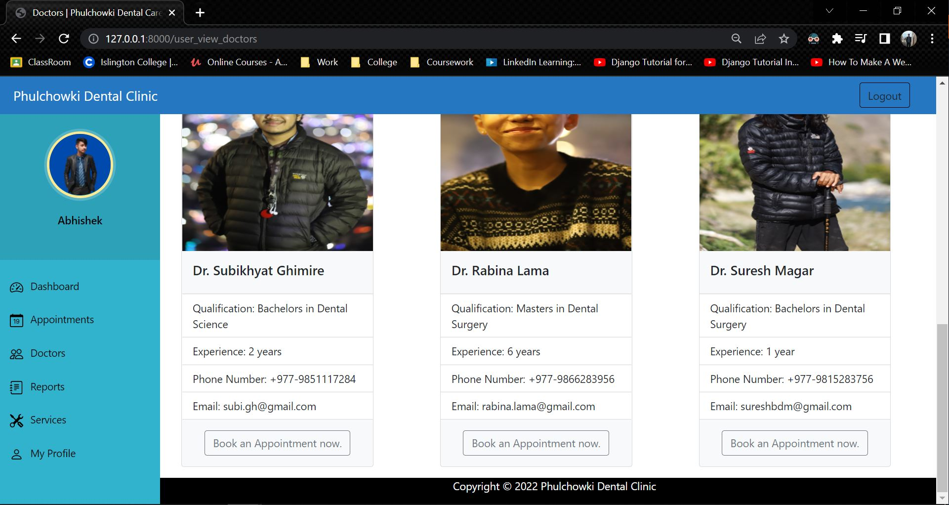

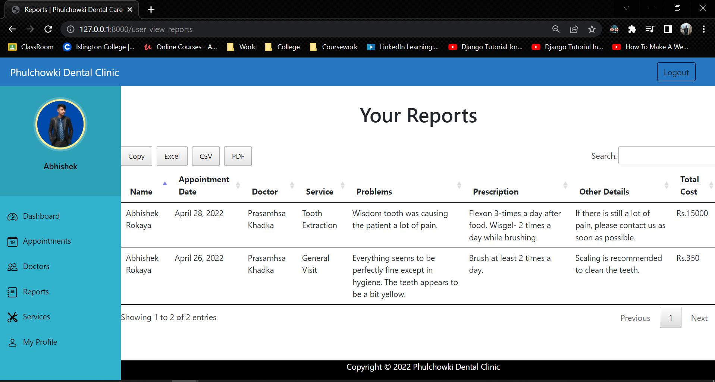

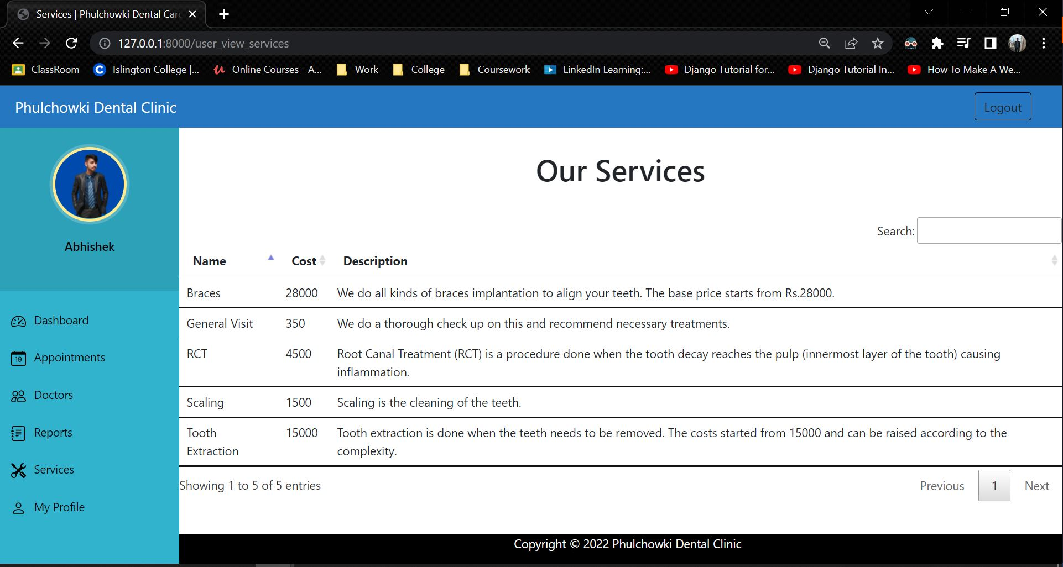

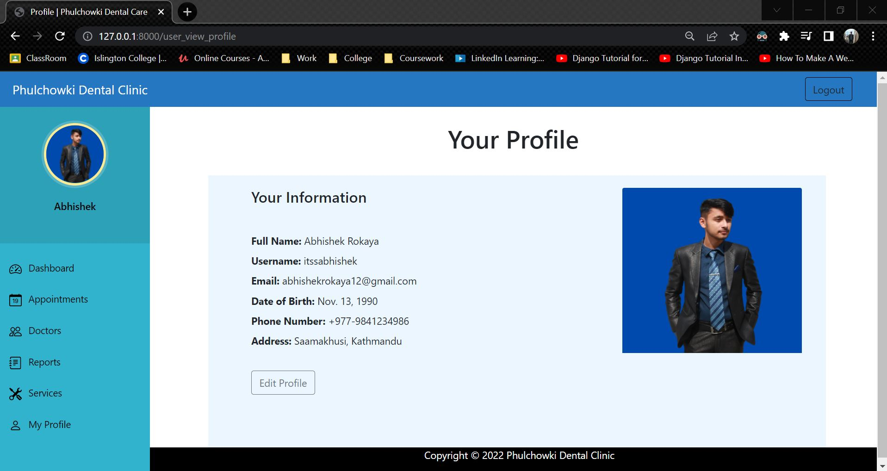

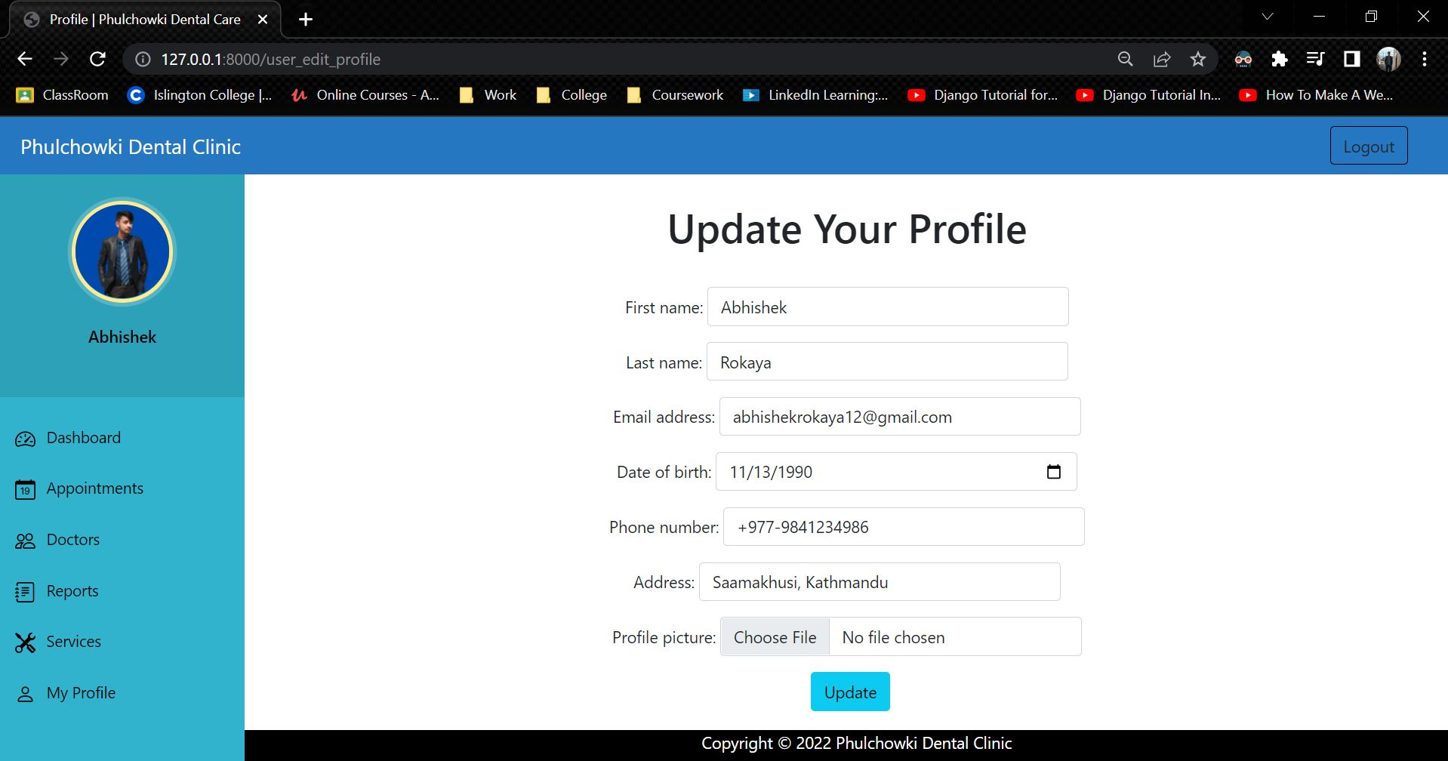

**Admin Side**

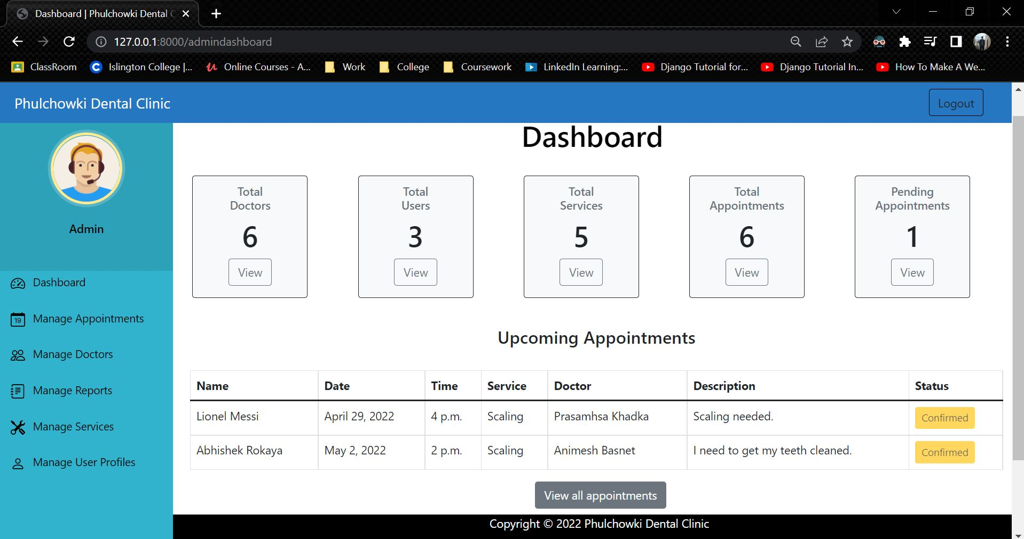

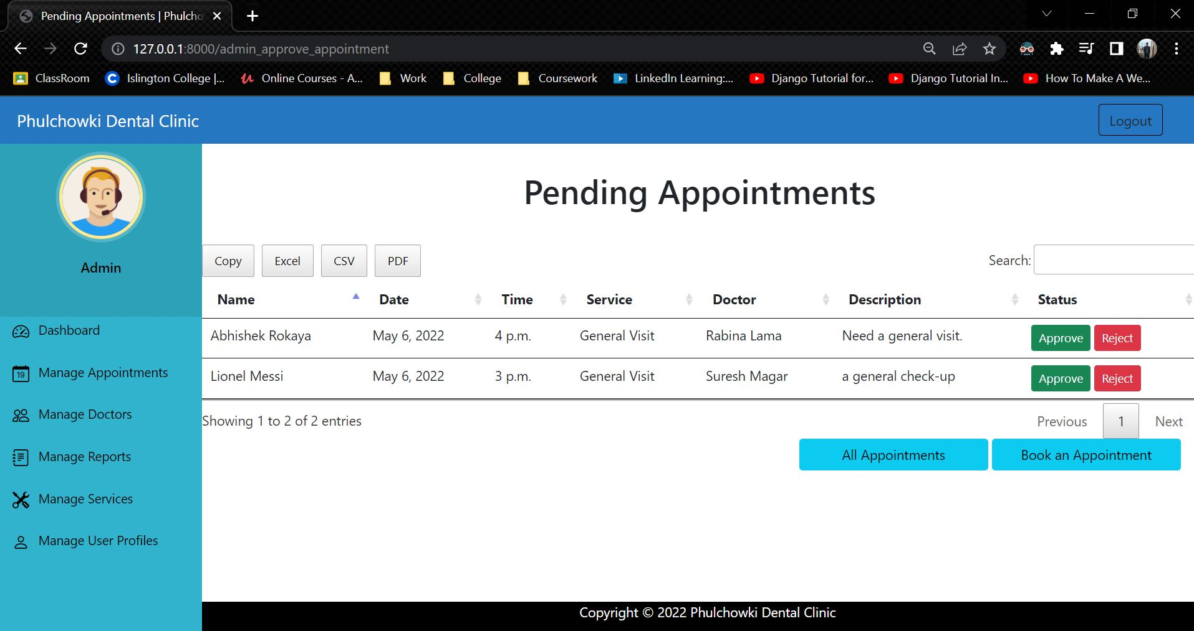

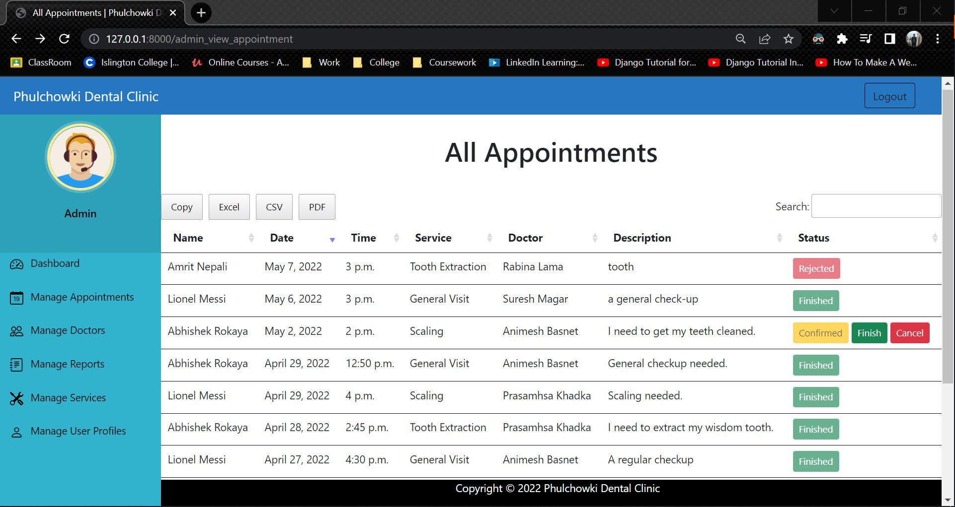

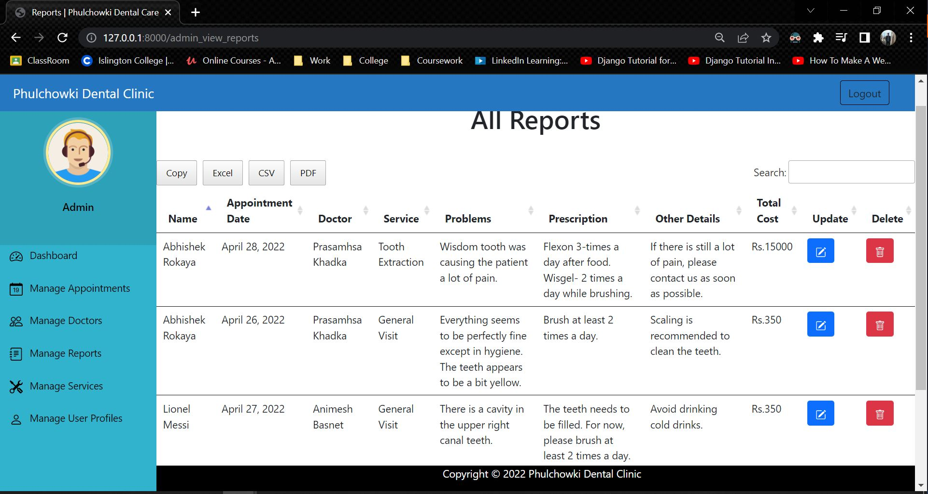

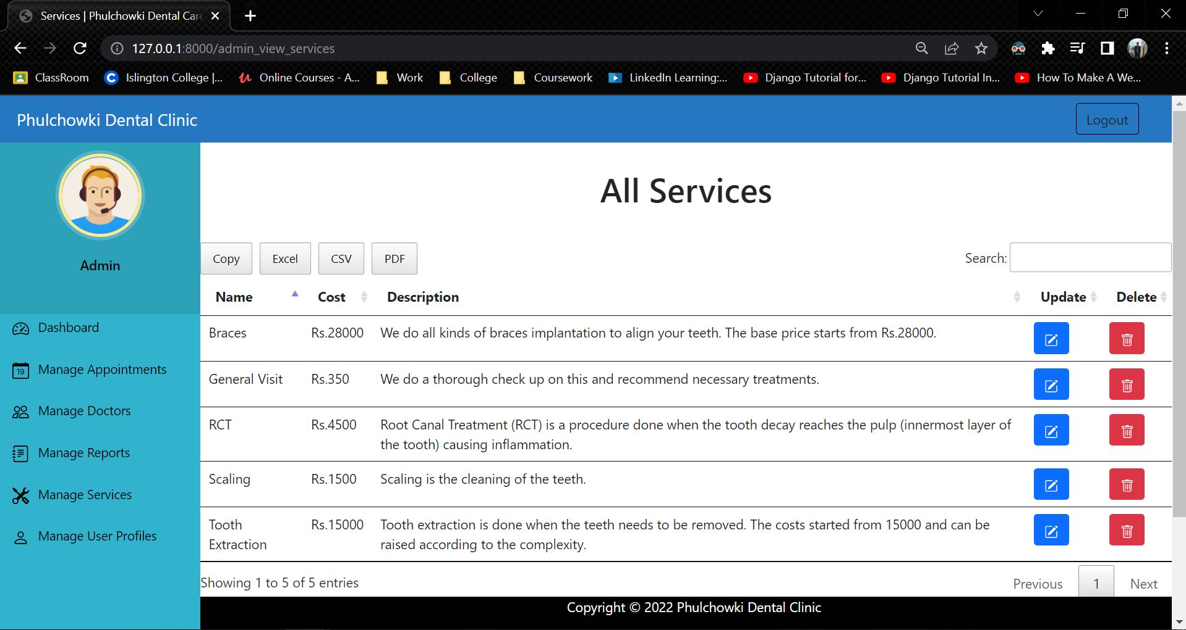

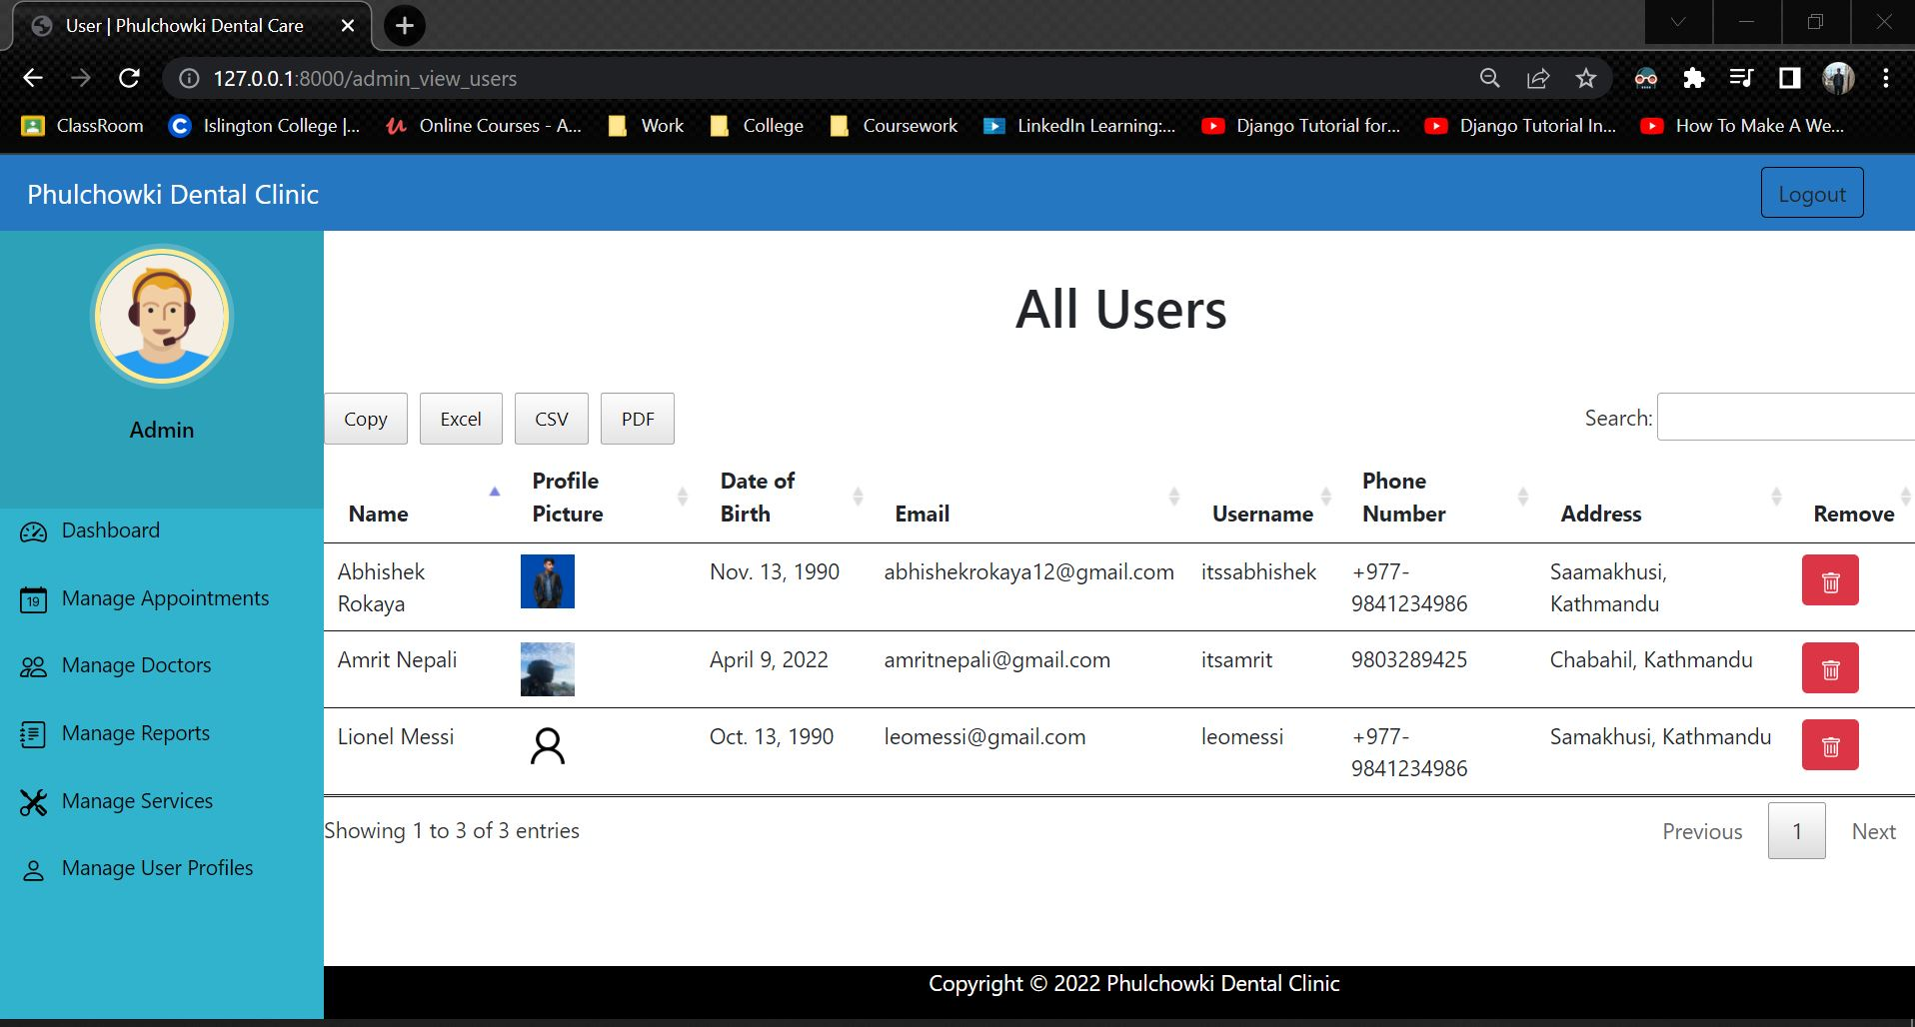

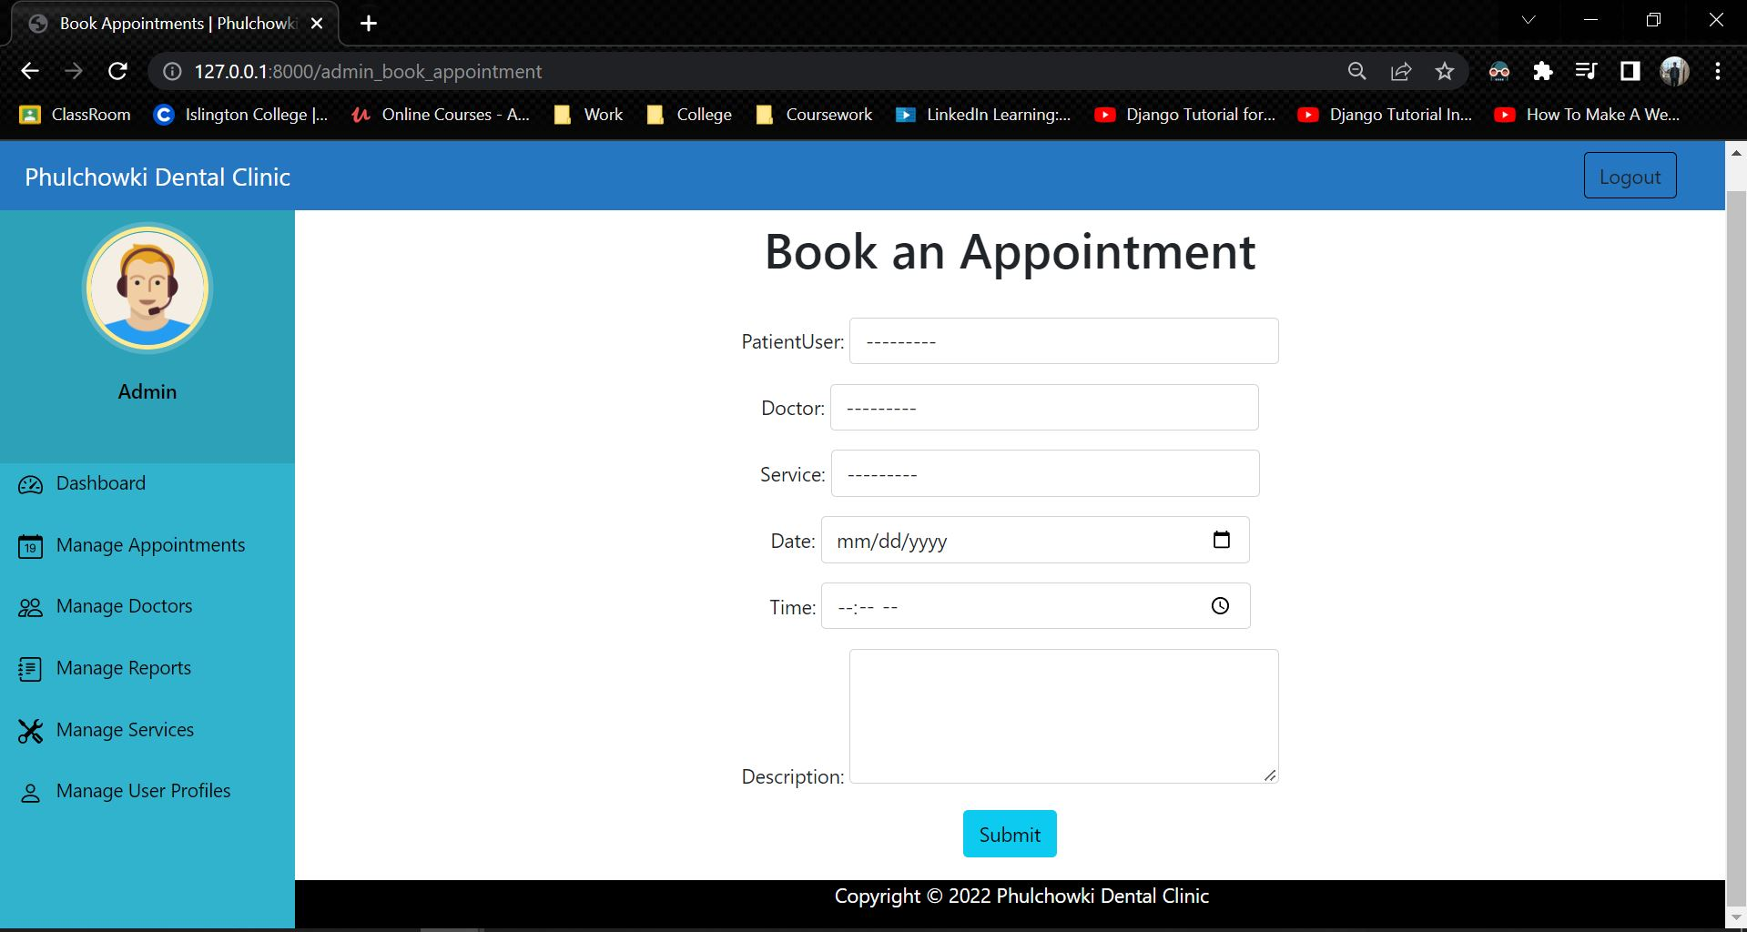

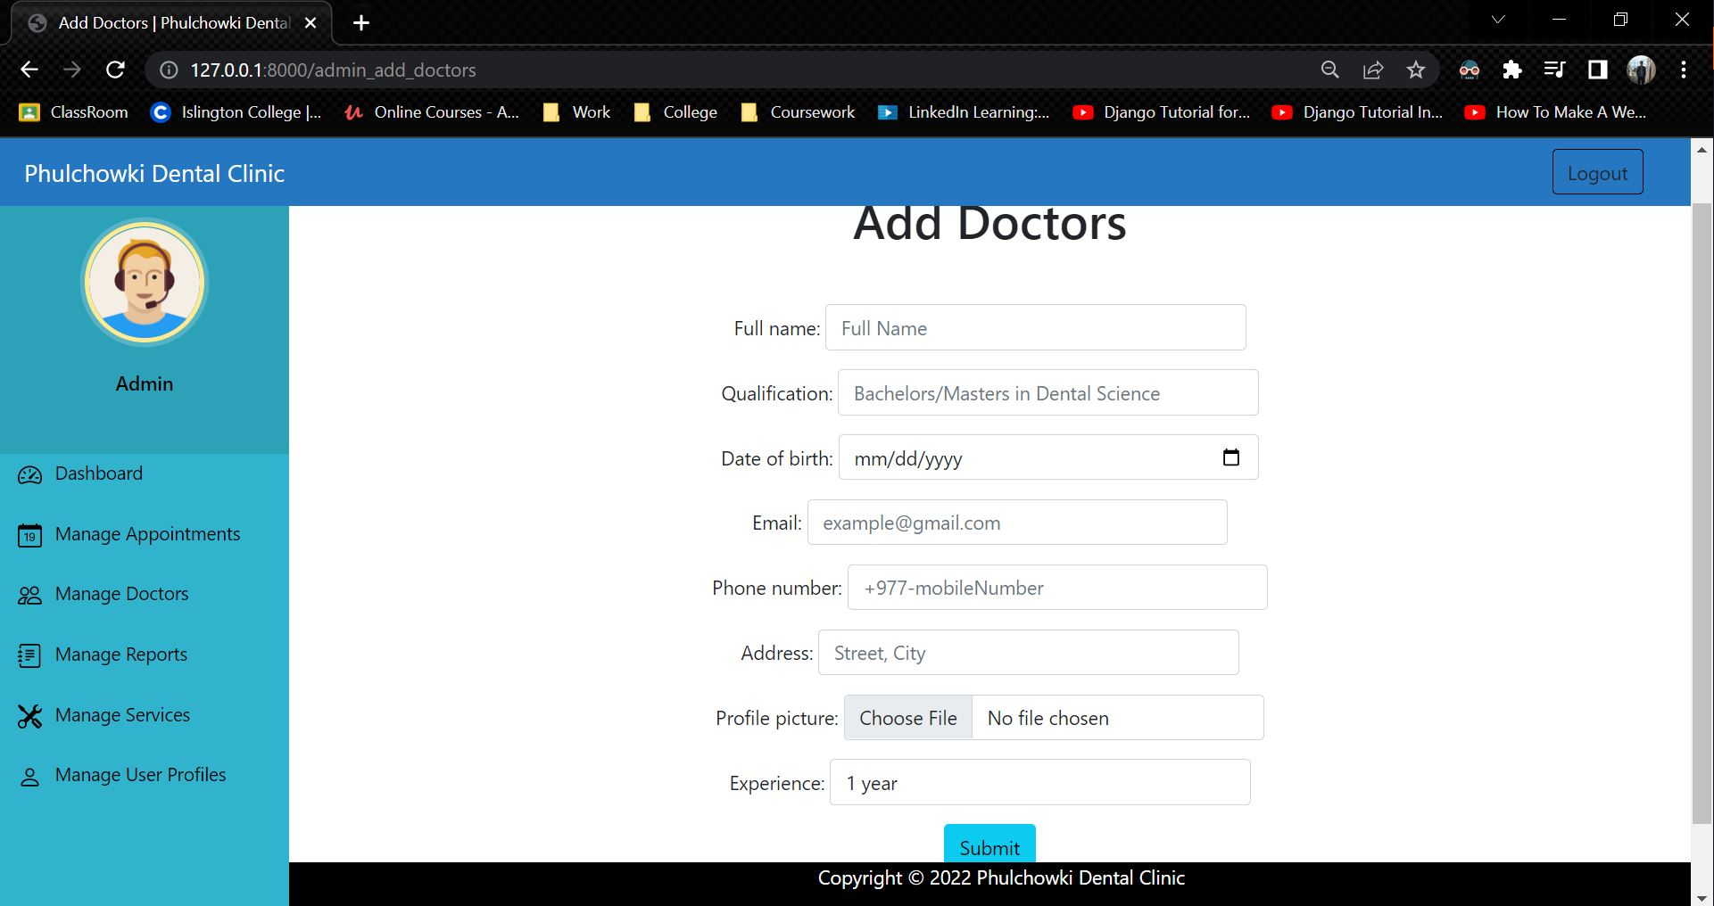

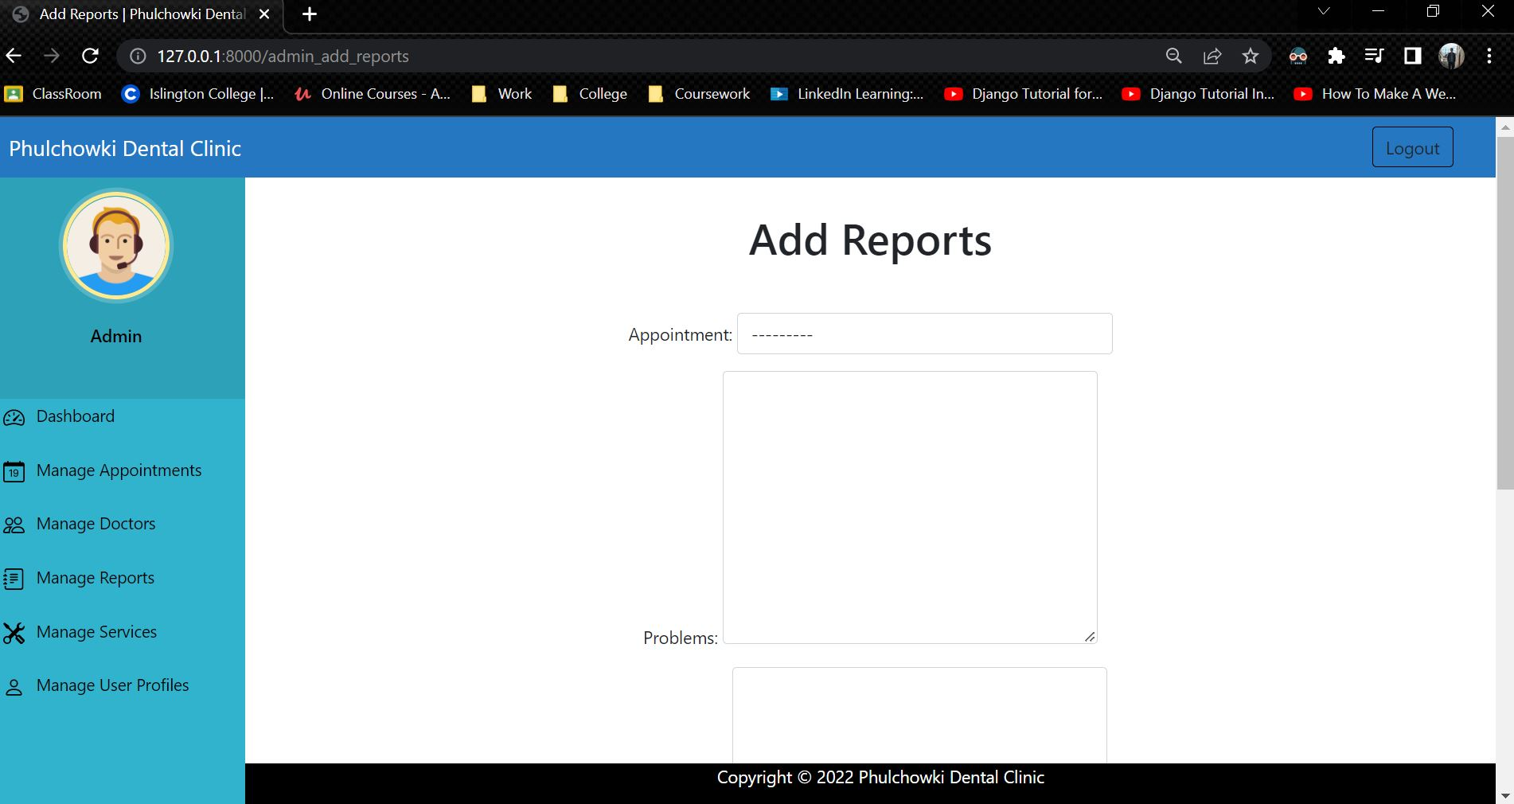

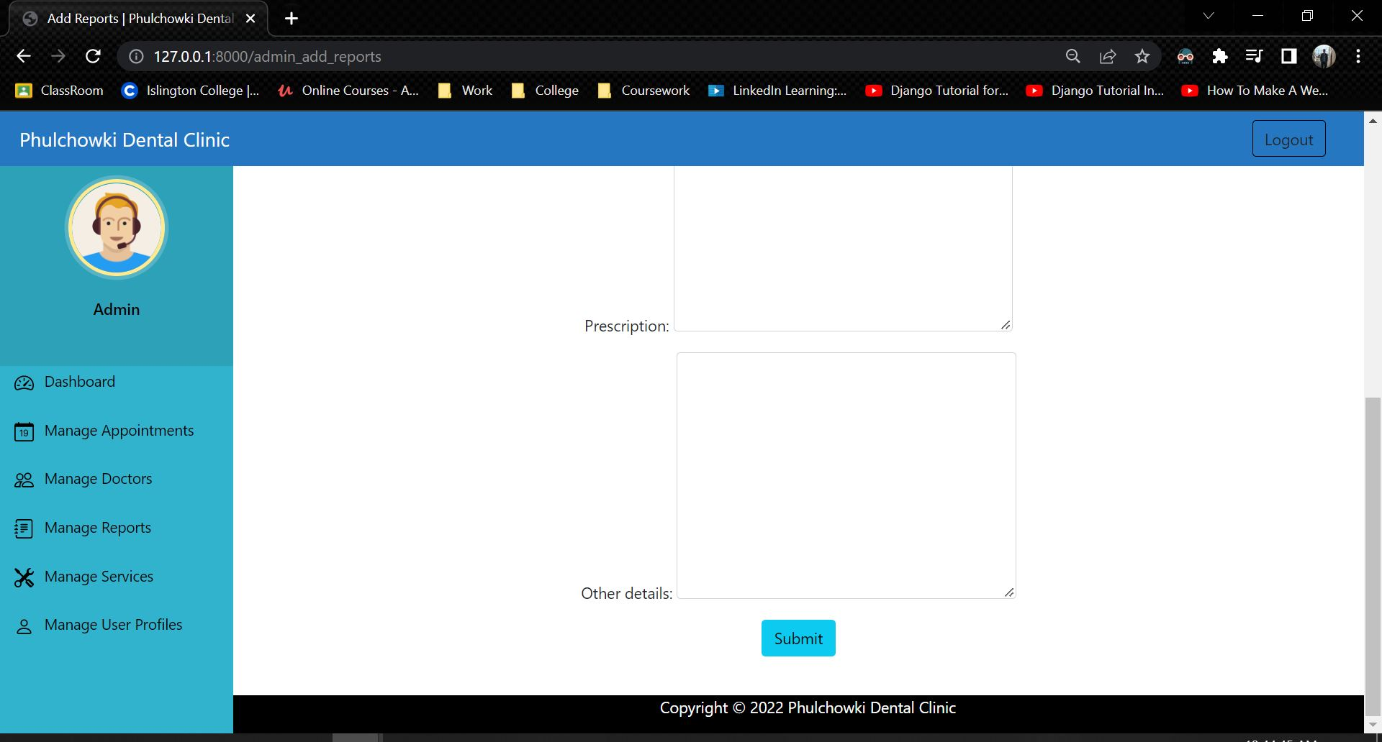

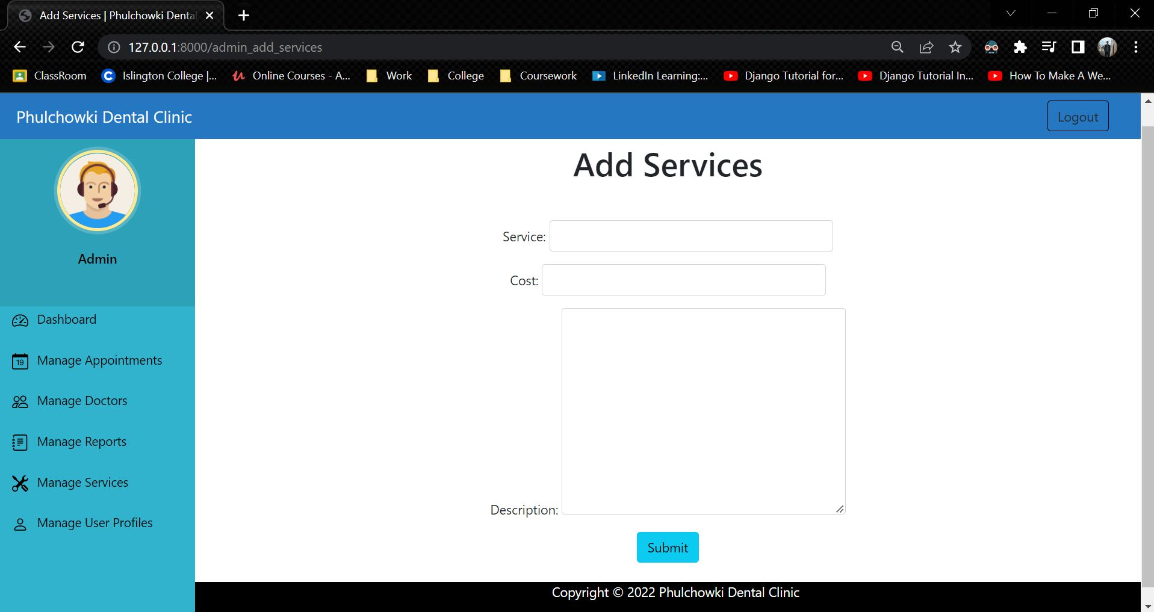

## 7.6 Appendix F: User Feedback

### 7.6.1 User Feedback Form

### 7.6.2 Sample of Filed User Feedback Forms

## 7.7 Appendix G: Future Work

### 7.7.1 Readings for future work